Effects of Surface Modification and Graphene Nanoplatelet Reinforcement on Adhesive Joint of Aluminium Alloys
Marzena Pawlik, Yiling Lu, Huirong Le*
School of Mechanical Engineering and Built Environment,
University of Derby, Markeaton Street, Derby, DE22 3AW, UK
*Corresponding author: Huirong Le – h.le@derby.ac.uk

Abstract
In this study, the combinative effects of surface treatments and the reinforcement of graphene nanoplatelets (GNPs) on the adhesive joint of aluminium alloy were investigated. Aluminium alloy plates were treated with acetone cleaning, grit blasting, chemical etching, and phosphoric acid anodisation (PAA) under various conditions. The effects of hydrothermal sealing of the anodised aluminium were also studied. Surface energies of the treated aluminium plates were determined using contact angle measurements. The samples were then bonded with epoxy or GNPs reinforced epoxy adhesives. The bonding strength of the aluminium joints was measured by single lap shear tests. The joint strength was significantly affected by both surface treatment and the reinforcement of GNPs. For grit blasted and PAA samples with hydrothermal sealing, the joint strength increased by 64% and 57% respectively with 0.42 wt% of GNPs. Across all surface treatments, the highest average shear strength (17.6 MPa) was achieved for PAA samples with hydrothermal sealing and the addition of GNPs followed by PAA samples with no sealing and pure epoxy (17.0 MPa). Fractal surface images were analysed, and the correlation between epoxy infiltration behaviour, surface treatments and nano-reinforcement was critically discussed.

Keywords: Adhesive Joint; Surface Modification; GNPs; Epoxy; Nanocomposites

Introduction
Adhesive bonding is a widely used technique in the fabrication of hybrid aluminium-composites structures, especially in the aerospace and wind energy industries. Adhesive bonding offers many advantages over conventional mechanical fastening such as lower structural weight, lower stress concentration in the structure and better airtight capabilities; but this type of joints may suffer from weak adhesion between epoxy and aluminium substrate resulting in reduced shear strength. Joint strength depends on many factors, including types of adherends and adhesive, thickness of adhesive, and surface treatments applied [1]. Generally, five broad categories of aluminium surface treatments exist including mechanical, chemical, electrochemical, coupling agent and dry surface treatment. Critchlow and Brewis [1] stated that optimal surface treatment produces a surface, which is free from contamination, wettable by the adhesive, mechanically and hydrolytically stable with good corrosion resistance. Many studies have investigated the effects of surface treatment on the bonding strength for various types of epoxy [2–4]. Boutar et al. [2] investigated how abrading influenced the lap shear strength and found that aluminium with a surface roughness of 0.6 µm produced the highest adhesive strength. Prolongo et al. [3] compared several mechanical and chemical surface treatments and different adhesives to optimise the joint strength. It was found that joint strength depends not only on the properties of the oxide layer, such as its composition, pore aspect ratio and porosity, but also on the viscosity of the adhesive during the application. Xu et al. [4] reported that the joint’s bonding strength could be improved by adjusting phosphoric acid anodising conditions. Anodising parameters such as voltage, time and acid concentration have significant effects on the surface energy, roughness and the ability of epoxy to penetrate the aluminium nanostructures [4]. So far, all these studies used pure epoxy resins as bonding adhesive.
More recently, carbonaceous nanofillers such as graphene nanoplatelets (GNPs) or carbon nanotubes (CNTs) have been increasingly used in epoxy adhesive due to their superior mechanical and electrical properties [5–15]. Salom et al. [12] reported 20% increase in Young’s modulus of GNPs reinforced epoxy with 2 wt% of GNPs. Moriche et al. [11] observed 206% and 306 % enhancement in thermal conductivity with 8 and 10 wt% GNPs reinforcement in the epoxy adhesive. Moreover, graphene increases adhesive thermal stability [6] and mechanical performance at elevated temperatures [10]. The improvement in mechanical, thermal properties and competitive price of GNPs make them an excellent candidate to reinforce epoxy adhesive.
Most of the work on adhesive bonding focuses on the effects of the volume fraction of nanofillers on mechanical properties [5,6,11,12]. Akpinar et al. [5] reported 276% increase in lap shear strength for epoxy reinforced with 2 wt% of GNPs. The same research group also observed that the method of mixing nanofillers with epoxy has a significant influence on the adhesive properties. On the other hand, some studies reported no improvement [11] or even a decrease (~20%) in adhesive properties caused by the introduction of GNPs [12,13]. The decrease in properties of nanocomposite was usually attributed to poor nanofiller dispersion, the weak interface between nanofillers and epoxy and agglomeration effects caused by Van der Waals force. In adhesive bonded joints, the interface between aluminium and epoxy plays an important role in the adhesion properties. So far, most studies on GNPs reinforced adhesives focus only on single surface treatment, usually grit blasting or chemical etching. To the best of authors’ knowledge, only one study compared the effects of two selected surface treatments on aluminium, i.e. alkaline cleaning and P2 etch [12]. However, no correlation between the surface treatments and GNPs epoxy adhesive strength was observed.
The present work aims to carry out a systematic study on the effects of different aluminium surface treatment and GNPs reinforcement on the strength of adhesive joints of aluminium alloy. The surface energy of aluminium with mechanical, chemical and electrochemical surface treatment was measured using sessile drop method. The surface morphology and wetting behaviour of epoxy on the aluminium surface were studied by scanning electron microscopy (SEM) and contact angle measurements. The bonding strength of surface-treated aluminium plates with epoxy or GNPs reinforced epoxy was investigated by using single lap joints and correlated with surface morphology and energy measurements.

2. Materials and experimental procedure

2.1 Materials
Aluminium alloy grade 1050A is widely used in applications such as tanks, boilers, fan blades, automotive trim and many more [16]. Sheets (RS Components, UK) with a thickness of 2 mm were used as adherends in this study. Low viscosity epoxy resin IN2 (Easy Composite, UK), composed of epoxy resin and slow hardener AT30, was used as adhesive due to its excellent flowability and compatibility with carbonaceous materials. This mixture has a pot life around 80 - 100 min and low viscosity in the range of 250 - 450 mPa·s at 20°C. The mixing ratio of resin to hardener is 100:30 by weight. The maximum Tg temperature of the cured resin is 98 °C according to the supplier datasheet. Graphene nanoplatelets (xGnP Grade C750, Sigma Aldrich, UK) with a thickness of a few nm, the surface area of 750 $m^{2}/g$ and the bulk density of 0.2 - 0.4 g/mL were used as reinforcement. Remaining chemicals used for surface treatment were sodium hydroxide, hydrochloric acid, phosphoric acid and acetone (Fisher Chemicals or Sigma Aldrich, UK).

2.2 Surface treatment
It is well known that aluminium surfaces have a weak natural oxide layer [16]. The bonding between this layer and aluminium is weaker than that of oxide with adhesive. Without any surface treatment, this oxide layer is often pulled off from the aluminium substrate, which is usually responsible for adhesive failure. The purpose of surface treatment is to modify the metal surface to achieve the best conditions for bonding. To improve bonding strength, five types of surface treatments were applied, including solvent cleaning, mechanical abrading, chemical and electrochemical treatments. Note that surface treatments were performed on aluminium strip of dimensions 100 mm in length and 25 mm in width. Details of each treatment are as follows:
- Degreasing: Aluminium samples were cleaned with acetone to remove grease and contaminants and then dried in room temperature.
- Grit blasting: Aluminium samples were abraded with steel particles (Chronital®) for 2 min at 2.2 bar in the grit blasting cabinet (Sealey SB970.V3, UK), rinsed with water and dried in the air.
- Etching: Aluminium was immersed in 40 ml of $NaOH$solution (5 wt%) at 60°C for 2 min, then rinsed with water followed by de-smutting in 40 ml of 5 wt% $HCl$ solution for further 2 min.
- Phosphoric acid anodisation (PAA): Schematic of the process is shown in Figure 1. Prior to anodisation, samples were cleaned with water and etched as in step iii. Samples were then rinsed with water and transferred to the beaker with 12 wt% of $H_{3}{PO}_{4 }$solution. Copper rod was used as a cathode. Anodisation was carried out at constant voltage (12V) in room temperature for 15 min.
- Phosphoric acid anodisation + sealing (PAA + sealing): After completion of steps in iv. samples were subsequently sealed in boiling water for 15 min. The hydrothermal sealing process is applied to form a protective layer between the surface and environment, hence improves the corrosion resistance of the substrate [17].
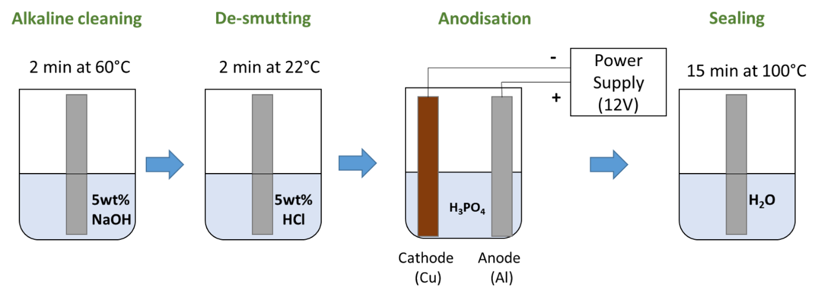
Figure 1. Schematic of phosphoric acid anodisation of aluminium samples.

2.3 GNPs reinforced adhesive
Appropriate GNPs dispersion has a significant influence on the mechanical properties of the epoxy adhesive [18]. Mixing GNPs with epoxy resin follows a similar procedure as given by [14]. Firstly, the GNPs were mixed with the hardener. The hardener used in this study (AT30) has low viscosity of around 20 mPa.s. It was used as solvent for initial de-agglomeration of GNPs. 0.055 g GNPs was added to 3 g hardener under continuous stirring using a magnetic stirrer (IKA C-Mag HS 7) for 30 min at 1000 rpm. Subsequently, 10 g epoxy resin was added to the suspension for a further 30 min mixing. The epoxy resin with GNPs was degassed in a vacuum chamber for 30 min at −1.0 bar to remove bubbles induced in mixing process. Under the current processing conditions, the desirable value for GNPs concentration was around 0.5 wt% to obtain reasonably good dispersion. Considering the loss of resin and hardener during this process, the final concentration of GNPs was set at 0.42 wt%.

2.4 Surface analysis
Wettability studies were performed by measuring the contact angle when a solid and liquid interact. Large contact angles (above 90°) correspond to low wettability, while small contact angles (below 90°) represent good wettability. In other words, the lower the contact angle, the better the ability of a liquid to spread over a solid surface. The contact angle of the aluminium subjected to different surface treatments was measured using a sessile drop method with an optical tensiometer (Theta Lite, Biolin Scientific, UK). Glycerol, deionised water and diiodomethane were used as probing liquids with a drop volume of 4.0 µl. The experiment was recorded for 10 s and frames were analysed using the proprietary software called One Attention. Surface energy of aluminium was determined by Owens Wendt Rabel Kaelble (OWRK) method. Average contact angle across three samples was used to find apparent surface energy of aluminium. The contact angle of epoxy resin on aluminium was recorded for 120 s, and the average contact angle of liquid drops on selected surface treatment was used to calculate the work of adhesion.
Surface morphologies were inspected using SEM (VEGA3, TESCAN), and the acceleration voltage was 20 kV. Samples, before observation, were gold sputter-coated at a 50 mA current for 2 min.

2.5 Single lap shear joints
Aluminium adherends of dimensions 100 x 25 x 2 mm were joined with an overlap length of 12.7 mm as recommended by ASTM D1002. Bondline thickness (0.3 mm) was controlled by a method provided in [2]. The fillet of the joint was not particularly controlled. A fillet formed naturally with a curvature due to bonding material exudation during the preparation. The same amount of adhesive was applied for each sample, which yielded similar fillets for all samples. All samples were cured for 24 h at room temperature followed by a 6 h post-curing cycle at 60°C as recommended by the epoxy supplier. Aluminium tabs were bonded at the end of single lap joints to ensure correct alignment during the tests. Specimens were tested using a universal tensile machine (Tinus Olsen HK50) with a load cell of 50 kN in room temperature. The crosshead speed was 1.3 mm/min. Summary of the prepared samples for the single lap joint test is presented in Table 1.
Table 1. Summary of prepared single lap joint samples.

Sample ID | Aluminium Surface Treatment | Adhesive | Number of samples
Al _{D}  Al _{D-GNPs}  Al _{GB}  Al _{GB-GNPs}  Al _{E}  Al _{E-GNPs}  Al _{PAA}  Al _{PAA-GNPs}  Al _{PAA+S}  Al _{PAA+S-GNPs} | Degreasing with acetone  Degreasing with acetone  Grit Blasting  Grit Blasting  Alkaline Cleaning + De-smutting  Alkaline Cleaning + De-smutting  Phosphoric Acid Anodisation (no sealing)  Phosphoric Acid Anodisation (no sealing)  Phosphoric Acid Anodisation (sealing)  Phosphoric Acid Anodisation (sealing) | Epoxy  0.42 wt% GNPs  Epoxy  0.42 wt% GNPs  Epoxy  0.42 wt% GNPs  Epoxy  0.42 wt% GNPs  Epoxy  0.42 wt% GNPs | 5  5  5  5  5  5  5  5  5  5

3. Results and discussion

3.1 Surface topography
The surface morphology of the treated aluminium is presented in Figure 2. Aluminium alloy sample cleaned with acetone presents a rather smooth surface with some grooves arising from thermo-mechanical processing of the alloy (Figure 2a). On the other hand, after the treatment of grit blasting (see Figure 2b) the sample surface shows a significant increase in roughness. During the grit blasting process, abrasive particles impinge the aluminium surface at high speeds, forming craters with irregular sizes. This type of morphology effectively increases the contact area between the adhesive and metal, which has the potential to improve adhesion. Alkaline etching in NaOH solution tends to attack the aluminium, particularly the grain boundaries creating cavities. As a result of alkaline etching and de-smutting, a number of random pits of different depths formed on the surface as shown in Figure 2c. These cavities remain present after the anodising treatment.
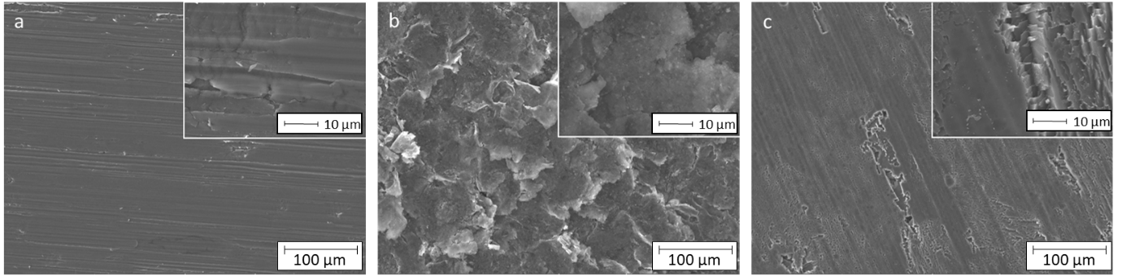
Figure 2. Surface morphologies of aluminium with different surface treatment a) acetone-cleaning; b) grit blasting; c) etching.

During anodisation, microscale pits and nanoscale pores are formed (see Figure 3a and b). The hydrothermal sealing process has a significant influence on surface topography. PAA without sealing (Figure 3a) shows much larger and deeper pits texture compared to PAA with sealing (Figure 3b). Sealing aluminium in boiling water forms aluminium hydrate known as boehmite and reduces the depth of cavities [17].
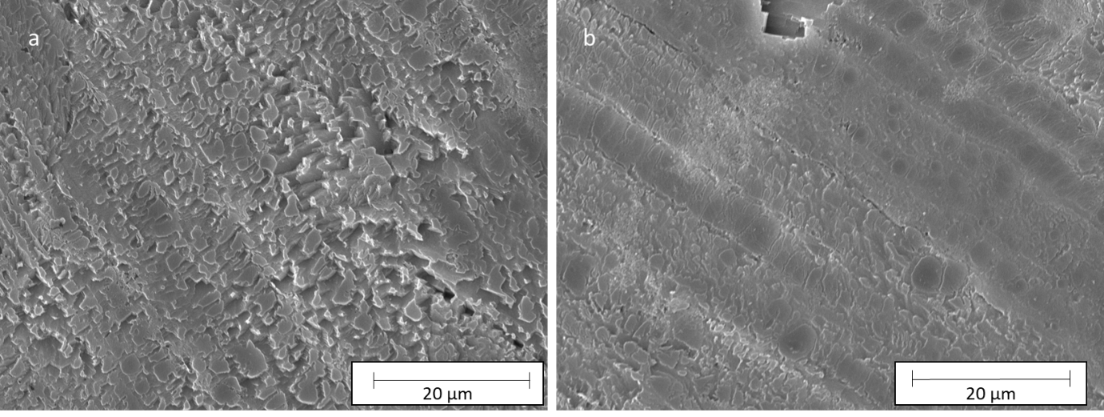
Figure 3. Surface morphologies of phosphoric acid anodised aluminium a) without sealing, b) with sealing.

3.2 Effects of surface modification on surface tension
Contact angle measurement was performed to investigate the effectiveness of the surface treatment with regard to liquid wettability. The relationship between the contact angle and surface energies is defined by Young’s equation:
$γ_{S}-γ_{SL}-γ_{L}cosθ_{c}=0$ (1)
where $γ_{S}$, $γ_{SL}$ and $γ_{L}$are solid-vapour, solid-liquid and liquid-vapour surface energy respectively, and $θ_{c}$ is Young’s contact angle. The work of adhesion ($W_{A})$ of liquid on the solid surface can be expressed as equation (2).
$W_{a}=γ_{L}(1+cosθ_{c})$ (2)
To compute solid surface energy in the OWRK method, water, glycerol and diiodomethane were used as probe liquids with known dispersive and polar parts of surface tensions (Table 2). The OWRK method considers the geometric mean of the dispersive and polar parts of the liquid’s surface tensions and of the solid’s surface energy (see equation 3).
$γ_{SL}=γ_{S}+γ_{L}-2\sqrt{γ_{S}^{d}γ_{L}^{d}}-2\sqrt{γ_{S}^{p}γ_{L}^{p}}$ (3)
Combining equations 1 and 3, a linear equation of the type $y=mx+c$ can be obtained:
$\frac{γ_{L}(1+cosθ_{c})}{2\sqrt{γ_{L}^{d}}}=\sqrt{γ_{S}^{p}}×\sqrt{\frac{γ_{L}^{p}}{γ_{L}^{d}}}+\sqrt{γ_{S}^{d}}$ (4)
In equation (4), $\frac{γ_{L}(1+cosθ_{c})}{2\sqrt{γ_{L}^{d}}}$ and $\sqrt{\frac{γ_{L}^{p}}{γ_{L}^{d}}}$ are measurable or known quantities for a given liquid. Therefore, solid surface energy component ($γ_{S}^{p}, γ_{S}^{d})$ can be derived when when contact angles of three test liquids are measured on a given substrate.
Table 2. Details on probe liquids used in contact angle measurements (adapted from One Attention software liquid database).

Probe liquid | Polar component  $γ_{L}^{p}$ (mN/m) | Dispersive component $γ_{L}^{d}$ (mN/m) | Surface Tension  $γ_{L}$ (mN/m)
Water | 51.0 | 21.8 | 72.8
Glycerol | 26.4 | 37.0 | 63.4
Diiodomethane | 0.0 | 50.8 | 50.8

Measured contact angles and calculated surface energies are presented in Table 3. Chemical and electrochemical treatments on aluminium surfaces decreased the contact angle drastically for water and glycerol probe liquids, indicating the hydrophilic nature of surfaces with good wetting capabilities. For example, acetone-cleaned aluminium had a water contact angle of 94.5°, while all anodised samples showed the contact angles less than 2.0°. These values are similar to reported elsewhere [4]. The total surface energies increased from 31.9±1.3 mN/m for acetone-cleaned samples to around 73.0 mN/m for anodised ones. Aluminium anodised in PAA without sealing yielded the total surface energy of 71.6 mN/m, which is close to 76.2 mN/m under similar anodisation conditions [4].
Table 3. Measurements of contact angles and apparent surface energy of aluminium with various surface treatment.

Sample  ID | Water  $θ_{c}$ (°) | Glycerol  $θ_{c}$ (°) | Diiodomethane  $θ_{c}$ (°) | Polar  component  $γ_{S}^{p}$ (mN/m) | Dispersive component  $γ_{S}^{d}$ (mN/m) | Surface  Energy  $γ_{S}(mN/m$)
Al _{AC}  Al _{GB}  Al _{E}  Al _{PAA}  Al _{PAA+S} | 94.5±0.2  86.6±1.2  23.0±9.8  1.0±0.2  1.7±0.9 | 93.5±0.5  90.3±4.5  44.3±12.2  11.8±4.5  13.7±0.6 | 54.9±1.0  45.2±4.3  44.5±2.9  50.0±4.6  38.2±1.8 | 0.3±0.1  0.7±0.7  27.4±1.5  37.1±2.0  32.6±0.7 | 31.6±1.4  37.0±2.3  37.2±1.7  34.5±2.7  40.6±1.0 | 31.9±1.3  34.7±2.3  64.6±3.1  71.6±0.7  73.2±0.4

Etching and anodisation treatments increased the polarity of aluminium compared to grit-blasted and acetone-cleaned samples. The increase in polar components should improve the bonding to epoxy resin. Epoxy resins having hydroxyl group (-OH) along their chain will form a strong attraction to polar functional groups on the aluminium surface. Etching and anodisation increased the dispersive components by approximately 20%, which reflects higher Van der Waals effect.

3.3 Effects of surface modification and nano-reinforced adhesive on single lap shear strength

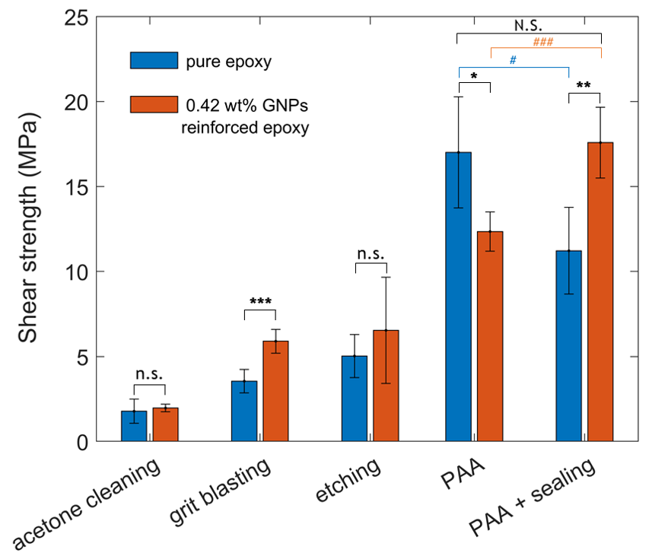
3.3.1 Lap shear strength

Figure 4. Average shear strength of unreinforced and GNPs reinforced joints with various surface treatment. Statistically significant differences for the same surface treatment are indicated by: * p < 0.05, **p < 0.01, *** p < 0.001, n.s., non-significant. Statistical significance between different group of samples are indicated by: # p < 0.05, ### p < 0.001, N.S., non-significant.

The maximum failure load and the apparent bonded area were used to calculate single lap joint strength following the ASTM D1002 standard. Average shear strength for five aluminium joints with various surface treatments with pure and GNPs reinforced epoxy was compared in Figure 4. Surface treatments had significant effects on the adhesion strength of pure epoxy. For example, samples with acetone cleaning or grit blasting treatments exhibited the mean shear strength of 1.8 MPa (SD = 0.6) or 3.6 MPa (SD = 0.6) respectively. Alkaline etching improved the lap shear strength up to 5.0 MPa (SD = 1.1). The most significant increase was found for samples subjected to anodisation treatment. Moreover, the adhesion strength of anodised samples was found sensitive to the sealing process. The highest adhesion strength for pure epoxy was achieved for PAA anodised aluminium and amounted to 17.0 MPa (SD = 3.2). This was approximately 8 times higher than the lap shear strength of acetone cleaned aluminium. Sealing of anodised aluminium decreased the lap shear strength of pure epoxy joints to 11.2 MPa (SD = 2.6), which is 34% lower in comparison with unsealed counterpart.
The addition of GNPs to the epoxy along with surface treatments affected the joint’s strength significantly. Some surface treatments contributed to larger improvement in the lap shear strength than others. If there were no correlation between surface treatment and GNPs, the increase in the lap shear strength would have been caused by the change of epoxy properties only. Therefore, the increase in the lap shear strength between pure epoxy and GNPs reinforced epoxy should be proportional for each surface treatment. However, this study showed an interplay between surface treatments and GNPs. The statistical analysis using t-test was conducted to compare the lap shear strength for (1) the same surface treatment in either pure epoxy or GNPs reinforced epoxy conditions and (2) different anodisation conditions. A statical significance level of α = 0.05 was used. For acetone-cleaned aluminium, there was no significant difference in the lap shear strength for epoxy (M = 1.8 MPa, SD = 0.6) and GNPs reinforced epoxy (M = 2.0 MPa, SD = 0.2). Grit-blasted samples showed a significant improvement of 64% in the lap shear strength from 3.6 MPa (SD = 0.6) for pure epoxy to 5.9 MPa (SD = 0.6) for GNPs reinforcement. There was no significant effect of GNPs reinforced adhesive in the case of etched aluminium, despite GNPs reinforced adhesive (M = 6.7 MPa, SD = 2.8) attaining higher average lap shear strength than pure epoxy (M = 5.0 MPa, SD = 1.1). The lap shear strength for aluminium anodised in phosphoric acid without sealing was significantly improved to 12.4 MPa (SD = 1.2) compared to grit blasting and etching. Nevertheless, this was significantly lower than the pure epoxy (M = 17.0 MPa, SD=3.2). The highest average shear strength of 17.6 MPa (SD = 2.1) was reported for the combination of PAA, sealing and GNPs reinforced epoxy. This value was significantly higher than the shear strength for pure epoxy and PAA sealing (M = 11.2 MPa, SD = 2.6). The lap shear strength of epoxy joints and PAA without sealing (M = 17.0 MPa) was significantly higher than the sealed counterpart (M = 11.2 MPa). Contrarily, the addition of GNPs to the epoxy showed a significant enhancement (42%) when PAA anodised aluminium was sealed. There was no significant difference between pure epoxy and PAA without sealing and GNPs reinforced epoxy and PAA with sealing.
Table 4 compares the lap shear strength of joints subjected to various surface treatment and bonded with nano-reinforced epoxy published in the literature. Mechanically surface treated aluminium and addition of GNPs generally shows an increasing trend in the lap shear strength. For example, Jojibabu et al. [6] reported 49% increase with 0.5 wt % of GNPs mixed with epoxy when the grit blasting was applied to aluminium samples. Akpinar et al. [5] sanded aluminium adherends and bonded with 0.5 wt% GNPs reinforced epoxy; they observed 27% increase of the lap shear strength due to the presence of GNPs. While in the present work, an enhancement of around 64% was observed by a combination of grit blasting and GNPs reinforced epoxy.
In the literature, chemical treatment and nano-reinforced epoxy showed both increases [10,15] and decreases [9,12] in the joint strength. Salom et al. [12] observed a 15% reduction in joint shear strength by the addition of 1 wt% of GNPs into the epoxy resin where the aluminium samples had the oxidised surface (P2 etch). Barra et al. [15] investigated the effects of chromic acid anodisation with the addition of 0.5 wt% of CNTs into the epoxy formulation. Khoramishad et al. [10] reported 50% improvement for a combination of sulphuric acid anodisation (SAA) and 0.1 wt% of GO nanoplatelets. Gkikas et al 2012 [8] noted 4% enhancement in the lap shear strength by introducing 1.0 wt% of CNTs to the adhesive while aluminium was subjected to PAA process. To the best of the authors’ knowledge, the lap shear strength of PAA anodised aluminium bonded with GNPs reinforced adhesive has not been reported yet. This work suggested an interaction between the anodic layer and GNPs and further explanation will be provided in section 3.6.
Table 4. Comparison of the lap shear strength (LSS) results published in the literature.
Aluminium type | Surface Treatment | Type of nanofillers | Wt% | LSS  (MPa) | Improvement in LSS (%) | Ref.
AA6061 | Grit blasting | GNPs | 0.5 | 20.7±0.9 | +49% | [6]
AA2024-T3 | Sanding | Graphene-COOH | 0.5 | 4.3 ±0.2 | +27% | [5]
AA1050 | Grit Blasting | GNPs | 0.4 | 5.9±0.6 | +64% | *
AA2024-T3 | Sanding | CNTs | 1.0 | 5.6 ±0.9 | +50 % | [8]
Not specified | P2 Etch | GNPs | 1 .0 | 9.6 ± 0.6 | −15% | [12]
2024-T3 | CAA | CNTs | 0.5 | 17.0±2.0 | +50% | [15]
A2024 | P2 etch | GNPs | 0.5 | 5.9±1.6 | −8% | [9]
AA6061-T6 | SAA | GO nanoplatelets | 0.1 | 21.5±2.0 | +50% | [10]
AA6061-T6 | SAA | GO nanoplatelets | 0.3 | 19.2±1.2 | +35% | [10]
AA2024-T3 | PAA | CNTs | 1.0 | 11.5±0.5 | +4% | [8]
Not specified | Not specified | GNPs | 1.0 | 7.4 ±0.5 | −12% | [11]
AA1050 | PAA | GNPs | 0.4 | 12.4±1.2 | −27% | *
AA1050 | PAA+ sealing | GNPs | 0.4 | 17.6±2.1 | +57% | *
*-present work, SAA- sulphuric acid anodisation, CAA- chromic acid anodisation

3.3.2 Elongation at failure

Figure 5 illustrates the representative curves of joints strength against elongation at failure. Samples subjected to five various surface treatments bonded with pure epoxy (dashed line) were compared with GNPs reinforced epoxy (solid line). Abbreviations used in this figure legend were provided in Table 1. When aluminium samples were cleaned with acetone only, shear strength for GNPs epoxy increased slightly. Both types of specimens failed rapidly. For these joints bonded with either pure epoxy or GNPs reinforced epoxy, the elongation was as small as 0.2 mm. GNPs reinforced grit blasted joints showed increased elongation at failure and shear strength, which was almost doubled in comparison to pure epoxy. Aluminium joints subjected to etching and bonded with GNPs reinforced adhesive showed somewhat similar behaviour to the grit-blasted one. The joints treated with chemical etching and bonded with GNPs failed at higher stress, but at a slightly smaller elongation compared to pure epoxy.
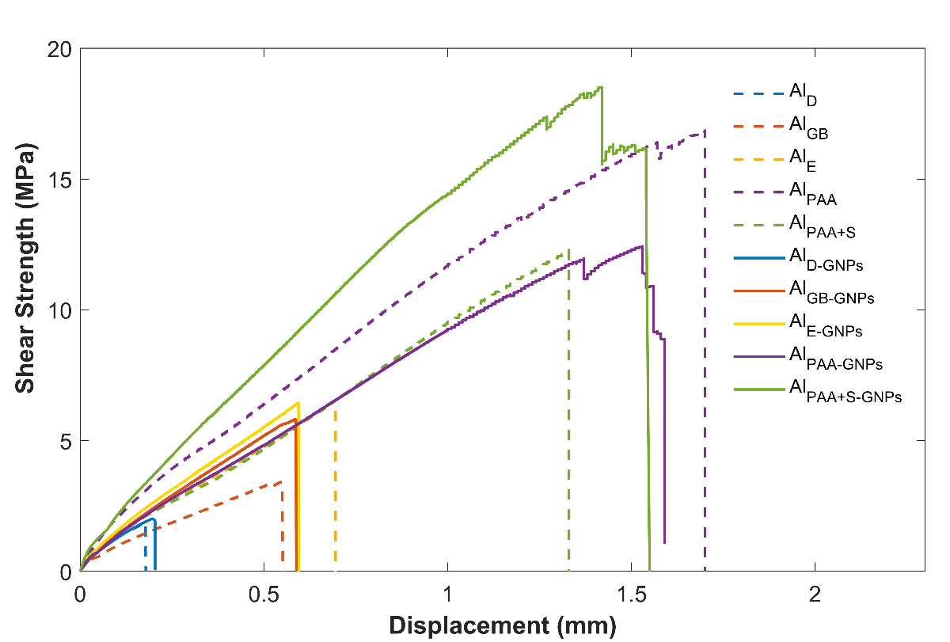
Figure 5. Representative shear strength-displacement curves obtained of single lap shear tests for aluminium joints with various surface treatment and addition of GNPs.
A dramatic increase in shear strength and elongation were found in anodised aluminium samples; however, the sealing process affected the extent of increase hugely. For anodised samples with no sealing and pure epoxy, the joints failed at the highest elongation of 1.7 mm. On the other hand, epoxy joints subjected to anodisation and sealing showed significantly lower shear stress and elongation. In the case of GNPs reinforced epoxy, sealed PAA aluminium showed much higher bonding strength and a slightly lower elongation than the non-sealed counterpart ($Al_{PAA})$. In all anodised samples, the shear strength curves are almost linear until 1.0 mm of elongation; then they become more step-like. GNPs reinforced epoxy shows rapid drops in shear strength near failure loads. These samples were carefully examined after testing. Many shear deformation lines were observed (as indicated by red arrows in Figure 6). These lines indicate strong bonding between the adhesive and substrate, resulting in plastic deformation of adhesive during shearing.
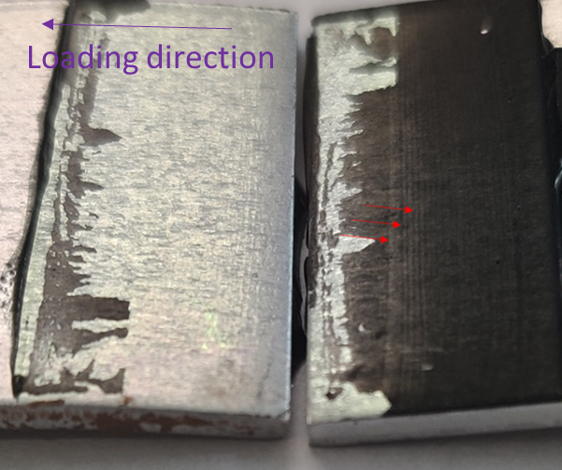
Figure 6. Fracture surface of GNPs reinforced single lap joints PAA+ sealing (red arrow indicates plastic shear deformation of epoxy).

3.4 Fractal surface analysis
It is commonly accepted that the addition of graphene to the epoxy resin improves its mechanical properties [18]. Nevertheless, in the bonding mechanism the interphase between adhesive and adherend plays a crucial role. Certain surface treatment of aluminium will create a unique surface texture, which can possess microscale features, i.e. grit blasting, chemical etching or combination of nano and microstructures by PAA (see Figure 2 and 3).
In order to study the mode of failure in the joint, the fractal surfaces were investigated by SEM. Figures 7a and b compare the fracture surfaces from a joint which was either grit-blasted or etched and bonded with GNPs reinforced epoxy. Mixed adhesive-cohesive failures were observed for tested samples.
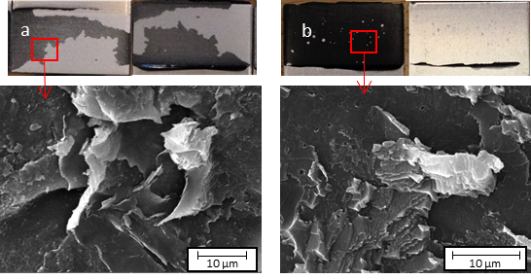
There is evidence that GNPs reinforced adhesive was anchored to the rough surface of the aluminium and pulled out of the surface during fracture, which is likely responsible for the increase in the lap shear strength.
Figure 7. Fracture surfaces of GNPs reinforced epoxy bonded joints with various surface treatment: a) grit blasting b) etching.

Figure 8 illustrates the fracture surfaces of various lap shear specimens subjected to anodisation. Images were taken from different regions of tested samples to investigate the failure mechanisms. Mixed adhesive-cohesive failures and in some cases aluminium oxide failures were observed in the tested samples.
Figures 8a and b show the fractal surface of the PAA anodised aluminium bonded with GNPs reinforced adhesive. Figure 8a exhibits a non-uniform layer of resin on the fracture surface. Some large resin residuals are formed by resin pulled out from aluminium cavities created by etching. On the adhesive side, both smooth (as indicated by orange arrows) and rough regions (blue arrows) are distinguished. Smooth regions have small ridges, which indicate the cohesive failure of epoxy. On the rough regions, the surface is spotty, which could result from the fragments of aluminium oxide pulled out of the anodised surface.
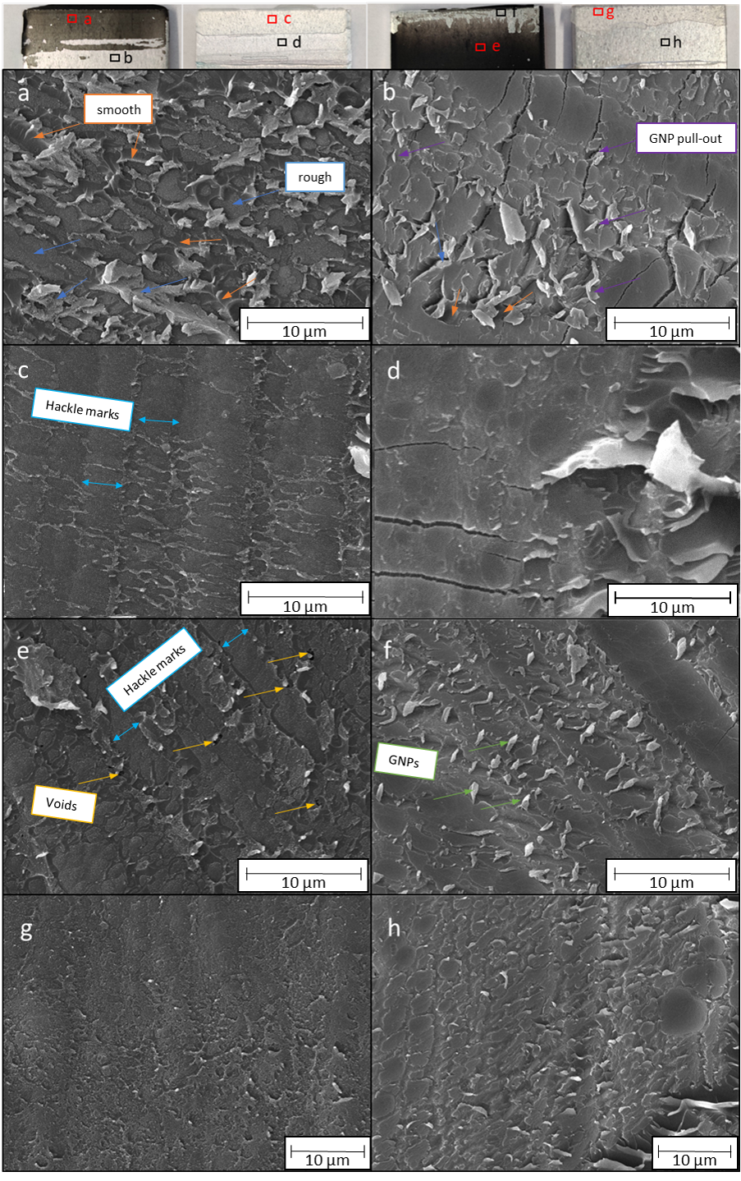

Figure 8. Fracture surfaces of PAA anodised single lap joints: PAA bonded with GNPs epoxy (a,b), PAA bonded with pure epoxy (c,d), PAA with sealing bonded with GNPs epoxy (e,f), PAA with sealing bonded with pure epoxy (g,h).

Figure 8b examines the behaviour of the tested samples on the aluminium side. Multiple microcracks in oxide layer were observed indicating the fracture of the oxide layer due to the plastic deformation of the substrate. This could be facilitated by both the substrate bending and GNPs crack deflection mechanism [18,19] as shown in Figure 9. GNPs in the adhesive could deflect the main crack to the surface of the adherends, creating more microcracks in the brittle oxide layer.
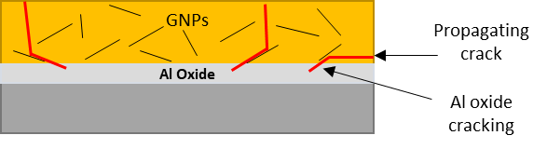
Figure 9. Crack deflection mechanism facilitating the formation of cracks in the non-sealed aluminium oxide layer.

Figures 8c and d present the fractal surface of PAA anodised joints bonded with pure epoxy. The high plastic deformation of epoxy adhesive in the hackle pattern-zone is found in Figure 8c, which effectively dissipates the energy of crack growth. The observation of the aluminium surface reveals some aluminium oxide fracture (Figure 8d). Fewer microcracks are observed in the oxide compared to GNPs reinforced joints described above (c.f. Fig. 8b). Large resin residuals are observed on the oxide surface, confirming mixed cohesive-adhesive failure mode. Some cavities on aluminium exist where the resin and aluminium oxide were pulled out.
Figures 8e and f present the fractal surface of the anodised and sealed aluminium samples bonded with GNPs reinforced epoxy. On the adhesive side (Figure 8e), perpendicular to the loading direction, the hackle marking areas are found. In the regions indicated by yellow arrows, plastic deformation of the adhesive is observed causing the formation of voids. This is one of the toughening mechanisms reported in GNPs reinforced composites [18]. Interestingly, on the aluminium side (c.f. Figure 8f), many pulled out particles of a few micrometre widths are present indicating pull-out behaviour of GNPs. Most of the large particles are positioned almost perpendicular to the aluminium surface. Moreover, sealed aluminium presents fewer cracks, implying that the sealed anodised oxide layer possesses higher mechanical properties than non-sealed one (c.f. Figure 8b).
Finally, the surface topography of the sealed aluminium bonded with pure epoxy is illustrated in Figure 8g and h. In comparison to non-sealed aluminium, the fractal surface of the epoxy is smoother. This was caused due to the difference in surface topography of the aluminium subjected to anodisation with or without sealing treatment. As discussed previously (Figure 3), sealed aluminium presented fewer cavities and smoother surface. No cracks are visibly detected on the aluminium side (Figure 8h); which corroborates the speculation that sealing in hot water improves the mechanical properties of the anodised layer.

3.5 Wettability of epoxy on the nanoporous aluminium surface

Contact angle measurements of pure and GNPs containing epoxy on surface treated by PAA with/without sealing were performed. Firstly, to investigate the effects of epoxy wetting on aluminium, the surface tension of epoxy was determined using a pendant drop method (see Table 4). The surface tension of pure epoxy was found to be 30.6 mN/m, which matched well with another experimental measurement [20]. Addition of GNPs to epoxy increased the surface tension to 32.7 mN/m. The contact angle of epoxy resin was measured for various types of samples according to the methodology provided in the literature [21].

Table 4. Measurements of liquid tension of epoxy and GNPs reinforced epoxy using the pendant drop method.
Probe liquid | Surface Energy $γ_{L}$ (mN/m)
Epoxy  0.42 wt % GNPs reinforced epoxy | 30.6±0.1  32.7±0.1
The average contact angle of liquid drops on selected surface treatment was used to calculate the work of adhesion based on equation (2) (see Table 5). In the case of PAA surface treatment and pure epoxy, an average contact angle of 94.2° was found. When the sealing process was activated (Al _{PAA+S}), the average contact angle of pure epoxy increased to 134.4°. Based on the contact angle measurements, the average work of adhesion for PAA without sealing was calculated as 28.4 mN/m, which was higher than that of sealed samples (M = 9.3 mN/m). These results can be correlated with the joint shear strength (see Figure 4). PAA treated aluminium without sealing had a higher work of adhesion corresponding to a higher lap shear strength of joints. GNPs reinforced epoxy and PAA treated aluminium had an average contact angle of 111.9° corresponding to work of adhesion of 21.0 mN/m. The highest average work of adhesion across all samples (29.85 mN/m) was observed for GNPs reinforced epoxy on sealed PAA anodised samples, which corresponds to the maximum joint shear strength.
Large standard deviations in measured contact angles were found particularly for PAA surface treatment without sealing (Table 5). This can be explained as follows: two types of wetting behaviour on anodised samples was observed, i.e. epoxy drop spreads quickly within less than 2 min as shown in Figure 10 (a-c) or epoxy drop that remains stable for longer time (15 min) in Figure 10 (d-f). In wettability studies, there are several possible mechanisms to describe the contact angle between the liquid and rough surface. When the liquid impregnates the surface completely - this is so-called Wenzel state. When the liquid is suspended on the top of rough peaks, this behaviour is described by Cassie-Bexter state. In the case of porous aluminium surface, it is possible that epoxy does not infiltrate the nanopores, and that gas is trapped in the oxide nanostructures [22]. This behaviour will result in a discontinuous interface between liquid and solid [2] and slower epoxy infiltration.
Table 5. Measurements of contact angle and work of adhesion for the epoxy drop on PAA anodised samples.
Sample ID | Contact angle (°) | Work of adhesion (mN/m)
Al _{PAA}  Al _{PAA-GNPs}  Al _{PAA+S}  Al _{PAA+S-GNPs} | 94.2±41.9  111.9±27.6  134.4±10.3  95.0±2.5 | 28.4±20.9  21.0±14.9  9.3±4.1  29.9±3.2

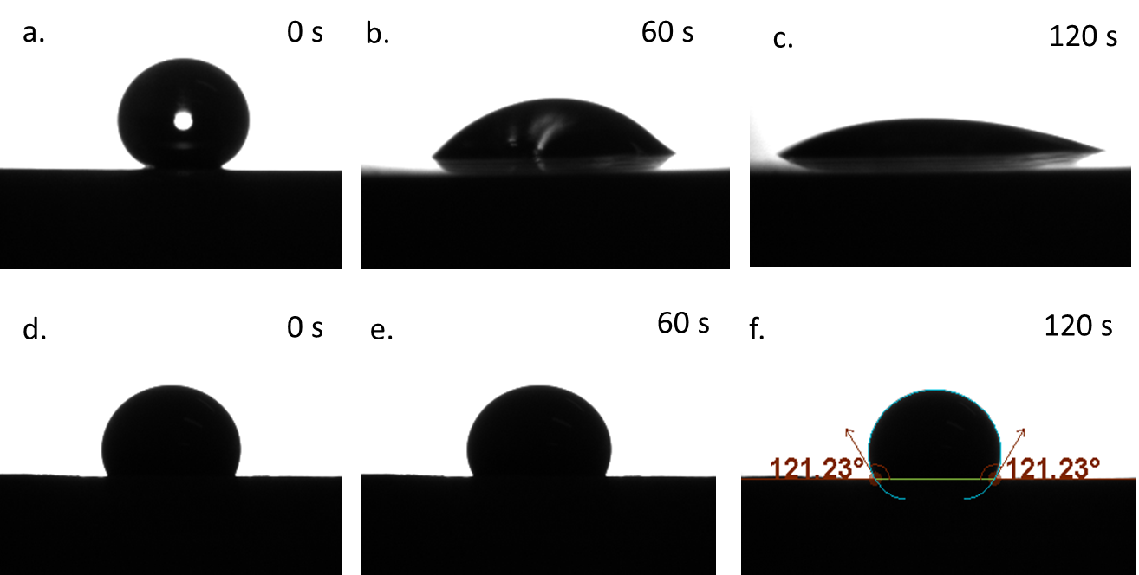
Figure 10. The contact angle of 4 µl epoxy droplets on anodised aluminium recorded for 120 s; pure epoxy on PAA (a, b, c), PAA + sealing (d, e, f).
A decrease in the contact angle due to the addition of GNPs was observed for sealed PAA treated aluminium compared to pure epoxy. Similar finding was reported in previous studies that investigated the effects of nanofillers on contact angle [7]. This decrease in contact angle was explained by the nano-scale size of the nanofillers, where GNPs could enhance their permeation into the grooves of the adherend surface, which would increase the wettability of the adhesive. The epoxy permeation behaviour will greatly depend not only on the surface morphologies but also on the size and shape of the nanoparticles.

3.6 Interplay of GNPs and aluminium surface texture - discussion
Grit blasting results in a very rough surface but does not have a significant effect on the apparent surface energy compared to acetone cleaning. Higher surface energy was found for etched samples (Table 3). Both treatments led to the lap shear strength improvement with pure epoxy compared to acetone-cleaned samples. Craters and cavities at microscale increase the contact area between adhesive and aluminium, thus enhance adhesion. The addition of GNPs further improves the joint’s strength. GNPs would strengthen the adhesive and have good connectivity with surface craters, as shown in Figure 7.
The results show that anodisation with PAA provides a significant improvement in the lap shear strength with pure epoxy. Surface topography influences the phenomenon of epoxy penetration into the holes, which is driven by capillary forces [22]. After PAA, the resultant oxide layer had distinctive morphology on the surface with nanopores, whiskers or protrusions, which increases the bonding strength [1]. Xu et al. [4] observed that the epoxy penetration into nanopores is related to the geometrical features of the oxide layer. For pure epoxy resin capillary wetting of the nanopores is controlled by the ratio of the nanopore diameter to the spacing and the nanopore depth to the diameter. Moreover, lowering the epoxy viscosity by the application of high-temperature cure adhesives can improve epoxy infiltration process [15].
Contrarily, some reduction in the lap shear strength was observed with the addition of GNPs and non-sealed anodised aluminium. This decrease could be related to the poorer penetration behaviour of the GNPs containing epoxy. The pore diameter of 35 nm was reported for the same type of anodised aluminium [23]. It is reasonably speculated that GNPs were too large (~2 µm) to enter the nanopores in the oxide layer. According to findings in the literature, Yu et al. [24] tested graphene oxide (GO) sol-gel coating to seal anodised aluminium. EDS analysis revealed the absence of C elements inside the nanopores and indicated that GO did not enter the pore. Similarly, the addition of GNPs will also increase the viscosity of the epoxy, which may influence the infiltration process and lead to interfacial porosity.
Sealing process of the anodised sample in boiling water was intentionally used to improve the corrosion resistance of aluminium oxide but leads to the closure/reduction of nanopores [17]. In comparison to PAA and pure epoxy, the sealing process caused a 35% decrease in the lap shear strength. This decrease is related to the much smoother surface of the aluminium as shown in Figure 3. Interestingly, sealing of aluminium and addition of GNPs epoxy was able to restore the lap shear strength of pure epoxy and non-sealed anodised aluminium. The effect of sealing after anodisation on bonding strength is more complicated. The increase in the lap shear strength of the sealed joint was related to the toughening mechanism of GNPs reinforced epoxy and interaction between GNPs and boehmite. Some typical toughening mechanism such as void formation and particle pull-out were observed in the SEM images (see Figure 8e). GNPs particle anchored well to the boehmite surface and remained present on the fracture surface after testing (see Figure 8f).
Addition of the GNPs to the epoxy increased its surface tension (see Table 4). According to equation (2), higher work of adhesion for the same surface treatment can be achieved by increasing the epoxy surface tension and decreasing the interfacial energy. One possible explanation is that formed aluminium hydroxide after sealing reduces the interfacial energy with GNPs containing epoxy. Furthermore, it has been observed that sealing aluminium oxide increases its mechanical properties [17], which helps prevent the oxide failure.
The addition of GNPs makes epoxy electrically conductive [11], which may affect galvanic corrosion of the joint. Gkikas et al. [8] reported that incorporation of 0.1 wt% of CNTs in the epoxy could even reduce the galvanic effect compared to aluminium and neat epoxy. However, increasing the wt% of CNTs closer to the percolation threshold (0.5 wt%) significantly accelerated the galvanic effect. In this study, 0.42 wt% of GNPs was used, and it is likely to be below the percolation threshold of GNPs reinforced epoxy. However, more experiments are required. Sealing in the boiling water creates hydrated alumina (boehmite), which occupies a greater volume and fills the pores in the anodised layer. The ingress of chloride ions and oxygen is retarded, which improves corrosion resistance [17]. Both sealing and presence of GNPs increase diffusion barrier for moisture, which increases the durability of the adhesive joints in a moisture environment [8].
The orientation of GNPs may affect epoxy properties [25], which in turn affects the joint strength. The alignment of nanofillers can be controlled in many ways. For example, Quan et al. [13] created the preferential alignment of GNPs parallel to the adherend surface using flow-induced shearing by pressure applied while curing joints. This orientation was partially responsible for the decrease in the joint’s strength. Future research on the cross-sections of the joints at higher magnification might extend the explanation of GNPs orientation on resin diffusion into nanopores and interfacial porosity. The efficacy of resin penetration behaviour will also be heavily influenced by the viscosity of the resin and concentration of nanofillers. Testing different concentration of nanofillers and providing the epoxy properties will help to find the optimal concentration for selected surface treatment. The surface spectroscopy would be useful to predict the fracture location and elemental composition of the fracture surface.

4. Conclusions

This work investigated the combinative effects of aluminium surface treatments and GNPs reinforced adhesive on the joint’s strength. Mechanical, chemical and electrochemical surface treatments were applied to aluminium, and resultant surface morphologies were discussed. Surface energy of aluminium was doubled due to the applied electrochemical surface treatment. The effects of phosphoric acid anodisation, hot water sealing process and GNPs to the adhesive on the joints’ strength were for the first time investigated.
Single lap shear strength for both pure epoxy and GNPs epoxy joints depended greatly on the surface treatments. Combination of selected treatment such as grit blasting with GNPs reinforced epoxy increased the joints strength in comparison to pure epoxy. Porous structure caused by phosphoric acid anodisation surface treatment enhanced the lap shear strength significantly. Work of adhesion was derived and correlated with the lap shear strength of adhesive on anodised samples. It was observed that the infiltration of the resin is sensitive to the sealing process and the presence of GNPs. Sealing process makes PAA oxide layer more ductile, and in conjunction with GNPs reinforcement yields the highest average lap shear strength (17.6 MPa) among all samples.
The present findings can be applied in the manufacturing of hybrid fibre-metal laminates as well as aluminium-fibre reinforced composite joints. The type of resin selected for this project is commercial low viscosity resin, which is used for resin infusion and manufacturing of glass and carbon fibre reinforced composites. The combination of proposed surface treatment and GNPs reinforcement can improve the adhesion between aluminium and composite layers.

Acknowledgements
Marzena Pawlik is supported by graduate teaching assistant and postdoctoral fellowship funding from the College of Engineering and Technology at the University of Derby. The authors want to thank Dr Graham Souch for his contribution in SEM study.

Declaration of interest
The authors declare no conflict of interest.

References:
[1] Critchlow GW, Brewis DM. Review of surface pretreatments for aluminium alloys. Int J Adhes Adhes 1996;16:255–75. https://doi.org/10.1016/S0143-7496(96)00014-0.
[2] Boutar Y, Naïmi S, Mezlini S, Ben M, Ali S. Effect of surface treatment on the shear strength of aluminium adhesive single-lap joints for automotive applications. Int J Adhes Adhes 2016;67:38–43. https://doi.org/10.1016/j.ijadhadh.2015.12.023.
[3] Prolongo SGÃ, Uren A. Effect of surface pre-treatment on the adhesive strength of epoxy – aluminium joints 2009;29:23–31. https://doi.org/10.1016/j.ijadhadh.2008.01.001.
[4] Xu Y, Li H, Shen Y, Liu S, Wang W, Tao J. Improvement of adhesion performance between aluminum alloy sheet and epoxy based on anodizing technique. Int J Adhes Adhes 2016;70:74–80. https://doi.org/10.1016/j.ijadhadh.2016.05.007.
[5] Akpinar IA, Gültekin K, Akpinar S, Akbulut H, Ozel A. Experimental analysis on the single-lap joints bonded by a nanocomposite adhesives which obtained by adding nanostructures. Compos Part B Eng 2017;110:420–8. https://doi.org/10.1016/j.compositesb.2016.11.046.
[6] Jojibabu P, Jagannatham M, Haridoss P, Ram GDJ, Deshpande AP, Rao S. Effect of different carbon nano-fillers on rheological properties and lap shear strength of epoxy adhesive joints. Compos Part A Appl Sci Manuf 2016;82:53–64. https://doi.org/10.1016/j.compositesa.2015.12.003.
[7] May M, Wang HM, Akid R. Effects of the addition of inorganic nanoparticles on the adhesive strength of a hybrid solgel epoxy system. Int J Adhes Adhes 2010;30:505–12. https://doi.org/10.1016/j.ijadhadh.2010.05.002.
[8] Gkikas G, Sioulas D, Lekatou A, Barkoula NM, Paipetis AS. Enhanced bonded aircraft repair using nano-modified adhesives. J Mater 2012;41:394–402. https://doi.org/10.1016/j.matdes.2012.04.052.
[9] Prolongo SG, Moriche R, Jiménez-Suárez A, Sánchez M, Ureña A. Epoxy adhesives modified with graphene for thermal interface materials. J Adhes 2014;90:835–47. https://doi.org/10.1080/00218464.2014.893510.
[10] Khoramishad H, Ashofteh RS, Pourang H, Berto F. Experimental investigation of the influence of temperature on the reinforcing effect of graphene oxide nano-platelet on nanocomposite adhesively bonded joints. Theor Appl Fract Mech 2018;94:95–100. https://doi.org/10.1016/j.tafmec.2018.01.010.
[11] Moriche R, Prolongo SG, Sánchez M, Chamizo FJ, Ureña A. Thermal conductivity and lap shear strength of GNP/epoxy nanocomposites adhesives. Int J Adhes Adhes 2016;68:407–10. https://doi.org/10.1016/j.ijadhadh.2015.12.012.
[12] Salom C, Prolongo MG, Toribio A, Martínez-martínez AJ, Cárcer IA De, Prolongo SG. Mechanical properties and adhesive behavior of epoxy-graphene nanocomposites. Int J Adhes Adhes 2018;84:119–25. https://doi.org/10.1016/j.ijadhadh.2017.12.004.
[13] Quan D, Carolan D, Rouge C, Murphy N, Ivankovic A. Mechanical and fracture properties of epoxy adhesives modified with graphene nanoplatelets and rubber particles. Int J Adhes Adhes 2018;81:21–9. https://doi.org/10.1016/j.ijadhadh.2017.09.003.
[14] Yu S, Tong MN, Critchlow G. Use of carbon nanotubes reinforced epoxy as adhesives to join aluminum plates. Mater Des 2010;31:S126–9. https://doi.org/10.1016/j.matdes.2009.11.045.
[15] Barra G, Vertuccio L, Vietri U, Naddeo C, Hadavinia H, Guadagno L. Toughening of epoxy adhesives by combined interaction of carbon nanotubes and Silsesquioxanes. Materials (Basel) 2017;10. https://doi.org/10.3390/ma10101131.
[16] Davis JR. Aluminum and Aluminum Alloys. Alloy. Underst. Basics, 2001, p. 351–416. https://doi.org/10.1361/autb2001p351.
[17] Hao L, Cheng R. Sealing Processes of Anodic Coatings- Past, Present and Future. Met Finish 2000;98:8–18. https://doi.org/10.1016/S0026-0576(01)80002-7.
[18] Chong HM, Hinder SJ, Taylor AC. Graphene nanoplatelet-modified epoxy : effect of aspect ratio and surface functionality on mechanical properties and toughening mechanisms. J Mater Sci 2016;51:8764–90. https://doi.org/10.1007/s10853-016-0160-9.
[19] Johnsen BB, Kinloch AJ, Mohammed RD, Taylor AC, Sprenger S. Toughening mechanisms of nanoparticle-modified epoxy polymers. Polymer (Guildf) 2007;48:530–41. https://doi.org/10.1016/j.polymer.2006.11.038.
[20] Page SA, Mezzenga R, Boogh L, Berg JC, Månson JAE. Surface energetics evolution during processing of epoxy resins. J Colloid Interface Sci 2000;222:55–62. https://doi.org/10.1006/jcis.1999.6613.
[21] Leena K, Athira KK, Bhuvaneswari S, Suraj S, Rao VL. Effect of surface pre-treatment on surface characteristics and adhesive bond strength of aluminium alloy. Int J Adhes Adhes 2016;70:265–70. https://doi.org/10.1016/j.ijadhadh.2016.07.012.
[22] Ran C, Ding G, Liu W, Deng Y, Hou W. Wetting on Nanoporous Alumina Surface: Transition between Wenzel and Cassie States Controlled by Surface Structure. Langmuir 2008;24:9952–5. https://doi.org/10.1021/la801461j.
[23] Dasquet J., Caillard D, Conforto E, Bonino JP, Bes R. Investigation of the anodic oxide layer on 1050 and 2024T3 aluminium alloys by electron microscopy and electrochemical impedance spectroscopy 2000;6090. https://doi.org/10.1016/S0040-6090(00)01016-6.
[24] Yu M, Dong H, Shi H, Xiong L, He C, Liu J, et al. Effects of graphene oxide- filled sol-gel sealing on the corrosion resistance and paint adhesion of anodized aluminum. Appl Surf Sci 2019;479:105–13. https://doi.org/10.1016/j.apsusc.2019.02.005.
[25] Pawlik M, Le H, Lu Y. Effects of the graphene nanoplatelets reinforced interphase on mechanical properties of carbon fibre reinforced polymer – A multiscale modelling study. Compos Part B Eng 2019;177. https://doi.org/10.1016/j.compositesb.2019.107097.

