Social Constructs of Online Feminine Identities in Social Media: A Thematic Analysis

Abstract

It has been argued that femininity is a form of control over women’s identity, and that femininity is predominantly performative. This research examines the performative nature of femininity in Instagram posts, based on the idea that social media is a means through which young women negotiate and perform their feminine identity. Self-presentation theories suggest that female social media users perform aspects of self-presentation as influenced by the audience, the situation, and implicit social constructs of gender. This study used Reflexive Thematic analysis of semi-structured interviews with ten women Instagram users aged between 18 – 27, who post regularly to Instagram. The focus was on exploring the participant's detailed accounts of how they manage their online identity and self-presentation of femininity on Instagram. Emerging themes emphasised the performative aspects of self-presentation, such as self-surveillance and self-monitoring and impression management in relation to online social situations. Findings highlight the significant, influential aspect the audience plays in performative femininity as well as the importance of Goffman’s (1959) dramaturgical theory of self-presentation and Walkerdine’s (1989) concept of femininity as a performance. The study raises important questions about the presentation and performative elements of femininity on Instagram and how femininity is still a form of hegemonic control over women.

Introduction
In a roundtable discussion, Dahl et al. (2018) discuss the issue of femininity in relation to womanhood and women’s identity. They discussed the problematic nature of femininity as the notion of femininity often excludes women of colour and ethnic groups, which can be seen as a form of control. Paradoxically, femininity itself can be seen as oppressive to womanhood, and often performative in nature, and its understanding is dependent on other aspects of identity, such as ethnicity and culture (Dahl et al., 2018) therefore, the presence or absence of ‘femininity’ for women can be oppressive, as the negotiation of women’s femininity is crucial to their identity. Feminists have argued that femininity is something that women ‘do’, that it is performative. Butler (1990, 1993) identified the social constructive and performative nature of femininity, and how this constrains women, as a form of hegemonic control. However, to explore the extent to which femininity is performative today, this article will use Goffman’s (1959) dramaturgical theory of identity, and the work of Walkerdine (1989), and thematic analysis (Braun & Clarke, 2019) to explore how women through discourse negotiate their feminine identity through Instagram usage.

Social media platforms have been characterised as laboratories for identity exploration (Turkle, 1997), growing in popularity (Perrin, 2015) and becoming a predominant feature of everyday life (Olan et al., 2021). They provide an online-based curated platform that allows individuals to share life activities, identity characteristics, and momentary thoughts with large audiences (Bayer et al., 2020). In the context of this research, social media refers to user-generated and internet-based social communication tools. While various social media platforms are available to users (e.g. Facebook, Snapchat, Twitter), current trends indicate Instagram is the most popular (We Are Social, 2019). Evolving from long-winded blog posts, Instagram made image orientated communication instant (Van Dijck, 2013). As a result, images became important in online self-presentation, as users can edit, share, and explore different identities and versions of the self (Buckingham, 2008). Furthermore, research suggests that Instagram is more focused on self-presentation when compared to other social media sites, which tend to focus on the creation and maintenance of social relationships (Harris & Bardey, 2019). Consequently, this highlights the need for researchers to examine Instagram and its flexibility in allowing users to control and shape their image, together with how online identity is formed through self-presentation and how large situational online audiences influence this.

Goffman (1959) defines the theory of self-presentation as individuals adopting roles when around other people, performing and presenting a malleable identity depending on the audience. Situationally motivated by the evaluative presence of other people, self-presentation typically relates to face-to-face social encounters (Elliot, 2001; McKenna, 2007). However, the theory has become the broader basis of understanding online social environments, user behaviours, motivations, and identity formation (Bullingham & Vasconcelos, 2013; Fullwood et al., 2020; Merunková & Šlerka, 2019). The idea of adopting and performing to convey an image of oneself to an audience is prevalent in online environments (Bullingham & Vasconcelos, 2013). Furthermore, research suggests that self-presentation could reflect unconscious, habitual responses triggered by relevant social cues (Baumeister, 1987; Schlenker, 1980).

Following the idea that self-presentation could reflect habitual social cues, this research aims to explore the concept that Instagram users portrayed identity through imagery and how these are used to negotiate social constructs of femininity. Research suggests that Goffman's (1959) self-presentation theory is linked to self-monitoring and self-surveillance, especially in female Instagram users (Olan et al., 2021). This idea that women need to monitor and survey their images for social cues of femininity is particularly prevalent in female athletes (Devonport et al., 2019; Marshall et al., 2019; Reichart-Smith et al., 2021). The research suggests that female athletes do this to ensure their audience identifies them as feminine and not too masculine. Marshall et al. (2019) propose that female athlete's use Instagram to frame themselves first and foremost as feminine and female, then athletes as second to appeal to a broader audience, offering a clear example of how women manage their self-presentation of femininity on Instagram, however this study focused predominantly on the ‘gaze’ of those viewing posts. Therefore, this study aims to explore how everyday Instagram users self-represent on the platform and explore if femininity and female identity are connected and self-presented in Instagram.

Self-presentation conceptualises impression management as on social media is seen as a form of self-promotion. Indicating individuals aim to create idealised online identities to appear more favourable to an audience (Goodwin et al., 2016). While these strategies are shaped by individuals producing an exaggerated identity, the research does not explicitly address or consider how femininity may influence an individual to manage their impression online.

Goffman's (1959) dramaturgical model indicates that behaviour is influenced by the interaction of self-presentation, an audience, and a situation. According to this model, the audience and situation influence an individual's self-presented identity (Goffman, 1959).
Self-presentation in the context of this study refers to the process of performative aspects controlling how others perceive one. It does this through the way individuals present themselves on Instagram, offering a customised version tailored to an audience at a specific time. It also explains how an audience may, in turn, influence an individual's identity and the way femininity is portrayed. The theory is well supported in social psychology in terms of both online and face-to-face social situations.

Goffman's (1959) theory has primarily been applied to social media in a generalised sense to all social media platforms or applied explicitly to Facebook (Caldeira et al., 2021; DeVito et al., 2017; Intezar, 2021; Leban et al., 2021; Low et al., 2020; Schlosser, 2020). There are parallels between Facebook and Instagram, highlighting the relevance of using the theory in this context. By building on previously researched and established conceptualisations of self-presentation on social media, this study aims to explore Goffman's (1959) theory by focusing on a particular aspect of identity: femininity. While essential research has previously explored Goffman's theory with femininity, for example. Walkerdine (1989) focuses on women in the classroom, referring directly to Goffman's (1959) dramaturgical metaphor. She emphasises that women perform aspects of femininity, acting out a series of roles is a part of the life performance for women, with the true self-being clouded by layers of social conditioning, claiming from a young age that women are conditioned into performing femininity because of gender stereotypes. A more recent study by Butkowski et al. (2020) corresponds with Walkerdine (1989), finding that Instagram 'selfies' correlate directly, even if subtly, with gendered displays of identity, concluding gender displays are, in fact, prevalent in women's Instagram selfies (Hong et al., 2020).
Nevertheless, this study is focused on women's Instagram selfies and their reflection on their femininity identity in relation to these. Bullingham and Vasconcelos (2013), on the other hand, emphasise the front stage or foreground aspects of projected identity, where individuals deliberately choose to manage their impression, embellishing parts of the self to emphasise desirable aspects, including femininity. However, this is limited as they refer only to bloggers or those who purposely use social media to create a second identity. While Olan et al. (2021) claim this is only a 'front stage' identity, they find no significant difference between front stage and backstage performances. Therefore, these restricted gendered displays are prevalent in women's everyday life, not just online. Contrastingly, Caldeira et al. (2020) claim that Instagram exhibits far more diverse representations of femininity, therefore upending hegemonic representations of feminine identity (Moscovici, 1972). Hegemonic representations are social constructs so profoundly established that they are rarely questioned; feminine hegemonic representations include, for example, being looking a certain way, compassionate, passive, dependant, maternal and gentle (Krane, 2012). Merunková & Šlerka (2019) investigate identity formation on Facebook; using qualitative research and the perspective of Goffman's (1959) dramaturgical approach, they analyse and describe self-presentation methods along with the dynamics of online social interaction. However, none of these studies has specifically explored identity as theorised by Goffman (1959), in specific relations to femininity and Instagram. Therefore, responding to the gap in the literature, this study aimed to explore self-presentation on Instagram concerning female identity. By focusing on the self-presentation of femininity, this research aims to answer the research question: how do female social media users manage their online identity and feminine presentation of the self?

Method

Design

The study was conducted following the principles of Thematic Analysis (TA; Howitt & Cramer, 2014), which provides flexibility in terms of the theoretical framework and descriptive and detailed accounts of a phenomenon (Braun & Clarke, 2013). The study used semi-structured interviews to collect rich and detailed data (Howitt & Cramer, 2014). Interview questions were developed as a guide comprising of open-ended and non-directive questions (Braun & Clarke, 2013).

Participants

Young women represent a high percentage of active users on Instagram (Perrin, 2015), and Instagram itself is one of the most popular social media platforms (We Are Social, 2019), which is stereotypically associated with gendered activities, such as self-representational femininity (Burns, 2015; Tiidenberg, 2018). Based on this, a moderately homogenous sample of women Instagram users was sought (Howitt & Cramer, 2014) (see Table 1); this ensured in-depth data would be obtained. The participants in the study were cis-women, aged between 18 and 27 and posted to Instagram regularly, as in a constant or definite pattern. Eligibility criteria were based on statistics showing that Instagram users between 18 – 34 make up more than half the Instagram population, with a high percentage of female users between 18 and 27 (We Are Social, 2019), and Instagram was used to recruit participants; a total of ten participants were recruited.
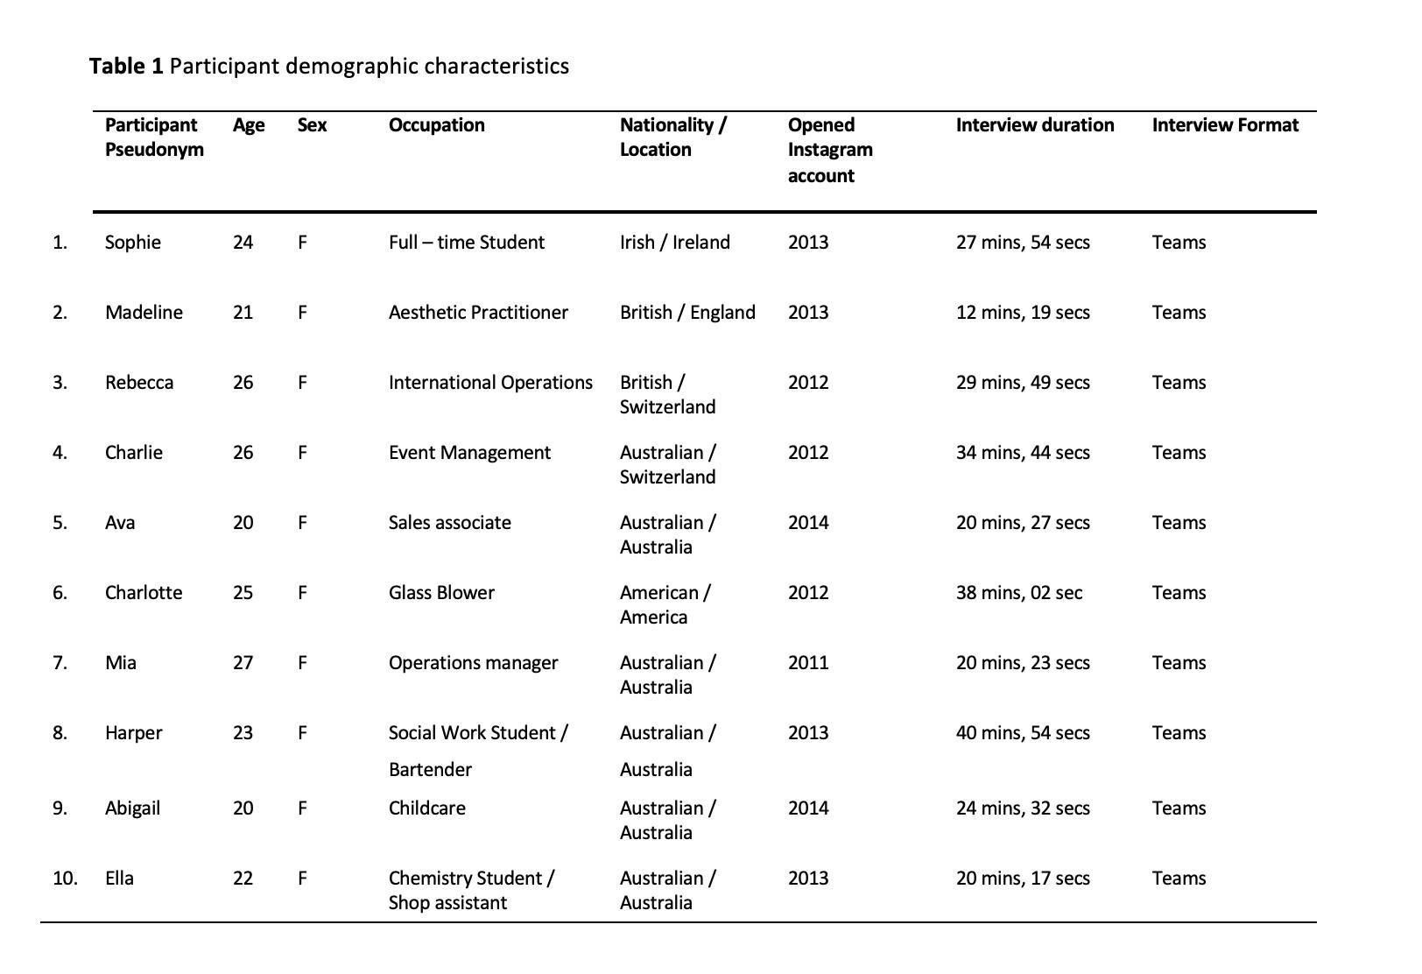

Procedure

Following ethical approval granted by Brunel Universities College of Health Medicine and Life Sciences, participants were emailed a Participant Information Sheet, after which they gave documented informed consent. There was no deception, and participants could withdraw at any time. The interviews occurred via Microsoft Teams (M= 26.935 mins). Although no risks were anticipated, all participants were debriefed and made aware of accessible support if required. The discussions began with grand tour questions (McCracken, 1988) about the participants latest Instagram post and a description of their profile; this was to place the conversation around the participants personal Instagram. Next, participants were invited to reflect on their Instagram behaviours, asking, for example, 'Could you tell me about your latest Instagram post?' and 'Could you describe your Instagram feed/profile?'. Topics were prompted throughout, and participants were encouraged to elaborate, describe, and reflect on their Instagram profiles, posts and stories. Sample questions included 'What is feminine behaviour for you?', 'What does it mean to you to behave in a feminine way?' and 'Could you tell me about a post that fits in line with your idea of femininity?'. Overall participants were encouraged to discuss what they typically posted to Instagram and how their audience may view this. As the researcher, participants were prompted to reflect deeply on their thoughts and beliefs (McCracken, 1988) surrounding femininity and how this might be evident, if at all, in their Instagram profiles. The audio recordings were then transcribed verbatim (Denzin & Lincoln, 2000) before analysing using constructionist TA, as set out in Braun and Clarke (2013).

Analytic approach

Following Braun and Clarke's (2013) Reflexive Thematic Analysis (RTA) guidelines, the iterative and inductive TA stage uncovered and interpreted how individuals (i.e. the participants) make sense of their lived experiences in managing their presentation of self and feminine online identity. Additionally, RTA (Braun & Clarke, 2013) allowed the researcher to accept personal experiences and subjective accounts in order to contribute to existing theory and generate new questions for research. Thematic Analysis also allows for the recognition of the crucial role of the researcher plays in consolidating the participants’ experiences (Braun & Clarke, 2013). Examining the lived realities and experiences of the participants required a social constructionist epistemology as this method is ideal for examining gendered identity discourses, experiences and effects within online social contexts (Braun & Clarke, 2013). Social constructionism was deemed the most useful epistemic approach as this allowed for the analysis of the shared knowledge of femininity to be examined and allowed for a ‘situated’ examination of participants’ discourses (Gergen, 1987). Also as the interviews were focused on the social practices of young women and their social media accounts, by using social constructionism, it was possible to link their social world and social practices to their discourses (Burr, 2015). Furthermore, the social constructionist approach, based on notions of ‘archaeology of knowledge’, allowed for the examination of shared understandings of femininity and their relevance to femininity in the 21st Century (Burr, 2015; Willig, 2013). The analysis led to three major themes: (1) Scripted Authentic Moments, (2) The Put Together Self and (3) People Don't' Need to See That (see Table 2). Throughout the interpretation and making sense of the participants' experiences and perceptions, my influence in the development of the themes was taken into consideration, and the transcripts were entered into NVivo; this allowed for systematic qualitative coding of the data set (Rose, 2016) and allowed me to double-check for the links and connections of themes across all ten participants.

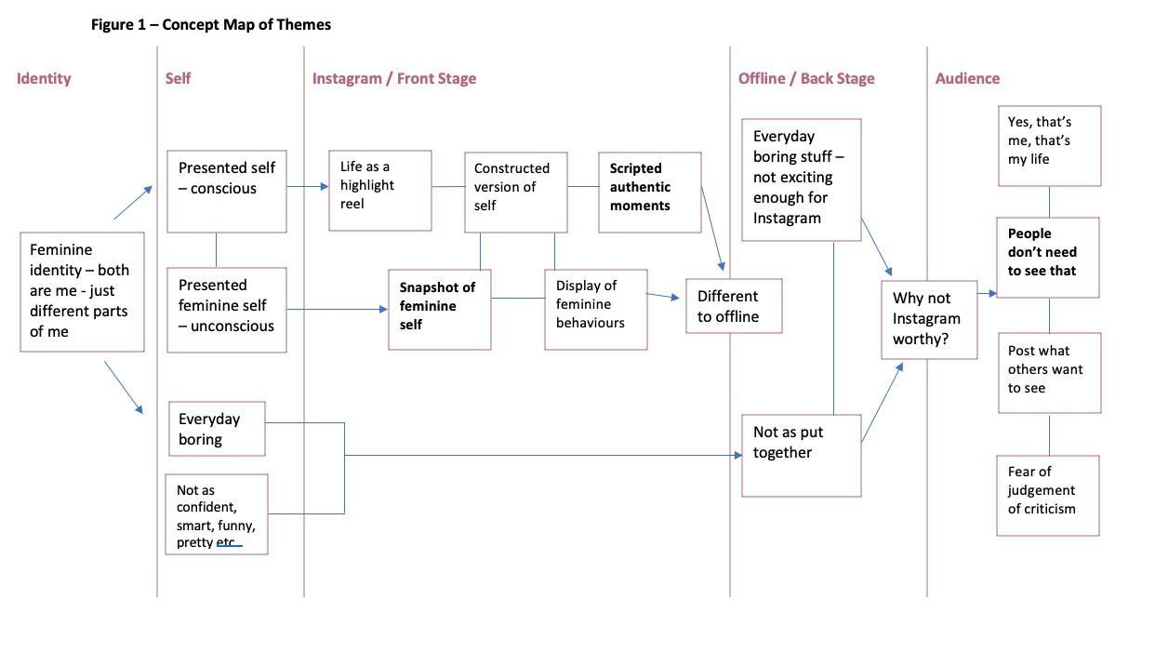

Analysis

Data analysis identified three major themes, with each a varied number of subsidiary themes as shown in Table 2. These related to the participant's experiences of managing their online identity and presenting the feminine self. Each theme is discussed and supported by participant illustrative quotes further below.

Table 2 Summary of themes describing the balancing act of online self-presentation.
1. Scripted authentic moments | 1.1 | identity as a constructed version
 |  | of the self
 | 1.2 | life highlight reel
 | 1.3 | Front stage/backstage
2. The put-together self | 2.1 | presented feminine self
 | 2.2 | snapshot of feminine self
 | 2.3 | unconscious displays of
 |  | feminine behaviour
3. People don't need to see that | 3.1 | everyday boring stuff
 | 3.2 | audience expectations
 | 3.3 | not as put-together self

Scripted Authentic Moments

The first theme focuses on how participants navigate Instagram to present themselves authentically, yet artistically scripted. Motivated by the presence of an audience (Goffman, 1959), participants will self-survey and self-monitor images before they upload to Instagram to present a scripted and structured identity . Influenced by presenting herself to an audience, Rebecca discusses how she composes her Instagram account to 'show off' (P 15). Describing that while the moments she shares are authentically her and appear to be natural to the audience, she goes to a considerable effort to script and manage the presentation of herself she puts out there; this takes a time and background work, which the followers do not see:
[…] um when choosing the photos … I like to choose obviously the one where I look good … where the … the … um ((long pause)) […] um … ((hesitant)) […] because I like to make sure that I look nice in the photos … and I mean … I don't look bad without makeup on … but I wouldn't.. I would still make sure that I look nice if I wanted to post a photo […] cause I have lots of different people … um … watching … like people from from home from here that I've met work colleagues … people that I know from high school that haven't I haven't seen for maybe five or six years … and then I want the idea of me to be like … well … I'll be I'll be doing really well … like she's looking good … she's looking after herself … she's living her best life kind of thing […] um so it does reflect me because I'm doing the travelling and stuff but on the other side it's like the background work the operations I guess (nervous laugh) […] you don't see that.

From this extract it is apparent that Rebecca is aware of societal expectations of femininity and how these need to be depicted visually. There is an emphasis on appearance and how this aligns with success. She expresses an awareness of those who have known her for a number of years and the need to reflect feminine aesthetics and the markers they indicate. Looking youthful is indicative of taking care of oneself, and travel indicates a level of success she is driven to display. Rebecca reveals this need for a care-free appearance, but to achieve this requires a level of work; she is indicating this need to appear naturally youthful, attractive, and successful is carefully constructed. There is a sense of disequilibrium: to reflect the ‘real’ her requires ‘background work’.

These views are echoed by other participants, the idea that their Instagram account presents a selected specific frame of themselves is standard; for example, Madeline states, " there’s normally twenty photos and you post one ” (P 8), thus indicating participants will search for the perfectly presented image. This is reflective of the work by Goodwin et al. (2016) where young women negotiated images displayed on Facebook to ensure that the images reflected them in a positive light, with a focus on how they presented themselves and how this would be interpreted by others. Furthermore, ‘Scripted Authentic Moments’ create narratives for an audience to follow. However, participants are also situationally motivated by evaluating what it is their followers want to see and by doing so participants will present a scripted sense of themselves ensuring their followers identify them in a certain way (Elliot, 2001). In other words, goes both ways, for example, Ava states, "[…] I go out a lot on my Instagram ... but I actually don't go out a lot in real life [..]" (P 15). Ava presents herself as socially active on Instagram to script through a busy social life, this is what she has interpreted her audience wants to see, and how she wants to portray herself. This indicates the drive to present herself as social; interpersonal skills and highly socialised are seen as stereotypically feminine characteristics. This drive to appear socially active is what Goffman (1959) refers to as performing and presenting a malleable identity depending on the audience. In Marshall et al.’s research (2019) female athletes, self-monitor their images to appear first and foremost as feminine then athletes second, meaning women create scripted narratives to avoid appearing too masculine ). This indicates that performance, including femininity, is used situationally depending on the audience. Consequently, authentic yet scripted moments help female Instagram users self-present a highlights reel as a narrative that coincides with how they want to be perceived by their audience, based on socially constructed ideals of attractive femininity. This also relates to participants’ self-presentation of femininity which can be seen in the next theme.

The Put-Together Self

T he Put-Together Self, focuses on how participants negotiate their self-presentation in the Instagram social environment against gendered ideas of what it means to be feminine (Krane, 2012). Although participants agree that their self-presentation on Instagram is tailored to an audience, they also agree that their presented self needs to be representational of perfection in terms of feminine attributes and behaviours (Walkerdine, 1989). These attributes and behaviours directly correspond to hegemonic femininity (Moscovici, 1972). Ava (P 20) explains,

[…] feminine means to me getting dressed up and looking nice and putting my best self out there ... putting my favourite outfit on ... um (long pause) looking nice within myself because I think that all girls should respect the way they dress and look when they go out places ... nice places ... um …. rather than go out looking like they just rolled out of bed ...

Ava here ascribes to the socially constructed knowledge of what it is to be feminine, with a focus on personal appearance, not only for herself but women in general. There are markers similar to those stated by Rebecca, appearance, clothing and travel. These are indicators of ‘feminine attractiveness’: socially adept, successful, and investing in one’s appearance. Harper describes, […] I have long hair and I am usually wearing make-up especially in photos I post on there … (p 8).
Charlie recounts:
[…] so you know … its like dresses and makeup and looking pretty … like these typical things […] when you see like a photo a beautiful women in a dress that looks very soft and feminine that says that to you … and then if you see a women whose wearing a suit … its maybe less so … (p 14)

Both Harper and Charlie draw upon socially constructed markers of femininity: long hair, make-up and appropriate dress. The use of the word ‘softness’ alongside femininity highlights how Harper and Charlie are attempting to present themselves according to specific socially constructed feminine ideals. Charlie’s use of the word ‘suit’ is used to invoke images of masculinity, as a contrast to how she presents herself. As an extension of this, Mia (P 16) composes her Put-Together Self on Instagram to be perceived as more feminine, acknowledging that the audience might find it more appealing as well as obtain a different impression of her:
[…] ... yep when I think about it … I think I definitely show up on insta more feminine online than I am in real life […] Um yeah possibly I think ((long pause)) they might think that my life is a lot more exciting and a lot more put together on a day to day basis when it comes to you know hair and makeup and style and things like that ... were generally speaking I don't look like that every day or I don't show up like that every day and obliviously not […] [the audience] might get a different impression ... someone who was a bit more exciting maybe.
This indicates that Mia is presenting an exaggerated feminine identity online, indicating an overriding drive to present the feminine ideal. In support of previous research suggesting femininity is performed (Walkerdine, 1989), the data indicates there is a tendency for female Instagram users to self-present femininity in a performative way to appeal to their audiences, thus connecting performative aspects of femininity and female identity to Instagram. To appeal to their audiences, they draw upon socially constructed, culturally and social bound feminine ideals. Accordingly, Butkowski et al. (2020) and Hong et al. (2020) women are socially conditioned into performing femininity because of these socially constructed gendered stereotypes. The participants' ideas surrounding representational perfection appear to be socially constructed, with Ella choosing to present her Put-Together Self on Instagram because "[…] it's just natural like that […]" (P 14), expressing that this is the expectation of her as a woman. Abigail (P 20) agrees:

[…] I think that there’s a very sort of expected way for people to portray themselves especially women I think on Insta like your expected to be this pretty like done all the time … um person […]”.

Here Abigail is indicating that she is constrained by these societal expectations of performative femininity, thus supporting the descriptions put forward by other participants in how they present themselves in Instagram. She elucidates that these expectations are amplified for women, which suggested that these expectations are a form of oppression and enforced performative femininity.

People Don’t Need to See That

The final theme focuses on how participants engage in impression formation by using a front and backstage style of self-presentation (Goffman, 1959). This means participants manage their profile by explicitly selecting content to share and what is to be excluded. For example, the participants stated that unsatisfactory images should stay backstage, off Instagram, while all agreed that sharing positivity. However, all stated that honesty was important, while indicating that what is presented on Instagram is an idealised and carefully scripted version of them, based on socially constructed feminine ideals. Therefore, being honest but not too honest was prevalent, and like the other themes, audience perception was significant in their decision-making process, Charlie explains:

[…] yeah … definitely, like how its … yeah … how its perceived like … by other people like… I guess like most why I post on social media is for other people … so it’d be thinking … its like … how is that being perceived […] you don't want to seem like you're showing off or like you … or ((nervous laugh)) trying to like make people feel bad about their situation [...] but I wouldn't particularly be quite outspoken on my social media ... like I wouldn't use it as a platform to talk about my views or opinions on things ... or I rarely would like ... yeah ... it's sort of not how I would express that kind of stuff ... and maybe that's tied into that like that I have this view that I shouldn't be doing that or that that's not appropriate […] (p 15)
Here Charlie recognises the perception of others, which is a driving factor in her decision-making of social media content. Charlie draws on a number of socially constructed ideals of feminism, such as modesty (not showing off, not being outspoken). So not only is Charlie aware of how she presents herself in terms of physical appearance of feminine ideals, she is aware of self-presentation in terms of personality characteristics.
What Goffman would describe as surface level or highlight frontstage sharing was deemed the most appropriate content to have on Instagram; Sophie (P 6) discusses, […] you're showing people ah you're letting people see things that are free to see … and they can see that on Instagram […]
Sharing positivity related directly to the nurturing of others:
[…] no I think obviously there's always two sides to social media in the sense of pushing femininity and empowering each other and wanting to spread that message for other people or sharing positive things to hopefully reflect that to somebody else […] or something that might make someone smile or do something positive for their day rather than sharing negativity (Mia, P 23).
Mia expresses a sense of responsibility as a woman on social media. To mediate her focus on her feminine self-presentation, she frames this as ‘empowering’ or inducing positive affect in others. This indicates a sense of obligation for her audience, being driven to meet their needs in her Instagram posts. This is also expressed by Charlotte in the extract below:
[…] it definitely comes into my mind to how it is for other people like … yeah … so yeah …and I … I guess that's also why I try and keep it pretty positive because like … that's also nice for people to see like when you go on to see positive stuff […] (Charlotte, P 6).

Participants use impression management in their profiles by sharing the presented self that meets the needs of the audience perception and expectation (Chae, 2018; Djafarova & Trofimenko, 2019; Goodwin et al., 2016; Harris & Bardey, 2019; Khamis et al., 2017; Tseelon, 1992). Simultaneously, they focus on impression management and how to be perceived in a positive light, based on constructed ideals of femininity. There is tension in how they negotiate their sense of self, their self-presentation and audience expectations. This is undoubtedly leads to frontstage-backstage performative aspects where participants deliberately project an identity to the front stage that emphasises positive aspects of their lives (Bullingham & Vasconcelos, 2013), based on these feminine ideals, while avoiding to share backstage moments, or undesirable content such as ‘negativity’, or what is deemed by participants as ‘unfeminine’.

Discussion

The self-presentation of femininity as a performance on Instagram is under-researched. This qualitative study introduces the importance of Walkerdine’s (1989) femininity as a performance in the online environments and correlates particularly well to the online environment of Instagram. While at the same time, it highlights the significance of Goffman’s (1959) dramaturgical theory of self-presentation in the online environment and how his theory could be used to explain how an Instagram audience may, in turn, influence female online identity and the way femininity is portrayed.
Online feminine identity is influenced by the interaction of self-presentation, the audience, the situation, and the participants’ implicit gendered social constructs. The three themes emphasise performative concepts of self-presentation by building on previously established research; all themes are found to be highly influenced by the presence of an audience (Goffman, 1959). The first theme, ' Scripted Authentic Moments', focused on how female Instagram users are very much influenced by the audience’s perception of them, that they will self-monitor and self survey any images for gendered signs of implicit femininity before uploading them to their feed. This supports previous research exploring females’ athletes feminine (Marshall et al., 2019; Reichart-Smith et al., 2021). The second theme 'The PutTogether Self, explored how participants negotiated implicit ideals of femininity with self-presentation. The emergence of this theme is in support of research that emphasises; women perform aspects of femininity. Walkerdine (1989) refers directly to Goffman's (1959) research, highlighting that gender stereotypes condition women into performing femininity. More importantly recent literature agrees finding that gendered displays of femininity are prevalent in women's Instagram selfies (Butkowski et al., 2020; Hong et al., 2020). The final theme 'People Don't Need to See that' highlights the idea of foreground and background regions to convey a specific image of oneself by adopting a performative role (Goffman, 1959; McKenna, 2007). Literature identifies and conceptualises self-presentation as impression management (Tseelon, 1992), linking it with self-prompting behaviours. However, recent research including this study, suggest that social media impression management is linked to aiming to appeal to a broader audience by presenting an idealised version of the self (Chae, 2018; Djafarova & Trofimenko, 2019; Goodwin et al., 2016; Harris & Bardey, 2019; Khamis et al., 2017) rather than anything manipulative.
The present study successfully demonstrates that women use self-presentation to display characteristics of femininity to manage their online Instagram identity. Participants perform and present a more feminine image of themselves (Walkerdine, 1989) by controlling how the audience perceives them (Goffman, 1959). Implicit social constructs influence the image participants self-present of themselves, especially regarding feminine attributes and behaviours (Walkerdine, 1989); this somewhat supports the idea that self-presentation could reflect habitual social cues, but this area would require future research; further research into the language participants used would also support this. Furthermore, future research could also include an analysis of the participants actual photographic content and follower comments on Instagram to examine how social media is a form of oppression, driving women to meet femininity ideals.

References

Allen, M. (2017). The Sage encyclopaedia of communication research methods (Vols. 1-4). SAGE Publications.

Baumeister, R. F. (1987). How the self became a problem: A psychological review of historical research. Journal of Personality and Social Psychology, 52(1), 163-176.
Bayer, J. B., Trieu, P., & Ellison, N. B. (2020). Social Media Elements, Ecologies, and Effects. Annual Review of Psychology, 71(1), 471-497.

Bornstein, M. H., Jager, J., & Putnick, D. L. (2013). Sampling in Developmental Science: Situations, Shortcomings, Solutions, and Standards. Developmental review, 33(4), 357–370.
Braun, V., & Clarke, V. (2013). Successful qualitative research: a practical guide for beginners. SAGE.

Braun, V., & Clarke, V. (2019) To saturate or not to saturate? Questioning data saturation as a useful concept for thematic analysis and sample-size rationales. Qualitative Research in Sport, Exercise and Health, 13(2), 201-216.

Buckingham, D. (2008). Introducing identity. In Buckingham, D. (Ed.), Youth, identity, and digital media (pp. 1-24). MIT Press.

Bullingham, L. & Vasconcelos, A.C. (2013). The presentation of self in the online world': Goffman and the study of online identities. Journal of Information Science, 39 (1), 101 - 112.

Burns, A. (2015). Selfies| Self(ie)-Discipline: Social Regulation as Enacted Through the Discussion of Photographic Practice. International Journal Of Communication, 9(1), 1-20.

Burr, V. (2015). Social constructionism (3rd Ed.). Routledge.

Butkowski, C. P., Dixon, T. L., Weeks, K. R., & Smith, M. A. (2020). Quantifying the feminine self(ie): Gender display and social media feedback in young women’s Instagram selfies. New Media & Society, 22(5), 817–837.

Butler, J. (1990). Gender Trouble. Routledge Classics.

Butler, J. (1993). Bodies that matter. Routledge Classics.

Caldeira, S. P., De Ridder, S., & Van Bauwel, S. (2020). Between the Mundane and the Political: Women’s Self-Representations on Instagram. Social Media + Society, 6(3), 1-14.

Caldeira, S. P., Van Bauwel, S., & De Ridder, S. (2021). Photographable femininities in women’s magazines and on Instagram. European Journal of Cultural Studies, 25(1), 79-96.

Dahl, U., Kennedy-Macfoy, M., Sundén, J., Gálvez-Muňoz, L., Martĩnez-Jiménez, L., Gopinath, G., Hemmings, C., & Tate, S-A. (2018). Femininity revisited –
A round table. European Journal of Women’s Studies, 25(3), 384-393.

Denzin, N. K., & Lincoln, Y. (2000). The handbook of qualitative research. SAGE.

Devito, M.A., Birnholtz, J. & Hancock, J.T. (2017). Platforms, People, and Perception: Using Affordances to Understand Self-Presentation on Social Media. Proceedings of the ACM conference on Computer-Supported Cooperative Work, 740-754.

Devonport, T, J., Leflay, K., & Russell, K. (2019). Examining the construction of identity among high performance male and female athletes using photography. Sport, Exercise and Health, 11(5), 720-739.

Elliot, A. (2001). Concepts of the self. Polity Press.

Fullwood, C., Wesson, C., Chen-Wilson, J., Keep, M., Asbury, T., & Wilsdon, L. (2020). If the Mask Fits: Psychological Correlates with Online Self-Presentation Experimentation in Adults. Cyberpsychology, behavior and social networking, 23(11), 737–742.

Gair, S. (2012). Feeling Their Stories: Contemplating Empathy, Insider/Outsider Positionings, and Enriching Qualitative Research. Qualitative Health Research, 22(1), 134-143.

Gergen, K. (1987). Warranting the new paradigm: A response to Harré. New Ideas in Psychology, 5(1), 19-24.

Goffman, E. (1959). The presentation of self in everyday life. Penguin.

Goodwin, I., Griffin, C., Lyons, A., McCreanor, T., & Moewaka Barnes, H. (2016). Precarious popularity: Facebook drinking photos, the attention economy, and the regime of the branded self. Social Media + Society, 2(1).

Guest, G., Bunce, A., & Johnson, L. (2006). How Many Interviews Are Enough?: An
Experiment with Data Saturation and Variability. Field Methods, 18(1), 5982.

Hancock, J. T., & Dunham, P. J. (2001). Impression formation in computer mediated communication revisited: An analysis of the breadth and intensity of impressions. Communication Research, 28(3), 325-347.

Higgins, E. T. (1987). Self-discrepancy: A theory relating self and affect. Psychological Review, 94(3), 319–340.

Highfield, T., & Leaver, T. (2016). Instagrammatics and digital methods: Studying visual social media, from selfies and GIFs to memes and emoji. Communication Research and Practice, 2(1), 47–62.

Hong, S., Jahng, M. R., Lee, N., & Wise, K. R. (2020). Do you filter who you are? Excessive self-presentation, social cues, and user evaluations of Instagram selfies. Computers in Human Behavior, 102.

Howitt,D., & Cramer, D. (2014). Introduction to Research Methods in Psychology (4th ed.).
Pearson.

Intezar, H. (2021). Speaking pictures, silent voices: Female athletes and the negotiation of selfhood. Integrative Psychological and Behavioral Science, 55(1), 89-111.

Khamis, S., Ang, L., & Welling, L. (2017). Self-branding, ‘micro-celebrity’ and the rise of Social Media Influencers, Celebrity Studies, 8(2), 191-208.

Krane, V. (2001) We Can Be Athletic and Feminine, But Do We Want To? Challenging Hegemonic Femininity in Women's Sport. Quest, 53(1), 115-133.
Kvale, S. (2007). Doing interviews. SAGE.
Leban, M., Thomsen, T. U., von Wallpach, S., & Voyer, B. G. (2021). Constructing personas: How high net-worth social media influencers reconcile ethicality and living a luxury lifestyle. Journal of Business Ethics, 169(2), 225 -239.
Lobato, L., Bethony, J. M., Pereira, F. B., Grahek, S. L., Diemert, D., & Gazzinelli, M. F. (2014). Impact of gender on the decision to participate in a clinical trial: a cross-sectional study. BMC Public Health, 14, 1156.
Low, T., Miller, M., Doran, A., & Hardwick, L. (2020). Women’s outdoor adventure experiences on Instagram: exploring user-generated content. Annals of Leisure Research. 1-25.
Markus, H., & Kunda, Z. (1986). Stability and malleability of the self-concept. Journal of Personality and Social Psychology, 51(4), 858 - 866.
Marshall, K., Chamberlain, K., & Hodgetts, D. (2019). Female bodybuilders on Instagram: Negotiating an empowered femininity. Feminism & Psychology, 29(1), 96–119.
McCracken, G. (1988). The long interview (Vol. 13). Sage.

Merunkova, L., & Slerka, J. (2019). Goffman’s Theory as a Framework for Analysis of Self
Presentation on Online Social Networks. Masaryk University Journal of Law and Technology,13(2), 243-276.

Moscovici, S. (1972). Society and theory in social psychology. In J. Israel and H. Tajfel (eds.) The Context of Social Psychology: A Critical Assessment. Academic Press.

Olan, B.L., K. M. Scott, Michael L. Naraine & Brody J. Ruihley (2021). Tell Me a Story: Exploring Elite Female Athletes’ Self-Presentation via an Analysis of Instagram Stories. Journal of Interactive Advertising. https://doi.org/10.1080/15252019.2020.1837038

Patton, M. Q. (2002). Qualitative research and evaluation methods. SAGE.

Perrin. A. (2015, October). Social Networking Usage: 2005-2015. Pew Research Center. http://www.pewinternet.org/2015/10/08/2015/Social-Networking-Usage-2005

Pew Research Center. (2019). Share of U.S. adults using social media, including Facebook, is mostly unchanged since 2018. Pew Research Center. www.pewresearch.org/fact tank/2019/04/10/shareof-u-s-adult s-using-social-media-including-facebook-ismostly-unchanged- since-2018/

Schlenker, Barry R. (1980) Impression Management. Monterey Brooks/Cole.

Schlosser, A. E. (2020). Self-disclosure versus self-presentation on social media. Current Opinion in Psychology, 31(1), 1-6.

Rose, G. (2016). Visual methodologies: A introduction to researching with visual materials.
SAGE.

Turkle, S. (1997). Life on the screen: Identity in the age of the internet. Phoenix.

Tiidenberg K (2018) Selfies: Why We Love (and Hate) Them. Bingley: Emerald Publishing.

Van Dijk, J. (2013). The culture of connectivity: A critical history of social media. Oxford University Press.

Walkerdine, V. (1989). Femininity as Performance. Oxford Review of Education, 15(3), 267- 279.

We Are Social. (2019). Global digital report 2019. We Are Social https://wearesocial.com/global-digital-report-2019

Willig, C. (2013). Introducing qualitative research in psychology (3rd ed.). Open University Press.

