

Figure 1 – Models representing the relationships between learning dimensions and the adoption level of I4.0 base technologies (*n* = 129)



Figure 2 – Relationship between learning dimensions improvement and I4.0 base technologies' adoption

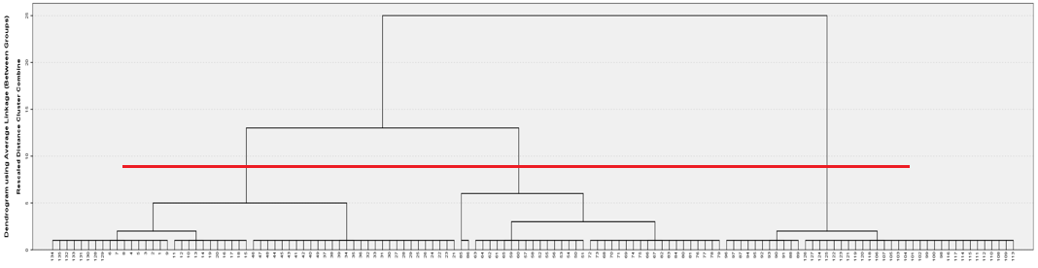

Figure 3 – Dendrogram indicating three clusters in the sample of companies

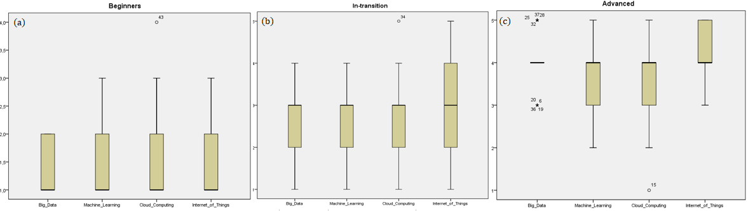

Figure 4 – Box-plots of I4.0 technologies' adoption levels in (a) beginners, (b) in-transition, and (c) advanced clusters