1 What have you learnt from using S.H.E.D as an alternative space for delivering your creative activity?

2 Has the S.H.E.D enabled you to have conversations with young people, parents/carers etc that you would not normally have been able to have?

YES / NO

3 In the space below please doodle a picture of the S.H.E.D to map its location/position in relation to the school buildings & playground/gates.

4. Please indicate on the image below any key area(s) of S.H.E.D that you have felt a significant encounter took place during your activity.
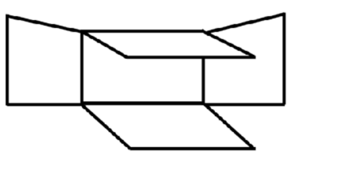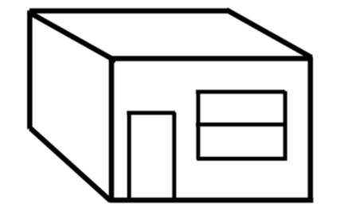

Please circle the word below that best defines the type of encounter that took place.
For example: a conversation/ laughter /a revelation/ a connection/a reflection/a disagreement / emotional experience/ special experience / other ______________________________

5. Would you want to work in S.H.E.D again, or in a different configuration?

