A Framework for the Systematic Implementation of Green-Lean and Sustainability in SMEs

Abstract
Evidence suggests that smaller organisations find the implementation of combined operations- and environmental Sustainability improvement initiatives such as Green-Lean and Sustainability (GLS) challenging. This paper, therefore, develops a framework for the systematic implementation of Green-Lean and Sustainability in small and medium-sized enterprises (SMEs) to achieve long-term improvement of environmental, social and economic processes and performance. A literature assessment of theories, frameworks, and concepts was employed in the study to better comprehend the difficulties confronting the modern business world. In addition, the research employed expert perspectives from the lean, green-lean, and sustainability fields to propose, develop, test, and validate a framework for addressing business concerns. The research uncovers considerable implementation problems, such as employee motivation and integration, responsibilities, and measurements. It also underlines the success factors for the implementation process, such as management, firm- goals and strategy, reviews and audits, vision, and guidance by lean, green and sustainability frameworks. The novelty in this research lies in the approach where Green-Lean and Sustainability are combined and applied in an SME context. The presented framework offers the potential to be implemented in SMEs that operate in different sectors and contexts and are affected by different environmental and social considerations.
Keywords: Green-Lean, Lean Green, Sustainability, SMEs.

1. Introduction
Over the last decades, there has been growing pressure on organisations from a variety of stakeholders to conduct their operations conscientiously to improve their environmental and social performance (Singh, Singh and Khamba, 2020; Choudhary et al., 2019). Growing customer demands for socially and environmentally responsible products and procedures have, in recent years, led to companies adopting new approaches in their processes and operations management to remain competitive (Abualfaraa et al., 2020; Sony and Naik, 2019; Cherrafi et al., 2017a; Garza-Reyes, 2015a). Sustainability requirements were established as a new criterion for competitiveness (Cherrafi et al., 2016; Wong and Wong, 2014).

To this effect, Green and Lean have been adopted as important tools for the implementation of Sustainability criteria, and therefore a means for companies to maintain their competitive advantage (Lartey et al., 2019; Duarte and Cruz-Machado, 2019; Cherrafi et al., 2018; Zhou, 2016). The combination of the two paradigms is seen as a natural alignment through their similar operations management approach (Huo, Gu and Wang, 2019; Dieste et al., 2019). Lean as an approach for performance improvement identifies and eliminates waste through continuous improvement (Kovilage, 2020; Dey et al., 2018). It was merged with the Green paradigm to incorporate further environmental concerns and improve environmental efficiency under the label Green-Lean (Singh, Singh and Khamba, 2020; Wu et al., 2018; Cherrafi et al., 2016; Garza-Reyes, 2015a).

Many practical examples established in the scientific literature argue for the significance of Green-Lean. Implementing both approaches simultaneously stimulates process innovation (Huo, Gu and Wang, 2019; Fercoq et al., 2016), which allows companies to accomplish sustainable performance with the highest efficiency and minimal resources (Huo, Gu and Wang, 2019; Farias et al., 2019b). For companies that are already Lean, simply implementing Green methods will allow them to see an improvement to their sustainable performance (Kuo and Lin, 2020; Cherrafi et al., 2017a). Both Green and Lean concentrate on the reduction of waste and the increase of efficiency of production processes (Dieste et al., 2019; Cherrafi et al., 2017a). In their research, Dieste et al. (2019) point out that measures such as energy use, materials use, air emissions, and toxic chemicals used can be positively affected when Green-Lean is applied.

In the last ten years, the business world has noted the significance of exchange among the daunting preferences of environmental protection, economic development, and social equality, with the pursuit for sustainability as a practical challenge rather than just a scientific or conceptual notion (Casula and Soneryd, 2012). The main idea that has encouraged enterprises to adopt sustainable development is that a company hopes to gain significantly by exercising sustainability (Sy, 2016). Also, there is a growing demand for businesses to focus from a boardroom sustainability strategy to the deployment and monitoring of these initiatives. Moore and Manring (2009) suggest that SMEs must reassess their corporate approach and seek a better sustainable solution for their operations. SMEs inability to incorporate sustainability into their organisations has been a significant hindrance to their development, and they are continually up against intense competition from local and foreign markets (Lee et al., 2021).

In order to truly fulfil sustainability requirements, however, organisations must take into account and implement all three dimensions of sustainability. While the economic and environmental dimensions of Sustainability have been amply explored in literature and practice, thus far, the social dimension has been found to not be sufficiently science-based and operational and therefore requires subsequent development (Popovic et al., 2018; Missimer, Robèrt and Broman, 2017; Ahmadi, Kusi-Sarpong and Rezaei, 2017). Social sustainability occurs when formal and informal protocols, structures, affiliations, and encounters actively improve the potential of current and future generations to create healthy and lively communities (Masocha, 2019).

Despite the increased interest in social sustainability, there is still a lack of information (Popovic et al., 2018; Mani, Gunasekaran, and Delgado, 2018; Eizenberg and Jabareen, 2017). The lack of theoretical and empirical studies concerning social sustainability demonstrates that the social dimension was incorporated late into debates on sustainable development (Eizenberg and Jabareen, 2017; Missimer, Robèrt and Broman, 2017). The authors, therefore, see the need to further consolidate the social dimension within the concept of Sustainability as a means to improve competitiveness and to contribute to the strengthening of the scientific foundation of the social dimension within Sustainability.

This study takes a novel approach by joining Green-Lean and Sustainability as an improvement strategy to be implemented specifically in small and medium-sized enterprises. It attempts to answer the questions of how Green-Lean and Sustainability are defined in the literature, what linkages exist between them and what possible challenges and key success factors an implementation of both concepts poses. By interviewing practitioners, we expect to expose overlapping themes, and our framework will be guided by the question of how to integrate these themes into our core model. We also hope to gain more insight into necessary methods and mechanisms that must be employed for the framework to be practical and ensure long-lasting success. In addition, we look to determine the existing limitations of Green-Lean frameworks in order to overcome them through our model.

It was found that only very few studies have focused their Green-Lean research on small and medium-sized enterprises (Yadav et al., 2019; Verrier et al., 2016; Piercy and Rich, 2015). It is mainly large organisations that are familiar with the implementation of Lean (Kumar, Antony and Tiwari, 2011), with a dearth of research into Lean in SMEs (Hu et al., 2015). Specific characteristics of SMEs, such as little spare human resources, a general lack of financial resources and an emphasis on short-term objectives to achieve quick results, aggravate the integration of improvement strategies (Yadav et al., 2019).
In more recent research, Siegel et al. (2019) conducted an extensive literature review on the relationship between Green-Lean and Sustainability and on the pre-existing models aimed at implementing both paradigms in practice. The study demonstrated that existing frameworks for Green-Lean are predominantly generic models that use predetermined tools, do not take into consideration the specific needs of SMEs and additionally lack long-term efforts to sustain an integration.
Some other past work in this area, e.g. Pampanelli et al. (2014), offered an integrated green and lean method in global manufacturing firms to address, in particular, a firm's environmental sustainability performance. Cherrafi et al. (2017a) recommended combining Green, Lean, and Six Sigma methodologies to improve the sustainability performance of various businesses. Their research is primarily concerned with economic and environmental sustainability. They also did not reveal the industry's size (SMEs / large industries) in which the framework is used. Given this and the above-stated benefits of Green-Lean, we propose a framework that promotes the simultaneous integration of Green-Lean and Sustainability in SMEs in a comprehensive, simplified and systematic manner. Furthermore, the primary focus of this research is on social sustainability.
The remaining structure of the paper is as follows: Section 2 reviews the past literature on green, lean, and sustainability, with particular emphasis on SMEs. Section 3 presents the research methodology of the paper, followed by the results in Section 4. Furthermore, Section 5 provides the discussion and implications of the current study. Finally, Section 6 offers the conclusions, limitations and further research directions drawn from this study.
2. Literature Review
Due to a vastly competitive business environment and increased pressure to adapt to stakeholder demands for sustainable operations and products (Lartey et al., 2019; Farias et al., 2019a; Cherrafi et al., 2017a), companies need to adjust their modus operandi (Kaswan and Rathi, 2020; Sony and Naik, 2019). As a result, the importance of Green-Lean as a supporting measure has increased (Abualfaraa et al., 2020; Saetta and Caldarelli, 2020). This section, therefore, focuses on key themes and motivating factors of GLS and SMEs. In this literature review, articles from different databases and sources were systematically selected and examined. Five search engines, namely Elsevier, Taylor & Francis Online, Wiley Online Library, Emerald Insight and Springer were used to locate relevant journal articles. Search strings included (Lean), (Green), (Green Lean), (Lean Green), (Sustainability), (SME), (small and medium-sized enterprise), (model) and (framework). While using the same search strings in every database led, to some extent, to the appearance of the same articles, this approach was essential to ensure a complete and thorough exploration of the literature. The search was considered complete when the same articles continued to appear. A final sample of 45 articles was identified. These articles enabled us to articulate a sound discussion that linked the three main themes of this research, i.e. Green-Lean, Sustainability and SMEs. The discussion is presented in the following subsections.

2.1 Green-Lean and Sustainability
The literature review revealed that the amalgamation ‘Green-Lean’ utilises the best aspects of both methods: lean processes and enhanced environmental performance (Dieste, Panizzolo and Garza-Reyes, 2020; De Giovanni and Cariola, 2020). Environmental management is frequently also equated with Sustainability, both in theory and practice, yet this neglects the two remaining dimensions of social and economic Sustainability. Companies cannot be truly sustainable if they do not take employee and community wellbeing into account, alongside their long-term financial goals. Ultimately, Sustainability “provides a balanced relationship among economic, social and environmental aspects” (Alves and Alves, 2015). Figure 1 illustrates the interrelation of the three dimensions of Sustainability. When the pillars interact with each other, ‘fair’, ‘feasible’ and ‘bearable’ relationships can be achieved. Where all three dimensions intersect, a sustainable relationship is accomplished (Oliveira et al., 2012).
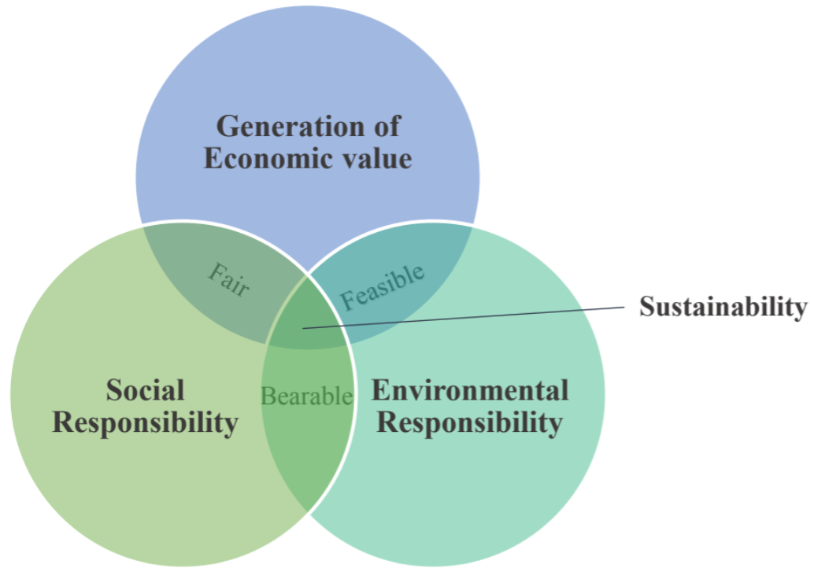
Figure 1: Pillars of Sustainability
Source: Adapted from Oliveira et al. (2012), p. 73.
A social transformation of the company is crucial to support and sustain the successful implementation (Arumugam, Kannabiran and Vinodh, 2020) of Green-Lean and Sustainability. The social pillar is complex and includes various stakeholders, and the lack of theoretical and empirical studies in the existing Green-Lean literature creates an even greater need to explore the human factors that enable the effective integration of improvement strategies (Cherrafi et al., 2016). Long-term financial goals characterise the economic dimension and enable the commercial Sustainability of a company’s operations (Wong et al., 2018). In the end, being mindful of the environmental, but also the social and economic pillars of Sustainability will lead to added benefits, such as fair practices for the community, employees and partners; and will generate economic value that meets shareholder’s expectations and benefits the community and wider society (Alves and Alves, 2015).

The existing literature considers Green-Lean and Sustainability as complementary (Inman and Green, 2018). Green-Lean is an effective tool to reduce waste and improve environmental efficiency, but only joined with Sustainability can long-term success be achieved (Cherrafi et al., 2016; Garza-Reyes, 2015a). Figure 2 illustrates the common elements that Green-Lean and Sustainability share (overlapping circles), along with the elements that each individual concept brings along additionally and which can be integrated (outside overlap). The two approaches are complementary through shared factors and provide mutual support through individual aspects.
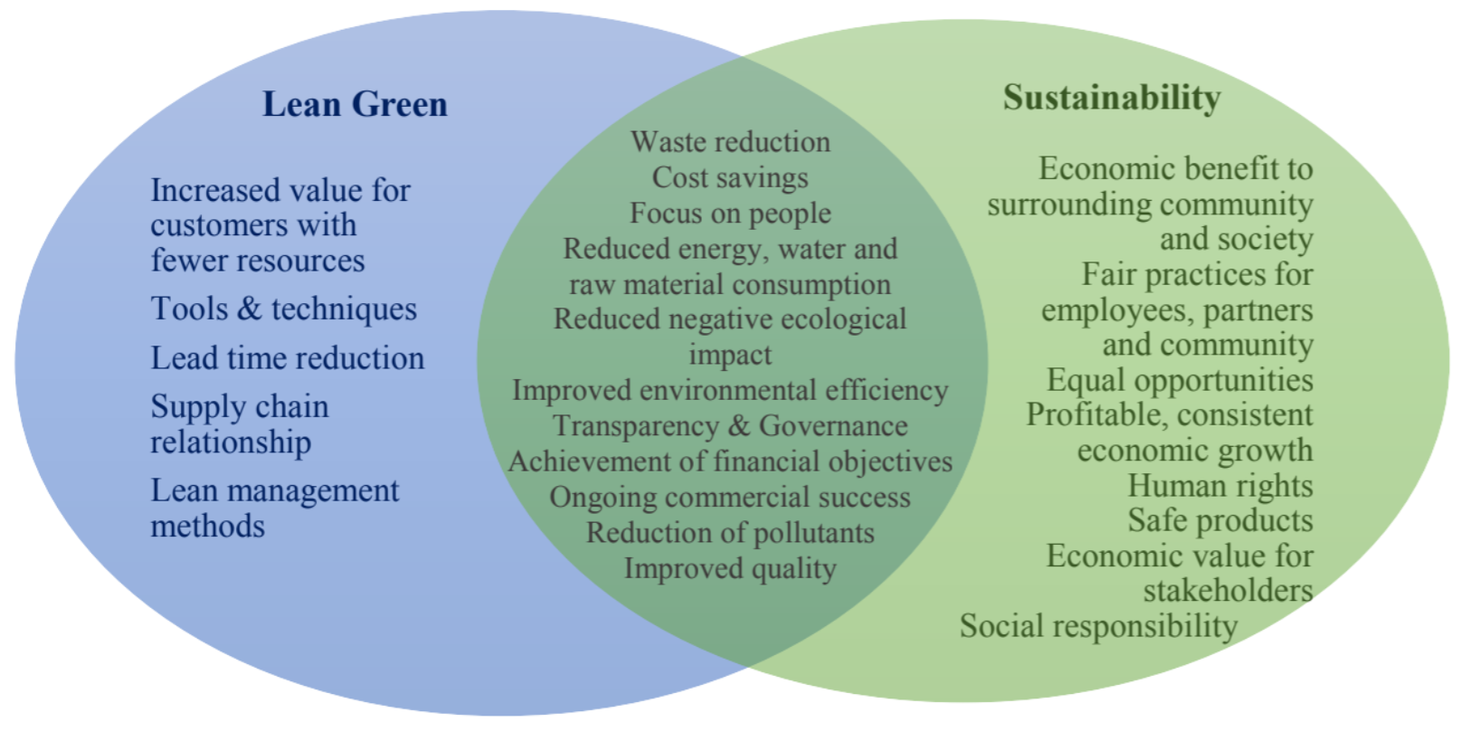
Figure 2: Lean Green and Sustainability Venn diagram
Source: Adapted from Dües, Tan and Lim (2013), Piercy and Rich (2015)

From our literature review into Green-Lean and Sustainability, key themes emerged that outline these concepts in their entirety. These can be categorised as challenges, tools and techniques, success factors, frameworks, factors of Sustainability and benefits of Green-Lean (Siegel et al., 2019).

Reportedly, many companies struggle with the implementation and sustainment of Green-Lean practices (Arumugam, Kannabiran and Vinodh, 2020; Grigg, Goodyer and Frater, 2020; Alefari, Almanei and Salonitis, 2020; Cherrafi et al., 2019; Sony and Naik, 2019). The most common challenge proved to be a lack of metrics and measurements, as well as the absence of management support and the cultivation of a corporate culture and employees mindset (Alves and Alves, 2015; Duarte and Cruz-Machado, 2013). In addition, it was found that Green-Lean tools developed to date have either not been adapted, lack maturity or are frequently not acknowledged by the industry (Siegel et al., 2019). Key factors for successful implementation were considered to be employee involvement and, again, the commitment and support of (top) management (Cherrafi et al., 2017b; Wong and Wong, 2014; Cherrafi et al., 2016; Duarte and Cruz-Machado, 2013).

A number of models and frameworks for the integration of Green-Lean or Lean and Sustainability in organisations have been developed in recent years. While every framework has unique and beneficial features, each exhibits one or more limitations inhibiting their applicability in various environments. These limitations include models being sector or industry-specific, (Alves and Alves, 2015; Zhang and Awasthi, 2014; Aguado, Alvarez and Domingo, 2013; Sawhney et al., 2007); with potential for improvement in the design and comprehensibility of the different stages (Duarte and Cruz-Machado, 2013) and; a lack of ensuring company readiness for a GLS initiative (Piercy and Rich, 2015; Bergmiller and McCright, 2009). Few frameworks discuss which tools may work best for an individual company, but rather predetermine the type of Lean and Green tools and techniques an organisation should deploy (Piercy and Rich, 2015; Zhang and Awasthi, 2014), thereby restricting the scope of their application. In addition, most frameworks only address the environmental and economic dimension of Sustainability but fail to include the social dimension (Sawhney et al., 2007; Bergmiller and McCright, 2009). Table 1 summarises the advantages and limitations of each examined framework.
Table 1: Green-Lean Frameworks
Green-Lean Frameworks
Key objective | Complexity | Practicality | Effectiveness | Usability | Limitation
Cherrafi et al. (2017a)
The framework explains how organisations can integrate Lean Six Sigma and Green systematically to improve economic, environmental and social performance. Consists of self-assessment models and five  phases which are broken down into sixteen steps. | Designed in comprehensible steps that fit many industries and company sizes. | A generic framework that is designed to be implemented in all sectors. | The framework was tested for its validity before rolling it out to other companies. No feedback mechanism. | Stages are broken up into individual steps which guide users through the implementation process. | There is little detail about how to sustain the achieved results. A feedback mechanism is missing. Includes Six Sigma approach.
Alves and Alves (2015)
The model integrates the principles of lean manufacturing and Sustainability, supported by a cultural transformation in the organisation. | Very well-structured and comprehensive | No loop for feedback mechanism, designed for production sector only. | Model yet needs to be tested. Includes cultural transformation for sustaining change. | Stages are clearly defined, and tools are pre-determined | Focus is restricted to areas related to the production sector. Predetermined tools are tailored to the production sector.
Piercy and Rich (2015)
A theoretical model for lean and sustainable change in a single framework. Shows linkages between lean and sustainable operations and identifies the full Sustainability benefits of lean operations beyond green improvements at the workplace level, which includes community, supply chain and company strategy. | Easy to comprehend. Stages include necessary techniques and tools. | Loop for feedback mechanism in place. Lean and Sustainability stages are aligned according to their reference but have separate starting points. | The framework allows the integration of lean and Sustainability through an integrative stage-based model and captures the holistic change process. | Clear, consecutive approach including necessary steps. | Does not include a readiness phase or how to sustain Lean & Sustainability. Predetermines Lean and Green tools.
Verrier et al. (2014)
A tool to target and promote best practices for lean-oriented sustainable development.  Proposes Lean indicators, Green performance indicators and Green intentions indicators.  Enables benchmarking to target best practices. | Works with plotting graphs and matrices. Difficult to comprehend the overall structure. | Not one joint framework, but separate three indicators. | A repository that allows measurement of Green and Lean ability and bench-marking with other companies.  Maps various companies according to their organisational and Green performance. | Indicators are relatively easy to calculate. | Framework more useful and  applicable with a group of companies available to benchmark them to Lean and Green initiatives in order to target best in class and associated best practices.
Wong and Wong (2014)
The framework addresses human integration in lean for sustaining operations. | Quite complex through several hierarchical structures, matrices and indexes | Lacks a feedback mechanism | Benefits have been proven through a case study, results signify that people can be integrated through a scientific methodology in lean. | A detailed introduction into methods of model needed. | The framework does not incorporate the other two pillars of Sustainability (economic and environmental).
Zhang and Awasthi (2014)
The framework integrates Six Sigma and Sustainability. Fully presents the necessary steps to achieve truly sustainable development. | A very thorough model with straightforward instructions. | Tools and techniques are clearly stated, however, links between problems and solutions are only explained in a separate model. | No loop for feedback mechanism, the model yet needs to be tested. | Stages are clearly defined and show the necessary tools. | The framework is not validated in a real environment.  There is less focus on the economic dimension. It is geared to the needs of manufacturing companies, and additionally a Six Sigma approach instead of Lean.
Aguado et al. (2013)
The model identifies and quantifies efficient, sustainable improvements in a lean production system through processes of environmental innovation by waste elimination. | The model itself is not well structured nor expressive and hard to comprehend. The description, however, is well-structured and comprehensive. | Steps are achievable due to the use of tools. Able to identify and quantify improvements in environmental impact and productivity. | The model was tested in a small business. Results demonstrate a competitive advantage through reduced costs and a reduction in emissions and waste. | The approach can be easily adapted to most businesses oriented towards production. | Leaves room for improvement, does not address sustaining Lean and Sustainability.
Duarte and Cruz-Machado (2013)
Model for implementing Lean and Sustainability initiative. Indicates how and when Lean and Green strategies can be synergetic and compatible, using principles and tools from both philosophies. | Criteria for business model are expansive and comprehensible | A feedback mechanism is incorporated. Some criteria suggest ideas but do not explain them in more detail. | The model needs to be fully developed and tested and validated. | Good guidelines for different success factors, however, the model itself needs to be expanded further. | This model can be developed using an exploratory case  study methodology to understand if it is important to  industry and where the compatibilities between Lean and Green are.
Bergmiller and McCright (2009)
Model to integrate lean and Sustainability systems into one system that can contribute significantly to long-term financial and environmental Sustainability. | Comprehen- sible, yet lacks exemplification Identifies many different techniques and benefits. | The framework comprises many different elements but does not offer a comprehensive explanation of how to utilise them. | The framework has not been tested. The feedback mechanism is not implemented. | Proposes many specific techniques which may not work for every company. No further introduction into the procedure. | The framework is not validated in a real environment. It lacks a readiness phase and a feedback mechanism.
Sawhney et al. (2007)
The model assists in developing a relationship between environmental concerns and Lean principles for specific processes. | Complex, but thorough. | Loop for a feedback mechanism. Model designed only for one particular manufacturing  process (metal cutting). | Effective to use in the metal-cutting industry. | Specific software needed. | Needs to be evolved for other processes. Leaves out the social aspect of Sustainability.

The existing frameworks are more useful for larger organisations, and rarely consider the characteristics of SMEs, such as a lack of financial and human resources. Hence, we believe that the existing implementation frameworks demonstrate shortcomings, especially for SMEs, which can be overcome through the development of a single comprehensive, simplified and generic framework for SMEs, upon which this study focuses.

2.2 The importance of lean and green and the integration of sustainability into small and medium-sized enterprises (SMEs)
This paper focuses on the implementation of GLS in SMEs, many of which remain unfamiliar with the implementation of Lean (Hu et al., 2015). This has resulted in a dearth of research in this field (Yadav et al., 2019; Hu et al., 2015). Worldwide, SMEs comprise 90% of businesses and provide 50% to 60% of jobs (Antony, Vinodh and Gijo, 2016). In the European Union (EU), SMEs represent 99% of all businesses and have created approximately 85% of new employment in the past five years (European Commission, 2018). The competitiveness of SMEs influences the competitive ability of an entire economy, as SMEs and large organisations are frequently linked through complex networks of businesses (Wessel and Burcher, 2004).

SMEs typically pose several particular challenges to the adoption of improvement strategies (Alefari, Almanei and Salonitis, 2020; Caldera, Desha and Dawes, 2019; Dora, Kumar and Gellynck, 2016). In SMEs, every employee is allocated a key role, sometimes even several, which leads to little spare human resources. When employees are engaged in additional tasks or projects, they have less time at their disposal for their normal workload (Wessel and Burcher, 2004). Management may, therefore, consider training a waste of time; labour force constraints are regarded as a critical failure factor of Lean implementations in SMEs (Albliwi et al., 2014). A general lack of financial resources prohibits large investments in training, infrastructure or new technology and can prevent SMEs from maintaining or improving their competitiveness (Wessel and Burcher, 2004, Simpson et al., 2004).
Management and leadership in an organisation present one of the greatest challenges (Grigg, Goodyer and Frater, 2020; Antony, Vinodh and Gijo, 2016; Timans et al., 2012). Without the appropriate attitude, involvement and commitment of the top and middle management projects easily fail (Albliwi et al., 2014; Antony, Vinodh and Gijo, 2016). Since SMEs often emphasise short-term objectives to achieve quick results, overall objectives and a well-defined strategy may be missing (Grigg, Goodyer and Frater, 2020). Another major challenge, especially towards the integration of continuous improvement programmes, is resistance from employees. Implementing new methods raises employee concerns over job security. According to Timans et al. (2012), internal resistance is the key challenge for SMEs regarding the implementation of improvement strategies. Finally, the selection of projects plays a vital part in sparking employee and the top management interest and engagement, and in demonstrating potential cost savings. Su and Chou (2008) and Duarte et al. (2012) agree that an entire programme may fail if the wrong project is selected.

It is clear from the literature review that significant shortcomings exist, both in the incorporation of social sustainability, which is a decisive factor for successful Green-Lean integrations (Popovic et al., 2018; Mani, Gunasekaran, and Delgado, 2018; Eizenberg and Jabareen, 2017), as well as adjusted frameworks or guidelines specifically for SMEs in the context of Green-Lean (Yadav et al., 2019; Hu et al., 2015). In addition, the considered frameworks, beyond their individual limitations, stipulate predetermined tools and fail to provide a model applicable to many industry sectors (Cherrafi et al., 2016). Lastly, the lack of measures to ensure the long-term success of an integration (Siegel et al., 2019) means that many companies fail to either implement Green-Lean in the first place or to sustain it in their organisation (Arumugam, Kannabiran and Vinodh, 2020; Grigg, Goodyer and Frater, 2020; Alefari, Almanei and Salonitis, 2020; Cherrafi et al., 2019; Sony and Naik, 2019). To overcome these limitations, the authors were motivated to conduct this research and provide SMEs with a systematic and disciplined guide that has practical significance and value.
3. Research Methodology
This section outlines and discusses the methodology applied to conduct this research. Figure 3 illustrates the approach adopted in the development of the proposed framework. First, a literature review of theory, concepts and frameworks was conducted. In addition, practitioners with experience in Lean, Green-Lean and the integration of Sustainability in businesses were consulted to develop a model that was adapted to address the contemporary challenges in today’s corporate world. Finally, the framework was developed, validated and refined. It was reviewed by seven experts to capture any limitations and to review and present a revised version.

Literature Review

Interviews

Validation and Refinement

Framework
Figure 3: Framework development research methodology
This study used an exploratory data collection approach as it reassessed the phenomenon of Green-Lean in the context of Sustainability as an added dimension. Therefore, and to further investigate the concept and applicability of Green-Lean and Sustainability in businesses, interviews were selected as the most appropriate research strategy.

We also used a non-standardised, semi-structured interview approach to gather primary data. This type of interview gives researchers the flexibility to omit questions and adapt them to a specific organisational context or to ask additional questions to investigate the research questions and objectives further. It additionally enables an understanding of the relationship between variables (Saunders, Lewis and Thornhill, 2016). Moreover, due to the nature of the study, the interviews were conducted on a one-to-one basis between the researcher (and in this case, the interviewer) and a single participant.

Each participating company was required to:
- Have less than 250 employees; and
- Have implemented and used Lean for six months or more. This was to ensure that the company had some reasonable time to assess the impact of the new system.

Companies fulfilling all criteria and willing to participate in the study were located across all of Germany. Therefore, both face-to-face and telephone interviews were conducted. The companies were approached via email, telephone or through online business networks LinkedIn and XING. Lists of SMEs were obtained by contacting Trade Departments and the German Chambers of Commerce of individual federal states. The data was collected in the period between March 2018 and May 2018.

Due to their in-depth nature, semi-structured interviews are time-consuming, and hence sample sizes are limited. 12 companies agreed to be part of the study. One company provided two participants, resulting in 13 interviewees in total. Since the research aimed to develop a generic framework of Green-Lean and Sustainability, a cross-case study was conducted. This entailed studying companies in a range of industries and with different degrees of experience in Lean. The participants held a range of positions from different hierarchical levels, such as Managing Director, Head of Change Management or Lean Manager. Some of the interviewees additionally possessed Lean Six Sigma certifications such as Black Belt or Master Black Belt, making them experts in this particular field. Moreover, three of the interviewed companies were Lean or Green-Lean consultancies for specific industries. Table 2 shows the full list of companies, including the type of industry, company size, experience with Lean in years and the interviewee’s company position.
Table 2: Profile of interviewed companies
Company | Type | Size | Company experience with Lean (years) | Interviewee | Interviewee experience with Lean (years)
A | Software | Medium | 14 | Lean Java Expert | 7
B | Manufacturing (Printing) | Medium | 5 | Master Black Belt / Lean Manager | 12
C | AI and Machine Learning Solutions | Small | 3 | General Manager | 3
D | Consulting (Lean) | Small | 16 | Green-Lean Consultant | 8
E | Manufacturing (Furniture) | Medium | 3 | Head of Change Management | 12
F | Energy | Small | 2 | Managing Director | 2
G | Consulting (Lean) | Medium | 18 | Black Belt, Project Manager Lean Development  Consultant Holistic Lean Transformation | 11  8
H | Building materials | Medium | 7 | Lean Manager Group | 12
I | Consulting (Lean) | Small | 16 | Master Black Belt / CEO | 15
J | Engineering Consultancy | Small | 7 | Senior Manager Quality Management | 9
K | Software | Medium | 14 | Black Belt, Lean Manager | 10
L | Metal and metalworking | Medium | 10 | Lean Manager | 7

A semi-structured interview schedule was developed. The questions were derived from the literature, with each question supported by at least one source. The schedule began with a general enquiry into the company’s Lean operations and results, followed by questions regarding the interviewee’s understanding of Green-Lean and the company’s approach towards Sustainability. The questions were open-ended to encourage and promote in-depth discussion of the topics presented (Braunscheidel et al., 2011). The interview aimed to form a basis for the development of a framework applicable to SMEs. Through the assurance of anonymity, the participants were encouraged to talk openly about any issues concerning their company. The interviews typically lasted three-quarters of an hour, audio recorded where consent was given, and notes were taken for an accurate evaluation.

Once the data collection process was completed, template analysis was used to investigate the generated data. This type of analysis thematically organises and conducts analyses according to a set of codes developed a priori (O’Gorman and MacIntosh, 2015). It uses predetermined codes that can then be amended or added while the data is gathered and analysed (Saunders, Lewis and Thornhill, 2016).
Following the procedure of the template analysis, the interviews were carefully transcribed and the first round of coding the data was conducted. Emerging codes were identified and labelled. Levels of codes and later a hierarchy of codes (see Figure 4) was produced to maintain a structure and create an overview. Once all emerging codes were added, the template was applied to the entire data set and findings were interpreted and written up.
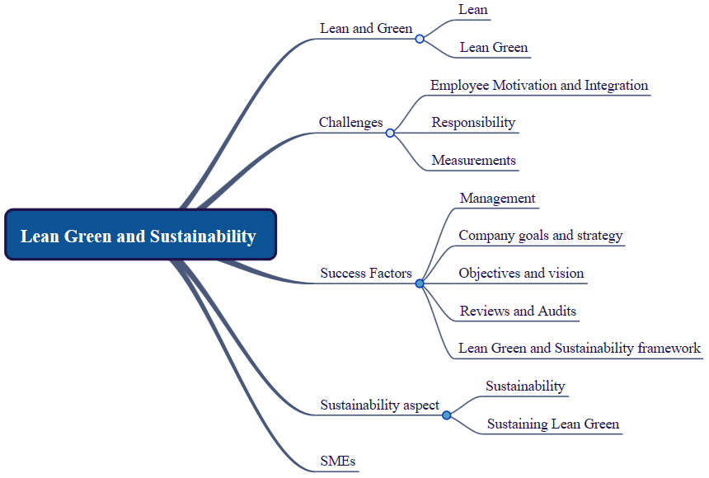
Figure 4: Coding levels
Source: Author’s own

Validity and reliability
For the purpose of maintaining quality standards throughout the data collection phase, validity and reliability were pursued through several techniques. Validity was assured through multiple sources of evidence and a chain of evidence (Yin, 2014). While interviews served as the main data collection method, information acquired through the company’s websites were additionally considered (such as Sustainability reports, organisation charts, etc.). These were used to complete an overview of the organisation and to fill in data that may have been left out by the interviewee. A chain of evidence was upheld through research questions that were connected to the design of the research strategy, creating and piloting an interview protocol that was followed by a detailed process of analysing data, which included relevant quotations and establishing relationships. Finally, an anonymised overview of participating companies was created.

The interview schedule was piloted with two academics and three practitioners from industry to ensure the intelligibility and relevance of the questions. Their feedback enabled the author to enhance the questions and revise the design of the schedule (Collis and Hussey, 2014; Bryman and Bell, 2015; Saunders, Lewis and Thornhill, 2016). Table 3 illustrates the participants that tested the interview protocol and the feedback that was given.

Table 3: Questionnaire feedback
Questionnaire Feedback
Participants | Professor of Quality Management and LSS Master Black Belt  Associate Professor in Marketing with a specialisation in  Sustainability  General Manager  Master Black Belt  Green-Lean Consultant
Feedback | Question for a definition of Lean by interviewees to see how perspective has changed over time  Strategic and tactical benefits of the company and the ratio of investment in Lean to its benefits  Number of employees trained on Lean per year and number and setting of Lean projects per year  Focus of Sustainability questions in regards to its application in business, such as through Sustainability management systems  Reduction of questions and elimination of redundancies  Refinement of German translation to clarify meaning  Suggestion to include Six Sigma  Focus of questions on SME requirements  Improvement of Sustainability-related questions

Apart from a suggestion to include Six Sigma questions, each piece of feedback was incorporated in the interview protocol. Six Sigma went beyond the scope of the research and was therefore not included. The final interview schedule is found in Appendix 1.

The limitations of this approach lay in the restricted number of interviewees per organisation, as a minimum of two employees per case company should be interviewed to ensure the viewpoint of a company (Lo, 2013). However, as the interviewees represented a range of positions from several hierarchical levels, the data gathered was regarded as a representative cross-section of viewpoints from SMEs.
4. Results
This section presents the results from the interviews that were incorporated into the framework. The purpose of this section is to:

- Overcome the shortcomings of existing frameworks by developing a practical framework that guides SMEs, regardless of their industry, to implement Green-Lean and Sustainability;
- Allow the rectification of implementation errors through a feedback mechanism;
- Enable the organisations to choose appropriate tools and techniques;
- Integrate and addresses social Sustainability to close a significant research gap;
- Incorporate methods to sustain the two strategies.

The model’s acronym is based on its five phases of Readiness, Conceptualisation, Planning, Execution, and Sustain (RCPES) and will be addressed as such.
The proposed RCPES framework enables SMEs to systematically implement Green-Lean and Sustainability within limited budgets and resources. It aims to improve their environmental, social and economic performance and to ensure long-term success. The conceptual model comprises five phases divided into 20 steps, illustrated in Figure 5.

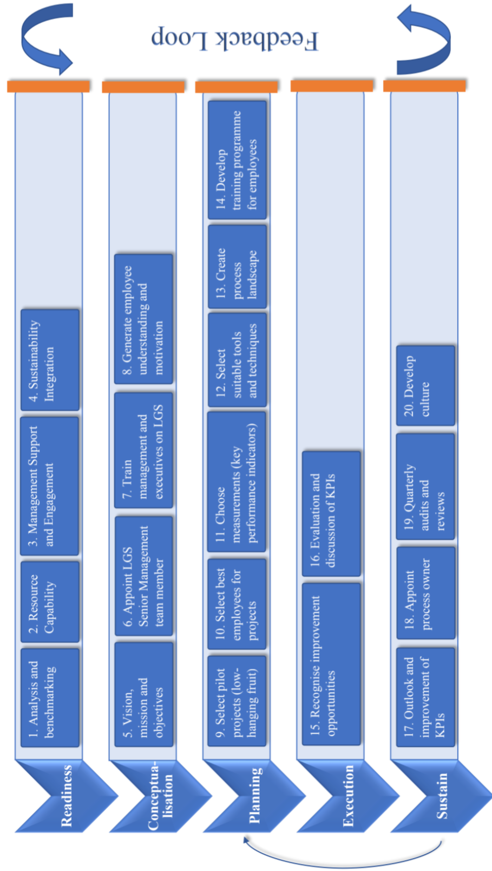

Figure 5: Original structure of the framework
4.1 Phase 1: Readiness
The readiness phase is designed to assess the willingness and maturity of a company to embark on a long-term journey that will transform their organisation to become leaner and more sustainable. It is essential for the success of the initiative to ensure that only companies with an evolved mindset and sufficient resource capabilities proceed to the next stage to prevent the failure of projects, which may result in a negative perception of Lean and Sustainability improvement strategies in their entirety.
Step 1: Analysis and benchmarking
Step 1 serves as an opportunity for the company to analyse its current situation and position and assess whether they have reached a maturity level sufficient enough to proceed with the integration of an additional management method (Kumar, Antony and Tiwari, 2011). It allows the organisation to consider its desired target state and compare its position with the competition through benchmarking.

To comprehend a company’s situation, the authors suggest using the self-assessment model for SMEs developed by Machado et al. (2018). With a reduced set of dimensions, the model specifically considers the characteristics and limitations of SMEs. Companies can use the self-assessment questionnaire to test their degree of compliance with the necessary attributes.

Step 2: Resource Capability
Organisations also need to ensure the availability and capability of the necessary resources for a Green-Lean and Sustainability integration. These include labour skills, machines condition, materials quality and professional expertise. These aspects need to be considered in regard to both Lean and Sustainability requirements.

Step 3: Management Support and Engagement
Commitment and involvement of top management are crucial to the success of the initiative (Grigg, Goodyer and Frater, 2020). Managers must carry the implementation of RCEPS through their involvement, demanding results, supporting and motivating teams, removing barriers and monitoring progress (Cherrafi et al., 2017a). According to the Holistic Lean Transformation Consultant from Company G, “once the owner of a company has acknowledged a topic as important, it is much easier to intensely promote the topic among the employees”. If management is not convinced and unwilling to invest, the initiative should not be pursued further, as the prospects of success are minimal (Albliwi et al., 2014; Snee, 2010).

Step 4: Sustainability Integration
The integration of Sustainability should not present an entirely new phenomenon for the company. While the aim of RCPES is to enable the organisation to become more environmentally, socially and economically sustainable, the implementation of two wholly unknown concepts at once (Lean and Sustainability) may lead to incomprehension and resistance amongst employees. It is advisable to include Sustainability in the company strategy to generate an understanding of the basic concepts across all organisational levels.

The next phase of implementation should only begin after the execution of each preceding step and when the necessary criteria are met.
4.2 Phase 2: Conceptualisation
The conceptualisation phase establishes foundations and paves the way for a successful implementation of the two paradigms. It creates the knowledge, understanding, motivation and authority that is required for the initiative to continue effectively.

Step 5: Vision, mission and objectives
Developing a vision, mission and objectives will enable the organisation to create a holistic concept for GLS and demonstrate its commitment. A vision allows the company to give its employees an understanding of the reasons why the organisation is implementing GLS measures. It supports the development of a mindset that assists employees to see and embrace Green-Lean and Sustainability as a philosophy instead of a single project. The vision also describes the 5-year-goal that the company should set as a preliminary achievement. This long-term goal should be aligned to the company strategy (Grigg, Goodyer and Frater, 2020) and can be broken down into annual, short-term milestones to track progress more effectively.

Step 6: Appoint GLS Senior Management team member
Through the appointment of a GLS Senior Management team member (SMTM) or GLS executive department, companies can create a position solely responsible for the successful implementation of RCPES and its progress. These should be employees with expert knowledge on both Lean and Sustainability, or a minimum of two experts with individual knowledge on either Lean or Sustainability. Their responsibilities include framing the project charter, defining stakeholder requirements, identifying the areas to integrate GLS, conducting training and monitoring the advancement of the initiative. They represent the connection between the strategic management level and the operative level and need to be afforded the necessary trust, tools, freedom and authority to look after the implementation.

Step 7: Train management and executives on Green-Lean and Sustainability
In order for the executives to bring GLS to a wider base, motivate employees and engage in the implementation of the RCPES framework, the management level needs to receive training for both Lean and Sustainability. This includes knowledge of tools, principles and the philosophy of each paradigm. This will allow the management to grow in the system. To save costs, training can be conducted by the GLS experts of the Senior Management team or through collaboration with non-profit organisations. Without an adequate level of knowledge, the implementation should not proceed, as the executives will be unable to meet their obligation of engaging in the process (Grigg, Goodyer and Frater, 2020).

Step 8: Generate employee understanding and motivation
Without the acceptance and commitment of employees, the integration of GLS has little chance of success (Alves and Alves, 2015; Duarte and Cruz-Machado, 2013). As the Master Black Belt of Company B summarised: “The biggest crux is to get the people on board”.
Staff should be openly integrated and educated on the change that is happening in the company, its reasons and the benefits for both employees and the company. A thoughtful communication plan including newsletters, assemblies, team meetings, etc. can be established to generate trust and understanding (Cherrafi et al., 2017a).

4.3 Phase 3: Planning
This phase serves for the detailed preparation, specification and careful selection of resources for the execution of individual projects in the following stage.

Step 9: Select pilot projects (low-hanging fruit)
SMEs should start with simple pilot projects, also called low-hanging fruit, to gain confidence in the tools’ effectiveness (Johansson and Sundin, 2014), demonstrate savings potential (Su and Chou, 2008; Duarte et al., 2012) and earn the trust and approval of management and employees. The selected projects need to be aligned to the company strategy (Grigg, Goodyer and Frater, 2020) and stakeholder requirements and can gradually move towards the bigger transformation of the processes. An important source of inspiration for potential pilot project selection, besides company strategy and stakeholder requirements, are for instance the United Nations Sustainable Development Goals. These 17 universal goals are designed “to achieve a better and more sustainable future for all” and provide important directions for firms’ sustainability performance improvement projects (United Nations, 2022). It is important to present successful projects in the beginning, as employees and management will otherwise doubt the effectiveness of the entire initiative.

Step 10: Select best employees for projects
The right employees will come from all levels and areas of the company and possess good social and technical skills. It is advised to consider their availability, level of knowledge, commitment to the initiative and sense of responsibility (Cherrafi et al., 2017a). These employees need to receive the necessary training, tools and expertise to conduct the project.

Step 11: Choose measurements (Key Performance Indicators)
The effectiveness of RCPES and the individual goals should be measured and documented with suitable KPIs (Aguado, Alvarez and Domingo, 2013; Duarte and Cruz-Machado, 2013; Kurdve et al., 2014). According to the Master Black Belt of Company I, making problems measurable “is the most important message of all Lean approaches”. This makes the change towards the target state measurable, confirms whether the company is moving in the right direction and detects any deviations. For this purpose, both Lean and Sustainability KPIs appropriate to the projects should be chosen. It is necessary to obtain measurements of the current performance that can be compared to future results. Environmental, social and economic measurements should be identical for all projects to generate a basic understanding of the impact of the company’s processes.

Step 12: Select suitable tools and techniques
The purpose of this step is to identify the most suitable and useful tools and techniques for the respective projects. While there are many tools available for Lean and Sustainability, they should be chosen according to their problem-solving ability and how well they can improve the measurements selected in step 11. Additionally, they should fit well with the organisational culture and available resources (Duarte and Cruz-Machado, 2013; Alves and Alves, 2015). A good starting point is the implementation of 5S, an easy and practical tool to improve workplace safety, organisation and cleanliness (Sobral et al., 2013). Further tools and their environmental and social benefit are described by Cherrafi et al. (2017a).

Step 13: Create process landscape
Creating a process landscape will optimally connect every process in the organisation, thereby removing further waste that is idle capacity. Production is strongly impacted by its linkage with upstream processes, which is why a company should be viewed as an organism. A process landscape connects information, work packages, responsibilities and expertise, and aims to cover the entire spectrum of the organisation. Integrated from the beginning, this will ensure that every employee possesses the necessary expertise and tools to accomplish the given task.

Step 14: Develop training programme for employees
For employees to be able to take part in the implementation, they need to be properly trained and educated on GLS concepts. Training programmes should additionally include soft skills such as team building, motivation and communication, based on the needs of the employees (Cherrafi et al., 2017a). Smaller workshops can be conducted ahead of each project to introduce specific tools. These programmes and workshops can again be performed by the SMTMs to save costs.

4.4 Phase 4: Execution
The execution phase comprises the execution of training programmes, improvement project execution and resulting change implementation.

Step 15: Recognise improvement opportunities
With the execution of projects and the collection of data, the team identifies root causes and develops and implements solutions to address these. Brainstorming sessions are encouraged to develop creative solutions (Cherrafi et al., 2017a).

Step 16: Evaluation and discussion of KPIs
A dialogue is initiated to discuss and evaluate the measured KPIs and find ideas and solutions for their improvement.

4.5 Phase 5: Sustain
This phase enables the company to ensure continuous improvement of its processes in the long term. It is an opportunity to consolidate the perception of GLS as a philosophy rather than a singular occurrence.

Step 17: Outlook and improvement of KPIs
Rather than looking at specific KPIs in the context of the individual project, this step concerns the prospects of overall KPIs. Managers and project team members should come together to discuss what the metrics should show in the future to advance towards the target state.

Step 18: Appoint process owner
Another important step to sustain the GLS initiative is to select one participating employee and hand over the responsibility for a particular process. This responsibility includes maintaining the achieved results (performance monitoring- and benefit tracking mechanisms), supervising other employees and reporting to the SMTMs. The employee should be chosen carefully and rewarded accordingly for the additional responsibility.

Step 19: Quarterly audits and reviews
It is important to carry out audits and reviews on a regular basis to update goals and objectives and to reassess employee willingness to change. Frequency is dependent upon the duration of the projects (e.g. biannually). They can be carried out internally, by the SMTM, or externally with the help of a consultancy. Instead of focusing solely on numbers and data, the reviews should encourage dialogues with employees to understand their adoption of the intended mindset.

Step 20: Develop culture
The last step aims at the cultural transformation of the company. Especially important for the Senior Manager Quality Management in Company J was “what happens to the employees that are involved in the Lean projects. There should be a 'we'-feeling, a mindfulness and the celebration of success”. Kumar, Antony and Tiwari (2011) agree that successes should be celebrated. These can be communicated via newsletters, assemblies or other internal marketing opportunities such as the intranet. The generated environmental, social and economic benefits should be widely reported to increase commitment and enthusiasm around the Sustainability initiative.

Since Green-Lean and Sustainability address the continuous improvement of processes in an organisation, RCPES is an ongoing development. It is, therefore, recommended that companies return to the ‘Planning Phase’ after completing the first successful cycle of the framework, as well as after each conclusion of the ‘Sustain Phase’. This gives the organisation the opportunity to continuously and systematically increase productivity in the consumption of resources and enhance its Sustainability performance.

4.6 Feedback Loop and Tollgate Review
The Feedback Loop between the five phases is designed around double-loop learning theory, which reflects upon and questions the fundamental procedures, norms and rules of an organisation to establish new knowledge (Argyris, 1977). Feedback is gathered to challenge organisational methods and consequently identify opportunities to develop new practices, norms, policies or knowledge (Bagodi and Mahanty, 2013). It may initiate a cultural change with long-term effects on a company. The cultural change requires open communication to enrich the dialogue, accelerate the flow of insights and thereby support learning (Jaaron and Backhouse, 2017). Double-loop is considered a crucial learning system, as it not only complies with standards but also supports their improvement (Rauffet, Da Cunha, and Bernard, 2014).

To ensure that every phase is completed, they are each additionally provided with a Tollgate Review. This is a formal process designed to ensure the continuous progress of a project. It should be executed by a Lean champion, who approves the accomplishment of each phase before the project leader and his team can proceed to the next (Antony, Vinodh and Goji, 2016). For this purpose, the champion should utilise a checklist with key questions to be asked in each stage.

The RCPES framework was tested by seven experts. From these, five had initially been interviewed in the data collection process and two were not familiar with the model but had worked with Lean methods in the past. The overall feedback was positive and corroborated the general structure, all five phases and 20 steps of the framework. Table 4 presents the experts’ individual comments/feedback in regards to the proposed framework.

Table 4: Framework feedback
Company | Interviewee | Interviewee experience with Lean (years) | Feedback
B | Master Black Belt / Lean Manager | 12 | The framework should illustrate its compatibility with management systems such as QM or ISO. This can be covered by steps two and four (if it concerns a Sustainability system), as management systems should receive a separate implementation due to their scope. Hence, if the inclusion of management systems is deemed necessary, it should be taken care of in the Readiness Phase.
C | General Manager | 3 | While it is difficult to assess the implementation costs of the RCPES framework, a roughly estimated budget should be given in step two.
D | Green-Lean Consultant | 8 | The advantages of a joint GLS integration were considered unclear, but can and should be demonstrated through a number of steps (see Figure 5). This illustrates the reduced effort of carrying out only one implementation instead of two, and that better results can be achieved through the synergistic effects of GLS.
E | Head of Change Management | 12 | While an acknowledged definition of GLS does not exist to date, a general explanation of both concepts should be added to steps five and eight to ensure a general understanding. A visualisation of a process landscape can be included in step 13 as a practical addition.
L | Lean Manager | 7 | Benchmarking should occur more often than just during the readiness phase as otherwise market trends are not consistently observed. Therefore, benchmarking can be included in the audits and reviews of step 19.
Company X | Lean and Process Manager Ground Operations | 5 | The complexity of projects concerning strategy, tactics, etc. can be included in step 9.
Company X | Operations Manager | 5 | Where social and economic aspects are featured in the model, supplementary visualisation through colours or symbols can be added, while the engagement of employees in social actions and services can be added as a KPI in steps 16 and 17, as well as become part of the development of a culture in step 20.

These comments can be fed into the individual steps or phases they refer to, which is additionally visualised in Figure 6.

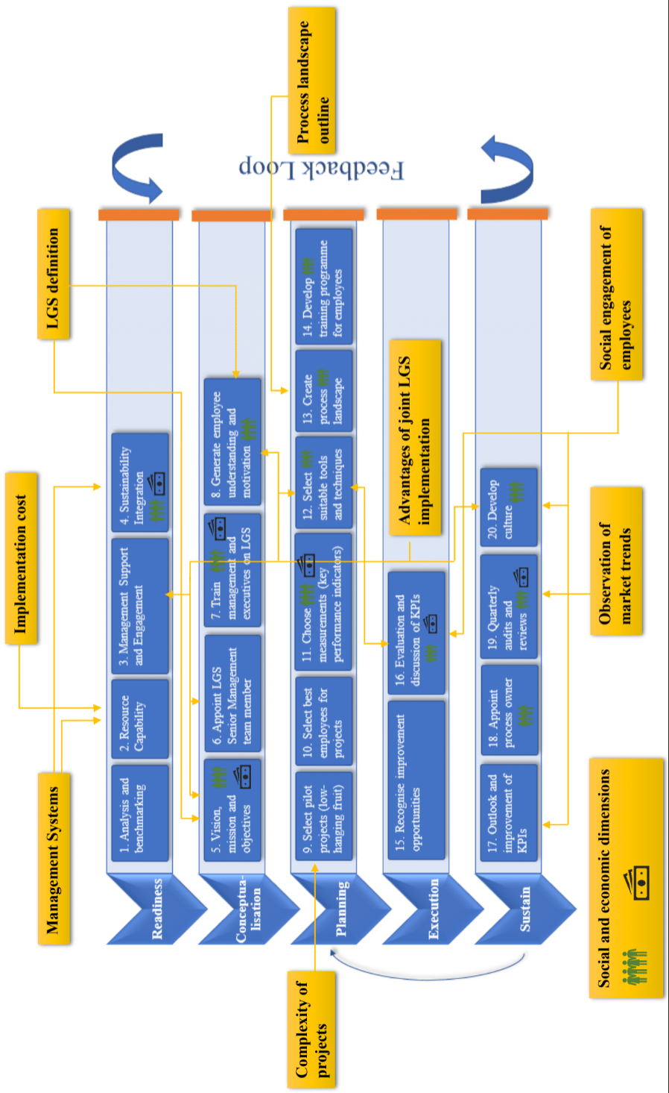
Figure 6: Revised version of the LGSF including expert feedback
5. Discussion and implications
The study demonstrated that the significant shortcomings in the understanding and application of Green-Lean and Sustainability in German SMEs can be overcome through a comprehensive, simplified and generic framework. Existing frameworks are useful primarily for larger organisations, and rarely consider the characteristics of SMEs (Piercy and Rich, 2015; Verrier et al., 2016), such as a different structure, resources, orientation and culture. This study takes into account the main challenges SMEs face when confronted with implementing a new strategy. These reach from spare human resources and a lack of financial resources to an emphasis on short-term objectives and internal resistance from both management and employees. The paper, therefore, proposes a practical step-by-step guide that will aid SMEs, regardless of their industry, to implement Green-Lean and Sustainability successfully with limited budgets and resources over the long-term. The overarching aim hereby is to improve SME’s environmental, social and economic performance and to ensure long-term success.
The paper will simplify the implementation of GLS in SMEs through a feedback mechanism that allows the rectification of errors at a later stage (Rauffet, Da Cunha, and Bernard, 2014) and a Tollgate Review that is designed to ensure the continuous progress of a project (Antony, Vinodh and Goji, 2016). Organisations can choose tools and techniques appropriate to their company size and characteristics. In addition, the framework integrates and addresses social Sustainability, which has been almost entirely overlooked in the literature to date (Martínez-Jurado and Moyano-Fuentes, 2014; Siegel et al., 2019). Since SMEs often emphasise short-term objectives to achieve quick results, the framework also incorporates methods to sustain the two strategies in the long term.
The framework is designed to be as easy to implement as possible for SMEs. However, its integration still requires an evolved company mindset and sufficient resource capabilities to start the journey of Green-Lean and Sustainability. The framework is oriented towards long-term success and therefore requires perseverance and diligence in the execution of activities such as the Feedback Loop and Tollgate Review.
Our findings suggest that the implementation of Green-Lean and Sustainability plays an important role in adapting to increasing stakeholder demands for sustainable operations and products. Thus, it is important to adopt these strategies for companies seeking the benefits from fair practices for the community, employees and partners, and the economic value that meets shareholder’s expectations and which benefits the community and wider society. Our findings are particularly applicable to SMEs, who will be encouraged to think, source and operate sustainably to preserve the environment and achieve long-term financial results.
The benefit of our study to SMEs is a step-by-step explanation of how to implement GLS that is specifically geared to their needs. The framework takes into account the main challenges SMEs commonly face, is based on the fundamental success factors that will allow SMEs to meet their goals, and has been reviewed, edited and approved by Lean practitioners. Challenges that might be encountered by SMEs with the adoption of LGS, such as the willingness of management to invest or the availability and capability of employees, are clearly defined and measures to overcome them are advised. Green-Lean practitioners in industry will find useful insights through our study as we offer a unique framework that implements Lean and Green, but additionally pays special attention to Sustainability, i.e. it incorporates all three dimensions including the social dimension, which has often been overlooked, and attends to the crux of sustaining Lean Green results in the long term. Besides SMEs, our framework can act as a useful guide for consultants as well as it is systematic, disciplined and has practical significance and value.
In terms of the theoretical implications gained from this study and its findings, it represents the first endeavour to help bridge the gap in the academic literature by studying and extolling the virtues of the GLS framework in providing social sustainability in the context of SMEs. In this sense, the research might be utilised as a starting point for analysing the current framework in other nations' SMEs. In exceedingly chaotic and uncertain times, social sustainability is a source that can assist organisations in expanding and gaining long-term competitive advantages. Several previous studies have been undertaken to investigate the impact of green-lean integration on the sustainability of larger organisations. These studies, however, were directly associated with environmental and economic sustainability. As a result, our understanding of the potential impact of GLS on social sustainability is still restricted. In this sense, this study seeks to fill this gap in the literature.
Researchers and academics can build onto our study to expand the framework by incorporating Six Sigma, for example. Our framework must also be tried and tested in practical circumstances. This study can serve as a basis to dive deeper into the connection and interdependence between Lean, Green and Sustainability.

6. Conclusion, limitations and further research directions
With increasing pressure in recent years for progress on the environmental and social performance of organisations and their products and services, Green-Lean and Sustainability have been established as strategic requirements (Cherrafi et al., 2017a; Garza-Reyes 2015b). Consequently, a number of frameworks and management systems have been introduced to accomplish a truly sustainable organisation. Our research demonstrated significant limitations in the existing frameworks, especially for SMEs. Therefore, our study documents significant evidence for a five-phase framework, called RCPES, which incorporates Green-Lean and Sustainability concepts and their synergistic benefits to achieve long-term environmental, economic and social Sustainability in SMEs. The model was created to explore the potential benefits of jointly implementing Green-Lean and Sustainability approaches, with regards to reducing waste, energy, water and raw material consumption, fair practices for employees and economic benefit for the organisation and surrounding community. We identified particular challenges SMEs need to overcome when implementing the framework and addressed these by incorporating additional supporting measures.

To further advance research on this topic, it is important to highlight the issues and limitations of the study. Due to the novelty of research on Green-Lean, Green-Lean theory lacks an acknowledged research definition and has a restricted number of studies that provide evidence of its workings. The sample size of interviews conducted is relatively small. Given that this is the first theoretical testing of the framework, it is crucial to assess the validity of the model by repeating the approach with larger samples. In addition, the geographical focus of our study was Germany. Hence, samples must include additional geographic locations to ensure the viability of the framework in different geographical settings. These could provide further insights and strengthen the results of our evaluation. Should these results reflect different styles of leadership and organisational cultures in other countries, it is important to adapt the framework accordingly, especially when testing the framework in practice. Applying the framework in a real industrial setting is also part of the future research directions suggested to be conducted to advance the present research. This will allow testing the suitability of the proposed framework in different industrial sectors. Finally, incorporating financial measures such as return on investment (ROI) as part of the framework can also be investigated in future research to help in the selection and success measurement of projects.

Above all, the RCPES remains a conceptual framework that must be tested in a real-life environment. It is recommended to test the framework in several companies with diverse organisational characteristics and of various industry backgrounds, as these will be affected by different environmental and social conditions. The implementation on-site should be supported by discussions with both experts and researchers and should include oral and written feedback, workshops and seminars. The framework should be employed in a single company to test its validity and applicability and to make any required changes before rolling it out to other companies (Cherrafi et al., 2017a).
Disclosure statement
No potential conflict of interest was reported by the authors.
References
Abualfaraa, W., Salonitis, K., Al-Ashaab, A. & Ala’raj, M. (2020). Lean-Green Manufacturing Practices and Their Link with Sustainability: A Critical Review. Sustainability 12(3), 981. https://doi.org/10.3390/su12030981
Aguado, S., Alvarez, R. & Domingo, R. (2013). Model of Efficient and Sustainable Improvements in a Lean Production System through Processes of Environmental Innovation. Journal of Cleaner Production, 47, 141-148. https://doi.org/10.1016/j.jclepro.2012.11.048
Ahmadi, H.B., Kusi-Sarpong, S. & Rezaei, J. (2017). Assessing the Social Sustainability of Supply Chains Using Best Worst Method. Resources, Conservation and Recycling, 126, 99-106. https://doi.org/10.1016/j.resconrec.2017.07.020.
Albliwi, S., Antony, J., Abdul, S., Lim, H. & van der Wiele, T. (2014). Critical Failure Factors of Lean Six Sigma: A Systematic Literature Review. International Journal of Quality & Reliability Management, 31(9), 1012 – 1030. https://doi.org/10.1108/IJQRM-09-2013-0147
Alefari, M.; Almanei, M. & Salonitis, K. (2020). Lean Manufacturing, Leadership and Employees: The Case of UAE SME Manufacturing Companies. Production & Manufacturing Research, 8(1), 222-243. https://doi.org/10.1080/21693277.2020.1781704
Alves, J.R.X & Alves, J.M. (2015). Production Management Model Integrating the Principles of Lean Manufacturing and Sustainability Supported by the Cultural Transformation of a Company. International Journal of Production Research, 53(17), 5320–5333. https://doi.org/10.1016/j.jclepro.2016.08.101
Antony, J., Vinodh, S. & Gijo, E.V. (2016). Lean Six Sigma for Small and Medium Sized Enterprises: A Practical Guide. CRC Press.
Argyris, C. (1977). Double Loop Learning in Organisations. Harvard Business Review, 55(5), 115-125.
Arumugam, V., Kannabiran, G. & Vinodh, S. (2020) Impact of Technical and Social Lean Practices on SMEs’ Performance in Automobile Industry: A Structural Equation Modelling (SEM) Analysis. Total Quality Management & Business Excellence, 2020. https://doi.org/10.1080/14783363.2020.1791067
Bagodi, V. & Mahanty, B. (2013). Double Loop Learning in the Indian Two-Wheeler Service Sector. Learning Organisation, 20(4/5), 264-278. https://doi.org/10.1108/TLO-04-2012-0029
Bergmiller, G.G. & McCright, P.R. (2009). Parallel Models for Lean and Green Operations. IIE Annual Conference. Proceedings, 1138-1143.
Braunscheidel, M.J., Hamister, J.W., Suresh, N.C. and Star, H. (2011). An Institutional Theory Perspective on Six Sigma Adoption. International Journal of Operations & Production Management, 31(4), 423-451. https://doi.org/10.1108/01443571111119542
Caldera, H.T.S., Desha, C. & Dawes, L. (2019). Evaluating the Enablers and Barriers for Successful Implementation of Sustainable Business Practice in ‘Lean’ SMEs. Journal of Cleaner Production, 218(2019), 575-590. https://doi.org/10.1016/j.jclepro.2019.01.239
Casula V. A., and Soneryd L. (2012). Organising matters: how “the social dimension” gets lost in sustainability projects. Sustainable Development, 20(1),18–27. [CrossRef]
Carvalho, H., Duarte, S. & Cruz Machado, V. (2011). Lean, Agile, Resilient and Green: Divergencies and Synergies. International Journal of Lean Six Sigma, 2(2), 151-179. https://doi.org/10.1108/20401461111135037
Chiarini, A. (2014). Sustainable Manufacturing-Greening Processes Using Specific Lean Production Tools: An Empirical Observation from European Motorcycle Component Manufacturers. Journal of Cleaner Production, 85, 226-233. https://doi.org/10.1016/j.jclepro.2014.07.080
Cherrafi, A., Elfezazi, S., Hurley, B., Garza-Reyes, J.A., Kumar, V., Anosike, A. & Batista, L. (2019). Green and Lean: A Gemba–Kaizen Model for Sustainability Enhancement. Production Planning & Control, 30(5-6), 385-399. https://doi.org/10.1080/09537287.2018.1501808
Cherrafi, A., Garza-Reyes, J.A., Kumar, V., Mishra, N., Ghobadian, A. & Elfezazi, S. (2018). Lean, Green Practices and Process Innovation: A Model for Green Supply Chain Performance. International Journal of Production Economics, 206, 79-92. https://doi.org/10.1016/j.ijpe.2018.09.031
Cherrafi, A., Elfezazi, S., Govindan, K., Arturo Garza-Reyes, J., Benhida, K. & Mokhlis, A. (2017a). A Framework for the Integration of Green and Lean Six Sigma for Superior Sustainability Performance. International Journal of Production Research, 55(15), 4481-4515. https://doi.org/10.1080/00207543.2016.1266406
Cherrafi, A., Elfezazi, S., Chiarini, A., Mokhlis, A. & Benhida, K. (2017b). Exploring Critical Success Factors for Implementing Green Lean Six Sigma. In: International Manufacturing Strategy in a Time of Great Flux, Cham, Springer International Publishing, 183–195. https://doi.org/10.1007/978-3-319-25351-0_9
Cherrafi, A., Elfezazi, S., Garza-Reyes, J.A., Benhida, K. & Mokhlis, A. (2017c). Barriers in Green Lean Implementation: A Combined Systematic Literature Review and Interpretive Structural Modelling Approach. Production Planning & Control, 28(10), 829-842. https://doi.org/10.1080/09537287.2017.1324184
Cherrafi, A., Elfezazi, S., Chiarini, A., Mokhlis, A. & Benhida, K. (2016). The Integration of Lean Manufacturing, Six Sigma and Sustainability: A Literature Review and Future Research Directions for Developing a Specific Model. Journal of Cleaner Production, 139, 828-846. https://doi.org/10.1016/j.jclepro.2016.08.101
Choudhary, S., Nayak, R., Dora, M., Mishra, N. & Ghadge, A. (2019). An Integrated Lean and Green Approach for Improving Sustainability Performance: A Case Study of a Packaging Manufacturing SME in the U.K. Production Planning & Control, 30(5-6), 353-368. https://doi.org/10.1080/09537287.2018.1501811
Daily, B. F. & Huang, S. (2001). Achieving Sustainability through Attention to Human Resource Factors in Environmental Management. International Journal of Operations & Production Management, 21(12), 1539-1552. https://doi.org/10.1108/01443570110410892
De Giovanni, P. & Cariola, A. (2020). Process Innovation through Industry 4.0 Technologies, Lean Practices and Green Supply Chains. Research in Transportation Economics, 2020. https://doi.org/10.1016/j.retrec.2020.100869
Dieste, M., Panizzolo, R., Garza-Reyes, J.A. & Anosike, A. (2019). The Relationship between Lean and Environmental Performance: Practices and Measures. Journal of Cleaner Production, 224(2019), 120-131. https://doi.org/10.1016/j.jclepro.2019.03.243
Dieste, M., Panizzolo, R. & Garza-Reyes, J.A. (2020). Evaluating the Impact of Lean Practices on Environmental Performance: Evidences from Five Manufacturing Companies. Production Planning & Control, 31(9), 739-756. https://doi.org/10.1080/09537287.2019.1681535
Dora, M., Kumar, M. & Gellynck, X. (2016). Determinants and Barriers to Lean Implementation in Food-Processing SMEs – a Multiple Case Analysis. Production Planning & Control, 27(1), 1-23. https://doi.org/10.1080/09537287.2015.1050477
Duarte, S. & Cruz-Machado, V. (2019). Green and Lean Supply-Chain Transformation: A Roadmap. Production Planning & Control, 30(14), 1170-1183. https://doi.org/10.1080/09537287.2019.1595207
Duarte, S. & Cruz-Machado, V. (2013). Modelling Lean and Green: A Review from Business Models. International Journal of Lean Six Sigma, 4(3), 228-250. https://doi.org/10.1108/IJLSS-05-2013-0030
Duarte, B., Montgomery, D., Fowler, J. & Konopka, J. (2012). Deploying LSS in a Global Enterprise – Project Identification. International Journal of Lean Six Sigma, 3(3), 187-205. https://doi.org/10.1108/20401461211282709
Dües, C.M., Tan, K.H. & Lim, M. (2013). Green as the New Lean: How to Use Lean Practices as a Catalyst to Greening Your Supply Chain. Journal of Cleaner Production, 40, 93-100. https://doi.org/10.1016/j.jclepro.2011.12.023
Eizenberg, E.; Jabareen, Y. Social Sustainability: A New Conceptual Framework. Sustainability, 9(2017), 68. https://doi.org/10.3390/su9010068
European Commission (2018). Entrepreneurship and Small and Medium-Sized Enterprises (SMEs). Available at: < http://ec.europa.eu/growth/smes_en> [accessed 10 May 2018].
Farias, L.M.S., Santos, L.C., Gohr, C.F., de Oliveira, L.C. & da Silva Amorim, M.H. (2019a). Criteria and Practices for Lean and Green Performance Assessment: Systematic Review and Conceptual Framework. Journal of Cleaner Production, 218(2019), 746-762.
https://doi.org/10.1016/j.jclepro.2019.02.042
Farias, L.M.S., Santos, L.S., Gohr, C.F. & Rocha, L.O. (2019b). An ANP-based approach for lean and green performance assessment. Resources, Conservation and Recycling, 143(2019), 77-89. https://doi.org/10.1016/j.resconrec.2018.12.004
Fercoq, A., Lamouri, S. & Carbone, V. (2016). Lean/Green Integration Focused on Waste Reduction Techniques. Journal of Cleaner Production, 137(2016), 567-578.
https://doi.org/10.1016/j.jclepro.2016.07.107
Garza-Reyes, J.A., Kumar, V., Chaikittisilp, S. & Tan, K.H. (2018). The Effect of Lean Methods and Tools on the Environmental Performance of Manufacturing Organisations. International Journal of Production Economics, 200, 170-180. https://doi.org/10.1016/j.ijpe.2018.03.030
Garza-Reyes, J.A. (2015a). Lean and Green: A Systematic Review of the State of the Art Literature. Journal of Cleaner Production, 102, 18-29. https://doi.org/10.1016/j.jclepro.2015.04.064
Garza-Reyes, J. A. (2015b). Green Lean and the Need for Six Sigma. International Journal of Lean Six Sigma, 6(3), 226–248. https://doi.org/10.1108/IJLSS-04-2014-0010
Garza-Reyes, J.A., Winck Jacques, G., Lim, M.K., Kumar, V. & Rocha-Lona, L. (2014). Lean and Green – Synergies, Differences, Limitations, and the Need for Six Sigma. In: Advances in Production Management Systems. Innovative and Knowledge-Based Production Management in a Global-Local World, Berlin, Springer, 71-81. https://doi.org/10.1007/978-3-662-44736-9_9
Grigg, N.P, Goodyer, J.E. & Frater, T.G. (2020). Sustaining Lean in SMEs: Key Findings from a 10-Year Study Involving New Zealand Manufacturers. Total Quality Management & Business Excellence, 31(5-6), 609-622. https://doi.org/10.1080/14783363.2018.1436964
Hu, Q., Mason, R., Williams, S.J. & Found, P. (2015). Lean Implementation within SMEs: A Literature Review. Journal of Manufacturing Technology Management, 26(7), 980-1012. https://doi.org/10.1108/JMTM-02-2014-0013
Huo, B., Gu, M. & Wang, Z., (2019). Green or Lean? A Supply Chain Approach to Sustainable Performance. Journal for Cleaner Production, 216(2019), 152-166. https://doi.org/10.1016/j.jclepro.2019.01.141
Inman, R.A & Green, K.W. (2018). Lean and Green Combine to Impact Environmental and Operational Performance. International Journal of Production Research, 56(14), 4802-4818. https://doi.org/10.1080/00207543.2018.1447705
Jaaron, A.A.M & Backhouse, C.J. (2017). Operationalising “Double-Loop” Learning in Service Organisations: A Systems Approach for Creating Knowledge. System Practice and Action research, 30(4), 317-337. https://doi.org/10.1007/s11213-016-9397-0
Johansson, G. & Sundin, E. (2014). Lean and Green Product Development: Two Sides of the Same Coin? Journal of Cleaner Production, 85, 104-121. https://doi.org/10.1016/j.jclepro.2014.04.005
Kaswan, M.S. & Rathi, R. (2020). Green Lean Six Sigma for Sustainable Development: Integration and Framework. Environmental Impact Assessment Review, 83(2020). https://doi.org/10.1016/j.eiar.2020.106396
Kovilage, M.P. (2020). Influence of Lean–Green Practices on Organisational Sustainable Performance. Journal of Asian Business and Economic Studies, 2020. https://doi.org/10.1108/JABES-11-2019-0115
Kumar, M., Antony, J. & Tiwari, M.K. (2011). Six Sigma Implementation Framework for SMEs – a Roadmap to Manage and Sustain the Change. International Journal of Production Research, 49(18), 5449–5467. https://doi.org/10.1080/00207543.2011.563836
Kuo, S. & Lin, P. (2020). Determinants of Green Performance in Container Terminal Operations: A Lean Management. Journal of Cleaner Production, 275(2020). https://doi.org/10.1016/j.jclepro.2020.123105
Kurdve, M., Zackrisson, M., Wiktorsson, M. & Harlin, U. (2014). Lean and Green Integration into Production System Models: Experiences from Swedish Industry. Journal of Cleaner Production, 85, 180-190. https://doi.org/10.1016/j.jclepro.2014.04.013
Lee, C. M., Che-Ha, N., & Syed Alwi, S. F. (2021). Service customer orientation and social sustainability: The case of small medium enterprises. Journal of Business Research, 122, 751–760. https://doi.org/10.1016/j.jbusres.2019.12.048
Lo, S.M. (2013). Effects of Supply Chain Position on the Motivation and Practices of Firms Going Green. International Journal of Operations & Production Management, 34(1), 93-114. https://doi.org/10.1108/IJOPM-04-2012-0133
Machado, M.C., Mendes, E.F., Telles, R. & Sampaio, P. (2018). Towards a New Model for SME Self-Assessment: A Brazilian Empirical Study. Total Quality Management & Business Excellence. https://doi.org/10.1080/14783363.2018.1460195.
Mani, V., Gunasekaran, A. & Delgado, C. (2018). Enhancing Supply Chain Performance through Supplier Social Sustainability: An Emerging Economy Perspective. International Journal of Production Economics, 195, 259-272. https://doi.org/10.1016/j.ijpe.2017.10.025
Martínez-Jurado, P. J., & Moyano-Fuentes, J. (2014). Lean Management, Supply Chain Management and Sustainability: A Literature Review. Journal of Cleaner Production, 85, 134-150. https://doi.org/10.1016/j.jclepro.2013.09.042
Masocha, R. (2019). Social sustainability practices on small businesses in developing economies: A case of South Africa. Sustainability, 11(12), 3257. https://doi.org/10.3390/su11123257
Missimer, M., Robèrt, K.H. & Broman,G. (2017). A Strategic Approach to Social Sustainability – Part 1: Exploring the Social System. Journal of Cleaner Production, 140(1), 32-41. https://doi.org/10.1016/j.jclepro.2016.03.170.
Moore, S. B., & Manring, S. L. (2009). Strategy development in small and medium sized enterprises for sustainability and increased value creation. Journal of Cleaner Production, 17(2), 276–282. https://doi.org/10.1016/j.jclepro.2008.06.004
Oliveira, L. R., Medeiros, R.M., Terra, P.B. & Quelhas, O.L.G. (2012). Sustainability: The Evolution of Concepts to Implementation as Strategy in Organisations. Production, 22(1), 70–82. https://doi.org/10.1590/S0103-65132011005000062
Pampanelli, A. B., P. Found, & A. M. Bernardes (2014). A Lean & Green Model for a Production Cell. Journal of Cleaner Production, 85(2014), 19–30. https://doi.org/10.1016/j.jclepro.2013.06.014
Piercy, N. & Rich, N. (2015). The Relationship between Lean Operations and Sustainable Operations. International Journal of Operations & Product Management, 35(2), 282-315. https://doi.org/10.1108/IJOPM-03-2014-0143
Popovic, T., Barbosa-Póvoa, A., Kraslawski, A. & Carvalho, A. (2018). Quantitative Indicators for Social Sustainability Assessment of Supply Chains. Journal of Cleaner Production, 180, 748-768. https://doi.org/10.1016/j.jclepro.2018.01.142
Rauffet, P., Da Cunha, C. & Bernard, A. (2014). A Double-Loop Learning System for Knowledge Transfer and Reuse in Groups: Application of a Roadmapping Approach. International Journal of Knowledge and Learning, 9(½), 63-85. https://doi.org/10.1504/IJKL.2014.067171

Saetta, S. & Caldarelli, V. (2020). Lean Production as a Tool for Green Production: The Green Foundry Case Study. Procedia Manufacturing, 42(2020), 498-502. https://doi.org/10.1016/j.promfg.2020.02.042
Saunders, M., Lewis, P. & Thornhill, A. (2016). Research Methods for Business Students (7th ed.). Harlow: Pearson Education Limited.
Sawhney, R., Teparakul, P., Aruna, B. & Li, X. (2007). En-Lean: A Framework to Align Lean and Green Manufacturing in the Metal Cutting Supply Chain. International Journal of Enterprise Network Management, 1(3), 238-260. https://doi.org/10.1504/IJENM.2007.012757
Shah, R. & Ward, P.T. (2003). Lean Manufacturing: Context, Practice Bundles, and Performance. Journal of Operations Management, 21(2), 129-149. https://doi.org/10.1016/S0272-6963(02)00108-0
Siegel, R., Antony, J., Garza-Reyes, J.A., Cherrafi, A. & Lameijer, B. (2019). Integrated Green Lean Approach and Sustainability for SMEs: From Literature Review to a Conceptual Framework. Journal of Cleaner Production, 240. https://doi.org/10.1016/j.jclepro.2019.118205
Singh, C., Singh, D. and Khamba, J.S. (2020). Understanding the Key Performance Parameters of Green Lean Performance in Manufacturing Industries. Materials Today: Proceedings, 2020.
https://doi.org/10.1016/j.matpr.2020.06.328.
Sobral, M.C, Sousa Jabbour, A.B.L & Chiappetta Jabbour, C.J. (2013). Green Benefits from Adopting Lean Manufacturing: A Case Study from the Automotive Sector. Environmental Quality Management, 22(3), 65-72. https://doi.org/10.1002/tqem.21336
Sony, M. & Naik, S. (2020). Green Lean Six Sigma Implementation Framework: A Case of Reducing Graphite and Dust Pollution. International Journal of Sustainable Engineering, 13(3), 184-193. https://10.1080/19397038.2019.1695015
Snee, R.D. (2010). Lean Six Sigma – Getting Better All the Time. International Journal of Lean Six Sigma, 1(1), 9-29. https://doi.org/10.1108/20401461011033130
Su, C.T. & Chou, C.J. (2008). A Systematic Methodology for the Creation of Six Sigma Projects: A Case Study of Semiconductor Foundry. Expert Systems with Applications, 34(4), 2693-2703. https://doi.org/10.1016/j.eswa.2007.05.014
Sy, M. V. U. (2016). Impact of sustainability practices on the firms’ performance. Asia Pacific Business & Economics Perspectives, Summer 2016, 4(1), 4-21. [CrossRef]
Timans, W., Antony, J., Ahaus, K. & van Solingen, R. (2012). Implementation of Lean Six Sigma in Small- and Medium-Sized Manufacturing Enterprises in the Netherlands. The Journal of the Operational Research Society, 63(3), 339-353. https://doi.org/10.1057/jors.2011.47
United Nations. (2022). Sustainable Development Goals. https://www.un.org/sustainabledevelopment/sustainable-development-goals/, accessed 4-2-2022.
Verrier, B., Rose, B., Caillaud, E. & Remita, H. (2014). Combining Organisational Performance with Sustainable Development Issues: The Lean and Green Project Benchmarking Repository. Journal of Cleaner Production, 85, 83-93. https://doi.org/10.1016/j.jclepro.2013.12.023
Verrier, B., Rose, B., Caillaud, E. (2016). Lean and Green Strategy: The Lean and Green House and Maturity Deployment Model. Journal of Cleaner Production, 116(2016), 150-156. https://doi.org/10.1016/j.jclepro.2015.12.022
Wessel, G. & Burcher, P. (2004). Six Sigma for Small and Medium-Sized Enterprises. The TQM Magazine, 16(4), 264-272. https://doi.org/10.1108/09544780410541918
Wong, W.P. & Wong, K.Y. (2014). Synergising an Ecosphere of Lean for Sustainable Operations. Journal of Cleaner Production, 85, 51-66. https://doi.org/10.1016/j.jclepro.2014.05.093
Yadav, V., Jain, R., Mittal, M.L., Panwar, A. & Lyons, A.C. (2019). The Propagation of Lean Thinking in SMEs. Production Planning & Control, 30(10-12), 854-865. https://doi.org/10.1080/09537287.2019.1582094
Zhang, M. & Awasthi, A. (2014). Using Six Sigma to Achieve Sustainable Manufacturing. Proceedings of the 2014 International Conference on Innovative Design and Manufacturing, 311-317. https://doi.org/10.4018/978-1-5225-9570-0.ch013
Zhou, B. (2016). Lean Principles, Practices, and Impacts: A Study on Small and Medium-Sized Enterprises (SMEs). Annals of Operations Research, 241(1), 457-474. https://doi.org/10.1007/s10479-012-1177-3

