UNIVERSITY OF DERBY

A STRATEGIC FRAMEWORK FOR PERFORMANCE MEASUREMENT IN LOCAL GOVERNMENT:

An empirical study of three District Councils in the UK.

Hilary Coyle

Doctor of Philosophy 2017

Contents

Preface 7

Abstract 8

Acknowledgements 10

Chapter 1 – Introduction and Aim and Objectives. 11

Chapter 2 - Literature Review 16

2.1 What is the Public Sector and Local Government? 16

2.2 Transparency in Local Government 22

2.3 Political Environment 24

2.4 Why do we need to measure performance? 26

2.5 What is performance measurement? 28

2.6 Strategic Performance Measurement (SPM) 30

2.7 What are the current trends in performance measurement? 32

2.8 Balanced Scorecard 34

2.9 Public Sector and Performance Measurement. 40

2.10 Performance in LGA’s 43

2.11 Current Political Climate 49

2.12 Resilient Authorities? 50

2.13 Stakeholders 52

2.14 Principal – Agent Theory 56

2.15 What should organisations measure? 59

2.16 Leadership 64

2.17 Quality of staff. 68

2.18 Practical performance measurement issues 72

2.19 Political Interference 75

2.20 Elected Members 76

2.21 Themes and critical success factors from the literature 77

2.22 Summary table of the themes from the literature review. 82

2.23 Conclusion to the literature review 85

Chapter 3 – Research Methodology 88

3.1 Philosophy 88

3.2 Approach 92

3.3 Case Studies 95

3.4 Design 97

3.5 Interviews 98

3.6 Transcribing Process 103

3.7 Action Research. 104

3.8 Bias 112

3.9 Details of data collection 114

3.10 Summary 115

Chapter 4 – Case Study One: South Derbyshire District Council. 117

4.1 The “Council” 117

4.2 Governance of the “Council” 121

4.3 Culture 123

4.4 Process for Performance Measurement for SDDC 124

4.5 Action Research Learning Process 132

4.6 Focus Group 136

4.7 Staff Survey 143

4.8 Discussion of the Measurements. 146

4.9 Theme 1 - Stakeholders & Communication 148

4.10 Theme 2 - Strategy & the Corporate Plan 155

4.11 Theme 3 - Leadership 161

4.12 Theme 4 - Transparency & External Perception 170

4.13 Theme 5 - Austerity, Resilience & Business-Like 173

4.14 Theme 6 - Balanced Measures & What Measures Are Chosen. 176

4.15 Summary of the first case study 184

Chapter 5 - Case Study Two & Three. 187

5.1 Background to Councils Two and Three. 187

5.2 Data Collection 189

5.3 Theme 1 - Stakeholders & Communication. 191

5.4 Theme 2 - Strategy & the Corporate Plan 207

5.5 Theme 3 - Leadership 212

5.6 Theme 4 - Transparency and External Perception 223

5.7 Theme 5 - Austerity, Resilience & Business-Like 227

5.8 Theme 6 - Balanced Measures & What Measures Are Chosen. 232

Chapter 6 - Discussion of Case Study Results 260

6.1 Summary of results. 260

6.2 Stakeholders & Communication 265

6.3 Strategy & the Corporate Plan 268

6.4 Leadership 268

6.5 Transparency & External Perception 269

6.6 Austerity, Resilience and Business-Like 270

6.7 Balanced Measures 271

6.8 The Model 274

Chapter 7 – Conclusion and Further Research 281

7.1 Academic Lessons Learnt 284

7.2 Practical Lessons Learnt 285

7.3 Limitations 285

7.4 Future Research 286

Bibliography 290

Appendices 302

1. Ethical Approval for the case study research. 302

2. Detailed documentation of transcribing process. 313

**Table of Figures**

Figure 1 Types of local government authorities in the UK (Hemming 2015, pVII) 18

Figure 2 Changes to local government structure in England since 1972 (Sandford 2016, p12). 19

Figure 3 Functions of local authorities in England (Sandford 2016, p13). 21

Figure 4 Political make up of district councils 2015-2019 (LGiU 2017). 24

Figure 5 The transitions of performance measurement and management (Yadav & Sagar 2013, p950) 34

Figure 6 Kaplan and Norton’s original balanced scorecard (Kaplan 2001, p356) 36

Figure 7 Adapting the balanced scorecard framework to non-profit organisations (Kaplan 2001, p361). 43

Figure 8 The seven perspectives of the public scorecard (Moullin 2011, p37). 49

Figure 9 Stakeholder matrix for a LGA adapted from Williams & Lewis 2008. 54

Figure 10 goals and performance measures (Bourne & Bourne 2002 p42). 59

Figure 11 The Performance measure record (Bourne & Neely 2002, p30). 60

Figure 12 The target setting wheel (Bourne & Franco-Santos 2010, p30). 61

Figure 13 The Vanguard model for check (Seddon 2008, p79) 67

Figure 14 Signals in the organisation (Lawrence et al. 2008, p18). 69

Figure 15 Responses to interviewing (Cooper & Branthwaite 1977, p81) 99

Figure 16 Spiral of reflective spirals (Koshy 2005, p4) 106

Figure 17 Elliott’s Action Research Model (Koshy 2005, p6) 107

Figure 18 The Topology of Landscapes. (Schon cited in McNiff & Whitehead 2011, p19) 109

Figure 19 Number of meetings for author at sddc. 114

Figure 20 Map of the District of South Derbyshire (SDDC 2016f) 118

Figure 21 summary of Accounts for SDDC 2015-2016 (SDDC 2016a p18) 121

Figure 22 Role of the Deputy Leader (SDDC 2016e p9-10) 122

Figure 23 The South Derbyshire Conservatives Manifesto for the May 2015 Elections (SDCA 2015). 124

Figure 24 South Derbyshire District Council Chamber (SDDC 2016h) 127

Figure 25 Timeline of the Corporate Plan 128

Figure 26 South Derbyshire District Council Corporate Plan Diagram (SDDC 2016i) 129

Figure 27 presentation delivered to members on the 11th January 2017 at SDDC. 130

Figure 28 The corporate plan values (SDDC 2016d, p5) 139

Figure 29 Signals in the Organisation (Lawrence et al. 2008, p18) 144

Figure 30 Q20 from Internal Communications June 2016 Survey (SDDC 2016e, p20). 146

Figure 31 SDDC Senior Management Team as at September 2017 162

Figure 32 SDDC Chief Executives Direct Reporting Staff 162

Figure 33 SDDC Finance and corporate services structure 163

Figure 34 SDDC Housing and Environmental services structure 163

Figure 35 Community and Planning Services Structure 164

Figure 36 Extract from the Performance Board for Quarter 1 2016 (SDDC 2016b, p13). 177

Figure 37 Data for the three councils in the research 187

Figure 38 Remuneration details and gross budget 2015/16 188

Figure 39 Gender of members across the three councils 188

Figure 40 The Performance Management Cycle (Council 2 2016, p1) 189

Figure 41 Summary of interviews undertaken for case studies two and three 190

Figure 42 Council Two Organisational Structure 212

Figure 43 Council Three Organisational Structure 212

Figure 44 APSE Refuse Performance Indicators for Council Three (APSE 2016) 257

Figure 45 The public sector model for creating a meaningful performance measurement system (Authors summary) 275

# **Preface**

The research and writing within this document are all the authors own work.

# **Abstract**

Purpose – To investigate performance measurement in Local Government Authorities and to find out if a tool such as Kaplan & Norton’s (1996) Balanced Scorecard can be effectively used. There is a pressing need for the public sector to be efficient and effective in these times of austerity and thus to find out what they do with regards to performance measurement. To find any themes within the public sector and to see if there is a pattern and a framework that can be created.

Design/Methodology/Approach – The current literature is first analysed both in the private sector and in the public sector. A deficiency of literature was found for the public sector and especially that of LGAs. The author is currently an elected member of a district council and an action research approach was taken within this case study. The data collected was then reviewed and followed up by semi structured interviews in all three councils. The data was analysed with a thematic approach. The councils chosen were all in the Midlands and are of a similar size and demographics.

Findings – The findings indicate that the balanced scorecard is a tool that the LGAs can use and they do use a version of it but that there are complications to using it. Several themes appear such as: Stakeholders, Communication, Strategy, Leadership, Transparency, Business-Like, Resilience, Austerity and the Use of Balanced Measures. The main finding was that although the councils had good intentions they are not clear about what their citizens and stakeholders want. Therefore the future discussion needs to take a step back and start at the stakeholders rather than starting with the scorecard and the measures.

Practical Implications – All LGAs are going through a period of austerity which is imposed by central government. They need to deliver the same quality of services for a reduced fee which means they need to work in an effective manner. By developing a framework that can show how the staff on the ground can influence and achieve the stakeholders’ expectations will enable the organisations to focus on what really matters. Once the council is focussed it can then let go of all the non-value adding activities in order to use their resources to satisfy their stakeholder needs.

Originality/Value – There is a gap in the literature for this type of study as all previous studies have been for a singular LGA and from a non-action research viewpoint. A multiple LGA study would give more scope to expand the good practice. Also there is a gap in the literature for action research studies where more depth of insights can be revealed. For the LGAs a framework that can help them decipher the stakeholder needs and translate them into objectives for their staff in all levels of the organisation would vastly help them achieve their targets within the constraints of their ever decreasing stream of funding.

# **Acknowledgements**

I would like to thank my family for all the support they have given me over the past five years. I could not have managed to write this without their love and backing.

I would also like to thank everyone else that has been involved in this research project including my supervisor and all the officers and members that have participated along the way. I appreciate their honesty and welcomed their involvement and ideas. Without the time they have spared for the interviews and meetings this research would have not been possible.

# **Chapter 1 – Introduction and Aim and Objectives.**

*“Nothing ever gets bigger by measuring it” (CEO SDDC Transcript p369, l15).*

The overall aim of the authors’ research for the PhD is;

“To identify, review and evaluate critical success factors to use for performance measurement and strategic mapping for local government”.

This aim is broken down into the following objectives:

1. Review literature on performance measurement in order to identify current themes and critical success factors. This review will be based on a comparison of private sector practices and local government practices.
2. Critically analyse the performance measurement currently in practice in three local government authorities.
3. Identify the gaps in the literature and knowledge in relation to performance measurement in local government.
4. Interpret and develop critical success factors for performance measurement in local government.

Some examples of the indicative research questions are:

* What performance measurement systems do the three case study authorities currently have?
* How effective are they?
* How do these councils use performance measurement in practice?

The author plans to link together the experiences of being an elected member of a local district council with being a qualified accountant.

The general public perception of local government is not a positive one. Van Helden (2005) comments that politicians, academics and business people have “criticised the public sector because of its inefficiency and ineffectiveness” (p99). Jackson (2011) adds to this by commenting that public sector performance is on show to everyone so there is an abundance of criticism. Unlike private organisations that can keep their issues out of the public eye unless there is a huge disaster.

As central government squeezes the purse strings local government authorities (LGA’s) are being forced to look for ways they can control their costs yet still deliver the same suite of services to the general public.

Before an organisation starts to measure their performance there needs to be a view on what is meant by performance measurement. For the private sector it is often based on profit however in the public sector Jackson (1995, p1) states that;

“Public sector performance means different things to different groups … performance measurement cannot and should not be reduced to the metric of the cost accountant”

Officers must have a way of making decisions regarding their organisations so there has to be some way of measuring performance (Jackson & Palmer 1989). Jackson (1995, p19) also believes that;

“performance evaluation of government activities is essential in any democracy. Government no matter the level should be accountable and responsible to the electorate and a host of other stakeholders”.

The view of Efficiency, Economy and Effectiveness (the three E’s) that is often used in the public sector drives a plethora of targets and indicators to be measured. The focus over the last two decades or more has been to do more with less, have more value for money and to convince the public that their money is being spent wisely (Jackson 1995b). Jackson & Palmer (1989) see measures as anything that can be accurately measured and indicators as anything that is softer and not specific.

The three E’s are the crux of the value for money focus of the public sector and came out of the Best Value initiative in 1997 (Speller in Johnson & Scholes 2001). Economy means to spend less on resources but not necessarily accept the cheapest price. Efficiency is to produce what we need to well with minimal waste and Effectiveness is to ensure we are spending money wisely on what will achieve our goals (Jackson 1995b).

The common view of the public sector is that it is intensely bureaucratic and everything must be measured to ensure it gets the job done. The best value initiative wanted to ensure all the views of the stakeholders were reflected and that local government was in touch with the local people. The downside of this was that it resulted in many measures and a huge emphasis on auditing and checking (Speller in Johnson & Scholes 2001).

However we are again looking at what does good performance look like, “How would we know higher performance if we found it?” (Jackson 1995, p2). We will find that performance is not simple in the public sector but it is complex and “multidimensional” (Jackson 1995b). However this does mean that the public sector have been searching for non-financial indicators for a long time so in theory should be way ahead of the private sector. Balkaran (2017) supports this by commenting that the value for money ethos is now very prevalent in the private sector.

When trying to define what performance measurement means in the public sector Jackson (1995, p27) states that there are a “complex mosaic of indicators … that are the substitute for profit in the private sector”. How can you define and measure social relationships which is essentially what the public sector is. There are many scenarios that appear and each one needs to be evaluated individually to gain any rich information.

Stewart and Walsh cited in Jackson 1995 (p51) believe that a “ full set of measures of performance are unlikely to be discovered”. The quest for the best way to measure public sector performance continues today, some 20 years after these comments were made. The focus is now moving towards balanced measures and not just low cost options.

LGA’s are led by elected members otherwise known as councillors. No qualifications are necessary to become a councillor. The roles are often part time but as in any voluntary role you can spend as much or as little time on it as you want to. The remuneration for the roles vary from council to council however it is an allowance for expenses and not a salary. The allowance is based on the average salary for the area and then reduced by a third. This is because it is seen as a public service role and councillors should work for a third of their time for free. For a back bencher role in a district council the author receives £6,000 per year. This the author would suggest is not enough to be a money motivated role. If candidates are affiliated to a particular political party then the party will have a recruitment process. However the authors own experience was during a parish council meeting where the author was the chair in 2006 the local district councillor fell asleep. The author said “well I could do better than that”. Six months later the nomination papers had been completed for the author, the author signed to say they would be a candidate and the rest they say is history. Although it is a good idea to have a recruitment policy in reality there is a lack of candidates so anyone that is willing to give up their time is looked at favourably. Then all that is needed is that the general public vote for you. In many cases the public do not know the councillor as an individual and vote for the national political party they prefer. The councillors are then the equivalent of a senior board of a private company. They decide on the focus and strategy of the organisation. Heavy influence will come from central government and from the national political parties however after that it is up to the local members to shape the future of the local environment.

For some LGA’s Decision making meetings happen every six weeks, reams of paperwork are produced for each meeting and members are expected to read and digest this within a week and come to an informed decision.

There is great potential to be able to devise a framework to enable performance measures to be linked with objectives so it becomes transparent as to how the authority is performing. Otherwise decisions are made on the basis that all members have read and digested the huge tomes and clearly understand the implications. The researcher challenges this and thinks members place huge trust in the officers to guide them without truly understanding all the details even though they have been made available.

According to literature available there is a lack of empirical evidence in this area hence the current research interest (Kong 2007, Ross 2011). Jackson (2011) also comments that “little of the literature is grounded in serious analysis” (p13). Franco-Santos et al. (2012) have looked at 76 articles that discuss contemporary performance measurement systems to look at the consequences of using these systems. Balanced scorecard falls within the scope of their research. They have focussed on 15 specific journals covering Accounting, Operations and Strategy but they have concentrated on the private sector and have excluded all research from the public sector. Again reiterating the fact that there is a distinct lack of literature relating to the public sector in this area. Their key findings were that “Contemporary Performance Measurement systems significantly affect people’s behaviour, organisational capabilities and performance” (Franco-Santos et al. 2012, p98).

This thesis will critically evaluate the literature for both the Balanced Scorecard and what happens in the public sector. It will show that there is very little empirical evidence of research into performance measurement in LGA’s. The methodology will discuss various ways of approaching research within an accounting area and will conclude that the case study route is the most meaningful albeit with less general conclusions available. The findings will then discuss the position of three LGA’s and ultimately provide details of the further research that is needed.

The outcome of this PhD research will be a contribution to academic knowledge that is the addition of literature to fill a portion of the gap that exists. In practice the framework and critical success factors will be useful for senior management of local government to develop their strategy and strategy mapping. This means that senior officers of the LGA’s can link their objectives to performance measurements. This should then guide the staff to all work towards the same goal (Drury 2015).

Once the findings from the qualitative research are analysed the question can be asked as whether any generalisations can be made.

# **Chapter 2 - Literature Review**

## **2.1 What is the Public Sector and Local Government?**

In order to set the scene for this thesis some back ground information on the public sector and local government is needed.

The public sector is often referred to as meaning the government and the state. The state is defined by Leach et al. (2011, p2) as a “unit of government, a compulsory association that is sovereign over a particular territory”. They go onto then discuss what an authority is and feel that it is “widely used to describe the rightful use of political power or legitimate power” (Leach et al. 2011, p3). This would support the fact that most people will abide by what a council says or local government authority says as they believe in the power of the authority. That it is lawful and legitimate.

Smalski in Balabonienė & Večerskienė (2015, p315) defines the public sector as “the systems of organisations managing and using state resources”.

Resources come from national taxation and central government has a responsibility to spread this across the country. “Who gets what is a national responsibility and a national preoccupation” (Seitz cited in Wilson & Game 2011, p4). Debates in local government continue as authorities have to pay into the central government pot and often receive very little back. The legislation to implement the retaining of business rates was left behind after the June 2017 snap election. Local government are now waiting for a reform in funding and may have to wait until the outcome of the Governments Fair Funding Review in 2020-21 (Conrad 2017).

Byrne (2000) comments that national government can only deal with national issues and has to make decisions based on the whole country and not just one particular area. National government consists of members of parliament (MP), ministers (some MP’s and some peers from the House of Lords) and civil servants. The latter both advise and deliver government policy.

National government is based on a party political system. Often when people talk about politics they mean the government in its various forms. The parties have evolved over time as there are too many MP’s to govern if they were all independent and had different views. The party system allows like-minded people to come together and form a view of how to lead the country. In Britain there have been two parties in power since 1945, the Conservatives and the Labour party’s. There are other smaller parties that continue to exist and can potentially form coalitions or alliances but they are not large enough to govern on their own (Leach et al. 2011).

National politics deals with not only the nations’ affairs but also global affairs which are seen as varied and exciting. On the other hand local government is often seen as being dull with a very narrow focus (Leach et al. 2011). At the lowest level of Local Government, at Parish Council Level, this is not political. Members of the local community put themselves forward for election independently with no allegiances to any political parties. However the next step of district, county and city councils are political. Leach et al. (2011) argue that this is a necessity at this level as political parties train their candidates, organise and produce policy and they also give the public a choice between the different teams of leadership. The author supports this view as being an elected member it would be chaos if there were 36 independent councillors looking to run the district council all with different policies and ideas, nothing would ever be achieved.

Local government are smaller units of the government and they report directly to the government. This is different from countries like the United States of America or Germany where there are self-governing federal states which are united by a central government (Wilson & Game 2011). However local government is not just another quango or version of central government. It is locally elected and forms another “tier of democracy”(Wilson & Game 2011, p39).

So local government is important in many ways. It delivers services to the local community and the community can have an impact on those choices. By voting for their elected members and their manifestos the community can help to shape their area. Often community activists stand for election and become elected members also known as councillors (Leach et al. 2011).

Wilson & Game (2011, p37) define local government as:

“a form of geographical and political decentralisation, in which directly elected councils, created by and subordinate to parliament, have partial autonomy, to provide a wide range of services, through various direct and indirect means, funded in part by local taxation”.

|  |  |  |  |
| --- | --- | --- | --- |
|  | | | |
|  |  |  |  |
| |  |  |  |  |  | | --- | --- | --- | --- | --- | | **Types of Local Government Authority in the UK** | | | | | |  |  |  |  |  | | County | 27 |  |  |  | | District | 201 |  |  |  | | London | 33 |  |  |  | | Metropolitan | 36 |  |  |  | | Unitary | 55 |  |  |  | | Scottish Unitary | 32 |  |  |  | | Welsh Unitary | 22 |  |  |  | | Northern Ireland | 11 |  |  |  | | Total | 417 |  |  |  | |  |  |  |  |  | |  |  |  |

Local government has been constantly changing. In 1994 there were 540 councils in the UK (Wilson & Game 2011, p15) and today this has dropped to 417 (Sandford 2016).

Figure 1 Types of local government authorities in the UK (Hemming 2015, pVII)

You can see from the table above that the district councils are the most prevalent in the UK today.

Central government creates legislation to tell the country what it wants to achieve. Many of the bills passed are to do with local government. National government can give powers and take them away from local authorities whenever they want to. Local authorities have some decision making powers but they have to act within the legislation set (Wilson & Game 2011).

The overall theme for the local government authorities is that the power to do things differently locally is diminishing all the time. Although the current government is pushing for devolution and more localised decision making there are many rules in place which restrict how much impact the local authority can have (Wilson & Game 2011). A very local example of this is where an area that was not identified for housing development by the council was given planning permission by the secretary of state. This is essentially over ruling the local council’s decision. Quite often local government does not want to do what central government wants. This could be due to opposing political control but it can still happen when the political groups are the same.

The figure below shows how the changes are all leading to fewer councils and more unitary authorities (Sandford 2016). Local government has undertaken many attempts at reform since it was originally designed (Pemberton & Goodwin 2010).

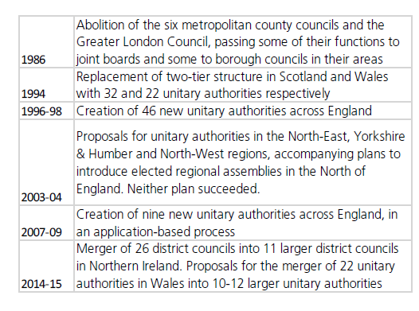

Figure 2 Changes to local government structure in England since 1972 (Sandford 2016, p12).

Governments have been wanting to improve the performance of the public sector for decades. Australia has gone through many iterations of new public management (West & Blackman 2015). In the UK the government are keen to be seen as efficient and to reduce the amount spent on the public sector services. To do this they, this conservative government and many others before including Thatcher’s government, want to “seek greater value for money, the reduction of waste and the elimination of over government” (Jackson 2014, p271).

Local authorities provide many local services and the table below shows which type of council is responsible for which service.

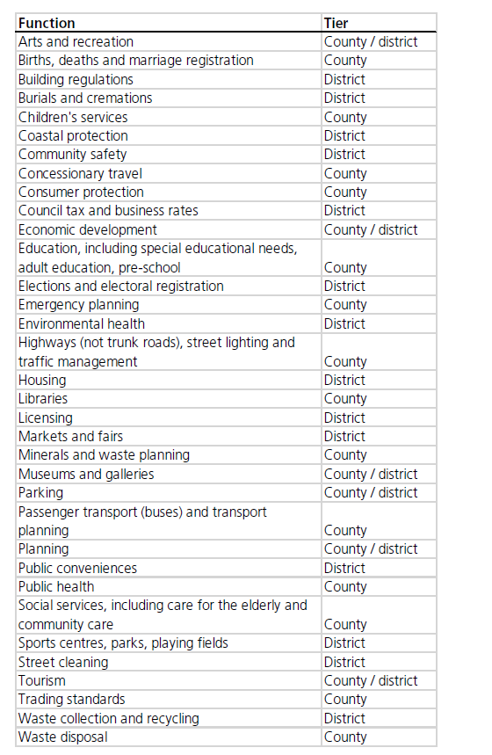

Figure 3 Functions of local authorities in England (Sandford 2016, p13).

From the figure above we can see what responsibilities that the councils have however who, within the organisation makes the policy?

Wilson & Game (2011) suggest three models of creating policy. The first is the formal model where the councillors make the policy and the officers carry it out. A fairly simple idea.

The second model is the technocratic model where the officers have the technical knowledge and tell the part time often unqualified councillors what to do (Wilson & Game 2011).

The third model is the joint elite model where the policy making is carried out by the senior leaders of both the officers and the members (Wilson & Game 2011).

The author suggests an addition to the third model where the members of the controlling party create their vision and manifesto and then the senior leaders work with senior officers to create the policies. In some organisations there are splinter groups within parties and they split off to debate their own policies and ideas. Recently we have seen splits in both the two main national parties regarding the choice of leadership and policies.

As Cartwright (1975, p46) says:

“The crime of ‘being run by the officers’ is one of the most heinous that can be levelled against any local councillor”

Ritz (2015) challenges this split of duties and believes that the councillors are also responsible for the implementation of the policies. They are merely supported by the professional officers but ultimately the elected representatives are accountable.

## **2.2 Transparency in Local Government**

The general public are often disillusioned with the public sector and believe it to be poorly run and poorly administered and often corrupt. Low transparency supports these views and creates a circle of uncertainty (da Cruz et al. 2015).

da Cruz et al. (2015, p872) define transparency as;

“The publicity of all acts of government and its representatives to provide civil society with relevant information in a complete, timely and easily accessible manner (i.e. online)”.

In todays’ modern era of computers, websites and social media the general public can access huge amounts of data and this makes the local government organisation more accessible to the public. Many councils film their meetings and stream them live on the internet. This helps the quality of governance as the public can interrogate the data available to find out more information. Although it may not openly improve the quality of the democracy it means the public can scrutinise decisions made and monitor what is happening more than they could in the past (da Cruz et al. 2015).

Although this is true for district councils it may have a detrimental effect on other public areas such as healthcare. It would probably not work in countries where there is endemic corruption. However the UK has a democracy and this transparency should, in theory, improve and not hinder good governance (da Cruz et al. 2015).

“This type of information disclosure has the potential to unravel private interests which can conflict with the collective interests and make actors accountable” (da Cruz et al. 2015, p872).

All local councils are subject to both internal and external audit. The audit report is important and all councils want a clean bill of health and “unqualified” accounts. This means they have been accepted by the auditors and the auditors have no issues with them. However do the general public read the auditor’s report or are they more likely to read the local newspaper or social media to obtain information about their council?

Carr-West ( 2017, p11) claims that we do not care these days if what politicians say is true “we are more concerned about how statements make us feel”. Social media gives people the news but within their comfortable circle, no views that challenge the reader. However local government have an advantage here as the people can really see what is or is not happening in their areas. Carr-West (2017, p11) gives the example that we need to trust the government when they tell us what the GDP growth is but “we can see whether potholes in our street are being fixed”. Local government can be transparent in their actions.

## **2.3 Political Environment**

A Map of the 2017 Political control of local authorities.

Content removed for copyright reasons.

Figure 4 Political make up of district councils 2015-2019 (LGiU 2017).

“Politics is bound up with controversy, which is one reason why it both attracts and repels” (Leach et al. 2011, p1). The public can change their minds at each election depending on what is happening in the country at the time.

The map above often changes colours depending on the mood of the country and the timing of the elections. From the authors own experience it is noted that when local elections coincide with national elections the local results follow the mood of the nation. However for stand-alone local elections there is more scope for local issues to be at the top of the publics’ priorities and often people will change their vote to be a personal one and not a political one. The downside with the election being purely for local government is the turnout is often much lower. Fewer members of the public turnout to vote for a local election compared to a general election. In South Derbyshire 69% of people voted in the general election in 2017 compared to 20% for a local councillor by-election (SDDC 2017a).

The political environment of the Midlands has a mixture of both Conservative and Labour controlled local councils. The above map was produced after the county council elections in May 2017. The district councils had their elections in 2015.

The district councils discussed within this thesis can be described as rural councils. Large parts of their area are made up of villages and agriculture.

“Rural areas have recently been subject to widespread demographic, social and economic change” (Pemberton & Goodwin 2010, p272). The current focus on housing needs has meant that rural areas are growing and expanding with new residents.

Pemberton & Goodwin (2010) believe that there is no longer a clear differential between rural, urban or town and country. Much has been studied about understanding urban government which has effectively left the understanding of rural government behind. Rural government is having to look towards partnerships as the local government organisation cannot provide everything required.

## **2.4 Why do we need to measure performance?**

Balabonienė & Večerskienė (2015, p317) state that “it is not possible for any organisation to act effectively without having its performance measured”.

Nath & Sharma (2014, p2) believe the “use of performance indicators is important because they are an essential part of the monitoring of programs and employee performance”.

Is this correct? Do we need to measure our performance at all? There are some theorists that believe if you employ the right people in the right roles then there is no need to measure their performance as they will always do the right thing. This is the view of Stewardship theory. There is no extrinsic or monetary motivation but a sense of achievement when a job is well done (Glinkowska & Kaczmarek 2015). This also supports the view of McGregor’s’ Theory Y that staff will work on their own and without line management (Seddon 2008). However the view of the general public that the public sector is lazy and inefficient means that the electorate will not leave the staff to their own devices but need the targets to prove that public money is being used fairly. This is also supported by the command and control view of management from Seddon (2008).

This thesis will be evaluated whilst using an “Agency Theory” lens. Where there is a hierarchy of structure and the CEO is ultimately accountable and has the legitimate authority to control the officers of the council with the leaders’ permission.

There are two school of thought regarding the use of target setting according to Bourne & Franco-Santos (2010, p29) “Good” or “Divisive and counterproductive”. Evidence from management literature believe that having a realistic and achievable target is better than no target at all with just an overall focus of work hard or do your best. On the other hand there is the dysfunctional behaviour that can “create fear, undermine teamwork and destroy performance improvement” (Bourne & Franco-Santos 2010, p29).

Performing well as part of a team means that all parts of the team have to work together. If this does not happen then it is hard to deliver the performance targets (Bourne & Franco-Santos 2010). Opposing this is the view from the control theorists that peer pressure can help everyone achieve their targets. People will work together to achieve their goals as they do not want to let down their colleagues (Merchant & Van der Stede 2012).

Organisations should not just look at individuals’ performance. It has to be the whole team. The whole team creates the synergy which is not there if they are kept separate as individuals. Recruiting the right team is vital. Managers who inspire are needed to bring out the best in staff supported by Human Resources to train, coach and mentor. (West & Blackman 2015). “All levels of management and employees … must drive the change” (West & Blackman 2015 p76).

The most obvious purpose of a performance measurement system is to improve performance. Whether this is improvements and increases in funding or whether it is about controlling costs. Sometimes it is used to identify defunct processes or procedures (Lewis 2015).

However as soon as people are measured their behaviour changes and the deviousness of peoples characters come out (Lewis 2015). Bevan & Hood (2006) agree with this sentiment as they believe that gaming occurs and people begin to adapt and look out for themselves.

Lewis (2015) feels that all the dysfunctional consequences of measuring performance cannot be pre-empted and there will always be some non-intended side effects.

Pavlov et al. (2017) believe that performance measurement does influence performance in a good way as it provides focus for managers and means they can organise and co-ordinate resources together. However the key remains the correct translation of the strategy into the actions which is the heart of the arguments of Kaplan & Norton (1996).

As such measurements are prolific in many organisations.

## **2.5 What is performance measurement?**

Performance measurement was being discussed in 1956 by Ridgway (Ridgway cited in Neely 2005) and it has been reviewed many times however in the 1980’s and 1990’s it became the fashionable topic to research and many authors came up with frameworks (Neely 2005). Ghobadian and Ashworth state that it also became a topic of interest for local governments around this time as they were being pressurised from central government, the public and new competitive market strategies, amongst other pressures (Ghobadian & Ashworth 1994). Organisations are “clearly searching for performance measurement solutions” (Fitzgerald in Hopper et al. 2007 p223).

Thus there is agreement across many academics that performance measurement is a subject for discussion and has been for several decades. “Performance measurement has for a long time been one of the crucial issues among scholars and business managers” (Larimo et al. 2016, p877). The business environment is constantly changing and thus performance measurement, too, has to change and continuously update itself (Yadav & Sagar 2013). Globalisation and the increase in the capability of technology are some of the factors that are pushing organisations to analyse their performance in greater detail (van der Meer-Kooistra & Vosselman 2004). The journal Management Accounting Research created a special issue, 25 2014, to look at the issues in performance measurement. Bourne et al. (2014) describe performance measurement as being at a crossroads. The literature has been inconsistent in their findings when trying to link performance to performance measurement. They suggest that there are still gaps in knowledge about the effect performance measures have on the overall performance of organisations.

However despite the fact that there is a plethora of literature addressing performance measurement and management issues very little of it examines the public sector. (Michelli & Neely 2010). There are a few pockets of literature with scholars such as Northcott & Taulapapa (2012) in New Zealand and Spekle & Verbeeten (2014) in Holland carrying out detailed surveys of Local Government Organisations (LGO). There are also studies in the UK regarding healthcare and the police however there are few UK studies based on Local Government Authorities. The studies appear to be ad hoc and one off case studies for example Woods & Grubnic (2008).

There is the opinion that the public sector is inefficient and all it needs is the tools and techniques from the private sector along with the management ideas and thinking (Nath & Sharma 2014). However if that were the case all the public sector issues would be solved and clearly that is not the case.

Neely et al. (1995, p80) comment that the term “performance measurement” is not very often defined as it can mean different things to different people depending on what discipline you are coming from. However they do produce a short definition:

“Performance measurement can be defined as the process of quantifying the efficiency and effectiveness of action” (Neely et al. 1995 p80).

Hall (2008 cited in Franco-Santos et al. 2012) states that performance measurement systems;

“Translate business strategies into deliverable results […] combining financial, strategic and operating business measures to gauge how well a company meets its targets” (p80).

Other authors suggest that performance measurement can be used to rank different initiatives to see which one performs the best and which one will be the one the organisation focusses on (Ittner et al 2003 cited in Franco-Santos et al. 2012).

Melnyk et al. (2014) define performance measurement systems as;

“The process for setting goals (developing the metric set) and collecting, analysing and interpreting performance data” (p175)

A performance measurement system, if designed well, can be used to translate the goals of an organisation into an action plan to deliver. However it can also identify if the strategy is the right one for the organisation. It can point out any gaps or confusion as the behaviour it creates could not be what the organisation had in mind (Franco-Santos et al. 2007).

When discussing what the definition of a business performance measurement system is Franco-Santos et al. (2007) do not include the public sector in this. They did find that many authors use the terms “performance measurement”, “Objectives and Goals” frequently as well as “strategy implementation” (Franco-Santos et al. 2007, p795).

Focussing on performance measurement for business Franco-Santos et al. (2007) believe that measures are necessary however many authors do not define what those measures should be so herein lies the key question of this debate. What do organisations measure?

How far organisations go in terms of data collection will depend as well. Some will have very basic manual systems and some will develop complex data bases (Franco-Santos et al. 2007). However there is still very little guidance regarding what to measure in the literature.

Franco-Santos et al. (2007) have suggested a process for a business performance measurement system:

1. Selection and design of measures
2. Collection and manipulation of data
3. Information management
4. Performance evaluation and rewards
5. System review (Franco-Santos et al. 2007, p798).

This indicates a very logical process but many organisations stumble across the first step which is what to measure and how to decide what to measure.

## **2.6 Strategic Performance Measurement (SPM)**

Dossi & Patelli (2010, p499) believe that “strategic pms’s are considered as strategy implementation tools, capable of co-ordinating dispersed actions and creating goal congruence”. They can help the staff in an organisation talk to each other and share knowledge.

Dossi & Patelli (2010) are strong supporters of non-financial indicators as they believe these provide a much deeper picture than just financial measures.

Micheli & Manzoni (2010) believe that strategic performance measurement processes have a positive effect on the performance of a business. However it has almost turned into an industry of its own with:

“UK government departments estimating that they spend over £150m per year solely to monitor progress on national targets. This is without the data gathering costs of front line organisations” (Micheli & Manzoni 2010, p466).

The benefits of a SPM are that there is a consistent message and communication and this will strengthen the corporate brand and reputation. It can also help to improve motivation by generating a performance improvement culture. However if it is not implemented properly it can fail and end up costing the organisation a lot of money. The key to success is the link to the strategy. Firms with just a PMS show no difference in performance to firms without a PMS (Micheli & Manzoni 2010).

Micheli & Manzoni (2010) argue that SPMS can be used as a diagnostic tool to find problems and issues but it can also be used to stimulate organisational learning and identify new opportunities. Again they agree that there is no one version that suits all organisations.

Performance measurement can provide information to management however if the “wrong” things are measured then the results will not be what the leaders wanted. The measurements have to “fit” with the aims to achieve the goals (Melnyk et al. 2014, p173).

So the fact that the scholars cannot agree on a definition makes the process of comparison all the more harder as it is difficult to make sure you are comparing like with like when reviewing the research regarding performance measurement. Also academics use the terms performance measurement and performance management interchangeably.

Jones (2013, p7) explains that performance management is “about getting results”. It is about working together towards the vision of the organisation. Teams helping each other out and achieving their potential in order to achieve the goals of the organisation.

Melnyk et al.( 2014) define performance management as;

“The process of assessing the differences between actual and desired outcomes, identifying and flagging those differences that are critical” (p175).

Essentially a thermostatic system of management control. The performance measurement and management together will help the organisation achieve their goals (Melnyk et al. 2014).

Yadav & Sagar (2013) use the terms measurement and management, when linked with performance, interchangeably. They do not differentiate between the two. Kaplan views the Kaplan and Norton balanced scorecard as a performance management system and a performance measurement system (Kaplan 2001). de Waal & Kourtit (2013) define performance management and measurement as;

“the process in which steering of the organisation takes place through systematic definition of mission, strategy and objectives of the organisation, making these measureable through critical success factors and key performance indicators in order to be able to take corrective actions to keep the organisation on track” (p446).

As you can see de Waal & Kourtit (2013) do not distinguish between the two either.

## **2.7 What are the current trends in performance measurement?**

Radnor & Barnes (2007) have completed a detailed review of performance measurement and management systems with regards to operations management however the techniques are transferrable to other disciplines. In the early twentieth century at the time of the industrial revolution factories were starting to expand with new machinery and managers were starting to think about economies of scale and time and motion studies. How to get the maximum output from your labour force. Taylor (citied in Radnor & Barnes 2007) started to measure the performance of individual workers to be able to incentivise them to work even harder and to produce even more. Cost accountants would produce figures based on the financials of the factory. Although Seal et al. (2012) comment that more emphasis was based on financial accounting at this time due to the fact that factory owners were looking to finance their expansion plans by borrowing funds. To prove that they were reliable the owners would have to produce audited accounts and thus the accountants’ time was spent on this type of accounting more than the management accounting discipline.

The 1920’s saw the growth in techniques such as Return on Investment and the Pyramid of Financial Ratios as tools to measure the performance of an organisation. At this time traditional management accounting costing techniques were being used but were inadequate at tracing costs of products and focussed mainly on control of resources (Yadav & Sagar 2013).

The Japanese developed tools such as Total Quality Management and Just in Time manufacturing with their focus directed towards efficiency and effectiveness. Japanese companies were seen to be outperforming western businesses. Western businesses had focussed on the efficiency to the detriment of being effective. Long production runs and stock piling products took the emphasis away from what the customer wanted. As western organisations started to examine their effectiveness they found that improved quality would drive this forwards (Radnor & Barnes 2007).

The change in emphasis for performance measurement tools over the last 30 years has moved away from being purely financially focussed to also including non-financial information. There will always be financial information included but it is now recognised that it is not enough on its own (Yadav & Sagar 2013). Organisations started to see the issues and problems that arose from directing a business from purely financial data (Bourne 2008). Following this the next phase has seen organisations incorporating non-financial measures and financial measures into frameworks that also link into the strategy of the organisation. The Figure below shows (Yadav & Sagar's (2013) view of the key influences up to 2002.

Content removed for copyright reasons.

Figure 5 The transitions of performance measurement and management (Yadav & Sagar 2013, p950)

Neely (1999, p207) refers to this time as the “Performance Revolution”. Thousands of articles have been written about performance measurement and the membership of the various accounting institutions has increased by huge amounts as more and more businesses look to improve their performance measurement systems.

## **2.8 Balanced Scorecard**

When reading extensively about performance measurement a reoccurring theme appears called the Balanced Scorecard. Kaplan and Norton were the authors of the original “Balanced Scorecard” which emerged from the research institute linked to KPMG in the early nineties (Kaplan & Norton 1996). However before this Eccles claimed that financial indicators were going to become one of many performance measurements as opposed to the only measure (Ghobadian & Ashworth 1994). Kaplan and Norton had originally designed the balanced scorecard framework for performance measurement for profit making companies. However Chang et al point out that Kaplan and Norton also believed it could be adapted for Not for Profit Organisations (Chang et al. 2002). Bourne (2008) also confirms that the balanced scorecard is the most famous of all the performance measurement techniques that have been proffered in the last 30 years.

Often these techniques are referred to as frameworks as the balanced scorecard is above. Folan & Browne (2005, p665) define framework as “the active employment of particular sets of recommendations”. The frameworks can be split between a procedural one and a structural one. Once you have these you can then start to develop a performance measurement system. Sharma & Gadenne (2011, p167) support this view by commenting that the Balanced scorecard has “long been recognised as a performance measurement framework”.

The balanced scorecard is a tool that helps to translate the strategy of the organisation into a set of targets and measures. These targets are then filtered down through the whole organisation so all staff are working towards the same objectives. As no two organisations have the same strategy it follows that all balanced scorecards are different. Kaplan & Norton (1996) originally visualised four sections to the scorecard which covered financial, customer, internal and the combined learning and growth perspectives see the Figure below. As the scorecard has developed over the years, organisations have been adapting it for their own needs and creating their own versions.

Content removed for copyright reasons.

Figure 6 Kaplan and Norton’s original balanced scorecard (Kaplan 2001, p356)

Along with the four perspectives Kaplan & Norton (2001) give guidance on how to translate the vision of the organisation, how to obtain feedback and learn from their existing procedures, how to communicate and link the strategy to the measures for everyone at all levels in the organisation. This then becomes a framework with which the organisation can begin to use to improve its performance (Folan & Browne 2005).

The balanced scorecard has the advantages of the mix of the different types of measures with both monetary and non-monetary. Bourne (2013) also comments that the balance comes from how you look at the scorecard. Both Financial and Customer perspectives are outward looking and this balances with the inward looking Internal Processes and Learning and Growth. Yet you can also look at it as now and the future. What we are doing now, the lagging measures, will affect the future, the leading measures.

The balanced scorecard has several advantages. It is very simple and easy to understand. It has also survived the test of time as it has been around for over twenty years (Bourne 2013). It is also useful because it has everything in a snapshot on one page which is often vital for busy senior management teams (Drury 2015). It also does force organisations to look at their long term plans and to develop a strategy if they do not have one or to fine tune a strategy they already have. However it is not a panacea and it does have its limitations such as it can become very complicated with far too many measures. Neely and Adams believe that management are obsessed with measurements. They feel that they must be controlling their organisations because they are measuring everything they can. This is also made possible by the sophisticated computer systems that businesses can use to slice and dice the data. “What should we measure?” is often a question asked and it is tempting to measure what is already known and what is easy to measure rather than challenging this and asking the question (Ryan 2012). Melnyk et al. (2014) support this view as they discovered that often when organisations changed their strategy they did not change their measurement system.

However twenty years ago when the scorecard was designed the computer systems would not be as able to meet the needs of the measurement hungry managers of today. So it is an easy concept where the difficulty is in the detail.

The cause and effect of the measures are sometimes not clear. For example will more spend on advertising increase sales? We would hope so but it cannot be proven (Drury 2015). Bourne (2013) believes it is very profit focussed and built mainly for the private sector. He also feels that the scorecard ignores many stakeholders such as suppliers and regulatory bodies.

Norreklit (2003) takes the disadvantages further and produced an article that claims that the balanced scorecard is all hype with no substance. That there is no theoretical underpinning to their views. Bessire & Baker (2005) support this view and feel that the scorecard does not address the political issues well enough and thus will never reach its potential. However there are many other authors that feel that the scorecard is a worthwhile tool whilst recognising that it is not a panacea. (Neely 2005,Northcott & Taulapapa 2012, amongst others).

Arnaboldi et al. (2015) believes that the balanced scorecard is just a management fad that has had its time. Due to the issues of the complexity of organisations and how the balanced scorecard tries to simplify the issues too much. Also there is no integration with the accounting system.

Yadav & Sagar (2013) claim the largest influence, on performance measurement, was the Balanced Scorecard. This is supported by Bourne et al. (2002, p1288) as they write that the Harvard Business Review cites the balanced scorecard as the “most important management tool in the last 75 years”. It changes the way organisations measured their performance. Neely (1999) asks the question why now? Why in the early nineties should scholars become interested in new ways of performance measurement? The limitations of traditional management accounting methods had been pointed out years ago.

Neely offers up seven main reasons which are:

* “The changing nature of work
* Increasing competition
* Specific improvement initiatives
* National and International awards
* Changing organisational roles
* Changing external demands and
* The power of information technology”

(Neely 1999, p210).

All of these contribute to organisations wanting to understand more clearly how they can translate their strategy and objectives into targets for their people to use to ensure the organisation performs well and is successful.

The balanced scorecard is constantly evolving and Kaplan and Norton are still heavily involved in the process so they are still the regarded as experts. They have developed the tool to include “strategy mapping” where the cause and effect linkages are shown clearly in pictorial form (Ross 2011). One of the issues with the original balanced scorecard was that there were too many measurements and it was difficult to choose the correct ones for your organisations strategy (Drury 2015). With this strategy mapping technique the measures that are not driving the organisation towards its goals can be identified and removed (Ross 2011). Never the less Kaplan & Norton (2004, p5) see the balanced scorecard as a “powerful management tool. A measurement system that gets everyone’s attention”.

The balanced scorecard is still one of the most influential frameworks around today as many scholars are trying to adapt it to eliminate the limitations of the original version. For example the Holistic Scorecard, the Total Performance Scorecard and the System Dynamics Based Scorecard are among several versions being offered up for discussion. As yet there is little empirical evidence to support their claims (Yadav & Sagar 2013).

Neely and Adams have taken the balanced scorecard further and created their “Performance Prism”. (Neely & Adams cited in Ryan 2012). They have added more dimensions to the scorecard and advocate the need for the organisation to analyse the needs of all their stakeholders before finalising their strategy (Ryan 2012).

Neely and Bourne argue that the emphasis has moved from the issue in the 1980’s of organisations measuring the “wrong things” to organisations now measuring “too much” (Neely & Bourne 2000, p6). There are too many measurements to be of any real use (Neely & Bourne 2000). This could be a symptom of not for profit organisations being complicated due to their many objectives and stakeholders (Ross 2011). Designing a performance measurement framework that works to achieve these many goals is a complex task that covers many disciplines, not just accounting (Neely & Bourne 2000). However Neely does not take the performance prism into the public sector so there is still a gap in the literature.

It is not easy for organisations to work out which measures to use. Plus as the organisation is changing and evolving with the environment the measures will also change. Organisations are happy to add new measures however many do not drop measures very easily (Neely 1999). The author has first-hand knowledge of this when managing a data input department. The reports requested expanded until the author challenged if all the reports were necessary. One third of reports were ceased when it was ascertained that they were not being read or used at all.

Even though performance measurement has been a topic researched for many years there is still much to be done. The tools need to be adapted to move with the changing organisations. There is more data available to be collected than ever before. Neely suggests that the;

“Challenge for the research community […] is to take the performance measurement agenda forward. If we fail to do so then we risk becoming trapped by solutions proposed for problems of the past”

(Neely 2005, p6).

**2.9 Public Sector and Performance Measurement.**

The issues that Cartwright (1975) was discussing in the seventies are still relevant today. Authorities needed to define the objectives of their organisation. Members needed time to think about what they wanted their organisation to achieve. Time was spent analysing how much money had been spent but not about what it had been spent on. How did members allocate scarce resources between different projects? What were the long term objectives and how could they be planned for rather than just looking at the short term. Did members have a choice of options for the key areas they needed to make decisions for? All these comments are still relevant in the public sector today, forty years down the line.

In the 1980’s and 1990’s the public sector underwent a modernisation strategy that is often referred to as “New Public Management (NPM)” (Williams & Lewis 2008, p655). Chief executive officers were encouraged to use some of the tools that were being used in the private sector such as benchmarking, six sigma and balanced scorecard. Williams & Lewis (2008) believe the motivation for using these tools were increasing competition, performance directives from central government such as the benchmarking standards and also the fear of being sued if the level of performance was unacceptable. Dreveton (2013) believes that the excitement that the private sector has shown for the scorecard has seeped into the public sector. This is where the public sector is moving to be more “Business-Like”. It will not be the same as a free market but it can move towards the characteristics of business.

Lowe (2013) delves into the realms of measuring the outcomes of social policy. The aims of the public sector are very complicated and not easily converted into measurable outcomes. How do you measure the effect an action has on a persons’ life? It cannot be measured by one thing but by understanding the individual and this would take an enormous amount of resource to collate the evidence. Thus an easy to calculate measure is used and the impact is not really understood.

Bevan & Hood (2006, p518) compare the “governance by targets and performance indicators theory of the public health care system” to the pre cold war Soviet regimes where those in charge ruled by “terror”. So much that it encouraged a gaming mentality to ensure that as a manager you survived but never exceeded at your role. Evidence of manipulation of hospital waiting lists and schools focussing on those pupils that may not pass to ensure they will pass the exams are two of the many examples available to support Bevan and Hoods views. These are classed a deviant or dysfunctional behaviours and do not help the organisation achieve its goals (Fryer et al. 2009).

Many implementations of the balanced scorecard fail which could be another reason why local government have not invested in this tool. Can authorities justify more performance measures on top of the many KPI’s especially if there is evidence to suggest that “70 per cent of balanced scorecard implementations fail” (Neely & Bourne 2000, p6). Fryer et al. (2009) suggest that the reasons why the balance scorecard fails in the public sector is that they have not invested enough time into changing and adapting it to the needs of their particular organisation.

Nath & Sharma (2014) suggest the issues with implementation of the balanced scorecard in the public sector come from trying to link it to the multidimensional organisation strategy.

Daniel et al. (2012) comment that the council they reviewed took a long time to implement the scorecard, six years in fact, due to the fact that they continued to provide the information to central government at the same time as trying to add new measures to implement a balanced scorecard. The council was very different to the other public sector organisations they researched (police and a hospital trust). Perhaps this was due to the fact that the police and hospitals do not have directly elected members who come with an agenda.

Kaplan and Norton understand that the definition of success is different for private and public organisations. The private sector can focus on the financial rewards and the profit. For the public sector they believe success is achieved if they “achieve their mission” (Kaplan & Norton 2004, p7). This is often difficult to prove as public sector organisations have so many objectives and with many it is difficult to measure the social impact of these missions without a costly investigation into the detail of people’s lives (Lowe 2013). Williams & Lewis (2008) agree that the public sector has many objectives and often this results in difficulties in collecting the data. This in turn results in a very bureaucratic system. So again reiterating that collecting the data and measuring the performance is problematic. This view is also supported by Balabonienė & Večerskienė (2015, p314) “The measurement of organisations in the public sector is quite problematic and a very relevant issue”.

Kaplan (2001) believes that although non-profit organisations must control and understand their finances, finance should not be the main objective. Money can help or hinder the way towards the goals of the organisation. Kaplan recognises that organisations have many measures and key performance indicators tracking numerous initiatives but these do not necessarily mean that the organisation is on track to achieve its mission (Kaplan 2001).

Kaplan and Norton adapted their balanced scorecard for the public sector and started by moving the financial perspective further down the scorecard and promoting the customer perspective to the top. However who are the customers of a public organisation? Is it those who provide the money or those who consume the services? In a private organisation these are often one and the same. However for the public sector there will be donors who have specific goals as to what they want their money to achieve and there are the consumers who use the services and products (Kaplan 2001). Some organisations have decided not to try to split these viewpoints but to achieve the goals of both. They will split out their customer perspective into two sections and try to achieve the goals for both, see figure 7.

Content removed for copyright reasons.

Figure 7 Adapting the balanced scorecard framework to non-profit organisations (Kaplan 2001, p361).

However Williams & Lewis (2008) feel that care should be taken when translating private sector strategies to the public sector. They will not always work. A significant amount of effort is needed to ensure they are adapted specifically for the organisation.

Fryer et al. (2009, p491) concludes that there are still problems with performance measurement and management in the public sector. The expected performance improvements have not appeared. There are merely a few “pockets of success”.

## **2.10 Performance in LGA’s**

What is performance in Local Government? Franco-Santos et al.(2007) believe that it is incredibly important to define what is meant by performance.

To the audit commission is it the “3 E’s”. Economy, Efficiency and Effectiveness. Economy is about the best value for money. It may not be the cheapest option but the ones that gives the best value. Efficiency is making the most out of the resources you have and Effectiveness is about doing what is needed (Drury 2015). There could be a fourth option of Equity. To ensure that resources are spread over the whole community (Wilson & Game 2011). However value for money and the 3 E’s have “failed to deliver a global model of performance measurement” (Arnaboldi et al. 2015 p9).

Arnaboldi et al. (2015) believe that just because the organisation has saved money and can deliver a balanced budget does not mean they have been effective and met all the service demands or been efficient. “The idea of ‘more with less’ has become a slogan” (Arnaboldi et al. 2015 p1). Say it too many times and it means very little.

New Labour tried to solve the issue of what to measure by using an extensive list of key performance indicators (KPI’s). Some unitary authorities had over 200 to report on. This was gradually reduced over time. Central government defined indicators were not always relevant for all local authorities. The audit commission has a substantial amount of power here as they can monitor performance and push for improvements (Wilson & Game 2011).

The conservatives had made many reforms and one of the most controversial was the Compulsory Competitive Tendering. This meant for a specified list of duties councils had to tender and they had to accept the lowest bid. Cost was the driver with no real thoughts on quality. Overall only 25% of the overall value of the contracts were outsourced. The cost reductions came with the introduction of competition to the local government departments (Wilson & Game 2011).

The local government act in 1999 brought in the Best Value concept. This was meant to help councils focus on the best value without having to go out to competitive tendering. However councils reported that members did not feel they were part of this process. It was officers providing information to the audit commission to tick the boxes rather than a real debate about value and quality (Wilson & Game 2011).

The next phase was to introduce “Beacon Councils”. To identify the “leading Lights” of councils (Wilson & Game 2006, p368). This was an initiative that was also used in the NHS and Education however it was soon discontinued in these areas but it remained for councils.

The Government set out plans for the Comprehensive Performance Assessment (CPA) in 2002 and it ran from 2005-2009. The then Audit Commission controller had made a statement that the performance management system was “fragmented and bureaucratic, and can hinder council’s capacity to focus on what matters” (Audit Commission cited in Woods & Grubnic 2008,p348). Thus the CPA was created. The Audit Commission carried out inspections of councils that looked into performance management as well as the use of resources, how well the council is run etc. It then graded the councils with zero up to four stars depending on how they performed. Woods & Grubnic (2008) decided that the CPA framework had many similarities with the private balanced scorecard so embarked on research with Hertfordshire County Council to investigate the linkages. Their findings were based on qualitative and quantitative data gained from the senior management team of the council. They chose Hertfordshire because the team were keen to work with the researchers and were very committed to the balanced scorecard and responding promptly to their expression of interest. They did find many similarities between the CPA and the scorecard. The version that Hertfordshire implemented was a hybrid of the two frameworks. One of the main benefits of the scorecard was the ability to interpret the strategy into objectives for day to day operations. However the authors noted that even though this is achieved this alone does not guarantee superior performance. All staff needed to be engaged with the scorecard and be all working together. Woods & Grubnic (2008) recognised that their research was only with one council and thus is limited to what general comments can be made. However it was a small contribution to an area that is known to have “scant scholarly attention given to the use of BSC in public management” (Johnsen cited in Woods & Grubnic 2008, p344).

Murphy et al. (2011) raise the question as to how successful was the CPA. The Audit Commission claimed it worked well but they had an interest in the scheme being successful so could not be classed as impartial. Murphy et al. (2011) completed a case study focussed on the administration of benefits and concluded that the CPA had had a positive effect on overall performance.

In 2009 the Government developed the CPA into the Comprehensive Area Assessment (CAA). This involved six bodies coming together to provide information on the performance of public services. This was more of a joined up approach that included the five other agencies to work together in partnership. This venture lasted just a single year before the government ceased its’ operation. Eric Pickles, Local Government Secretary, took this further and abolished the use of central targets. This included targets known as the Local Area Agreement and the set of national indicators. The targets were collected until March 2011 and then local government agencies were left to produce their own performance management information. All they need to produce for government was the “Single Data List”. The emphasis here is on the data as it is not information the government are seeking just the raw data (DCLG 2017). The aim of the government is to devolve the performance measurement and management issues to the local level. Eric Pickles stated that he is “handing over control of more than 4,700 targets to councils and their voters. To keep them or dump them as they see fit” (Pickles 2010).

So after completing all the data for the national government is there any energy or resources left to fulfil any performance measurement that can drive the organisation towards its goals?

Across the other side of the world Sharma & Gadenne (2011) carried out a case study analysis on a large Australian LGA. Here they found that the balanced scorecard was not being consistently used throughout the organisation. Some departments changed and adapted it for their needs. This again emphasises the fact that one size does not fit all even within the same organisation.

Sharma & Gadenne (2011) had a mixed response when they completed their interviews. Some managers thought the concept was good and others felt it was flawed. They found one of the key messages was that the strategy of the LGA needs to be clear and fed through to the lower levels. Understanding where the organisation was going was cited as a large and important issue.

Also Drury (2015) notes that one of the key downfalls of the balanced scorecard was the number of measurements created. Sharma & Gadenne (2011) found that their LGA did, indeed, try to collate too many measures and this did frustrate some of the staff they interviewed.

Andrews et al. (2006) surveyed 120 LGAs in the UK and assessed their CPA level. They were interested in the area of performance failure. They concluded that failure in local authorities is more likely if there are weak leaders in both the political and managerial arenas. They also continue to discuss the fact that the external environment has a huge impact on performance. They call it “misfortune” and conclude that not everything is within the control of the leadership team (Andrews et al. 2006, p290).

There are “unique challenges” when implementing the balanced scorecard in the public sector (Sharma & Gadenne 2011,p180). This is mainly driven by the fact that the organisation is accountable to the users of the services as well as the funders i.e. the constituents, rather than just to the shareholders as a private business would be.

Umashev & Willett (2008) discover even more complications with their case study of the implementation of the balanced scorecard in a hybrid Australian LGA. Their LGA has a public sector division and commercial units linked with them. This makes it more “Business-like” (Umashev & Willett 2008, p384). The commercial board is responsible for the overall strategy of the LGA. So this organisation has the complications of the public sector as well as the profit focus of the private sector.

Again the question emerges of how are the outcomes measured? What outcomes should we be measuring and how can we determine what is good performance and what is poor performance? (Sharma & Gadenne 2011).

Public sector organisations have tried to measure their performance with varying degrees of success. Some have looked at input – output models and some have followed instructions from central government as to what they should be measuring. However Moullin (2002) argues that very few will have linked these measures to the people the organisation is affecting. This supports (Lowes (2013) view that the consequences for the consumers are vital in understanding whether or not your organisation is successful. Kaplan and Norton adapted their private balanced scorecard for the public sector and Moullin took this further and developed a “Public Sector Scorecard” (Moullin 2002, p199). Moullin focuses specifically on healthcare and the various ways this can reach the general public. For instance case studies on lifestyle changes in “Let’s Change4Life” in Sheffield (Moullin & Copeland 2013). Also how do the aims and strategies of the organisation actually change the behaviour of the public? How can a scorecard stop people smoke or help them lose weight?

Moullin believes that the government does want to improve performance and hence that is why they set targets. However the people within the organisation also want to improve the services they deliver. Moullin argues that these two need to work together and local staff should not be afraid of central government keeping a close eye on them as they are both wanting the same outcome and the central government are not looking actively for mistakes (Moullin 2009b).

So can the balanced scorecard change behaviour? To achieve this, the scorecard has to fit in with the culture of the organisation (Moullin & Copeland 2013). It is argued that just adapting the private sector scorecard still means the focus is on the financials rather than the strategy of the organisation. Moullin (2009a) has developed a “Public Sector Scorecard” that focusses on Outcomes, Process and Capabilities. See figure 8 below. This has been offered as a “framework for delivering desired outcomes” (Moullin & Copeland 2013, p18). Firstly the organisation should determine what outcomes they want to achieve, then they look at the processes they have within their organisation. Are they achieving any of the outcomes presently or do they need to change what they do? Finally they assess the capabilities of their resources to see if they can potentially achieve the outcomes with the staff and assets they have. Moullin also comments that risk reduction is also included as one of the outcomes to ensure that there is a focus on risk management (Moullin 2011). It would be interesting to complete a post audit review on some of the case studies at Sheffield to see how much impact the Public Sector Scorecard had on the projects compared to similar projects in other organisations.

Content removed for copyright reasons.

Figure 8 The seven perspectives of the public scorecard (Moullin 2011, p37).

## **2.11 Current Political Climate**

Lowndes & Gardner (2016, p359) believe “local government is in the grip of super-austerity”. The structure of local government funding is changing as the government reduces the revenue support grants and moves to funding from business rates retention. There is a push for devolution where a “range of powers are passed from Whitehall to local government” (Lowndes & Gardner 2016, p364). However these powers are not to be passed directly to local government but to combined authorities which create a regional sub level. An authority that comprises of the leaders of the authorities involved. This means that there is not much of an opportunity for back bench councillors to get involved with the decision making.

The loss of the national performance indicator set has resulted in various different levels of service delivery at a local level. As local authorities look for cost savings they are bringing outsourced services back in house to become more flexible with their cost structure and reduce the amount of fixed costs they are tied into (Lowndes & Gardner 2016).

Many models of performance measurement “fail to tackle efficiently the communication of the strategy across all organisational levels” (Marinho & Cagnin 2014, p50). Pandey (2005) feels that if the scorecard fits in with the strategy and is aligned with it the communication and motivation will follow naturally and thus produce improved performance.

Marinho & Cagnin (2014) feel that a lot of effort goes into the design of the strategy and very little into the implementation.

Hamid et al. (2016) believe that the reason why there are so many poor implementations of performance measurement strategies come from the fact that the employees have a lack of knowledge. Employees focus on their statutory tasks and fail to engage with the performance measurement strategy.

In the past it was believed that tools used in the private sector could not be transferred to the public sector. Now there is evidence that this is not true are there are some successful implementations of the balanced scorecard in the public sector (Hamid et al. 2016).

Austerity has meant the need for better performance management has been heightened. Arnaboldi et al. (2015) believes there is an opening for more case study style research and to specifically look at the systems used and the issues with those systems.

## **2.12 Resilient Authorities?**

Authorities that can survive the cuts and the “super austerity” (Lowndes & Gardner 2016, p357) are being described as “resilient” (Shaw 2012, p281). Authorities have had to adapt and be able to change to be able to survive.

“There is further advantage to locally led innovation – which is the freedom to take risks” (Greg Clarke MP cited in Shaw 2012,p281). When local innovations are small if they fail they do not have a big impact however if they are successful they will grow and spread very quickly and hence have a large impact.

What does it mean for a local authority to be resilient? It means learning from experience and expecting the unexpected. To spot events coming up and to be ready for them. Not just staying the same and continuing to do the same things. Knowing when to change is key. “A resilient organisation is one that is still able to achieve its core objectives in the face of adversity” (Seville cited in Shaw 2012, p288).

Times of economic crisis and expenditure cuts will bring “ radical innovations in public services to make them better and more effective” (Bunt et al cited in Shaw 2012, p290). Shaw (2012, p291) quotes a CEO saying “Sod this, we know what we want, let’s just find a different way”. However many authorities are very risk averse and dare not change the way they do things. Carrying on the same way they have always operated.

Leadership again is a key driver for any change. A good leader will “successfully balance the needs of the internal and external stakeholders and business priorities” (McManus et al cited in Shaw 2012, p293). Shaw (2012, p293) advocates a leadership that “promotes a commitment to change which involves reappraising priorities and revisiting existing plans”. Seville believes that organisations need “great leadership and a culture of teamwork and trust which can respond effectively to the unexpected” (Seville cited in Shaw 2012, p292).

There is no one way to create resilience in an organisation. Experts can give advice but cannot say exactly how it should be done, “It is up to you. No one is going to do it for you” (Bay Localize cited in Shaw 2012, p295).

In order to increase resilience and to find the ability to deliver projects in the community Local authorities are partnering up with other agencies plus the private and voluntary sector. This is commonplace in Australia and it is becoming more popular in the UK (Shaw 2012). In South Derbyshire there is a partnership that includes local businesses such as Toyota and East Midlands Airport along with the Citizens Advice Bureau, Community Voluntary Service, Chamber of Trade, local authorities and local health care amongst others. Local projects can be supported for the needs of the community. Critics comment that communities should be left alone to do this and some communities are able to whilst others lack the skills or resources to do so.

The discussion around whether or not a local authority is resilient or not is a good start to discuss change however it is not a panacea. It is the start for organisations to see where they can take advantage of external shocks and move forwards and not just react to survive (Shaw 2012).

## **2.13 Stakeholders**

Kaplan and Norton tried to split the scorecard into two stakeholders, the funders and the users but there could be arguments for having a separate scorecard for the stakeholders and one for the organisation (Kaplan 2001). Stakeholders are important to any organisation and the key is to satisfy their needs and add value. Working out who your stakeholders are and analysing what they want is a key requirement for success (Williams & Lewis 2008).

The stakeholders will ultimately decide on the strategy of the LGA. The government will provide the rules for the statutory services that the LGA should provide. The controlling political party will decide what they want to achieve in order to satisfy their voters to enable them to remain in power at the next election. Then there are the discretionary services that do not necessarily need to be provided and these will depend on what the constituents want or what the council wants to provide. Examples of these are libraries and leisure facilities. The split between the two give the authority “Partial Autonomy” (Wilson & Game 2011, p34).

So we are back to the issue of many stakeholders within the public sector. Researchers often comment that there are differences between the private and public sector when it comes to performance measurement. Many authors report that the public sector is more complex however very few authors continue to discuss this further.

The fact that there are more stakeholders in the public sector is often recognised but not analysed. Consumers will want a high quality service at all times. However this will contradict with the aim of keeping costs low where quality will invariably slip (Jackson 1995a). It is not just the consumers versus the funders but also the staff. The employees will want to be paid well for the roles they do but can the LGA afford it? Jackson (1995) feels that if you look at your staff as assets and investments then facilitating staff with high morale and motivation will benefit the LGA in the long term. Remuneration packages are far less generous in the public sector than they are in the private sector. CEO’s for private businesses have the potential of earning a lot more money than public sector leaders however the risks of dismissal for poor performance is higher in the private sector (House of Commons Public Administration Select Committee 2009). So what does this say about the capabilities of the public sector leaders? Does the public sector attract the best leaders or do they attract the risk averse leaders that want to be more administrators than entrepreneurs? Franco-Santos et al. (2012) comment that very little is known about how the capabilities of the management team influence the success of the performance measurement tool. When investigating whether the tool has been a success it would be useful to see how the employees reacted to it. Further research is needed further down the hierarchy of the LGA to see if the staff believe in the senior management team and whether they are motivated by them.

It is also worth noting that the pay of the average public sector worker has now overtaken the private sector which is opposite to that of the senior team (Edwards 2017).

There is also the lack of material rewards that can be used in the public sector. In the private sector rewards are often linked to performance. The rewards are often extrinsic and organised in a structured way (Franco-Santos et al. 2004). This is harder to do for the public sector as the money is not available and only intrinsic rewards can be offered.

So we know there are complications with the public sector stakeholders and thus do some organisations focus on particular stakeholders to the detriment of others? The choice of performance indicators can ensure that some stakeholders needs are ignored (Jackson 1995a). Nevertheless Jackson (1995) argues that if the organisation is successful then it becomes easier to satisfy all the stakeholders needs.

Williams & Lewis (2008) look at the technique of stakeholder mapping and they have created a model based on Mendelow’s Matrix. They categorise the stakeholders with their levels of interest and power. This is a method to try to prioritise the objectives to enable the organisation to work out which stakeholders to satisfy. However it still results in a trade-off between the funders and the users of the services.

|  |  |  |
| --- | --- | --- |
|  | **Low Level of Interest** | **High Level of Interest** |
| **Low Power** | Minimal Effort  Suppliers  Other agencies | Keep Informed  Staff  Voluntary Organisations |
| **High Power** | Keep Satisfied  Voters  Community | Key Players  Government  Elected Members/Councillors |

Figure 9 Stakeholder matrix for a LGA adapted from Williams & Lewis 2008.

Using the stakeholder matrix adapted from Williams & Lewis (2008) in the Figure above the stakeholders can be analysed to look at how interested in the organisation they are.

Commencing with the high interest and high power quadrant the key players are the government and the members. There will always be conflict within the members depending on which group you are reviewing. The opposition will not be happy until they return to power and often will disagree with many policies. The controlling party will try to succeed with their manifesto so as to remain in power come the elections.

The government, as we have seen from this literature review, are pulling back from a centralised approach to control and leaving the local authorities more autonomy to do what they need to do for the local community. Central government at present prefer a hands off approach and are encouraging councils to work together in devolved areas or by creating unitary councils.

The keep satisfied quadrant with high power but low interest are the voters and the community. They could also be classed as customers of the council. The people that use the services are also not clear about the services that the district council provide as compared to the county council. This is not an issue for a unitary authority but it is for a district authority so they must be very clear as to which services they offer. Customers can become very frustrated when they are passed along many people when they have a query. This is the time when the members step in and help the constituents.

The staff are part of the high interest and low power area. They are to be kept informed. Staff need to know what they need to achieve for the organisation to be successful however apart from the senior leadership team they have very little power to influence the strategy. However they can influence the outcomes and thus clear communication is essential. Further research needs to be completed by interviewing staff at all levels to ascertain the opinions of the performance of the LGA.

The final quadrant has the suppliers and other support agencies in. As long as the suppliers know they will be paid they will mostly show low interest in the proceedings. However this may change in the future with the Social Value Act (2012) which will mean that suppliers will have to detail what added value they can bring to the contract and not just the cost of the contract.

Further research is necessary to determine the views of the other agencies that work with the council and this is outside the scope of this research area.

Strategy mapping looks at the goals of an organisation and breaks them down into targets that all link together. If everyone in the organisation works towards these targets then the goals should be achieved. This is more straightforward in a private enterprise when there is one overall goal. Again the multiple stakeholders make this a more complicated procedure in a LGA.

## **2.14 Principal – Agent Theory**

Jensen and Meckling (1976, p308) define the principal agent theory as;

“one or more persons (the principal) engage another person (the agent) to perform some service on their behalf”.

Besley (2006, p98) takes it further towards the political arena and defines the principal agent relationship as “where the principals are citizens and voters and the agents are the politicians and bureaucrats”.

Liu (2007) discusses three types of political agency models. The first version focusing on hidden actions and politicians avoiding work. The second discusses politicians using the office to further their own agenda and the third acknowledges that there are different types of politicians that are motivated by different things. Besley (2006) focuses on the third and more complex version although he remains pessimistic about the quality of politicians.

Citizens choose the politicians and they delegate their authority to them via a democratic election. However politicians then have an advantage over the citizens as they become more knowledgeable. Some politicians are honourable and act in the best interest of the electorate but some politicians are opportunistic and will act in their own best interests (Besley 2006). This links into the two schools of thought regarding governments in that one is working towards the best interests of the community and the other is the government promoting and accommodating private interests (Liu 2007).

Technically the citizens can vote out the politicians but in reality this rarely happens unless there is a scandal of some sort. Wagner (in Boettke and Coyne, 2009, p124) confirms this as he states the political arena does not have the mechanisms to “cope with principal/agent problems” like other markets do. Where profit is a clear target this drives the discipline to oust non performing actors however politics does not have this. Also many policies are decided by several politicians, which then becomes a multi-agent issue. How do you know which one is accountable? (Liu 2007).

The citizens need to select the best politician for the role. Those that will have the best interests of the community at the heart of what they do (Besley 2006). However this is all supposing that voters are rational and want the best for the community. In reality Caplan (in Boettke and Coyne, 2009) argues that this is not the case and voters are irrational and will chase their own interests. This ends up with a confusing set of interests which the agents then have to implement. This does not bode well to produce “good government” (Caplan in Boettke and Coyne, 2009, p124). However Liu (2007) asks what exactly is good government? How do we know that the policies are good? Besley (2016) does believe that politicians ultimately want to work with the citizens and have power with them and because of them rather than power over them.

None the less many politicians will hide their true forms in order to become elected or re-elected. It is difficult to tie performance back to individual politicians. In some cases politicians can bully the electorate and hide their actions so the public do not see this (Besley 2006).

So where do the politicians come from? Technically they come from the pool of voters but the major political parties have specific ways of selecting their candidates. Unfortunately this gives opportunities for “cronyism” and to be “able to reward corruption” (Besley 2006, p104). The public should be able to choose the right type of person for the role but how will they know? Plus they are limited by the candidates on offer. It is common knowledge as well that many politicians act differently on the run up to an election than they do for the rest of the term.

One of the key issues is the level of information that both parties have. The public gain some information but not everything. The politicians keep their power by holding onto a vast amount of knowledge. The public then have to find out via pressure groups, think-tanks and the media. The decision to go to war in Iraq is an example used by Besley (2006) to show that not all the information was known by the public and gradually it is emerging as time passes. This lack of transparency can then lead to a lack of trust. Liu (2007, p1201) supports this view in that “voters are poorly informed about the best policy and the exact policy implemented”.

When trying to change their choice of politician the voters will find it hard to find new candidates standing as the current incumbents usually have more knowledge and will use this to find success in re-election. New candidates will not have the knowledge of the area and the policies and incumbents can spin the policies to suit their re-election. (Beviá & Llavador 2009)

However the political party system will often mean that a poor quality candidate wins against a higher calibre candidate purely on national party policies so in this instance the incumbent can lose the advantage (Beviá & Llavador 2009). This is often the case at the local level when the election coincides with a general election. It will be interesting to see the outcomes for the 2019 local elections in the UK where the Districts and Boroughs are on their own. Will the local candidates win personal votes over national party votes?

On the other hand the evidence of party politics can suggest trust and an agreement with the political system. The more voters agree with a political party the more they engage with the party and also in the political arena thus developing a higher level of trust in it (Söderlund & Kestilä‐Kekkonen 2009). The level of participation in the UK political parties has been declining over the decades and has recently started to improve in 2014. This could mean that the level of trust for UK politics is rising however party members are still such a small percentage of the population that it will take considerable time to make an impact (Audickas et al. 2018).

Finally another issue of this principal – agent relationship is that the principal often cannot observe the agent at work, on a day to day basis. In business principals can provide incentives for the agents to act in their favour. In the political arena there are less incentives to act honourably for the principal (Jensen & Meckling 1976). Perhaps there are a few rents they can achieve or the sense of importance or power. Besley (2006) believes that citizens will only accept a certain amount of behaviour and if the politicians push it too far then there is the chance they will not be re-elected so this causes the politicians to rein in their behaviour to an acceptable level. Thus there needs to be a level of trust in the relationship.

Besley (2016) in his conference lecture talks about “cultural capital” and how to engage citizens into being proactive and connected with the legitimate state of governance. Being happy to support the politicians and work with them which again links back to trust. This is often easier to gain at a local level when citizens can see the outcome of their decisions such as have the bins been emptied or has the grass been cut. It is much harder to evaluate performance at a national level and gain the trust of citizens on the national stage.

## **2.15 What should organisations measure?**

Content removed for copyright reasons.

Figure 10 goals and performance measures (Bourne & Bourne 2002 p42).

Although the picture above is somewhat humorous it is also very often true. Areas of performance that are measured tend to be the areas that people focus in on. More effort is expended when it is known that the results will be published or individuals performance will be targeted (Drury 2015). Jääskeläinen & Laihonen (2014) found in their research that staff in the middle management levels liked the measures that they could have an impact on. This supports the view that when people understand the measures and they are clear they will work towards them with more vigour than when they are not bought into the measures. Irrespective of whether the measures are towards the goals of the organisation.

Some researchers have suggested that the measures chosen can have a key impact on the performance of the firm. Success or failure could depend on the measures chosen (Larimo et al. 2016).

Performance measures can be linked to goal theory, “conscious goals impact action” (Marginson et al. 2014, p64). This supports the theory of what you measure is what you get. Although goal theory suggests that people can create their own goals as well as having goals imposed on them. Some people are motivated by “the need to achieve a sense of personal satisfaction” (Marginson et al. 2014, p64). These people will strive to achieve their goals and keep going even when they miss achieving them. These people will respond positively to stretch targets whereas others will wilt under the pressure. Nevertheless the evidence suggests that defined goals work better than just an overall pledge of “we must all work to a high standard” (Marginson et al. 2014, p64).

However in all the guidance of how to create a performance measurement system it is rare that authors offer advice on how to design the performance measures themselves. There are many offers of advice regarding dysfunctional behaviour but not a lot regarding how to avoid it and create the right measures (Bourne & Neely 2002). Bourne & Neely (2002) in the figure below offer up a check list of questions to ask when creating your performance measures. They believe that following this process will produce better and more thoughtful measures that will produce the behaviour the leaders are looking for.

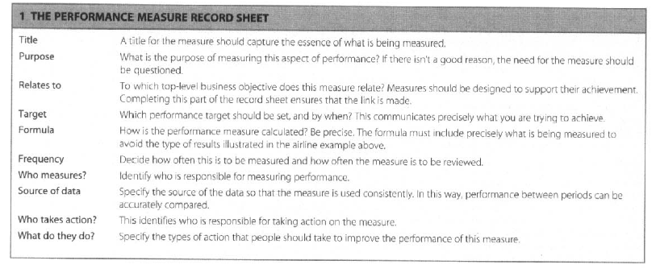

Figure 11 The Performance measure record (Bourne & Neely 2002, p30).

Bourne & Bourne (2002) state that;

“A good measurement system will help you achieve success in five ways:

Establish your current position,

Communicate direction,

Stimulate action in the most important areas for your business,

Facilitate learning,

Influence behaviour.” (p8).

Again the area of communication is discussed. Communication of the plan is vital. If it is only read by a few people in the organisation then it will not be effective (Bourne & Bourne 2002).

Bourne & Franco-Santos (2010, p30) have developed a model to help organisations set their targets:

Content removed for copyright reasons.

Figure 12 The target setting wheel (Bourne & Franco-Santos 2010, p30).

Communication is a key theme here and most of the managers in their research thought they communicated well whereas their staff did not (Bourne & Franco-Santos 2010).

Bourne & Franco-Santos (2010, p30) have produced a checklist for good target setting to make sure targets are:

1. Clearly defined
2. At the correct level – not too high or too low
3. Shared out appropriately
4. Consistent with the strategy and economic environment
5. Based on rigorous data – not just on past history
6. Reviewed regularly
7. Owned
8. Supported by a specific action plan.

This is a lot of work but as the authors say “If you can’t spare the time and effort then maybe it would be better not to set targets at all” (Bourne & Franco-Santos 2010, p30).

Performance measurement practices are often centralised. Jääskeläinen & Laihonen (2014, p355) comment that when choosing what to measure “strategic choices are often made without careful consideration and/or comparison of alternatives”. They also believe that “Academic literature has only a few studies investigating how public performance approaches have evolved to meet the changing information needs of public managers” (Jääskeläinen & Laihonen 2014, p355).

Jääskeläinen & Laihonen( 2014) found that the centralised management teams provided details of what to measure. Although effort was made to improve qualitative measures it very much depended on the individuals rather than it being a systematic approach.

(Larimo et al. 2016) feel that relying purely on traditional accounting measures is not enough and they want to see measures that show the effectiveness and competitiveness of the organisation.

Balanced scorecard is regularly used at the top of the structure of an organisation but often it does not flow down. Measures are tailored to the processes as they flow down the organisation (Jääskeläinen & Laihonen 2014). This is how it should work but often the communication breaks down (Bourne & Franco-Santos 2010).

Orr & Vince (2009) refer to local government as being culturally complex. How much of what Local authorities do today are traditions from the past? Often these “traditions” are embedded in the organisation and it becomes increasingly difficult to change. Once some measurements are calculated and used it is hard for staff to drop them. They are comforted by the numerous measurements they calculate.

So much that Evans (2017, p35) sees local government actors “develop a complex solution to an issue without the pragmatism or common sense to strip out the irrelevant and keep things simple”. Balabonienė & Večerskienė (2015, p315) feel that public sector organisations are “oriented to the processes and not the results”. Going through the motions of a regular process is safe and easy to measure that the process has been completed.

Evans (2017, p35) wants a “performance culture based on regular specific feedback and good conversations rather than a sterile, box-filling exercise once or twice a year”. Just measuring what we have always measured will not produce any different results. Jääskeläinen & Laihonen (2014) support this view that it is a tick box exercise rather than a useful management tool that can support the organisation.

The ways the results are measured need to be consistent otherwise the results will become meaningless (Bourne & Bourne 2002). If people in the organisation do not believe that the methods of data collection are valid then the targets will lose their value.

Another issue with the results is the accuracy of them. If the measurements are inaccurate or inconsistent then staff will not be committed to them and become less motivated to achieve them if they know they are wrong. Elg (2007 cited in Antonsen 2014) likened the measurement of results with no communication to anyone like measuring the outside temperature. You can measure it but you cannot change it.

Arnaboldi et al. (2015) feel that there is a lot of research on performance measurement but it has not achieved anything or produced any solutions for the issues of performance management. “We are fabulous at firing arrows into walls, drawing targets around them and then saying it was a brilliant shot” (Ezzamel et al 2007 cited in Arnaboldi et al. 2015 p9).

The public sector is so varied as it covers 196 countries which are all shaped differently with different influences (Arnaboldi et al. 2015). Often it ends up with results focussed measurement systems. Arnaboldi et al. (2015 p2) believes we have created a “performance measurement industry”.

It has long been known that the use of financial measures can create dysfunctional outcomes. If performance measures follow the strategic goals then benefits have been seen in recent research (Marginson et al. 2014). Marginson et al. (2014, p64) also suggest that “richer and more complete feedback about operations and results” come from measures that are non-financial.

## **2.16 Leadership**

What is meant by leadership in local government? Many theories focus on the individual skills and characteristics of the person in charge. What is the style of the leader? What behaviour do they exhibit and what tasks do they perform? (Bochel & Bochel 2004). Quite often the leader is at the top of a very structured hierarchy.

The present style of management in local government can be described as “command and control” (Seddon 2008, p47). Where the command comes from the top of the organisation due to the hierarchy and then the senior managers control everyone in the organisation with budgets and procedures. Seddon describes this as a way the organisation is structured and the way the work is designed and not about the personality traits of the managers (Seddon 2008).

Another method of control is the Symbolic process where the control process is based on shared values and is embedded into the organisation thus more people are involved (Tegarden et al. 2003). Evans (2017, p35) supports this view and wishes we could have;

“guidelines to replace lengthy policies and we empower our people to take responsibility, decisions and actions knowing they share our values and vision … it’s time to challenge the need for all encompassing policies and unnecessary rules”

Often local governments are criticised for being bureaucratic with too many procedures and hurdles to jump over before anything can be achieved. Weber produced a theory of bureaucracy which is spookily close to what happens in local government today:

1. “Clearly defined division of labour and authority
2. Hierarchical structures of officers
3. Written guidelines prescribing performance criteria
4. Recruitment to offices based on specialism and expertise
5. Office holding as a career or vocation
6. Duties and authority attached to positions not persons” (Weber cited in Seddon 2008, p49).

This type of thinking leads the organisation to be split into function and similar roles linked together. Although this does lead to economies of scale it also leads to worker boredom as the jobs become narrow and monotonous (Seddon 2008).

The local government act 2000 initiated reform which prioritised the cabinet and leader system. The committee system only remains in small authorities. Gains et al. (2009) believe that leadership is becoming stronger. The leaders of cabinet systems are being given authority to act on their own i.e. they can choose their own cabinet and the portfolios of each member. The committee system is often cited as being a slower way to make decisions but it does include more input from back benchers. How leaders deal with their partnerships externally often depends on how strong they were internally. Those leaders with a clear majority could spend time looking outside the organisation and developing partnerships whilst those with a slim majority or a coalition concentrated more on gaining internal support for their policies than creating strong external relationships (Gains et al. 2009).

Thrasher et al. (2015) found that only a very small fraction of councillors were capable of carrying out policy making and leadership. Three quarters of councillors concentrated on their constituency roles and did not specialise in any particular area.

Gains et al. (2009) concluded that stronger leadership did indeed produce and deliver more than weaker forms of leadership in terms of service delivery and customer satisfaction.

However does stronger leadership mean more entrepreneurial leadership? Gains et al. (2009, p92) comment that this style is needed for the “economic future of our cities” and they feel that leaders are more facilitators and networkers than the old style “Boss”.

When you think of entrepreneurs you immediately imagine business people creating new and exciting businesses and products like James Dyson or Richard Branson. However entrepreneurs are now starting to emerge in the public sector. Previously local governments relied purely on local taxes and central government funding as their income streams. Nowadays as austerity hits, local leaders are having to act smarter about the way they obtain funding (Zerbinati & Souitaris 2005).

Chief Officers need to look for opportunities to make some income. For example land negotiations and using the ownership of “ransom strips” to enable large businesses to bring their business into the area.

However entrepreneurship is often about coercion and domination which does not really fit with the democratic ideology of a local authority. It also implies it has a “disrespect for tradition” (Zerbinati & Souitaris 2005, p45).

Nevertheless having an entrepreneurial leader does help the community by encouraging new businesses and supporting existing businesses to move to the area and join the community. The entrepreneurial skill sets enables them to “spot market opportunities” (Zerbinati & Souitaris 2005, p46).

Hamilton (2017, p35) asks the question “do chiefs need the X Factor?” With all the different pressures and the need to be more “business like” do chief executives now have to be “Council entrepreneurs”? (Hamilton 2017, p35). Certainly the skills that are needed today are very different from those needed a decade ago. Councils are using consultants and business advisors due to the lack of these skills in house and often these come at an expensive price which can be ill afforded. To have a chief executive with these skills starts to look like necessity rather than a desire (Hamilton 2017).

Seddon (2008) believes managers and leaders should understand their organisation as a system and this will lead to better performance. He suggests a check list:

Content removed for copyright reasons.

Figure 13 The Vanguard model for check (Seddon 2008, p79)

Firstly find out what your customers want from you and thus find out what is the purpose of the organisation. Secondly how often do customers call and when do they call. Find out what matters to them and what is important. Thirdly does the system allow the customers to get what they want or are they just passed from one officer to another. Fourthly Seddon suggests that managers go and see what happens rather than just asking their staff what happens. If they see the issues for themselves they will have a better idea of how to solve them. Step five is to understand what is causing the waste, the extra phone calls and queries etc. Finally the managers can then think about the system and about the flow and work out the best way forwards (Seddon 2008).

Hutchinson et al. (2014) challenge the fact that CEO’s are impartial. They should be non-partisan but increasingly CEO’s are being recruited in the image of the elected members. The members are comfortable with a CEO that they can relate to and understand whether or not this is the best for the community.

“I am not sure why we are so surprised at some of the CEO appointments. When we look at most councillors, they are a group of grey haired old men who would prefer to talk about roads than needs of a really diverse community” (Hutchinson et al. 2014, p188).

Hutchinson et al. (2014) debate the lack of women in leadership roles. They discuss the stereotypical styles of men compared to women. There is very little research on this within local government. Quite often local government is seen as an old boys club within both the officer leadership domain and the political leadership. It becomes a vicious circle as women cannot access the male only dominated networks. Women usually end up in more caring and compassionate roles like administration and communications. These are not seen to be the experience needed to be a CEO.

Bochel & Bochel (2004, p49) believes there needs to be a “critical mass” of women in senior roles before they can make an impact. They suggest between 30% and 40%. Until this mass is achieved then the women are seen as a token and they do not really have a chance to influence the leadership style of the organisation.

## **2.17 Quality of staff.**

Lawrence et al. (2008) feel that measuring staff satisfaction because you care is very rare. Often managers are tasked with completing statistics about their staff and a staff satisfaction survey is used. Dissatisfaction amongst employees will influence the way they work and the way they interact with others. This negative attitude can spread and it becomes dangerous if it impacts customers and in the case of local government, the public.

Unhappy staff can become angry and rude. Often managers are not trained to cope with this (Adams 2007).

Content removed for copyright reasons.

Figure 14 Signals in the organisation (Lawrence et al. 2008, p18).

The figure above shows some of the signals that can appear to show that all is not well with the staff. Many managers know roughly what is happening but “research is the catalyst to take action” (Lawrence et al. 2008, p18). Lawrence et al. (2008) believe that if the staff take part more often in the research then they will engage more than if it is just a one off. Managers can also undertake mirror research where they try to predict what the staff will say to see if they really do know what is going on.

It is important to find out what motivates your workforce. If people are involved in setting their own targets and finding their own solutions to issues then they feel more motivated and they end up working harder and being more productive (Adams 2007).

Local sector organisations have to be more creative than the private sector in setting goals as they cannot use perks like the private sector can such as bonuses, free holidays, gym membership etc. Intrinsic motivation is needed for staff to be happy that they are being held responsible for their own actions and results (Adams 2007).

Managers often think their staff need constant monitoring and will only work for extrinsic rewards, along the lines of McGregor’s Theory X. Staff managed in this way will react as per theory x and it becomes a vicious circle (Seddon 2008).

Jackson believes that success will be measured by “wellbeing and happiness not material possessions” (Jackson cited in Shaw 2012, p290). However it is an easier task to measure possessions than the feeling of happiness.

A performance management system should ensure that the goals of the organisation flow down to all individuals for everyone to work together and to support accountability (West & Blackman 2015).

If the balanced scorecard, for example, is presented as a top down approach then teams and individuals will be given targets and will be constrained in their creativity. Antonsen (2014) does not discuss what the impact of the scorecard has if the individuals are party to its creation. What is discussed is the balance between employees being told what to do and finding things out for themselves. Finding out can encourage more creativity.

Training your employees and supporting them to learn is seen as a positive step towards competitive advantage. Additional value comes from when employees are able to reflect on their own work. Antonsen (2014) goes onto to then question whether this critical reflection can work in scenarios with multiple objectives such as the balanced scorecard.

If employees are not asked their opinions on key areas Antonsen (2014) believes they will shrink back to perform their operational tasks but they will not commit and join in with the organisation. In effect alienating themselves to task performing roles as opposed to strategic thinking. However imposing rules and new procedures means employees have little time or scope to complain.

Antonsen (2014) suggests that employees cooperate with the balanced scorecard because of pay and bonus incentives. The case study that Antonsen (2014) reports on is based in a bank and they have used bonuses from the start. This is very different to the public sector. They have also mentioned that the balanced scorecard has increased stress and workload levels. Antonsen (2014) found that the balanced scorecard increased the levels of formal controls the senior managers had but that it often was not very effective as staff did not change and continued to use their existing work practices.

Antonsen (2014) also discovered that although the balanced scorecard is a living document and can be changed the changes should not be sudden or quick especially if bonuses are provided on the outcomes. Staff do not like the quick changes and can become confused about what the aims are.

However there needs to be the desire to get started and have a go rather than to try to wait for all measures to be perfect. It will never be the right time and the organisation will be left without a plan or framework if they were to wait for all issues to be solved before commencing. Learning through the practical experience is invaluable and leads to a better plan in the end (Cartwright 1975).

Antonsens (2014) study also supports the view that if staff are involved with creating the balanced scorecard and its measures they will support it more than if it is imposed on them. Also employees should then collect the data in a more consistent way to make it more useful and accurate. The conclusion made by Antonsen (2014) is that the balanced scorecard increases the use of formal controls and decreases the opportunities for creativity by staff. Again this case study supports the need for further research to understand the impact the balanced scorecard has on organisations.

Employees are “the single most crucial element to any system as it is their behaviour that will determine the achievement of the organisations goals” (West & Blackman 2015 p74). Fletcher-Brown (2017), supports this view with a particular focus on middle management. Middle managers are always sandwiched between the senior leaders and the staff. Fletcher-Brown's (2017, p22) advice to senior leaders is look after your managers as “Middle managers make sense of the vision you sell to your organisation and can determine what your leadership means to their staff”. They are close to the staff that deal with the customers. They know and understand the mood of the organisation and if they deliver a message “I’ve been told to tell you” rather than with empowerment and belief that it is the right message the results will be vastly different. Middle managers need to fully believe in the senior team and be supportive otherwise nothing will change or be accomplished as staff begin to work against the goals whether blatantly or subtly.

## **2.18 Practical performance measurement issues**

The theory of performance measurement sounds simple and easy to implement and then you have an organisation that instantly becomes successful – no? What are the issues that affect organisations and their use of performance measurement tools? “Why do some organisations outperform others?” (Tegarden et al. 2003, p133). Just having a performance measurement system does not automatically mean you will become successful or better at what you do. “Measurement just keeps the score,” (Bourne 2008, p68) it is how you change the way you work and improve your processes that will lead to the overall performance increasing.

It is hard to decide on what to measure. Often it is easier to take the measures that are already collated and try to fit them around a tool like the balanced scorecard. This then misses the key point of linking the strategy to the targets. This can also happen when departments are able to create their own targets and often miss the vital strategy link (Bourne 2008).

Managers look at the organisation and try to allocate resources. What needs to be done? How many staff are available? Timed targets such as how fast is the phone answered becomes a major focus. However the question here should be what value does the customer receive rather than how fast can an operator answer the phone? Often in these targets very little is mentioned about the quality of the answer that the customer received (Seddon 2008).

This type of thinking is very similar to Activity Based Costing. Look at what staff are doing and what queries they are dealing with. For example if the content of the incoming calls are analysed it may identify a problem deeper within the organisation. If that problem is fixed then the number of calls will decrease. This means that value is added as there is no value answering a call quickly to the same person that phones 20 times with the same issue (Drury 2015).

Councils need to find out why people are calling and ensure they are not “wasted” calls. However central government are busy issuing procedures and guidelines that mean each council has to follow the same path and not investigate what the specific issues are for their organisation (Seddon 2008).

If the organisation understands what is important to the customer and gets it right first time then the customer has an excellent experience. The organisation then only has to deliver the service once. However if the organisation gets it wrong then the customer is unhappy and has a poor experience. This will often result in more time being used by staff to correct the issue and sort out the queries. By understanding the customer and setting targets that reflect this the organisation becomes more efficient. The issue with this is that the customer cannot walk away from a council, they are trapped and thus local councils are not as focussed on delivering an excellent service. It can be easier just to record the time taken to answer the calls rather than root out the origin of the issue (Seddon 2008).

Nilsen (2007 cited in Antonsen 2014) believes that the balanced scorecard misses out on analysing trends because the data collected is focussed on short term results. However Bourne (2008) feels that management need to have information yet all they have is data.

The issue is to get the targets right on the first place. Antonsen (2014) found that in the last five days of the measurement period the staff were focussing on achieving their targets and not achieving increased sales. The skill in creating the scorecard is to make sure these are the same.

Also performance measures are very often linked to employees own performance in their appraisals. In the private sector bonuses can be linked in as well. Staff focus on the targets and become excellent at achieving them and hitting their KPI instead of actually doing what is right for the organisation, similar to the example above (Bourne 2008).

Often studies focus only on the top management team so there are gaps in the research (Tegarden et al. 2003). Communication of the strategy and the measures is vital. Bourne (2008) believes that organisations that have branches are able to do this better. Effectively they can take one version and deliver it to all branches for example a chain of stores. In a large organisation without this structure it becomes more difficult to cascade the information right down to the bottom.

The staff of an organisation are key to performance and all staff members should be engaged and motivated to work for the good of the organisation and not just finding a work around to meet their targets. Data manipulation does not usually have a positive effect on the organisation. There are many examples in the public sector to support this for example NHS waiting times (Bourne 2008).

Organisations also wait until they need to save money or processes have deteriorated before they start to manage the issues through using the information from the measures. The key finding from Bourne's (2008) research is to take a leaf from the Japanese companies rule book of kaizen performance and look to continually improve the performance at all times.

Often when performance measurement is analysed in the public sector it is linked to processes and operating procedures rather than the effectiveness of the outcomes. Nath & Sharma (2014, p3) feel that sometimes performance measurement systems are often “disconnected from day to day activities”. The focus is slowly changing from strict procedures restricted by red tape to a more outcomes focus and information useful to management.

Downsides to performance measurement are the increase in bureaucracy and administration. The activity of collecting the data becomes the focus and not what is causing the actions (Lewis 2015).

Lewis (2015, p7) notes that there are many unintended consequences of measuring performance. Tunnel vision which involves focussing on the measure to the exclusion of everything else. Sub optimisation and myopia where staff focus on the local and short term targets at the expense of the overall strategic view and the long term. As commented above, measure fixation, so looking at the measurement rather than the activity. Manipulation of the data and being able to use a target in a different way to what it was intended as well as gaming. Finally the view that measures stop innovation.

The final point is supported by Seddon (2008) when discussing the procedures at Toyota and the fact that for years the managers refused to document their processes due to the fear that they would be set in stone and not be able to be continuously improved. Cartwright (1975, p48) supports this by commenting that the plan is not to be seen as a “straight jacket” and members need to be able to react and go with any new opportunities that present themselves.

## **2.19 Political Interference**

Most issues with performance measurement in the public sector are based on “conflicting influences […] political interferences and ambiguous objectives” (Nath & Sharma 2014, p2).

Performance measurement should be a logical and rational process. Identifying criteria to achieve and then measuring the results to see how much has been achieved. However Lewis (2015) believes many complex issues lie behind the process.

“If information is power the performance measurement is surely tightly linked to the creation and use of power” (Lewis 2015,p1).

Governments worldwide are fascinated by performance measurement. Trying to prove that the bodies they fund are providing the right services and are doing what they are supposed to be doing. Many questions are asked about the technical data and the goals of the organisation. However the key question is who chooses the measures? Who decides who wins and who loses? (Lewis 2015).

How is this power used? Is it to confirm the existing hierarchy and structure? Thus giving directors more power. Is it used as a control mechanism? Budget funding will follow the decisions. So linking into the transparency argument the public sector has lost the trust of the general public so now finds the need to measure everything to prove that it is using its resources wisely. In times of austerity the public need to be reassured that the allocation of scare resources is fair. The politicians then hope the public will continue to support them (Lewis 2015).

Central government will also use the framework of performance measurement to change the behaviour of local agencies. The national data set was an example of central government dictating what the local areas should focus on. “Measurement is assumed to change behaviour” (Lewis 2015, p6).

## **2.20 Elected Members**

Elected members or councillors as they are also known are voluntary and part time. Their roles have been described as “policymaker, scrutineer, representative and community leader” (Wilson & Game 2006, p262). They spend on average 79 hours per month working on council issues (Thrasher et al. 2015, p714). As noted in the leadership section many are content to be back benchers and look after their residents. Councillors in a more competitive ward will spend more time in surgeries and community meetings than councillors in a ward with a large majority (Thrasher et al. 2015).

The most popular reason for becoming a councillor is to “contribute to, improve or serve society” (Ritz 2015). However there are many other reasons and some of them include self-interest, networking opportunities, self-importance, closeness to important people and community recognition. These are not all for the good of the community (Ritz 2015). However the remuneration is negligible (£6,000 per year for the author) so it will not attract people that need to earn a living. More importantly it attracts very few young people. As Hutchinson et al. (2014) comment the councillors mainly have grey hair.

What skills the councillors have can vary hugely. Thrasher et al. (2015) found that women and retired councillors spent the most time working on council activities. Ritz (2015) found it also depends on how ambitious the politician is. If they plan on having a political career then they put more effort in and tend to be more skilled. They also put more time and effort into political party activities as well.

Women are known to be under represented in government at all levels. It is slowly improving. From 15% in 1973 to 26% on 2000 in English Shire districts (Bochel & Bochel 2004, p37).

McGuinness (1978, p3) asks the question “have elected representatives any control over policy? In theory the council decides the policy and the officers, the paid employees, deliver it. However it is not that simple. The officers are immediately in a position of power as they have the expert knowledge. Quite often policy goes through on the nod because the members do not really understand it and do not have the ability to question it. For example a several million pound budget will get approval in five or ten minutes with very few questions yet smaller more insignificant charges will be challenged with a long debate. Think of leisure centre fees, burial rates, etc. These are details that members are more familiar with and will actively test the officers (McGuinness 1978).

However elected members have to do what the public wants or they will be voted out of office come the next election. Although officers have the power the members have to agree and vote for the policy in the committee meeting. If officers have too much power and members are just nodding items through then the members may not be of a good enough standard and “ it is the fault of the councillors for not taking enough interest” (McGuinness 1978, p4). Cartwright (1975) supports this view by commenting that power will revert to officers if members do not participate with energy and interest.

## **2.21 Themes and critical success factors from the literature**

There are several themes coming out from the literature review.

**Stakeholders & Communication**

The main one is the number of stakeholders the LGA has compared to a privately owned organisation. This then translates into multiple objectives and so the issue is which stakeholder does the LGA satisfy. Can they satisfy everyone? (Sharma & Gadenne 2011). Finding out who the stakeholders are and what they want is a tall order. Communications are vital and so is finding the right method to reach each group. Once these have been identified they then need to make sure if the requirements of all can be satisfied or whether any conflicts need to be resolved. A balanced approach to ensure no stakeholder is left out.

**Strategy**

Following on from this, with the number of objectives, how can these be effectively translated into targets for all the staff of the organisation. The organisation must have a strategic vision in order to then progress to working out how to achieve it (Dreveton 2013). The strategy mapping is key to the success of the balanced scorecard. Sharma & Gadenne (2011,p176) refer to this as the “cascading of the LGA vision” (p176). This also links into the communication of the scorecard down to every last employee. If the organisation does not know what their stakeholders want how can they map their strategy to achieving and satisfying those needs? You get what you measure is the theme of Bevan & Hood's 2006 article of “What’s measured is what matters”. Unwanted behaviour can arise from poorly constructed targets so it is imperative that the targets drive people forward to the goals the organisation is seeking.

The organisation also needs to determine their core values and ensure these are implicit in the goals and measurements to ensure they are followed at each level.

All staff and the community need to be clear on how the strategy adds value and what are everyone’s roles and responsibilities to achieve the outcomes.

**Leadership**

Leadership is another key factor that drives the success of the balanced scorecard and performance measurement systems. A strong leader who believes in the scorecard and who can motivate the whole of the workforce can be instrumental in achieving success (Woods & Grubnic 2008). If the motivation is there from the senior team the next key point is the communication of the goals to the workforce. If all the staff know what the goals are and how they are expected to achieve them then this will encourage them to work together. If their manager does not believe in the framework then the staff will not have the motivation to make it succeed. However one way around this is to create incentives and rewards based on the scorecard performance measures. So another theme to look at is are there any rewards for staff linked to the scorecard (Sharma & Gadenne 2011). This is an acceptable approach for the private sector but there are very few rewards to be found in the public sector.

Another theme related to leadership is that the leader has inspired all the staff and in particular the middle management this also links into the communication of goals to the out reaches of all staff. The quality of middle management is key to the messages being received as they were intended.

There is little empirical evidence that the balanced scorecard does improve performance. There are several one off studies where researchers have investigated individual public sector organisations however ones based in UK local government are very few and far between. So with each organisation being different to find a control group for a study would be extremely hard thus the individual case study method is often chosen and subjective judgements are needed to decide whether or not the scorecard was successful. Kaplan (2001) found that those balanced scorecard implementations that failed did not have the support of the senior management team. They give an example of an organisation where only the CEO was involved. As soon as the CEO left his replacement scrapped the balanced scorecard. No one else on the senior team was involved so there was no opposition to changing to another performance measurement method.

(Woods & Grubnic 2008) support this view with a different example where Hertfordshire CEO, after a successful implementation, moved to Jersey and implemented the BSC again with a new senior leadership team. The key message here is that is has to be a senior team effort and not just an individual.

So leadership is key but what makes a good leader? Is it their qualifications, experience or reputation? How credible are they and are they “rated” by others?

Cartwright (1975) believes that the leadership from members is important as well. Members need to be determined to see it through and decide on the objectives and key priorities.

**Transparency & External Perceptions**

Everything that a council does is subject to public scrutiny. Nothing can or should be hidden as there should be a level of transparency to give the public confidence and faith that the money is being spent wisely.

How the general public view the organisation is important so that the public have the confidence in the council. The public need to trust the council and work with them in the community.

The communication to the stakeholders has to be consistent and fit for purpose. Do the stakeholders feel informed and know what is happening in the organisation?

**Austerity, Resilience and Business-Like**

Councils have been surviving for quite some time with resources shrinking each year. Burton (2017, p10) comments that “austerity has dominated UK politics for the last seven years”. Even though there was very little discussion about it at the recent national election and it didn’t appear in the manifestos that doesn’t mean to say finances will increase. Austerity is here for some time yet.

This means that councils are having to look for other ways to balance their books. This then brings on the theme of resilience. How long can they last before they will need to cut frontline services? How can they be entrepreneurial to generate new income? This brings in the “business-like” theme where councils are having to look at what their customers want and be more creative about how they can deliver it.

Copus (2017, p20) believes that it is time that local government had its own manifesto. He would like “councils to be financially independent of central government and to have the legal power to raise tax from a range of sources”.

This would enable councils to become more business-like as they would be in control of their income and not waiting to see what hand out they will receive from central government. This could potentially work well in affluent areas but in areas where the economic climate is not vibrant and unemployment is high the question would be who and what would they tax. At present there is a redistribution of income from more affluent areas to poorer areas via the business rates. For example at present district councils are not able to keep all of the income they receive from business rates in their areas.

**Balanced Measures – What do we choose?**

It is very easy to say we must find the correct measures but in practice it is a lot more complicated.

Bourne (2008) queries the usefulness of the academic research in such practical areas as performance measurement. Academics talking to themselves, via journal articles, in a language only they understand will not solve the problems. However working with practical managers will increase their knowledge of what is actually happening and how things are done in the field. More research is needed on longitudinal studies rather than surveys to really understand what is needed.

What measures are suitable for a local government authority? Who should be the ones choosing them? Leaders, staff, or combinations of both. The literature talks a lot about strategy mapping (Kaplan & Norton 1992) but how in practice can this be achieved successfully?

What to measure is also vital. Not just using measures that are already in place and easy to calculate. Really thinking about the measures and reflecting on whether they will drive the desired performance.

## **2.22 Summary table of the themes from the literature review.**

From the literature review the themes can be consolidated in the following tables and also the indicative research questions can be identified.

|  |  |  |
| --- | --- | --- |
| **Themes** | **Critical Success Factors** | **Indicative Research Questions** |
| Stakeholders & Communication | * Clear understanding of stakeholders requirements * Balancing the requirements * Solving any conflicts * Creating a robust communications method for each type of stakeholder. | * Who are the stakeholders? * How do you know what they want? * How do you decide to prioritise their needs? * How are any conflicts dealt with? * How do you communicate to each set? |
| Strategy & The Corporate Plan | * Creating a vision & mission * Clear core values * Creating a strategy * Creating a strategy map * Sustainability * Roles & Responsibilities * Value adding to the community * Citizenship | * Is there a vision or mission? * Is there a core strategy? How was this created? * Is this mapped? * Is this signed up to? * Is the strategy sustainable? How is that determined? What criteria is used? * What are the organisations values? * How far do these values penetrate down the organisation? * Are roles & responsibilities clearly defined? Who is responsible for what? * How will the strategy add value? |

|  |  |  |
| --- | --- | --- |
| **Themes** | **Critical Success Factors** | **Indicative Research Questions** |
| Leadership | * Leadership performance * Senior Management Team buy in * Executive & officer roles * Skills & business experience * Public duty * Quality middle management | * Who leads, Officers or members? * What is the performance record of the CEO and senior management /leadership team? * Are senior team all bought into the strategy? * What skills do they bring to the team? Any experience in business? * How do they fulfil the role of public duty? * How committed and proactive are the middle management team? |
| Transparency & Perception | * Building trust * Public & private partnerships * Sense of community * Communications strategy * Communications mix * Internal marketing | * Do the public trust the authority? * How is that trust built? * Is the authority seen as part of the community? * Is the community clear on what the authority does? * How does the authority engage with businesses and the voluntary sector? * What communication methods are used? Do they know which methods work? * Within the organisation what communication methods are used? * Do employees know what is happening at the leadership level? |

|  |  |  |
| --- | --- | --- |
| **Themes** | **Critical Success Factors** | **Indicative Research Questions** |
| Austerity, Resilience & Business-like | * Long term planning including contingencies * Robust * Resilient * Partnerships & collaboration * Process re-engineering * Business Excellence models * Business like structure, approaches & culture * Independence & the ability to survive * Community spirit | * How far ahead does the organisation plan for? * Are there any contingency plans to help combat austerity? * How robust and resilient are the finances? * Are there the correct skills in the organisation to survive? * What is the organisation doing to become more independent? * Are processes bureaucratic? Is anything being done to improve them? * Do they use terms like business-like? * What is the community doing to work with the organisation? |

|  |  |  |
| --- | --- | --- |
| **Themes** | **Critical Success Factors** | **Indicative Research Questions** |
| Balanced Measures | * Strategic * Empowering * Encourage positive behaviour * Avoid gaming * Balanced across financial & non-financial * Measure the future * Address stakeholder requirements * Community building * Supporting good citizenship * Wellbeing of employees and the community * Reward & recognition * Peer review * Policy of reduction * Personal development * Political * Regulatory & statutory with discretionary * Long range, medium & short term * Consensus * Over measuring. | * What sort of measures are used? * Is there a need to measure? * Is there an obsession with measurements? Over measuring? * Are they strategic? * What behaviours come out of this? Any that are dysfunctional? Any gaming? * Are the measures balanced between qualitative and quantitative? Internal & External? * Are they measuring what the stakeholders want? * Who chooses the measures? * Can the community relate to them and understand them? * Are they the statutory duties or are they purely discretional? Maybe both? * How far ahead do they measure? Just a financial year or farther ahead? * Are the measures political? Is there any dissent around them? * Are they used to evaluate and reward staff? * Are they used to save money and reduce costs? |

## **2.23 Conclusion to the literature review**

New Public Management reforms focusses, amongst other ideals, on the beliefs that the public sector and the private sector can be managed in the same way and that strategic management tools such as mission statements and corporate plans can be used within the public sector just as well as the private sector (Hoque 2003). Along a similar theme Christensen (2005) has investigated the influence of large consulting firms on the way the public sector is trying to imitate the private sector on accounting issues mainly accruals accounting. His research is based predominantly on Australia and the introduction of accruals accounting from cash based accounting. However the key theme from the consultants was the “belief that public sector accounting systems should converge on private sector accounting” (Christensen 2005, p467). Jackson (2011) believes that performance measurement in the public sector has improved over the last thirty years however he feels that the private sector does not have the answers to pass across to the public sector. There are too many firms failing in the private sector for them to have all the answers.

So how do LGA’s use performance measurement systems? Should LGA’s be striving to be like the private sector or do they need a system of their own?

There has been extensive research carried out in New Zealand regarding public sector reform and the literature suggests they are the leaders in this area (Ross 2011). However they are still no further on in the strive to find an answer to the measurement question.

The gaps in the literature appear after the public sector has been stated as being more complex than the private sector. Hoque (2014) supports the fact that more research is needed in this area, to link the objectives of the stakeholders with the targets for the organisation.

There is still not enough evidence to see what measures work? Jackson (2011) comments that it needs longitudinal studies to work out what makes a policy work. However politicians are only focussed as far as the next election so invariable they will ensure they have some “quick wins” in the short term to stay in power.

It is difficult to ascertain what effect performance measurement has on an organisation as there are many other factors that impact on the outputs. Performance measurement is used for “communicating direction, providing feedback on current performance, influencing behaviour and stimulating improvement action” (Pavlov et al. 2017, p432).

Councils will have to make the decisions of what to measure and how this will affect the behaviour of their staff. This is crucial as dysfunctional behaviour can easily occur if a person follows their targets religiously. Choosing the targets that provide goal congruence and not just measuring because it is easy to do. Clearly the right things need to be measured and these will be different for each organisation. A rule of thumb often used by management accountants is that is should cost less to collate the information than the benefits that the information can bring. Hoque (2014) comments that the balanced scorecard is the best we have at the moment and we will continue to use it until something better comes along.

There is a raft of literature regarding performance measurement but not so much regarding the public sector. More research needs to be done especially regarding what performance measurement tools the public sector use, what they measure and how this affects behaviour. The few ad hoc case studies that exist are limited as to what conclusions they can make for the sector in general.

This literature review has looked at the theory of how LGA’s should use a performance measurement system. The case studies within this thesis will investigate what actually happens in three district councils.

We can now move onto to analyse what research methods are suitable for this study.

# **Chapter 3 – Research Methodology**

Rather than producing a full chapter on methodology because it is formally required in a research thesis, Silverman argues that a heading of “The Natural History of My Research” (Silverman 2010 p335) would be a more apt title. Many methodology chapters are good cures for insomnia and can be extremely dull. However if the chapter is approached like a detective and all the “false leads” and “dead ends” are discussed this can make for a more interesting and robust discussion (Silverman 2010).

This chapter will look at the philosophy, strategy and choices of methodology for accounting research in general and then also the current research objectives.

Smith (2015, p1) begins his work with the comment that “accounting researchers are parasites who prey on the work of others to generate their findings”. This is a somewhat harsh comment however there is truth in it that accountants generally have adapted their research from the social sciences. Brown & Brignall (2007) support this by commenting that accounting tries to “quantify an organisation” and the way this is done is based on the social and political beliefs of those creating the format. Therefore research is often designed with mixed methods to cover all the different aspects of accounting (Brown & Brignall 2007, p34).

Gage asks if social research actually discovers any new information at all. Is it all just common sense and could anyone come to these conclusions without conducting any research? If the question of “Is it obvious?” is not asked then researchers could lose their credibility and also their funding (Gage cited in Hammersley 1993, p226). This is supported by the argument that all research needs to be validated in order for it “to be taken seriously” (Lukka & Modell 2010, p463).

## **3.1 Philosophy**

If we are to look at philosophy the question Williams & May (1996, p4) pose is “What is philosophy?” Most definitions will have some mention of abstract ideas. For practical accountants this is a challenging question. Generally there is not enough time to look into abstract questions and the research is usually aimed at their company with a direct question in mind. However the general aim is the same, to uncover new knowledge.

Wisker (2008) states that a researcher needs a framework in order to make sense of the results of the study. Saunders et al. (2009) agree that the research paradigm needs to be chosen before the research can begin. They have developed their “onion” that peels away the layers from research philosophy right down to how to collect the data (Saunders et al. 2009, p108).

Cryer (2006) believes there are many different frameworks that researchers can use to begin to develop their ideas. Researchers have many names for essentially the same paradigms so it becomes difficult to work out the actual number that exists. Cryer (2006, p76) narrows it down to two, which she defines as the “traditionalist and interpretivist”. This is often linked directly to quantitative and qualitative research respectively (Brown & Brignall 2007). Wisker (2008. p67) feels this is too simplistic and discusses “structuralism, postmodernism, poststructuralism and constructivism” in addition to the above two. However Vaivio & Siren (2010, p138) support Cryer in that in management accounting “We have subjectivist and objectivist or interpretive and positivist research approaches […] these can be conceived as two different research paradigms”. They also suggest that sometimes it is not a conscious decision as to which paradigm to adopt especially for a junior scholar it “is usually the only available option to hand that holds some appeal” (Vaivio & Siren 2010, p138).

The way the researcher views the world is important as this will have an effect as to how the data is collected and interpreted (Saunders et al. 2009). To undertake a research project looking into the processes of a manufacturing plant will be different to one looking into the motivation of the workers. Each project is valid but the data will be interpreted in a different way. Saunders et al. (2009) believe that the philosophies that are discarded are as important as those that are chosen as it is vital that researchers can defend their choices. However Brown & Brignall (2007, p32) challenged this by researching the same issue, to “evaluate accounting and management practices in a UK university central administrative service”, with two different teams of researchers with two different research paradigms. They wanted to see what the different approaches could bring to the outcomes. They discovered that the “dual approaches complemented each other and challenged each other” (Brown & Brignall 2007, p32). However they also realise that the different paradigms are always competing against each other and writers such as Zimmerman firmly states that “only economics based research has any status” (Zimmerman 2001 cited in Brown & Brignall 2007, p36). Scapens (1990, p264) believes the neoclassical economic theories “were developed by economists to predict general patterns of economic behaviour”. The theories produced can say how prices can change but not what the price will be for example. So these theories would be useful in looking at trends in accounting but not useful for trying to assess individual behaviour (Scapens 1990). Social science research is interested in the reason why people act in the way they do. The research is more qualitative but nonetheless as valid as research defined with variables (Patton 2002).

Ontology is all about the essence of being and the nature of reality, the “assumptions about the way in which the world works” (Saunders et al. 2009, p110). Do we see things in the same way or do different people have different perspectives on reality (Wisker 2008). Ontology can be further divided into objectivism and subjectivism which links directly to quantitative and qualitative research respectively. Objectivism is where the entities are separate from the actors. For example the management of a business is an entity on its own and is separate from the individual people within it (Saunders et al. 2009). Conversely to this view is where the social actors do make an impact on the “social phenomena” and this is described as subjectivism (Saunders et al. 2009, p111). This then feeds into social constructionism where researchers are interested in the motives behind the actions of people to see how they are creating and shaping their environment (Saunders et al. 2009).

However do we have inbuilt ideas programmed into our genetics about the way the world works? Do we approach research in a similar way? Epistemology addresses the issue of how we get to know. Do accountants “construct, interpret and represent” their knowledge differently to other disciplines? (Wisker 2008, p68). For every discipline there will be acceptable forms of knowledge. Researchers from different specialisms may view knowledge differently. For example research into computer programming would not find qualitative research acceptable as their main focus would be on testing a hypothesis and analysing the quantitative results (Bryman & Bell 2011). A hypothesis is defined as “an untested statement of the relationship between concepts within a particular theory” (Williams & May 1996, p198). The quantitative testing would seek to link the behaviour of variables to support the theory.

As well as the researchers discipline affecting the choice of philosophy the researchers’ values and ethics can also have an impact. The researchers’ values will be utilised from the beginning of the project starting with the choice of research topic. The topic chosen and those discarded will provide information as to the researchers values (Saunders et al. 2009).

There is not a one size fits all in terms of research philosophy. Saunders et al. (2009) argue that the research question will determine which philosophy the researcher will choose, this is classified as pragmatism. Accountants are taught to challenge everything and this is a mantra that researchers need to follow as well. Good critical analysis skills are essential for the research to be robust (Smith 2015). The fact that it is the question that will let us decide which approach we take supports the views of Tashakkori and Theddlie in that we must research what we are interested in and get on with it rather than procrastinating and having “pointless debates about truth and reality” (Tashakkori and Theddlie 1998 cited in Saunders et al. 2009, p109).

Positivists believe that knowledge can be gathered and facts and truths are discovered from this. They feel they can quantify the whole world into a set of numbers. This is linked closely with experiments that can be repeated so the results can be reliable (Wisker 2008). Positivists are also “grounded in empirical data” and do not have to “make any value judgements” (Scapens 1990, p260). This is often used in scientific areas where theories are deducted and these experiments can then be used in other areas to make generalisations (Wisker 2008). Wisker (2008) uses the example of Pavlov’s dogs to illustrate this approach. The dogs’ behaviour pattern remains the same each time the bell is rung. However, when investigating people, this repetitive approach does not always work as people do not act in a consistent way (Wisker 2008). This challenge supports the interpretivist point of view. People are different and these differences need to be understood. They cannot be neatly labelled and filed like the results of repetitive tests (Bryman & Bell 2011). Positivists are also interested in what is actually happening as opposed to what should happen which is the normative view (Scapens 1990).

Interpretivists believe there is no one single truth. The research results are studied and it all depends on the experiences and beliefs of the researcher as to how the results are viewed (Saunders et al. 2009). These interpretivist views can be linked to some of the early phenomologists such as Husserl however their beliefs are that the researcher should “bracket out preconceptions in his or her grasp of the world” (Bryman & Bell 2011, p18 , Psathas cited in Taylor & Bogdan 1998). However trying to be objective and not show any bias links back into the views of the positivists. Nevertheless there is clearly a difference between capturing data in the natural sciences compared to the social sciences. The phenomenological researcher is interested in the reasons why people act in the way they do rather than just examining the results of the acts (Taylor & Bogdan 1998).

Realism is another philosophy that can be divided into Direct Realism which is “what you see it what you get” and Critical Realism which argues that “we experience sensations and images of things in the real world, not the things directly” (Saunders et al. 2009, p115). For example a linesman at a tennis match who is a supporter of direct realism would say ‘The ball is out’, a similar linesman supporting critical realism would say ‘I saw the ball as being out’ (Saunders et al. 2009).

Traditionalists value the data and maintain that their results are valid because of the intense depth of the numbers however if the samples are unreliable then the research loses its validity. Just because we can measure things does not mean they are the right things to measure. (Cryer 2006, Drury 2015).

## **3.2 Approach**

Deduction is concerned with the testing of theories. Researchers will have a hypothesis in mind and carry out experiments and tests to try to prove that the hypothesis is correct. This type of analysis fits into to the natural sciences. It can be used elsewhere however the hypothesis has to be written in such a way that quantitative data can be collected (Saunders et al. 2009).

Induction on the other hand is about the development of a theory. Observations are made as to what the issue or question is then research is conducted to find out more information. This style was developed as social science developed and the methods that worked well for the natural sciences did not appear to be apt. The social scientists were wary of the fact that a cause and effect relationship was being produced without the understanding of why the research subjects acted in the way they did (Saunders et al. 2009).

Quantitative research is based on collecting data and measuring the data. This is the opposite of qualitative data where no measurements are made (Bryman & Bell 2011). However the differences between the two can be taken even further than just the basic data. Those researchers embarking on quantitative research often have a positivist philosophy and have commenced with a theory that they will deduce whether the theory is valid or not. Conversely qualitative researchers will often have an interpretivism philosophy and will be looking to create a theory (Bryman & Bell 2011, Saunders et al. 2009).

Accounting research is closely linked to the research of the social sciences because it is often examining the views of people within business. This then links to interpretivism and qualitative methods of research (Bryman & Bell 2011). It is very rare for accounting research to be solely based on quantitative methods (Kong 2007). However De Geuser et al. (2009) used a model created by Foster and Swenson (1997) to convert responses from people into a quantitative style study (Foster & Swenson 1997 cited in De Geuser et al. 2009). De Gueser et al developed a hypothesis and created a framework which they used to categorise the answers. They produced tables of responses and made their conclusions from these tables. They felt they had proved that;

“The adoption of new concepts, techniques or systems should not rely only on intuition or pathos but should be carefully analysed and evaluated”

(De Geuser et al. 2009, p117).

Nevertheless quantitative research is usually as part of a mixed methods approach for management accounting research as opposed to the sole approach (Smith 2015).

Qualitative research is research that “produces descriptive data” (Taylor & Bogdan 1998, p7). Researchers are interested in the meaning behind the actions. They have to:

“Empathise and identify with the people that they study in order to understand how those people see things”

(Taylor & Bogdan 1998, p7).

They are also interested in what actually happens to people in their daily lives. Observing and carrying out interviews means the researcher has first-hand knowledge as opposed to the activities being “filtered through rating scales” (Taylor & Bogdan 1998, p9). However the danger of this is that the researcher becomes too involved with the subjects and starts to try to make a difference. The researcher must remain as impartial as possible in order to not produce any bias of the data (Wray et al. 2007). Yet for how long should the researcher remain an impartial bystander before the general public would expect them to step in. Think for example of the syphilis experiments in America when the research project continued even when a cure was found. The subjects were not offered the cure so the research could continue (Foster 2001).

When investigating using qualitative methods the researcher is interested in all points of view. The Chief Executives view is no more important than the accounts clerk viewpoint. The researcher needs these different viewpoints to make the results richer (Taylor & Bogdan 1998). However in the authors’ research the questions are based around a tool that translates strategy into action and it could be argued that the Chief Executives view is more important as they understand the strategy far more than the accounts clerk.

The researcher is interested in the themes that come out of the research which is inductive rather than having preconceived ideas that they are trying to prove or disprove. The researcher is concerned with the accuracy of the data and the systematic review of all the data to discover themes is important. Just because the data collection is not deemed to be quantitative it is still as important (Taylor & Bogdan 1998).

Qualitative research is looking into the reason why people act as they do. This is not possible by analysing sets of numbers as with quantitative data analysis. However the qualitative researcher should be open to using numbers and statistics to support their findings. This then develops into the mixed method where there are both styles of data analysis (Smith 2015). Modell (2005) suggests that it is necessary to link the two types of research together to try to validate the research. Using more than one method will also limit any bias that may occur. Modell (2009) comments that there is evidence that mixed methods have been used extensively for management accounting research. Not only where the methods have the same philosophy but also when the philosophies are different. However this is not easy and many academics feel that the challenges are extensive.

## **3.3 Case Studies**

Case studies can be used where the researcher spends time within one organisation and carries out interviews and observations (Joseph 2009). “The detailed and intensive analysis of a single case” (Bryman & Bell 2011, p59). The single case can be an organisation, location, person or event. The reason this is separated out and called a case study is due to the fact that the research has very clear boundaries. Case studies are also often linked to qualitative research methods due to the nature of the data collection. There are more interviews and opinions sought than actual hard data collected (Bryman & Bell 2011).

Case studies are often used for management accounting research (Scapens 1990). Surveys were criticised for not having enough depth and also it is difficult to know who has answered the questionnaire. If sent to a chief executive they may delegate to a more junior person to reply (Northcott & Taulapapa 2012). Therefore a more detailed analysis is required so spending time within an organisation is essential (Scapens 1990).

Scapens (1990) discusses several types of case studies. Descriptive ones that look at what the accounting practices look like at present. Illustrative case studies can showcase new ideas that some accounting firms have used for example. Experimental and Exploratory are very closely linked and are both looking at trialling new ideas. Finally Explanatory case studies try to find the reasons as to why the accounting practices are what they are. Case studies can be the precursor to developing a hypothesis that can be tested by expanding the research to more organisations (Scapens 1990). (Smith 2015) comments that case studies are also useful when the organisation is complex and has many different variables. If the results are not clearly defined then it becomes difficult to use quantitative methods thus the qualitative style of a case study is a more suitable method.

Case studies are criticised for being subjective and therefore lacking in validity. The researcher will have to use their judgement and infer whether something has happened or not. The researcher then has to go back and check this by looking at any other data they have and checking patterns to see if this is a suitable inference or not (Yin 2009).

The next issue is can the data be used further afield and to make general statements. This is will depend on the case study and Yin (2009) suggested that one or two more case studies are used to test the information to see if it can be generalised.

Case studies looking into the balanced scorecard in private enterprises are fairly common but as Irwin (2002) observes they are few and far between in the public sector.

We have discussed various different ways of how to carry out a research project and they are not mutually exclusive. The various methods can be mixed together to form a range of ways of collecting data for one project. Mixed methods research in accounting often commences with qualitative research to investigate the issues and discovers areas for quantitative research to follow (Smith 2015). Although mixed methods is a major part of triangulation Modell (2009) argues that triangulation is more than using one method for background before using another method to collect the data. Triangulation is using several methods that are complementary and they are trying to explain the same issue. This means that the results are more valid than if just one method was used.

Research suggests that there is not a panacea for performance measurement within local government (Drury 2015). Every authority is different and the issues they face are different. However themes can be drawn out and a framework created that could improve their effectiveness based on the resources available to them. Further research can then be completed to assess the potential of making generalisations as to whether this framework could work in more authorities.

## **3.4 Design**

The philosophy of the authors’ research will be interpretative. There is no single truth or right or wrong, it will be a subjective study. The positivist viewpoint has been discarded because there is not a hypothesis to test. Although there will be the collecting of data, the data will be opinions. These will need to thematically analysed. The approach taken will be inductive as the themes emerge from the literature review. There is no theory that is already decided so the deductive view point was also discarded in favour of the inductive approach.

For the authors research there are many public sector bodies to investigate and it will be impossible to try to examine them all. There are several hundred local authorities within the UK and thus this will be filtered again to concentrate on three authorities within the Midlands. These authorities were chosen because the author was granted access to the key personnel.

A case study style approach will be taken and the researcher will spend time within the organisations. The strategy used to collect the data will be qualitative. Multiple interviews will be undertaken within this. The interview data will be collected via observations from informal interviews and also transcripts from formal interviews. A semi structured approach is taken so the questions can be amended depending on the responses. The author has interviewed the officers of the LGA as well as the members to maximise the different viewpoints. The research questions will include many opinions of people interviewed thus it is inappropriate to use quantitative methods only. Once all the data has been collected the use of grounded theory can help to organise and analyse the data. This will result in all insights being directly related to the original data (Charmaz 2006).

## **3.5 Interviews**

Interview technique is crucial to ensure the interviewee provides in depth answers and not just superficial responses. Cooper & Branthwaite (1977) developed a model for assessing interview responses. See the figure below. Level 1 are the easy responses like name and position held. Moving down into level 2 it becomes more personal. Level 3 shows a more serious response and here the “skeletons” will come out if there are any. All of these levels the interviewee is aware of their answers. To get to level 4 and into the subconscious of the interviewee needs long term observations as some answers the interviewee will not be aware of themselves (Cooper & Branthwaite 1977). The interviewer will need a set of skills to be able to gain access to level 3. The use of questioning strategies will help the interviewer dig deep to gain the knowledge. The use of silence to tease out more comments. Critical incidents to focus on a specific event to get details of what happened. Means to an end chain and story-telling can help find out why the interviewee behaved in the way they did plus looking at things from another perspective can help the interviewee expand their answers. To talk through the stages of a process and to empathise with the responder can help to gain the in depth answers that would not otherwise be forthcoming (Longbottom & Lawson 2017). Interviews should not just be a checklist of questions. There should be a “low degree of structure […] designed to facilitate a conversation with a purpose” (Longbottom & Lawson 2017, p29).

Content removed for copyright reasons.

Figure 15 Responses to interviewing (Cooper & Branthwaite 1977, p81)

An interview for an hour can yield around 8000 words. A recorder is preferred to taking physical notes. If the interview is recorded then the interviewer can concentrate on the conversation and observe the body language. However the downside to this is sometimes people are wary when they know they are being recorded and it can inhibit the conversation (Longbottom & Lawson 2017). The issue is then how do you condense and transcribe this into information for the research. The information could be condensed via each interviewee and discussed on a person by person basis. However the approach preferred by the author is to analyse the interviews for the themes that are emerging. The semi-structured interviews will be based on the themes of the literature review however there will also be themes arising from the interviews which could be different. These themes can be analysed by using a cross tab evaluation. Although cross tabs are probably one of the most popular tools used to analyse data they are mainly linked with quantitative data. The principles however can be used for qualitative data as well. By creating a summary table it will be clearer to review the key themes and to evaluate which ones will have the most impact (Smith 2015).

Using qualitative methods requires a more robust process. There are no rules to follow like there are with qualitative statistics. There needs to be a process of “data reduction” (Longbottom & Lawson 2017,p36). Interviews will generate copious amounts of raw data and this needs to be summarised then analysed. There are four steps in the data reduction process:

1. “Recording and transcribing,
2. Summarising the data,
3. Analysis and evaluation of the data,
4. Drawing conclusions, constructing solutions and further research” (Longbottom & Lawson 2017, p37).

The transcripts will be annotated with line numbers so direct quotes can be extracted. Also the transcripts and cross tabulation will be marked with the mood of the interview. The transcripts will be available separately so as to protect the identity of the councils in the study.

In order to ensure that the information gained during the interviews is reliable and valid, many interviews should be undertaken. For this PhD approximately 20 interviews will be carried out. This will enable the themes to be cross checked across multiple sources. This will be a process of iteration, returning and conducting further interviews. The process will end when no new information is emerging from the interviews and the researcher is “saturated” (Wray et al. 2007). This adds rigour to the process along with using documentation to support the comments (Longbottom & Lawson 2017).

The next step is then deciding whether to summarise the interviews on a case by case basis or on a themed basis. Case by case analysis is useful if it is important to “build up a case profile” (Longbottom & Lawson 2017, p41).

It is not good enough to leave the reader to make their own conclusions based on the summary of the data. There is a need for further analysis. The results relate specifically to the case studies and to keep the results valid and strong do not make general assumptions from them. This is one of the limitations of the case study analysis but the advantage is the amount of detail that can be uncovered. This can then be presented as a framework for further discussion or research (Longbottom & Lawson 2017).

The case study style methodology goes into depth for an organisation. This level of depth is not possible with questionnaires alone. Some discussions will be used to find some general information however spending time within an organisation and developing relationships with the people means the author can gain the trust of the people and gain more honest and reliable opinions. Once the opinions are gained these will also be cross checked with any documentation that is available. Whether this is published materials or internal documents the author can use them to check the reliability of the information supplied. This then makes for a more rigorous set of results.

Another way of checking the themes is to present the data to a third party to see if they extrapolate the same themes and trends. This will validate the view the author is taking as well.

One of the outcomes of the research will be the knowledge about the organisations goals and strategy and these will be mapped to the performance measures within the authority and the linkages will be stated, if possible. This will not be an easy task as many activities within the public sector are hard to quantify. If it was easy to measure the benefits then they would not be in the public sector. They would be in the private sector (Sanderson 1998).

The UK has been through many iterations of reform within the public sector and currently as the literature review shows there are few guidelines for performance measurement at the present time. However there have been many prescriptive procedures put in place in the past. The primary research will show that the authority has continued some of those measures but also discarded many that are now not needed.

Cryer maintains that the “research methodology needs to be appropriate for the research problem” (Cryer 2006, p71). To find out what is happening with local authorities the researcher needs to build relationships with the participants to be able to collate data. The fact that the researcher has been an elected member of an authority should mean the researcher can empathise with the participants and help to understand the issues. However the danger is the researcher may become involved with the organisation thus the researcher must take care not to interfere (Wray et al. 2007).

There are many different paradigms and philosophies researchers can take and some are more suited to accountancy then others. Although there is a general consensus that accountancy is all about numbers there is a high degree of ambiguous decision making that takes place. Accountants try to quantify actions into measurable targets however sometimes a more subjective and holistic approach is necessary. This is part of what the authors’ research is about. How organisations measure their performance and how numbers alone will not be enough.

Thus an interpretive stance is taken with an inductive set of interviews. The data collected will be systematically analysed to find out if any themes reoccur. Supporting this will be a critical evaluation of the performance measurement techniques that are used and whether these drive the organisation forward or not. Challenges will need to be made about current practices and the author must be mindful of their bias being an elected member of an LGA (Saunders et al. 2009). The mixed methods to be undertaken are common in the field of management accounting (Modell 2005). However a comment made by Vaivio & Siren (2010) rings very true in that once you have decided that qualitative research is the way forward researchers then spend their time in the field rather than improving their statistical skills to be able to be competent to use quantitative methods to improve the validity of their findings.

The author is also aware of the importance of their own values and as to how they interpret the data presented. Setting out clearly a plan of what values the author has will help when it comes to the data analysis (Charmaz 2006).

The author as an associate member of the Chartered Institute of Management Accountants follows their code of ethics during the normal course of work and life. In addition to this the University of Derby Policy and Code of Practice on Research Ethics has been followed. To undertake the research the University Research Ethics Committee granted the author permission to do this and permission was also asked and received from all three councils.

## **3.6 Transcribing Process**

At first the interviews were transcribed manually by the author. This has enabled the author to get closer to the data. However it is a time consuming process, as the author is not a professional audio typist, so the help of technology was sought.

Several free online products were tested with a sample file of just a minutes worth of interview dialogue. However the quality was poor. Products tested were American and perhaps it was the strong Midlands accents that could not be transcribed clearly. Any further use of software packages would incur a cost so another method was needed.

After extensive google searches a potential way of using subtitles and captions on YouTube was investigated.

The interviews were recorded on a Dictaphone and this created a WAV file. Unfortunately YouTube will not accept a .WAV extension so this had to been changed to be an MP3 file. In hindsight if the author had known about this process before the interviews it would have saved a step to record the interviews with a video camera instead.

Using, a free and non-commercial, switch sound file converter software this file was transformed into a MP3 file. As this study has been privately funded and is non-commercial this is possible. If the study had been commercially funded then this free software would not be an option and it would need to be purchased.

The author created a YouTube private account and uploaded the MP3 file along with a picture onto You-Tube. The MP3 file alone would not upload as there needed to be a black screen or a picture. The option of subtitles and captions was then chosen and the file was left to upload. When this was complete the file could be taken and copied into Word to create a file with just the subtitles. This could then be manually annotated with the speakers’ initials.

Some corrections needed to be made as there were errors in the dialogue in places. For example Derbyshire came out as “Dog Show”. However the bulk of the words were there so it made the process much quicker.

This free process speeded up the transcribing tremendously without taking away the authors ability to be close to the data. Manual transcribing took on average one hour for every ten minutes of dialogue whereas using the YouTube sub titles route reduced this to for every ten minutes of dialogue took twenty minutes to check.

The detailed documentation of the process used is included in appendix 2.

## **3.7 Action Research.**

The first stage of this research will be undertaken using Action Research methods. This method is different from other traditional research methods as the author will investigate their own work (McNiff & Whitehead 2011). As the Deputy Leader of the Council, from 2015 to 2017, the author was fully immersed in the strategy making process of the council and unable to stand back and view from afar. This is one of the advantages of action research in that the researcher does not have to be a distant observer (Koshy 2005). During the interviews and workshops various items have been changed due to the discussion with the author.

With action research it is easier to get to the truth than it is with one off interviews. You can see what really happens as opposed to what should happen.

The benefit of this type of research is that the access to the data is available. In an organisation there is usually a “gate keeper” that controls the access to the data (Silverman 2010). In this organisation it is the Chief Executive. The author, in her role as the Deputy Leader, had a weekly meeting with the Chief Executive and thus had access to the data.

This access to data was a motivating reason to research on the authors’ organisation. Silverman (2010) advises researchers to use their contacts rather than approach unknown people or organisations. However the downside of this is that there is so much information to hand and the skill of the researcher is to ensure the focus is narrow and not to become immersed in other aspects of the data (Silverman 2010).

The next stage of the research must incorporate other Local Councils and preferably to include one of a different political persuasion. Access to this data will be interesting as the researcher will need to be clear on the intentions of the research and to assure that there are not any hidden political agendas (Drake & Heath 2011).

So what actually is Action Research? There are various definitions of Action Research and many of these stem from education and schools however McNiff and Whitehead (2011) believe that this is now useful and popular in business as well as education.

“Understand, evaluate then change in order to improve” (Bossey 1998 cited in Koshy 2005 p8). “A personal attempt at understanding while engaged in a process of improvement and reform” (Hopkins 2002 cited in Koshy 2005 p8). However this definition rings true for the author as when learning what the processes are it is very difficult to stand by and not offer suggestions for improvements. This brings us to Koshy’s own definition which is the “production of practical knowledge that is useful for people in everyday life” (Koshy 2005 p9).

Action research is different from other types of research as people investigate themselves and their own work (McNiff & Whitehead 2011). Different questions are asked. Rather than asking “Does this management style influence worker productivity” (McNiff & Whitehead 2011, p8) the researcher can reflect on themselves and ask what can I do to improve my team’s productivity? Also by asking questions everyone around can learn as well. The author asked a question in a Housing and Communities committee meeting, in February 2016, about the validity of the work programme. This is a schedule that plans when various reports are brought before the committee. It would appear that this was the first time this question was asked as usually it went through “on the nod”. This means that no one questioned it and perhaps no one understood it but did not like to ask. After several discussions with the senior leaders a plan has been produced that is more meaningful and is understood and used by officers and members. This is a very simple example of how not being afraid to ask questions can improve everyone’s understanding.

“Learn through action leading to personal or professional development”. (Koshy 2005 p3). Kemmis & McTaggart (as cited in Koshy 2005, p4) have developed the “Spiral of Reflective Spirals”.

This is where you plan what you are going to do, do it and watch what happens. Then reflect on what the outcomes were and start the planning process again.

Content removed for copyright reasons.

Figure 16 Spiral of reflective spirals (Koshy 2005, p4)

Elliott also uses a repetitive model (Elliott cited in (Koshy 2005).

Content removed for copyright reasons.

Figure 17 Elliott’s Action Research Model (Koshy 2005, p6)

Koshy (2005) advises not to follow the models to the letter as there may be opportunities that can be taken along the way that do not fit into the models. Thus the models are there to be used as a guide.

Action research is not just a one off task. All the models show the cyclical nature of the research. The fact the researcher is embedded within the organisation means they can disseminate any research findings as soon as they are discovered (Koshy 2005).

Koshy (2005) summarises the many definitions by identifying the key words

“ Better understanding

Improvement

Reform

Problem solving

Step by step process

Modification” (P9).

Whitehead 1989 (Cited in McNiff & Whitehead 2011) suggests a set of questions to structure the research project:

“What is my concern?

Why am I concerned?

How do I show the situation as it is and as it develops?

What can I do about it?

What will I do about it?

How do I test the validity of my claims to knowledge?

How do I check my conclusions are fair and accurate?

How do I modify my ideas and practices in light of the evaluation?” (p9).

Again a cycle of reflection is suggested with the stages of “Observe – Reflect – Act – Evaluate – Modify” (McNiff & Whitehead 2011, p9).

However is this really research? Or is it just professional development. Scholarly research is often held in high esteem. Learned professors devise new plans and policies and these are felt to be intelligent research. After all anyone can implement a plan. This is often a view point held by university researchers and is controversial to those that are in the middle of an action research project. (McNiff & Whitehead 2011).

However is it easy to implement a plan? If reflection takes place this is creating new knowledge but if no action is taken then nothing will change. Einstein is often quoted as saying “The definition of madness is doing the same thing and expecting different outcomes”, although there is no evidence he did say this. However the meaning is there that if things do not change then the results will not change either. The author has been in many situations where a plan is created but then not implemented so thus the plan becomes worthless.

Schon analysed the types of researchers. He created the analogy found in the figure below.

Content removed for copyright reasons.

Figure 18 The Topology of Landscapes. (Schon cited in McNiff & Whitehead 2011, p19)

The Swampy Lowlands are the practitioners so Nurses, Shop Floor workers etc. They do not essentially create knowledge they just have a very practical approach to their work and can solve localised issues. The High Ground is inhabited by the intellectual elites such as University Researchers. Researchers that produce conceptual theories and ideologies. They are distant and remote from the practitioners. They do not speak the same language and struggle to understand each other. Those in the high ground use difficult language on purpose to maintain their elite status. (Schon 1983 Cited in McNiff & Whitehead 2011). This is historically what has happened within the authors own profession of accountancy. Once all the language has been stripped back to basics the subject is more readily understood. However today using Action Research methods the landscape has changed and is becoming a more levelled scene. Practitioners are able to research and they can produce new knowledge. Those that previously were labelled as being on the higher ground realise how much they can learn if they work with the practitioners.(McNiff & Whitehead 2011).

Success of the action research will also depend on the researcher and how they are perceived. What characteristics does the researcher have and how do they behave? Are they malleable and can they be exploited? (Silverman 2010). The author has trained as a management accountant and has been qualified for over 20 years. This training supports an ethical approach. The author is also a university lecturer and this supports an open and learning approach. Being elected to the role of Deputy Leader also confirms that the members of the controlling group are also supportive of the author as a leader and an example to follow. Finally being an elected member means that the author is able to talk to and reach all areas of the community and can communicate well at all levels. One minute discussing the issue of devolution of power from Westminster and the next finding out why a dustbin was not emptied or a grass verge not cut. This experience provides the author with skills to communicate with all levels of the organisation and to talk to all officers at all levels.

All levels of staff within the organisation that are involved with the research need to be able to trust the researcher. If this trust is there they will be willing to discuss the issues and be honest. If they are suspicious then the researcher will have trouble making progress (Silverman 2010). The author will also have to be mindful of how staff view the position of power held. In a local council the members are powerful and the leading members are even more so. Therefore it is important to be involved with the meetings and participate to ensure that the author sees the real picture and not a snapshot of what the officers’ think they should do in front of the leadership team. Over many meetings the author has developed a rapport with many officers where they feel comfortable to challenge and ask questions and to debate issues in front of the leadership team. One reason for this could be that the author is engaging with the officers and working with them rather than arranging separate meetings to discuss the research which takes time away from their busy schedules. Silverman (2010) maintains that if you help people and understand their time constraints they will be more likely to assist you in your research.

At the same time what does the author do if they come across some unethical behaviour in the organisation? Do they let it go or blow the whistle? Where the researcher is involved within the organisation they need to be critical and honest but they also need to continue to work together. They need to “maintain allegiance to the organisation but at the same time be critical” (Drake & Heath 2011, p55). This may not be such an issue as the author is part of the leadership team so is ultimately one of those responsible for how the organisation operates.

At the end of the research project the people involved may want something in return. Often they want to see the results of the research (Silverman 2010). This will happen during the cyclical nature of the action research method as feedback will be constantly given and actions taken to improve the process and results.

Data collection in an action research project is often more complicated than a set of interviews for example. Often the data comes from informal meetings, a chance conversation in a corridor, a weekly briefing with the chief executive are a few examples. These types of meetings are impossible to record so field notes must be taken. Field notes mean that the information and data given are interpreted by the author. There is no chance to go back to a transcript to evaluate if anything was missed or not. So it is vital that the notes are made in a timely fashion and are easy to understand (Silverman 2010). The author constantly has a notepad which any snippets of information can be quickly noted so they are not lost.

Silverman (2010) suggests that when obtaining data you must take into account:

“What you see,

What you hear,

How you are being treated,

How you are behaving” (P210).

This means that you can analyse the results later with the full context of the situation being noted.

When looking into the next steps of the research the question asked is how many case studies are enough? If the theory is to prove that all swans are white then you only need one black swan to disprove it (Silverman 2010).

## **3.8 Bias**

Bias can be defined as “the extent to which the researcher or researched may seek to influence the process of data collection, analysis and findings” (Longbottom & Lawson 2017, p15). How can the researcher guard against this? Bryman & Bell (2011) feel that is it not always possible to be value free and often researchers cannot “hold their values in check” (p29). Researchers that start a project with no bias can develop sympathy and empathy during the process of the research. (Bryman & Bell 2011).

Smith & Nobel (2014) list a selection of different types of research bias. Design Bias where the researcher has the potential to add their bias to the choice of research question and methodology. Participant bias so selecting the sample with certain experiences or skills may create a bias. Data collection bias can occur with leading questions in the interview process. Finally the analysis bias. The researcher may be looking for views that support their hypothesis. Lawson & Potempski (in Longbottom & Lawson 2017) believe that all qualitative data is biased as it is individuals viewpoints. The skill is to analyse the data objectively, “let the data tell the story” (Lawson & Potempski in Longbottom & Lawson 2017, p284).

One way around this is to tell the reader of the authors’ bias. This can add gravitas to the authors point of view for example a feminist article being written by a woman (Bryman & Bell 2011). Another way around is to create robustness and validity within the research as suggested by Miles & Huberman (cited in Longbottom & Lawson 2017).

The author is an elected member of the first case study council and there is the potential for bias here. It could occur in two ways. Either bias for the council or bias against. As the author is a member of the controlling group it could be assumed that the bias would be for the council. Looking for positive slants to the interpretation of the data. Longbottom (Longbottom & Lawson 2017) comments that this is an issue with case study research and can be difficult to solve especially as the case study is so specific and difficult to validate with other data.

To overcome any potential bias the author has chosen to research two further case studies to validate the findings from the action research of the first case study. The author has no links to the two further councils and they are of two political parties. The author knows of the leaders but does not know them personally. The author is then an arms-length researcher. The aim then is to check the data collected from the authors own council to see if the findings are valid.

With regards to the interviews completed full transcripts are taken rather than just field notes. This means that the data can be analysed and picked through to ensure there is the least amount of bias. Reflecting on a discussion after the date it was held can reveal new insights that can be missed if the interviewer is busy taking notes as well as listening. Quoting from the transcripts and reporting the actual words from the interviewees will also help reduce the bias.

On a positive note the author understands how the council operates so can then go deeper for further information that perhaps an outside researcher would miss. This links to Hancock et al’s “Depth Gauge” model of reaching the hard to get information in an organisation (in Longbottom & Lawson 2017). The observation of reactions and actions to events over time. Over a long period a consistency of behaviour appears and officers and members cannot be on their best behaviour for two years. The true actions will be seen and this is the added value that an “insider” can bring to the research.

Overall the author is very aware of potential bias and will seek all opportunities to validate any findings with data from the organisation and from linking to the further case studies.

With Action Research the information obtained can be cross checked with evidence such as reports and other documentation from the organisation. The interviews are rigorous in that they are transcribed and recorded.

For the Case Studies there is consistency in the semi-structured interviews and again these are all transcribed as well as interpreted. The use of documentation supports the rigour of the process to provide evidence to support the interviews.

## **3.9 Details of data collection**

For the first case study the author is involved within the council thus the action research method was chosen. During the period from May 2015 to April 2017 the author was a member of the senior leadership team and attended many meetings discussing the various strategic needs of the council. During this time the author attended 69 meetings with the Chief Executive and 38 meetings with the directors and senior politicians from the controlling group.

|  |  |  |  |  |  |
| --- | --- | --- | --- | --- | --- |
| **Number of meetings the author was involved in between May 2015 and April 2017** | | | | | |
|  | **Meeting with Chief Executive** | **Senior Leadership Team Meetings** |  | **Meeting with Chief Executive** | **Senior Leadership Team Meetings** |
| May-15 | 1 | 1 | May-16 | 2 | 1 |
| Jun-15 | 3 | 3 | Jun-16 | 2 | 2 |
| Jul-15 | 2 | 1 | Jul-16 | 3 | 2 |
| Aug-15 | 3 | 1 | Aug-16 | 2 | 1 |
| Sep-15 | 2 | 2 | Sep-16 | 4 | 2 |
| Oct-15 | 2 | 1 | Oct-16 | 3 | 2 |
| Nov-15 | 5 | 2 | Nov-16 | 4 | 2 |
| Dec-15 | 2 | 0 | Dec-16 | 3 | 1 |
| Jan-16 | 4 | 2 | Jan-17 | 4 | 2 |
| Feb-16 | 3 | 2 | Feb-17 | 2 | 1 |
| Mar-16 | 3 | 2 | Mar-17 | 4 | 2 |
| Apr-16 | 4 | 2 | Apr-17 | 2 | 1 |
|  | 34 | 19 |  | 35 | 19 |
|  |  |  |  |  |  |
| Total over the two years | |  |  |  |  |
|  | **69** | **38** |  |  |  |
|  |  |  |  |  |  |

Figure 19 Number of meetings for author at sddc.

The author was also present for a focus group and has held many meetings with the communications officers that had the task of writing up the corporate plan.

For the second case study nine semi structured interviews were completed. For the third case study eight semi structured interviews were completed. Each interview has a recording and a transcript. Follow up information has also been obtained via emails to all three councils.

## **3.10 Summary**

This research is interpretive and inductive. Mixed methods have been used. Action research with informal and formal meetings have been used for case study one and for all the case studies recorded semi structured interviews have been used.

The limitation of case study research “lies in its micro approach but this is also its strength” (Jääskeläinen & Laihonen 2014, p361). A framework of suggestions is gathered from the detail within the case studies and is created to offer a generalisation to other councils of a similar size and nature.

“The rich detail provided and examined by case studies increases the likelihood of generating novel theory and creative insights” (Cooper & Morgan 2008). Case study research provides details that a large quantitative summary cannot. It also provides information that can be practically applied to the organisations that have been involved in the research.

The research starts with the idea that an impact, on the way local government authorities approach their performance measurement, can be made. The literature review has revealed six themes and from these themes indicative research questions were composed. These questions were then taken into the action research of the first case study. Over the two years of the study these themes have been reviewed and discussed and analysed. An addition to the strategy theme was added which is specifically relevant to local authorities and that is the Corporate Plan. This is the terminology that local government use for what is effectively their version of the balanced scorecard. The study covers the design and implementation period of the corporate plan for the first case study. This adds to the literature and thus it is then time to test these themes in further local authorities. Two more district councils are approached and various officers are interviewed. The interviews are based around the indicative research questions. The data is then gathered together and analysed across the themes. This is then reduced into key points across the themes and case studies. An analysis and conclusion is then made bringing all the learning and insights together. Finally a framework is offered to clarify the steps that are needed to ensure that the local authorities deliver what their stakeholders want.

So the literature has been analysed, the themes have been set and the indicative research questions are ready for action. The research will now continue into the first case study and the action research.

# **Chapter 4 – Case Study One: South Derbyshire District Council.**

## **4.1 The “Council”**

The council, that this action research takes place in, is South Derbyshire District Council (SDDC). It is one of eight district and borough councils within the county of Derbyshire.

South Derbyshire has an urban area centred round the town of Swadlincote. This is an ex mining and pottery manufacturing town. The rest of the district is fairly rural with many villages covering approximately 340 square kilometres with an estimated population of 98,000 people (SDDC 2016c).

SDDC was 40 years old in 2014 and was created after the amalgamation of several rural councils and an urban council. A few years after it was created came the demise of the collieries which was a significant employer in the area. But then came a large car manufacturer to again become a large employer in the area.

The economy benefits from very low unemployment 0.7% recorded in September 2017 which is the second lowest in Derbyshire and way below the national average of 1.9% (DCC 2017). However using a different source unemployment is at 2.7% (Nomis 2017). However it is still very low and lower than the surrounding areas. There are approximately 3600 businesses within the district and many of these are micro businesses however there are some large organisations as well such as Toyota, JCB, Bison and Nestle.

Tourism is also growing in South Derbyshire at a faster rate than the rest of the East Midlands. The National Forest is providing a new tourist destination. South Derbyshire has a thriving tourist information centre that is run in partnership with Sharpe’s Pottery Heritage and Arts Trust (SDDC 2016c).

The area where SDDC is situated has one of the fastest growing populations in the UK. The population has grown by 16% from 2001 to 2012. 97% of the population are born inside the UK and 94% of the total being white British (2012 Census). Only 0.3% of the potential working population were taking Job Seekers Allowance in November 2016 and the percentage of all people claiming benefits, including disability etc. in November 2016, is only 5.7% which is lower than the rest of the East Midlands at 8% and the UK at 8.4%. This indicates that the demographics are not skewing towards those taking benefits and that more people are in work than in the rest of the country (Nomis 2017). However the old age population is growing and this does become an issue for areas such as housing to make sure the council is catering correctly for their needs.

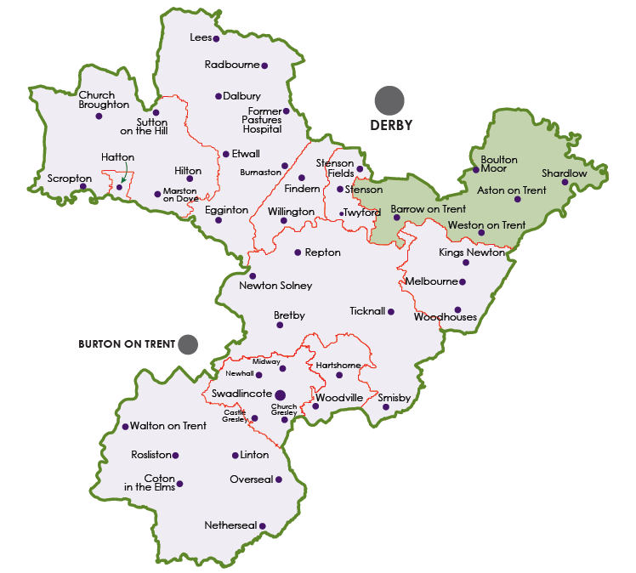

Figure 20 Map of the District of South Derbyshire (SDDC 2016f)

The map above is the map of the District and the green area at the top right hand side is the ward that the author represents.

As the district is growing the local plan shows that there is the need to build 12,600 houses by 2028 (SDDC 2016c). This becomes tricky when many people have moved to the district to live in a rural area that does not have many houses.

The financial position that the council is in is strong at the moment with a surplus planned for 2016/7 and 2017/18. However after that the Revenue Support Grant falls away and a deficit is forecast. This means that SDDC has to save over £1.5m over the next five years. This is a common theme across most authorities (SDDC 2016c). The government recommends that for a council the size of SDDC that a reserve of £1million is kept. If the reserves start to fall significantly below this then the audit commission would become interested. If this were the case a team of trouble-shooters would come in and assess the capabilities of the leadership team and either guide them to improvements or recommend that they are replaced (Murphy 2013).

SDDC employs around 360 people however many services were contracted out to a third party. SDDC had a seven year contract that saved the council several millions of pounds when it was first set up (SDDC 2016c). The council has recently taken these services back in house in 2017. At the time of writing there appears to have been a smooth transition.

SDDC is focussing on a “channel shift” from face to face operations to self service and on line transactions (SDDC 2016a p31). This is working well with more people using these facilities which means less queuing at the counters. This also means that the costs are reduced thus helping the council to maintain its services whilst cutting the costs. There are still some customers that prefer the face to face contact and this is still available.

The Figure below shows the annual summary of the accounts. The Finance Director and Section 151 officer comments that the “118 page statement of accounts is not read and is no longer printed”. A more user friendly Annual Report is produced for the people of the area.(SDDC 2016a).

One of the ways the council manages to “make South Derbyshire a better place to live, work and visit” (SDDC 2016a p5) is to work in partnership with commercial, voluntary and other government agencies across the district. There are many examples where the achievements have far outweighed the achievements that the council could have made on their own. For example Sainsbury’s supermarket has invested £1million in Swadlincote for it’s “Waste Less Save More” initiative and hopes to reduce food waste by 50 per cent in the area (SDDC 2016a p17).

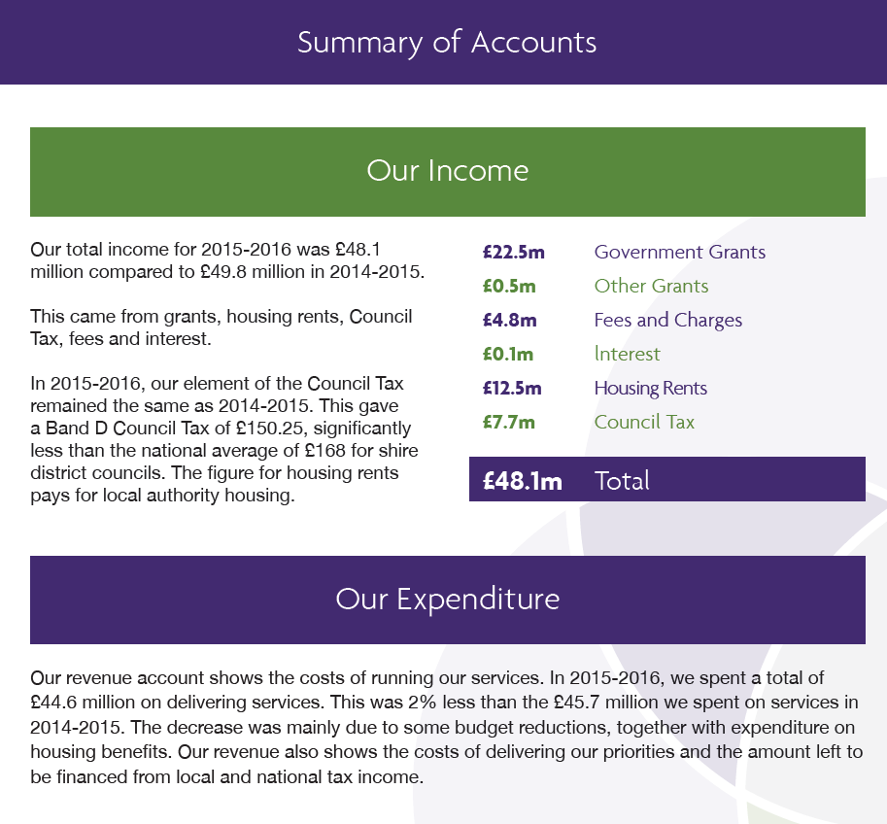

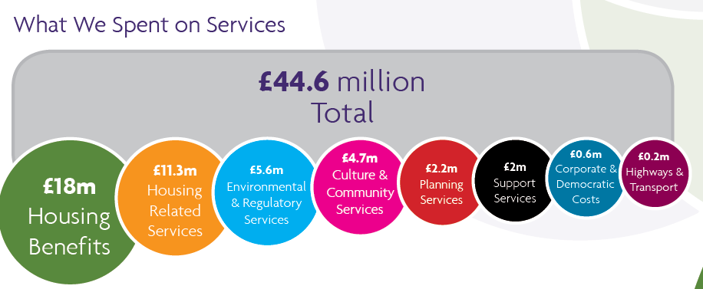

Figure 21 summary of Accounts for SDDC 2015-2016 (SDDC 2016a p18)

## **4.2 Governance of the “Council”**

South Derbyshire District Council is one part of a two tier local government system in Derbyshire. Some services are provided by the district councils and other services are provided by Derbyshire County Council. District councils were deemed to be too small to cope with certain areas of local government services such as education, social services, etc. The districts were left with the areas of housing, recreation, environment, economic development and planning (Leach 2009).

The council has statutory tasks to complete which are dictated by acts of parliament and also they have discretionary tasks which the council can choose to complete or not (SDDC 2016d).

The Council is a fourth option council which means they are operated via a committee basis. This is an option for smaller councils that do not want a Mayor or a cabinet system. There are 36 elected members and at present the political split is 24 Conservative Councillors and 12 Labour Councillors (SDDC 2016d).

The committees are shown below.

|  |  |  |
| --- | --- | --- |
| **Committee** | **Policy or Regulation?** | **Frequency of meetings** |
| Full Council | Policy | Every 6 weeks |
| Finance & Management | Policy | Every 6 weeks |
| Housing & Community Services | Policy | Every 6 weeks |
| Environment & Development | Policy | Every 6 weeks |
| Overview & Scrutiny |  | Every 6 weeks |
| Planning | Regulatory | Every 3 weeks |
| Licensing & Appeals | Regulatory | As & when required. |
| Audit |  | Every 6 weeks |
| Standards |  | As needed. |

Within the controlling group a Leader and a Deputy Leader are chosen. This is completed via a vote of the councillors within the controlling group. The author has been the Deputy Leader for two years 2015 - 2017. The senior leadership team of the controlling group consists of the Leader, Deputy Leader and Chief Whip who are all elected plus the Chairs of the Policy committees which are Finance and Management, Housing & Community and Environment & Development, who are chosen by the Leader. A total of six politicians. The politicians then meet with the Chief Executive and the Directors on a regular basis.

The role of the Deputy Leader consists of:

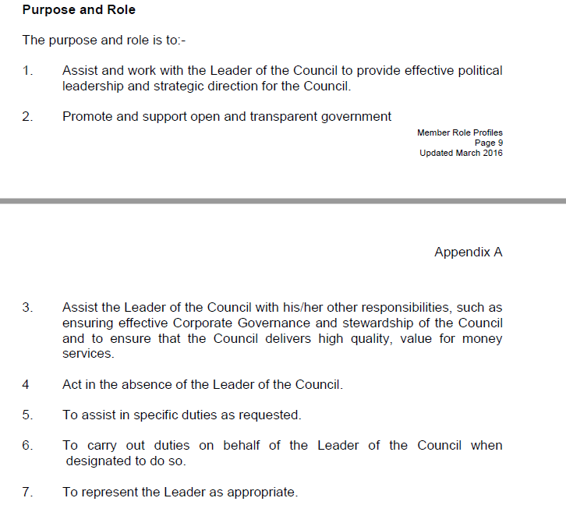

Figure 22 Role of the Deputy Leader (SDDC 2016e p9-10)

**4.3 Culture**

From the previous chapters it is suggested that the general public have a poor view of “councils” and they have a reputation of being bureaucratic and ineffective (van Helden 2005). The culture of SDDC has changed over the time of this study. The culture at the beginning of the time period studied was not as entrenched as other councils but there was still the feeling of a local authority. A job for life was the paradigm which was taken for granted and there were several levels of management which created the bureaucracy typically associated with a council (Johnson et al. 2011). Handy (1993) characterises culture into four views. The role culture would support a bureaucratic organisation such as a local council however there are also elements of the power culture as SDDC has a very experienced and proactive CEO.

A huge change occurred when the decision was made to outsource several functions to a third party commercial supplier. Initially SDDC looked to partner another neighbouring council but this failed to materialise. The senior officers of SDDC could foresee the savings that needed to be made and thus embarked on a commercial arrangement.

Anecdotal evidence from senior officers commented on how they underestimated the difference in the two cultures. Some staff that could not cope with the change subsequently left the organisation. In addition to this new partnership the senior management team underwent a restructure and reduced in number. The aim was to reduce the levels of management to make the savings needed in order to keep the services to the customer as high quality as before. Approximately four years ago the central government cut the funding by 28% and SDDC needed to save £2.3m. The CEO saved £1.6m by flattening out the senior management structure and ensuring that all directors are operational including the CEO. For the CEO the key to successful performance is clear goals and having the right people in place.

In 2016 it is a much leaner team that are taking forward the vision of the council than it was in 2009. The power is still with the senior officer team and the members but now there is another control in place. A constant check from the third party to see if there are any more savings to be made. Comments from the senior team are that they like this as it keeps the staff on their toes and able to adapt more easily. The change from the original culture to the more commercial style culture was managed in a directional way with the leaders deciding on the change of the strategy and then implementing it. This enabled the change to happen quickly (Knight & Baranova 2012). SDDC have now reversed this and have taken the staff from the 3rd party back in house in early 2017. This was again due to cost management and the need to have the flexibility within the costs and not a one large lump sum contract.

## **4.4 Process for Performance Measurement for SDDC**

The controlling group write an election manifesto to say what they want to do if elected and what they want to achieve. When they are confirmed as the controlling group after the election the officers at the council look at this manifesto and convert it to a strategy. This is often challenging as the manifesto is usually vague and will not commit to achieving anything specific.

Content removed for copyright reasons.

Figure 23 The South Derbyshire Conservatives Manifesto for the May 2015 Elections (SDCA 2015).

As you can see this is more of a press and publicity statement rather than a clear vision for an organisation. Not a lot of time was put into creating this manifesto and this causes issues when trying to implement it as there is no clear vision of what the conservative group want to achieve.

At a country level each time a government is elected they put forward their strategy of what they want to achieve over their term of office. This vision is then disseminated down through the unitary, county, districts, boroughs, towns and finally to parish council level. This is what is known as the “Golden thread” (Michelli et al. 2007).

The strategy, of the council, will be determined by the Leader of the Council in conjunction with the Chief Executive Officer (CEO). The officers are the consistent part of the council and will have the history and in depth knowledge of the organisation whereas the members can potentially change on a regular basis.

The council produces a corporate plan for a three to four year period. Usually this will coincide with a term of office for a political party. It is prudent to try to keep in line with the controlling group as making decisions on the eve of an election may not prove to be in the organisations best interests if the controlling party changes and the new regime rescinds all recent agreements.

After each election the corporate plan is refreshed. With the continuation of a controlling group there may not be many changes however if the power does change parties then changes could happen as the new party wants to put their stamp on the strategy.

Working groups were set up with members and officers to discuss the strategy and to agree it. All members were invited and only one member of the opposition attended all the meetings until the final wash up session.

This year very extensive discussions were held. The first meeting with the members gave the evidence base for what had happened over the last corporate plan term. As Deputy Leader the author challenged the process of this meeting as members did not get the chance to input anything until about 90 minutes into a two hour meeting. The format of subsequent meetings were changed and information was circulated beforehand to ensure everyone knew all the background before the workshop.

The members discussed the four current strategies. The author was concerned with having Value for Money as a separate strategy and suggested that this theme should run throughout everything the council does.

The timeline of the meetings for the corporate plan are listed below. The four initial workshops were held in the “committee room” which is a room with a large table that everyone can sit around and see each other. This leads to an inclusive style of meeting with everyone having an equal voice. The “Wash Up” session was held because members of the opposition had complained that they were unable to attend the original meetings. This was held in the Council Chamber. The chamber is a semi-circle with members on one side and officers on the other. The political groups are also split with the controlling group on one side and the opposition on the other. It does not encourage informal discussions as it is a very formal setting. However by this time the main focus of the corporate plan had been agreed and this was more of a catch up for members who had missed the other workshops.

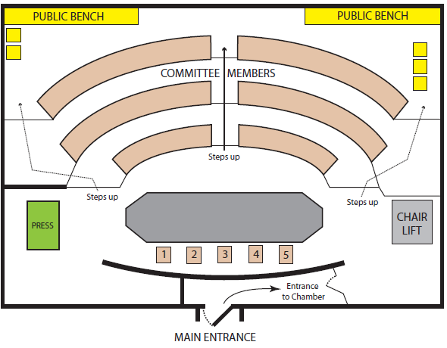

Figure 24 South Derbyshire District Council Chamber (SDDC 2016h)

**Timeline of the Corporate Plan**

|  |  |
| --- | --- |
| 2011-2015 | A Corporate plan exists that was predominantly designed in 2007/8 and revised in 2011. |
| Pre May 2015 | South Derbyshire Conservatives launch their manifesto for the May 2015 local elections. |
| 7th May 2015 | Election. New team of members are elected. 24 Conservatives, 12 Labour. Out of the 36 councillors 11 are new councillors. |
| 12th October 2015 | Corporate Plan Workshop – Sustainable Growth & Opportunity |
| 19th October 2015 | Corporate Plan Workshop – Value for Money |
| 26th October 2015 | Corporate Plan Workshop – Safe & Secure |
| 28th October 2015 | Corporate Plan Workshop – Lifestyle Choices |
| 14th December 2015 | Corporate Plan Workshop – Wash up session. |
| 11th February 2016 | Meeting with Communications team regarding the Action Plan. |
| 17th March 2016 | Corporate Plan presented to the Finance & Management Committee. |
| 4th April 2016 | Meeting with the communications team to discuss the Performance Management Framework, |
| 7th April 2016 | Corporate Plan presented to Full Council. |
| 11th April 2016 | Meeting with the communications team to discuss the Performance Management Framework, |
| 28th April 2016 | Performance Measurement Framework presented to Full Council. |
| 2nd November 2016 | Focus Group. |
| 11th January 2017 | Corporate Plan Refresh session for members. (14 out of 36 members attended). |
| 18th May 2017 | Refreshed Corporate Plan presented to Full Council. |
| 27th June 2017 | Interview with a Head of Service |
| 11th July 2017 | Interview with the CEO |

Figure 25 Timeline of the Corporate Plan

Officers then create a Corporate Plan – this is a glossy document containing the strategy. This is then announced and released to the public and is available on the website. An Action Plan is then created which details key objectives within each area of strategy. Service plans are created from this and targets are fed down to middle managers via personnel development reviews.

In 2016 the corporate plan changed visually as the Venn diagram was incorporated into the design. The author had draft a version of this that was in boxes with the over- arching theme of the outcomes and value for money. However the author quickly agreed that a director’s view with the softer circles was a much better approach and the workshop attendees were all happy to accept this. This visual picture of the circles has now been utilised for all corporate documents either via a watermark within the body of the document or in a heading or footer.

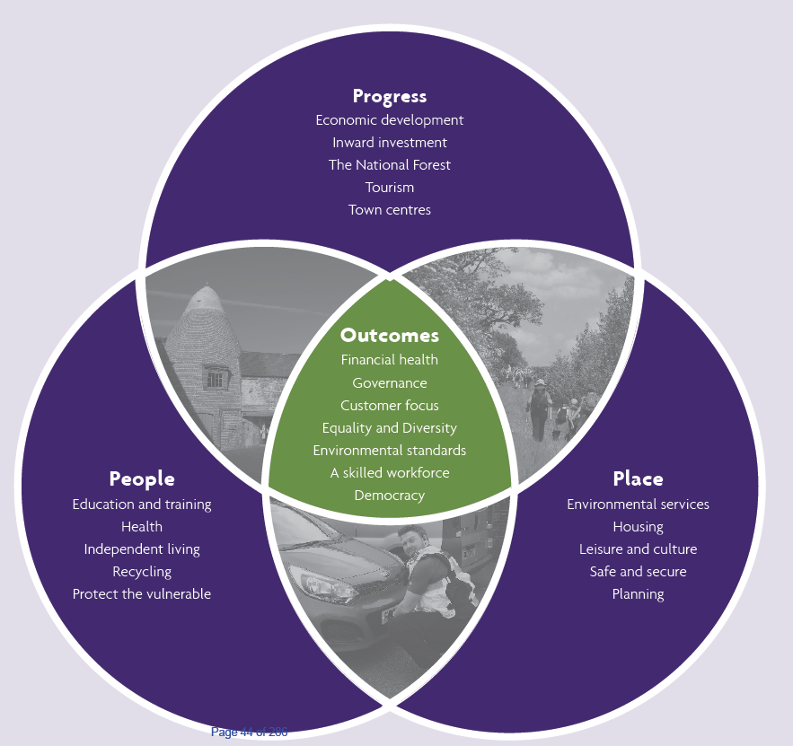

Figure 26 South Derbyshire District Council Corporate Plan Diagram (SDDC 2016i)

Performance reports based on the service plans are reported on a quarterly basis to the relevant committee. EG Waste Collection would report to Environment and Development. All reports are approved by the Finance & Management Committee as well.

This year the officers are all meeting to discuss the results across the teams. “This is the first time we have operated a physical performance board where the managers will meet together to discuss the results. In the past this has always been a paper exercise” (CEO 28th April 2016 Full Council). Here managers are trying to understand the performance of the whole council and not just their areas.

The communication of the corporate plan has involved many members and officers. Now the first draft of the plan is complete the chairs of the committees and the directors and senior managers are pushing the plan and the measurements so everyone understands the objectives and direction of travel. Plus they all understand how their role fits into the overall picture.

Objectives have been colour coded (and assigned shapes to aid identification) for strategic, management and tactical levels. Posters have been put up all over the buildings to remind everyone of the focus. This will hopefully engage everyone as they can see where they fit in. This is the theory but we will see later in the case study that this does not always happen.

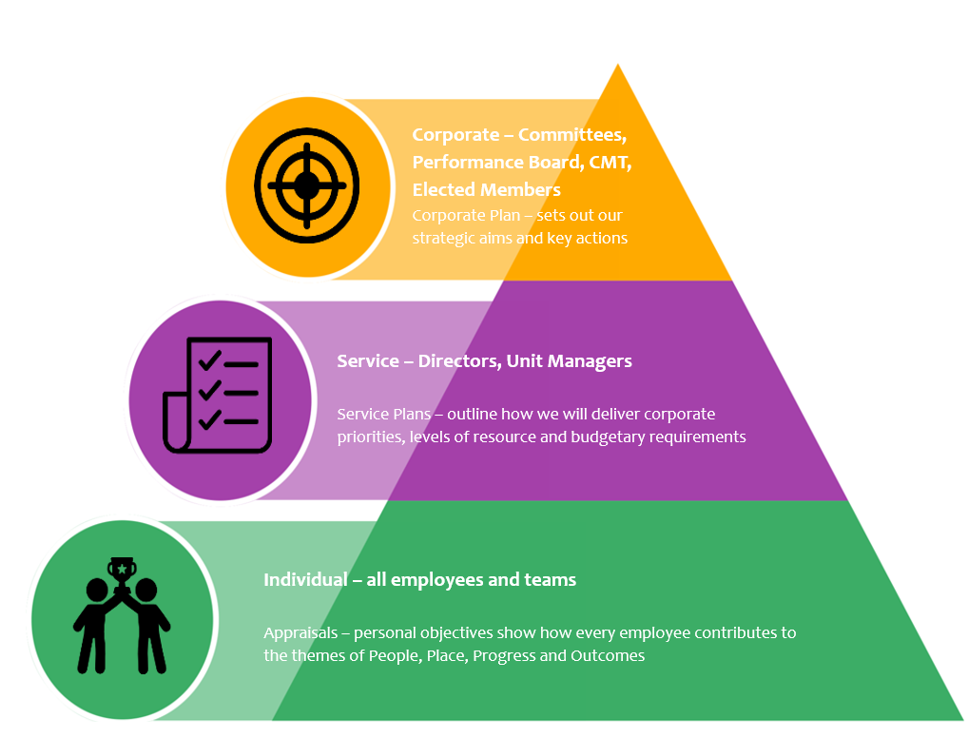

Figure 27 presentation delivered to members on the 11th January 2017 at SDDC.

It is important that the correct measures are undertaken. There is no point measuring just to measure. The “so what?” question must always be asked. What will you do as a result of this measurement? (Bourne & Bourne 2002).

SDDC have openly involved all members and many officers in the process of reviewing the current plan and moving it forwards. The timing of this has been important as well. In May 2015 several new members became elected and were new to the team. These members needed to take time to understand what the council is all about before trying to decide on the strategic direction. The workshops commenced six months after the election and had a large take up from members. Creating the right environment for the organisation to have these discussions is vital (Bourne & Bourne 2002).

This plan is then supported by the medium term financial plan where the money is allocated to support the themes. The corporate plan drives everything. According to a senior member “if it is in the plan then the funding is allocated. If a project is not in the plan then it will not happen”.

The corporate plan targets have been refreshed and presented to the annual council on the 18th May 2017. The disappointing aspect of this is that on the consultation process for the agreement of the measures only two members responded. The author and the Chairman of the Finance and Management Committee. Both professionally qualified accountants. No one else made any comments. This is perhaps because the members think it is a document that has been completed and that it is a once every four years exercise. Or is it that the members do not really understand the corporate plan so do not feel able to comment or challenge. They are happy to leave it to one or two members that they feel “know what they are doing”. On the other hand it could just be complete apathy that members are not really bothered and will rely on the officers to deliver a plan and do their job without needing member input.

## **4.5 Action Research Learning Process**

It all began in 2006 when the author uttered the words “I could do better than that” when the local district councillor fell asleep in the parish council meeting where the author was the chairman. Subsequently the author was elected to the council of South Derbyshire in May 2007.

The Conservative group took the control from the Labour group who had been in continuous power for 33 years. For each meeting a motorcycle courier would come and deliver the documents that needed to be read. The envelopes were thick and they were far too large to fit through the letterbox. All these papers had to be read, digested and then questions asked. This was too much for the average person to comprehend and it resulted in many members not reading the papers. This is what propelled the author to investigate whether there could be improvements made to this process (McNiff & Whitehead 2010).

When the author was re-elected in 2015 the author wanted to see if there was a better way to manage the decision making process. Having worked as an accountant in various industries the decision making processes were much faster with less paperwork than in the public sector. In the private sector a managing director would expect a one page summary to cover all the key points needed to make a decision. Would a commercial director read a 200 page document every week for a meeting? The author also checked their understanding by discussing the open papers (those which are on the website and the general public have access to them) with other colleagues. Colleagues at the University and from private sector businesses agreed the volume of paperwork was too high to be consistently read and understood by all members.

The author wanted to make a difference and to improve the processes to make it easier for members and to also make more informed decisions.

McNiff & Whitehead (2010 p288) ask “How did the author gather data to show what the situation was like at the time?” Having been re-elected in May 2015 the author gathered information internally from previous corporate plans and service plans. Previous experience from the council was reflected on. The council had moved to being “paperlite” with having all documents available to download to an iPad. Paperless was not an option as too many people still felt the need for some paper, including the CEO. However agenda’s and meeting papers seem to increase in size. The objective of saving paper had gone and thus the file sizes increased and officers added everything in “Just in case”. This can also have the effect of hiding any key messages.

Access to all the information was not a problem as it is all available internally and most is on the website and in the public domain. Having good relationships with officers has made this easier though as they have provided information to the author rather than the author having to forage for it.

So the author has gained access to the information but then McNiff & Whitehead (2010, p229) ask “What did the author think they could do about it?” Returning to the back benches of the political group would achieve very little so in order to make changes the author would need a seat at the top leadership table. Once in a position of influence then challenges could be made to improve the process.

The authors ward seat is in a fairly safe area, politically. A reasonable amount of pre-election campaigning returned all three conservative councillors to the Aston ward. However this would only bring the author into the back benches and not to the leadership team. The next step was to convince the group that the author should be the Deputy Leader. Fortunately, and after a weekend of lobbying, the majority of the group agreed and the author was elected as the Deputy Leader. This gave the author weekly access to the CEO and other senior officers. This has put the author in a position of influence. As the workshops progressed the author has gained respect from the officers by the level of questions asked. This was evidenced by the comments from both the CEO and the Chair of the Finance and Management Committee,

“The Chairman paid tribute to the members who had assisted officers with its implementation, in particular Councillor Mrs Coyle” (SDDC 2016f, p2).

The Corporate Plan is the vision for the council. It is updated every four or five years. The last major change was in 2007 with the change of political power. This plan was then tweaked but in October 2015 workshops were organised to review the plan and to see if the themes and objectives were still valid. The author met with the communications team to structure the member’s workshops to gain the maximum output. An interesting observation comes here at the start with the communications team driving the plan. Quite often it is the finance team that takes the lead because the majority of the controls and performance measures are financial (Nath & Sharma 2014). The workshops were well attended and many members contributed to the discussion. At the same time discussions between the author and the senior officers took place to review the outcomes of the workshops.

From the process of the research “What did the author learn?” (McNiff & Whitehead 2010, p229). The collective view of the members coupled with a constructive discussion brought out several key themes. The main point the author wanted to put across to the members was that the value for money theme should not be a theme on its own but should be part of everything everyone does at the council. This was discussed and agreed. The Chief Executive has since stated that this has been the best plan the council has ever had. The author believes this is because the workshop environment was open and welcoming for all to speak. The ideas and values of all members attending were noted and this improved the content of the plan.

The author has learnt that although the workshops were good and made good progress they could have been better if they were more focussed. More time was needed to really understand what the group wants to achieve and also how will this happen and what areas does the group want to measure and monitor. However this is hard to do at the first stage of a project. The reflective process has meant that each time we learn more and can add to the critical evaluation of the discussion. It is hard to get there without taking those initial steps.

The process of completing an action research project is that the author is in the organisation and can make changes so “How can the author evaluate the quality of their influence in other people’s learning?”(McNiff & Whitehead 2010, p229). Due to the authors interest in this topic area the author drove the members’ interest and encouraged many members to take part. Encouraging members to speak up and make sure their voice is listened to and views taken into account. This is possibly due to the authors experience as an educator but also the natural leadership style of inclusion. Several members have commented that they feel more comfortable about speaking out in a group.

Another issue is with the members recognising the efforts of the officers. All too often an officer will spend time writing a report for a committee meeting and no one asks any questions at the end of the presentation. Some officers heave a sigh of relief that they have not had to respond to questions and others feel demotivated that members have not wanted to challenge them as this appears as disinterest. Involving the members in this process has motivated officers to engage with the process as well.

There is a continual process of learning. Even with the final action plan coming to committees in August 2016 the author is still challenging the content. The plan is a living document so it can change. Reviewing the reports with the communications manager in August 2016 has hi-lighted the facts that there are many gaps in the data. Other members have noted things such as spelling errors or missing numbers in a sequence. The author is still asking about what measurements are missing. Taking time to read the documents and reflect on whether they link to the objectives or not and not just ticking the box to say the plan is now complete for another five years.

McNiff & Whitehead (2010, p229) are keen to see “How has this project extended the author as a professional?” The author has learnt from the approach of the communications team as opposed to a traditional financial approach. The project has made the author really think about the linkages of the strategy and vision to the measurements. Also the author has a keen interest in this particular area but what about other members? Working with the communications team to produce a “successes” page so members can look at one page to summarise what is great about the committee they sit on. Members often “zone out” from the lists of financial figures and results. Producing a colourful simple guide is a starting point for them to engage in the process easily. This has given the author practical experience of the plan for this authority and has developed the understanding of the authority which will be vital for the leadership role.

The next step is to communicate to the members that they now have some easy measures to read and understand. Plus these measures are based on the priorities that the members were involved in choosing during the workshops. Research shows that people who are involved in the development of the measurements are more likely to engage with them (Drury 2015).

Also the author has been openly engaging with the officers by taking an interest in their work, challenging some assumptions and measures but also congratulating the officers on their good work and positive attitudes. This attitude from members is now progressing to other chairs of committees as a best practice. The ad hoc feedback from officers is that they are appreciating the interest shown in their work and it also creates more robust pieces of work.

The communications team have sent out a survey to see how well the staff have understood the process. These results are interesting but only a small percentage of staff replied. The author has followed this up and by observing a focus group in November 2016 which is detailed below.

Completing the action learning review has pointed out the value this project has had on the authors understanding of the organisation. Taking time to analyse the data has meant a greater understanding with more challenges made to improve the final version. It has also set an example for others to take time to read in more depth and not just accept the officers’ first draft.

## **4.6 Focus Group**

On the 2nd November 2016 the author attended the first focus group that was purely for the Corporate Plan.

Twelve officers attended and they were from a range of levels and areas as follows:

Modern apprentices, planning & conservation, economic development, sport, grounds maintenance, housing, environmental health, business improvement and community support. There were eight females to four males which is not quite a true representation of the demographics of the council officers as it is about equal male and female.

The CEO ran an icebreaker quiz about the council and the district to show that not everyone knows everything but we all know something. The mood of the group was very buoyant. The author introduced herself as a member and also as a research student. The group were happy to have the author present and were very vocal in their discussions so they did not hold back anything. This is very positive as the presence of the Deputy Leader may have made people feel worried about what they said. However the mood was such that they were pleased a member was also taking time out to attend this group and learn more about the officers and their work. This was also fed back to the communications manager after the event where the feedback was the staff “liked to hear the member point of view”.

The group was facilitated by two officers of the communications team and they had invited everyone and had told them the topic of the focus group. The first responses were interesting as the group was asked to define the corporate plan.

“Never seen it”,

“Don’t know what it is”,

“Vision and aims of the council”,

“Vision, aims, directions and outcomes”

“Future”

“Direction”

“Blue print of what we do”

“Don’t know”

“Don’t know”

“People, place, progress and outcomes”

“What, how, why we do what we do”

“Aims of council moving forwards”

So a real mixed response. Some of the people that said “don’t know” were new to the organisation however some had been there for some time and still didn’t know. So some people, even though they knew the subject of the group, had not taken time to find out what the corporate plan was.

The actual definition designed by the council is:

“The Corporate Plan sets out the way in which South Derbyshire District Council intends to develop and further improve its services between 2016 and 2021.

Working in conjunction with other Council plans and policies, and those of our partners, it plays an important role in ensuring that our strategic objectives are achieved for the people of South Derbyshire.”(SDDC 2016g).

The vision of the council is “Making South Derbyshire a better place to live, work and visit” (SDDC 2016g). The CEO made it clear that there are no politics in the core activities of the council. As the control has shifted from the Labour group to the Conservative group the core activities have remained the same. The CEO has been an officer of the council for over 40 years so has the experience to be able to make these comments.

The focus group were then asked about the values of the council and the responses were:

“Honesty”

“Quality”

“Integrity”

“Openness”

The corporate plan states the values are:

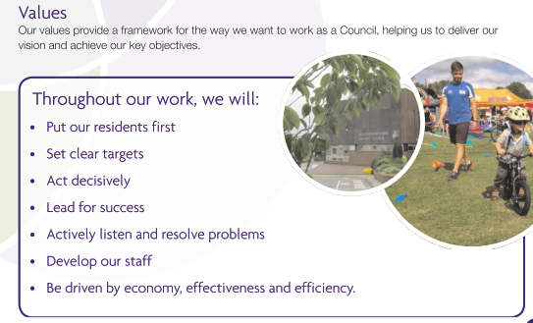

Figure 28 The corporate plan values (SDDC 2016d, p5)

The values the focus group identified are relevant and underpin the values above. The values in the corporate plan are more specific so unless the group had read the plan it would be difficult to match them exactly.

The CEO then gave the focus group members an analogy to help understand the goals of the council.

“The elected members take money from everyone in the district via the council tax. They take it on a promise to spend it well. If an individual were to go to the shops they could spend their money on whatever they wanted. For the council it is a promise to spend money on behalf of residents. We (the council) then have an obligation to deliver. We need to ensure we know what we are doing. It is important to understand what people want. We are constantly looking for improvements.

If you buy a cinema ticket you have a view of what the film is about and you take a risk hoping that you will like it. People move to South Derbyshire expecting to live in a decent place that is predominantly rural. The members are closer to the people and the people put their trust in the members to deliver on their promises. The members employ people and spend money to deliver this. There are approximately 98,000 people in South Derbyshire and they need to be satisfied with the services provided.

This corporate plan has had more interaction with members and officers than any other plan. We need to be clear about what we are setting out to do. We can write the words but then the staff need to deliver it. Members will hear about it. We are all visible in providing services. We need to be relevant. We need trainees to tell us what the youth of today want. We need to convince businesses to invest in South Derbyshire like Toyota did. The corporate message needs to get out to the people of the district and we need to deliver our vision. We are doing it FOR the people and not TO the people” (CEO of South Derbyshire District Council, Focus Group, 02/11/16).

The focus group enjoyed listening to the CEO and several people asked if he could do a podcast to get this message out to everyone. Also it was suggested this content should be included in induction meetings for new staff. The CEO took these comments on board but also pushed back and asked the officers to spread the word as well.

The focus group were then asked to identify three projects that they had worked on and identify which area of the corporate plan these fitted into. This proved quite tricky as many of the projects could fit into more than one area. This is supported by the literature as most authors of the balanced scorecard believe that there are many crossovers and targets could be placed in several areas.

So the key question for the focus group is “do staff really understand the corporate plan”? The feedback and discussions gave a varied response. One person had a very proactive manager that photocopied the aims of the corporate plan and highlighted the ones which that team covered. However this was very much a one off. The general feedback was that unit managers did not feel the need to tell staff about the corporate plan, “you don’t need to know this, just do your day job” was a quote frequently used by the staff in the focus group. Staff felt their managers would not tell them and told them it was not relevant to their role. Obviously this is a complete contrast to what the directors are saying.

Staff based on a different site felt they were left out and knew nothing of what the rest of the organisation was doing. The previous director held regular briefings the current one does not. Staff were saying they wanted to know but then in contrast they said they only needed to know where they fitted into the corporate plan. What did it mean for them? So here we have conflicting views from the same staff. Yes they did want to know about others but really the “what was in it for them” attitude took over.

One officer suggested a plan similar to the corporate plan for each area. This is a view supported by the literature that indicates the balanced scorecards are devolved in the organisation in order to become relevant to lower levels (Kaplan & Norton 1996).

However there are some staff that like to come into work and do their job and go home again without really thinking about the bigger picture. The key for these people is that their supervisors have interpreted the corporate plan and set their work targets in line with the plan.

This is where the discussion, again, became interesting as one officer could not see how the outcomes and targets had been decided on. What she did, did not fit into the targets at all and they appeared to be out dated. So how were the measures chosen? A key question for this research.

Also the group felt that the document was “boring” and “couldn’t something be put on you-tube? Is this the way forward? Communicating by television? Managers have told their teams to “go away and read the corporate plan” but no one wants to do this. Only one member of the focus group has read the plan and this was because they needed it in their job. The mantra of the organisation is to “do more with less” and the officers interpret this as finding things to cut out of their daily work and the reading of dull documents fits this perfectly.

All around the building are posters with the corporate plans three circles Venn diagram. Asked what the group felt about these and the feedback was “they are like wallpaper, no one notices them or reads them”. Even the relatively new people did not feel they were useful as they had not read them.

Another comment was made regarding the strategies that the council follows. For example there is a housing strategy, an asset management strategy, a volunteering strategy, a sustainable community strategy and the list is endless. If an individual is using one of these strategies for their role then what use is the corporate plan? Ideally the corporate plan should have been written first and then the strategies follow but this is not the case as many of the strategies were in place before the corporate plan was reviewed. In theory all the strategies should have been incorporated into the plan or the strategy dropped. The officers have assumed that the strategies are valid as they have been “approved by the committees, so they must be right”. No one felt the need to investigate this further and just carried on with their jobs. This along with managerial feedback of “just do your job” and “you don’t need to know” has reinforced this view.

So the communication of the plan seems to struggle after the directors and immediate managers. This appears to be a disjointed process with different standards across different teams. How can this be improved? How do you make it relevant and interesting? How many members of staff were involved in the creation of the corporate plan? Does a one size fits all work for the communication of the council’s vision and strategy? The focus groups shows that it cannot. There are many members of staff that are out and about every day and do not have access to emails or the intranet. These staff within the focus group commented that face to face briefings work better for them and also hard copies of documents put in their pigeon holes. The council has adopted a “paperlite” strategy where everything is communicated via emails rather than printed copies. However if you do not regularly check your emails you could miss out. The staff magazine has been moved to the intranet with one hard copy going to the outdoor based team for their noticeboard. It is understandable that they do not read it as much as they did when they each individually received a copy. This is something that can easily be resolved now that the issue is known.

One of the ways the vision of the council can be filtered through to everyone is within their personal appraisals. This has to start from the top, from the CEO and the other directors and flow down to each person. This is easy in theory but very clear it is not happening from the focus group feedback. The feedback from the majority of the group that they do not know where they fit into the overall vision and strategy of the council is concerning but not unexpected. Now the issue is can this information dissemination commence now it is known that there is an issue. Subsequent focus groups have been mentioned to check this, however at the time of writing nearly a year after this focus group they have still not materialised.

The overall feeling of the focus group was that of energy and enjoyment of working at the council. Potential to see where they fit in and to know more about the rest of the council came across which was a positive finding. The next steps are for the council to develop an action plan to see where improvements can be made.

For the research the key comment was “Where have the measures come from?” The senior management team have chosen these measures but they are not appearing relevant to staff further down the hierarchy.

## **4.7 Staff Survey**

Many managers complete staff satisfaction surveys because they “have to” and not because they have the wellbeing of their staff in mind. Lawrence et al. (2008 p18) suggest that “even though some companies know roughly what is going on research is the catalyst to take action”.

Staff will participate more if they think it is an ongoing research project and that there will be some outcomes and improvements. If they feel it is a one off tick box exercise then many staff will not engage. The diagram below shows some of the signs that all is not well with the staff. If employees are dissatisfied this will influence how they work and how they treat other people. The negativity will spread (Lawrence et al. 2008).

There appears to be a mismatch with what the management thinks and what the staff think in terms of the performance measurements of the council.

Content removed for copyright reasons.

Figure 29 Signals in the Organisation (Lawrence et al. 2008, p18)

In June 2016 the communications team carried out a survey on the internal communications of the council. However only 50 office based staff answered the survey. It could be argued that the results should be great for the communications team as the people that answered the survey were the office based staff who have emails and use of the internet on a daily basis and not the staff that work off site on grounds maintenance or bin collections. The survey also did not go to the staff employed by the 3rd party outsourcer as they have their own procedures for collecting feedback. The Communications manager expected a “mixed set of results” which is interesting as there was not a feel for how the staff would respond.

When asked what is the vision of the council 50% of respondents skipped this question so it would appear that this is too hard to write down quickly or respondents did not know. Only 18 out of 50 respondents knew the strapline of “Make South Derbyshire a better place to work, live and visit” (SDDC 2016e, p17). The rest that responded said they were unsure or didn’t know.

When asked if staff felt informed about the corporate plan over 70% felt they were informed but then 56% of staff felt they do not understand the aims and role of the corporate plan and 12 staff skipped the question. So although staff are aware of the plan the majority do not understand it.

Some of the comments that were made included:

“make it easier to understand for staff and give real live examples to translate it better” (SDDC 2016e, p20).

This supports the view that the corporate plan should include statutory measures and aims as well as aspirational ones so that staff can see where they fit into the goals of the organisation.

Staff also commented on the impact of the “drip feed” of the information “communications need to be thought through and delivered once instead of update after update on the same subject” (SDDC 2016e, p28).

So how did staff think the communication could be improved? Below are the comments produced in the survey and only eight suggestions out of 50 participants are offered. So it is easy to criticise but not easy to offer a solution.

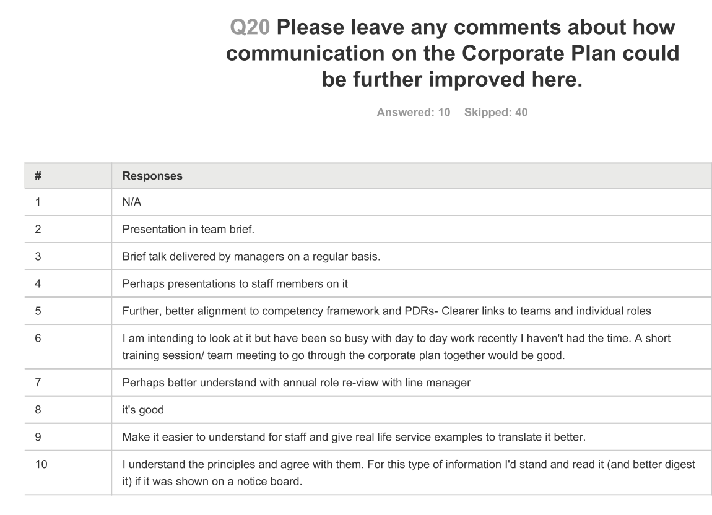

Figure 30 Q20 from Internal Communications June 2016 Survey (SDDC 2016e, p20).

Some staff feel the corporate plan is a one off announcement and others understand that it should be a “living” document and should keep up with the environment. This small survey to a few staff has shown the differences in understanding and the appetite for understanding and becoming informed from a small percentage of the workforce. Also as these people had actively completed the survey it would be reasonable to consider that they were the more proactive members of staff as well.

What was missing from the survey was an indication of how happy the staff are generally. A wellbeing index. A way of measuring the morale of the staff as this will colour their thoughts.

## **4.8 Discussion of the Measurements.**

The author talked to the Director of Planning and Community Services and asked how did he know what was going on across the whole organisation. It is through weekly meetings with the other directors plus fortnightly meetings with the senior politicians of the controlling group. There are only three directors plus the CEO so this is possible as it is a very small team. The CEO controls these meetings and is a strong leader. Often there is not much time for other directors to add comments.

The council is becoming more “business-like”. It is working in partnership to improve the economic prosperity of the region. It has less money coming in. Plus it needs to save £1.5m over the next four years.

Results have only just been drafted and collated and is referred to as the “Performance Board” which is being presented to councils in August 2016 for the first time and then every quarter. The results are linked to the aims under each of the headings.

Analysis needs to be done on why these measurements were chosen and do they take the council towards its goals.

There are no statutory measures in here. The author has challenged this and the feedback is this is aspirational and not statutory. The author has challenged do, for example, the bin men know where they fit into this plan? Without the statutory measures they may not know where they fit in and then does this reduce the effectiveness of this as a motivational and communication tool? The feedback from the focus groups is clear that the lower levels of the organisation do not know as much as the senior Directors think they do.

The Directors have commented that many staff have been involved in the creating of the measures however this is not how the staff feel. Many do not know why the particular measures have been chosen.

Some measures have been used because they were already being used as part of the national data set. The general view is that the measures come out of the service plans. However as most of the measures are aspirational there are many that are used because they are easy to calculate or there is a calculation available already by another organisation, a proxy measure. Examples of this are pollution levels, empty homes brought back into use etc.(SDDC 2016b).

Measures are also used that are utilised elsewhere. The author prefers a positive view. In the action plan for the year 2017-18 a target is given below.

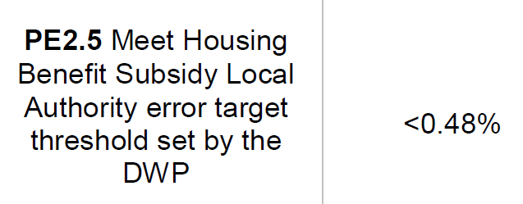 (SDDC 2017, p4)

The author queried this as to why it could not be a 99.52% accuracy target rather than an error based target. The response was “the finance director says this is due to the criteria set out and the way the information is recorded”. This supports the view that the public sector is slow to react to change. However as the author was the only member to comment on this then would it be worth the effort to change it? Later on, in this chapter, the apathy of members will be discussed.

So how good are the measures used and will they deliver the aims and goals of the organisation? If everyone in the organisation is focussed on delivering these aims then the measures are very important. However as we have seen from the evidence within the case study officers follow the service plans and the policies and do not often interact with the corporate plan. This makes it vitally important that whoever designs these measures links them into the service plans that sit below them and makes sure that all the aims and goals are communicated to all in the organisation.

## **4.9 Theme 1 - Stakeholders & Communication**

How does SDDC know what their stakeholders want? How often does SDDC canvass the public? The election of the councillors for SDDC coincided with the general election so it can be implied that national politics had an impact on the local vote. Usually the winning of an election gives the winners a mandate to go ahead and deliver what is in their manifesto. The Conservative manifesto was so short in 2015 that it cannot be classed as a consultation or a strategy.

There are many consultations on individual policies but not one on what should the council be focussing on. The Corporate Plan has been built up “following extensive consultation into South Derbyshire’s needs” according to the 15th June 2017 Finance and Management Committee. Probing further into this finds the process somewhat lacking;

“what we’ve done is we create a big evidence base for the performance management framework and for the corporate plan and what we do for that is we look at anything that has been consulted upon over a certain time period and then we look at current strategies moving forward which again have been consulted upon which are then used as part of this evidence base which is then presented back to elected members which is then presented back to officers and say this is the current situation we are in at South Derbyshire” (Head of Service SDDC Transcript p336, l6-12).

So nothing has gone out to the public to actually ask the residents and citizens of South Derbyshire what do you want from your council and what should it focus on.

Years ago national government introduced the Place Survey which was used to consult the public;

“But there was nothing like the place survey that says to us what do people want, what are people looking for moving forward and how do we fit our priorities around it so it’s certainly something we could improve upon” (Head of Service SDDC Transcript p337, l22-24).

The last time the place survey was carried out was at least seven years ago. Much has changed in the environment since then. In a recent meeting with the CEO he has agreed to produce a report to look into what consultation methods members would like to use in the future. However the CEO is very wary of asking the public what they want;

“Clearly you have to put the question in the right way to them otherwise you're going to get the answer that you don't want” (CEO SDDC Transcript p376, l22-23).

It may be the opening of Pandora’s Box to ask the public but it is something that members are now starting to feel strongly about. The CEO would like to focus this more on specific areas rather than a general open question;

“In our leisure industry is very important because we want to provide services that people want and not what they don't want. It might be all very shiny and new and look beautiful and no beggars using it, that's not very good so we consult widely on that” (CEO SDDC Transcript p376, l25-28).

Endless consultations for the local plan have been carried out and members of the public have attended events in village halls across the district. Planning is an area that generates public interest and opinion. Yet area forums where the public can attend and ask questions are very poorly attended by a few parish councils and the odd member of the public. The council classes this as public consultation but it does not reach many people. The author has requested the format of these meetings are reviewed as they are not a good use of officers and councillors time.

“everything has its day doesn't it even question time can be a little bit samey sometimes and I watch that because I find it interesting but sometimes I think I know the questions that are coming the topics of the day and all the answers you're going to get off PAT answers the stock answers yeah and that's becoming the same with with area forums it's a little bit samey how can we shape that differently well the danger is we could ask people what they want out of it and then give them what they want if we can and it might be they don't want it it might be that the same people turn up all the time in the rest of them couldn’t give a monkeys it might be that the parishes do such a good job that the parish liaison meeting is the only time they ever need to come together because the parishes are the ones individually that meet their customers’ needs at a very local level so we need to be careful we asked for on things like that but I'm up for change but I'm not up for just not doing it saying well the only eight people turned up so therefore let’s not do it. If you take that away without putting something in its place or taking the time to consider what if anything needs to be done rather than just not do that’s easy you run the risk of losing that contact with the public” (CEO SDDC Transcript p17, l31).

The report has just been presented to the Scrutiny committee (September 2017). It suggests combining two meetings that happen on the same evening. No different agenda or items of interest. Perhaps it is the same because everyone is having difficulty in finding a solution. Apathy from the public is seen as a sign of success. As a director points out “If there was a problem the meetings would be packed”. It is difficult to see how a meeting where no one turns up is a successful public consultation. Officers feel the meetings have good content however;

“There is a chance to have your say and listen to the matters, the issues that affect you. They are very good as a structure the difficulty has always been getting people to engage with it and […] we have tried an awful lot of publicity in terms of social media, in terms of leaflet dropping, this is all been over a number of years that they have been in place but as I say when you consider 6 out of a population of hundreds, thousands it’s not really representative of that communities views is it? (Head of Service SDDC Transcript p338, l9-15).

So is the issue that the community want to communicate in a different way? Perhaps on a one to one basis or via social media.

“So it’s how you reach everybody and then give them the decision about how they want to feed back” (Head of Service SDDC Transcript p339, l3-4).

More work needs to be done here to address the communication issues with the public.

What about members as stakeholders and the quality of the members? What skills do you have around the table? Elected members need no qualifications and just need to be prepared to stand for election and work in their community. But is this enough?

“By calibre what I mean is they come from the, the background that they live in and they bring that to the table, what I hope for in any member that elected, is a passion to serve because that passion can drive you on whether you have experience in law or, or architecture or engineering or, or anything. If you have a passion to make a difference for the people that elected you, you will challenge my officers and you will challenge the members around you to actually deliver something for those people. So if you ain't got that if you're just a name on the ticket and you need a sat-nav to find where the blinkin offices are I've got a big job on my hands to get you into my level of passion for this place because I'm better by having two passionate people than having myself talking to myself around the table with members. I want that passion so that's the first qualification for me you've got to have and like most things and you might say it back to me who some of my officers you've got it in some places you ain't got it in other places and that's no different for members. After that what you, I'm looking for is, how can I say this, I don't want a personal interest I don't want someone who's come to achieve something for themselves …to keep your people happy or worse still to people, small enclave of people's you live around happy I can't be doing with that and that's led me to conflict with members in the past” (CEO SDDC Transcript p378-9, l14-23,1).

At the same time as the passion and unbiased approach the CEO would like members to be consistent;

“if it's there a fair-minded approach to help the many not the few that they live and work with and then a cooperative in terms of joining into a group and and following that policy line and not going off on one every every committee so I've got a whole faction of people to try and keep on a message that to me is as much as I can ask for in members” (CEO SDDC Transcript p379, l12-16).

“Is it is a cooperative it is a collection of members that make decisions not individuals” (CEO SDDC Transcript p379, l7-8).

The political groups are then reliant on the officers to drive forward the agenda of the council. If members are not prepared to challenge then the officers have free rein and then it comes full circle back to the question of who runs your council? Officers or members? (Wilson & Game 2006). When the corporate plan has been presented at various council meetings, over the last two years, no members have made any challenges or asked any questions. The CEO would like members to challenge;

“one of the things I've found most recently with the administration as is now and I look back at you as the deputy for the last two years, is that challenging officers leads to better results than just allowing officers to put their own stamp on things and their own professional level of competences. The challenges are only valuable if they're intelligent challenges, if it's just “eh up, what's going on I'm not happy” that doesn't add, if it's have you thought of doing it this way because there are more than one way to do this then that is thought-provoking and it's stimulating for my,my directors” (CEO SDDC Transcript p364, l14-21).

Members are given a lot of information but understanding and the appetite to understand is lacking. The new performance board and action plan are huge improvements on the previous set of reports but they are still not perfect by a long way. What impact does it have on the organisation if members do not engage with the aims and objectives? It does mean the council becomes more of an officer led organisation. When asking members they will say it is a partnership of officers and members that decide on the direction of travel however the evidence from this research shows a level of apathy that points to a more officer led approach.

Staff are also stakeholders and there are employee forums where staff can raise questions. The CEO will brief the whole council whenever there is an important message to deliver. Also the focus group was a good way to engage a cross section of officers to deliver some feedback.

“Like stories that go on the intranet and Better online are linked back into the corporate plan priorities. We do a lot more in terms of making sure the success go up on the notice boards and they are very visual” (Head of Service SDDC Transcript p339, l25-27).

However the officers at a lower level have not been involved in the setting of the corporate plan;

“we want the corporate plan to be done from the bottom to the top and they feel that they are part of the decision making process, it’s their understanding of the process, how they fit into it and that’s something that we’ve never done here before and that’s something that we want to try and change based on the feedback that comes to us because it has always sat at a top level and we want to try and change that so we feel that everyone has got ownership of it” (Head of Service SDDC Transcript p339-40, l32-34, 1-3).

SDDC have prioritised the communication of the corporate plan as the communications team are the official lead officers on the project. Two internal communications officers plus a consultant.

The consultant has made a huge difference as she has experience of other councils and understands what other councils do with their target setting.

This team has responded very positively to challenges that the author has made. This resulted in discussions that moved some of the targets to be clearer. This team understand that the measures can change. The feedback from other officers and members has been one of “I thought we had done the corporate plan”.

Communication is very good at director level and the first line reporting staff. However the quality then depends on the people, the managers and how much they value the plan and feed it down the chain. The communications team are very interested in how far the information travels, they look at;

“How messages are communicated from top to the bottom and bottom to the top… Are you getting the right messages? Have you got the right one to one relationship with your manager? Are all your needs being fulfilled? Do you get right messages about the corporate plan, performance reporting, are they all cascaded down? Does communication work from top to bottom throughout the organisation? (Head of Service SDDC Transcript p334-5, l30-34, 1-3).

It will all depend on the managers and how committed they are to delivering the right messages.

“I mean we hold a quarterly performance board here sitting around that table I think part of it is to, one is to make sure the messages are coming from the very top and feeding into unit managers who are then supposed to pass it down but also it is a chance for people to have their say, ask any questions and you know really look into things in a different way and in a bit more depth and detail. And I think you will find it’s the same voices all the time that are doing that” (Head of Service SDDC Transcript p334, l29-34).

The focus group also made it clear that the communication was patchy and not consistent;

“Some didn’t even have a team brief or a one to one so it went to that kind of level with some and others got the gold package where they got a sit down, they got a walk through, they got told what it was all about and what it means for them and that was one of the things we have tried to change on the back of the focus group to give unit managers the same resources and same information to be able to sit with their staff and go into a meeting to talk about the corporate plan and what it means for their staff and also about the service plans and how that filters up to the corporate plan” (Head of Service SDDC Transcript p335, l19-25).

It is progress in the right direction otherwise;

“making sure that people know that needs to be done and that’s so important to make it otherwise it becomes like Chinese whispers and people get their own interpretation and people are out on the front line and as I say they have heard things that perhaps haven’t been verified and then that gets fed out to members of the public so it has a knock on effect internally and externally as well and it’s so important that we get that right” (Head of Service SDDC Transcript p335, l29-34).

The focus group supported the view that it depends on the manager. So once again the leadership themes come through and it is not only the CEO but all the managers in the organisation. All managers need to believe in the plan and promote it.

Other stakeholders consulted are those that SDDC work in partnership with;

“there's a strong partnership ethos so like South Derbyshire sport which I see that counts as a key driver for they all have seen that as part of it naturally I say in other areas where there's perhaps not so much of that focus on partnership working then it may be more of a miss than a hit in terms of how again there's a general rule the right partner should have been consulted as part of those policies and those procedures” (Head of Service SDDC Transcript p345, l25-30).

South Derbyshire has a very proactive partnership group that includes Toyota, East Midlands Airport, Representatives from the NHS, County Council, Chamber of Commerce and local businesses and charities. The South Derbyshire Partnership is chaired by SDDC and they fund a small amount to get the projects started and then the other partners join in. The partners and stakeholders here are seen to be very important to enable the objectives of the corporate plan to be delivered.

## **4.10 Theme 2 - Strategy & the Corporate Plan**

The CEO has stated that he believes this is the best corporate plan SDDC has ever done. As this is a particular interest of the authors then the author feels that maybe they had a large part to play in driving this forwards. The disappointing result is that other members do not see the importance of having a strategy and objectives. Members will nod and say “yes great plan, nothing to add”. Some members have openly said they don’t really understand it and others have not taken any interest in it to really read through and grasp the concepts.

The workshops for the corporate plan worked fairly well after the first one;

“I think we think is the first one it had to be information overload because we've never done it before so so you needed that context of background” (Head of Service SDDC Transcript p358, l6-7).

Too much talking by officers and not enough by members with the first workshop. The author commented that pre reading was essential so all members have the opportunity to comment.

The opposition didn’t really join in, apart from one member, until the last mop up workshop.

“last one we got a little bit more engagement with it and that that was really useful we got a bit of challenge and what was said at that was factored in” (Head of Service SDDC Transcript p358, l13-14).

However this time around the members have bought into the plan;

“I think for elected members it's much more comprehensive there's a lot more information and a lot more context for you to make informed decisions which is as it should be from a corporate management team perspective it's a lot more of a seamless process now it's a lot easier takes a lot less of their time hopefully but also at the same time when we're taking a little bit of the burden off them by trying to cascade those messages down and then for the staff who do the day-in day-out everything that we put out internally relates back to the corporate plan which didn't happen before” (Head of Service SDDC Transcript p360, l19-26).

Some members lack confidence to comment and others are happy to leave others to complete it.

The officer leading the corporate plan initiative sent out an email on the 12th April

“*The Corporate Plan refresh process for 2017-18 is at an advanced stage.*

*As a result, we are in a position to present an action plan to you, as Elected Members, for final approval (please see attached).*

*This outlines 44 proposed strategic measures and projects that will take forward our vision of making South Derbyshire a better place to live, work and visit.*

*Please would you review and come back to me with any feedback by the close of play on Friday, April 28?”*

Only two members out of 36 replied. The author being one of the two members. However the CEO is pleased with the members that have been involved;

“it's got enough member buy-in to make it aspirational and the Localism Act allows that to happen and why wouldn't we want to do that I have not been risk averse since since I took over because if I was we wouldn't be here now we'd be run by the government” (CEO SDDC Transcript p374 l3-6).

“So I am aware of how we need to be aspirational to meet the change in demands of the customers I'm pleased to say that corporate plan is the best attempt I've seen at doing that” (CEO SDDC Transcript p374 l20-22).

However more members are becoming engaged with the outcomes. The results are coming each quarter to each of the three policy committees. The whole document is there for each committee. This has made it easy to identify all the actions regardless of the committee the member sits on. So each members gets the holistic view.

“I think just as an anecdotal thing from what the feedback we've had from directors particularly they said they feel that elected members are more engaged in it through the committee process they get asked more questions now they've been asked to take more away from those meetings our look into a little bit more depth and detail” (Head of Service SDDC Transcript p354, l9-13).

Also the CEO feels that this plan is written by the members;

“you have to learn to write in the handwriting of the elected member so it's your words in handwriting that they recognize as their own and that way you tend to get what you need to get because let's face it if it doesn't work it's your head that's going to be chopped anyway but if you don't get it and you end up doing something that members want that hasn't been if you like proofed through your ability to delivery you're going to fail anyway. Now the corporate plan this time we've not had to do that for the first time the handwriting has been written by the members in great, great number and it's been owned by the officers and it's been confidently accepted as achievable from an officer and a member of perspective that's the best of all worlds I haven't seen that before before we've had lip service to some things we've had must do to other things what we have in the corporate plan now is an aspiration to do better must do better must improve and that has come from the members with the officers buying into it and delivering it in a framework that is realistic so that handwriting I recognize as written by members in a great number and you were one of the main authors of that I would say even if you were one of the great authors which you are if I felt it didn't work for us and we would strive to do it but you know I wouldn't be confident I am confident I've said that on record I'm pleased that my members and officers have worked together on it without my handwriting at all anywhere seen in it” (CEO SDDC Transcript p368-9, l25-33, 1-9).

The author has now been made the “Corporate Plan Champion”.

So what would happen if there was not a corporate plan?

“So five years down the line and basically nothing in the corporate plan had been done or achieved and it was this apocalyptic society you know, tumbleweed blowing through, crime was rife, there were problems everywhere. People didn’t know what they were doing and they didn’t feel like the council respected them and it was a really difficult place to be and what they were saying, the moral of the story is well it’s a good job we are five years before that and we have got the corporate plan and we can influence it and fulfil our vision” (Head of Service SDDC Transcript p340, l11-17).

“The moral of this story is that we need to do something that engages people on a different level. It’s not just that high level stuff that people don’t relate to it and they don’t know what it means for them. We’ve got to do something where they are thinking ok I can see the role I am playing and this is how I want to contribute towards it” (Head of Service SDDC Transcript p340, l19-23).

“It’s the things that we feel we can do to achieve our vision of making South Derbyshire a better place to Live Work and Visit beyond those statutory duties because we have to do those so it’s what do we want to do extras to make that vision happen” (Head of Service SDDC Transcript p342, l9-12).

How do the service plans link to the corporate plan?

“I mean strategic is very much it affects the district as a whole. The service plans tend to be more specific to those service areas. So the strategic ones to tend to be those that affects the wholes of the population affects the whole of South Derbyshire it fits into that much bigger vision” (Head of Service SDDC Transcript p343, l30-34).

“As a general rule you would be doing the service plan and what’s been set down as part of that but they need to know what they are contributing in towards what with the bigger picture and as I say their information that they will feed in up the chain will help their unit managers” (Head of Service SDDC Transcript p344, l13-16).

From the focus group the evidence suggests that there is a different standard of how managers communicate this overall bigger picture;

“we know from the feedback we’ve had that that the manager in there is sitting down with employees saying right this is what we’ve got a service plan level this is what we’ve got a corporate plan level but this is how you fit into this is how we want to achieve it these are your own personal targets for doing that people are very clear about how they’re fitting into that process” (Head of Service SDDC Transcript p345, l3-7).

“It gives you a framework doesn’t it gives you a foundation it gives you something aspirational to work towards so yes would everything fall down no of course it wouldn’t because people are professional and they want to do a good job so of course it wouldn’t but it gives you the direction it gives you the way forward it tells you where we want to be as a council it motivates to an extent in terms of where we want to get ones get so it’s absolutely crucial in that respect in terms of moving forward now everything won’t fall down I don’t think that for a second but if you didn’t have it it would be a little bit baseless be a rudderless ship almost wouldn’t we and just would just be sailing the seas are not really knowing where we are going” (Head of Service SDDC Transcript p359, l18-26).

“It’s about challenging it’s about being ambitious it’s about doing things differently from time to time and getting yourself to where you want to be which is where the corporate plan comes in” ” (Head of Service SDDC Transcript p359, l5-7).

“I think for the last couple years of the old corporate plan it’s fair to say it was given lip service and nothing else” (Head of Service SDDC Transcript p359, l32-34).

“The culture is the hardest thing to change in an organization … members it’s been a phenomenal difference have been a phenomenal step change in terms of from where we were and sometimes and personally I have to tell myself and have to tell the team that to say what difference makes as when you are so close to it you don’t see that” (Head of Service SDDC Transcript p360, l2-9).

“I mean we need to have a look at that process as a as a whole to be able to move that forward I think for us we need a baseline to go off to really see whether the key issues aren’t be able to affect them in the right way at the moment feels like we’re guessing a little bit we think we know and I’m pretty sure we won’t be far off but we don’t actually know and that’s where we have that’s the fundamental issue at the moment” (Head of Service SDDC Transcript p345, l16-21).

What comes first – service plan or corporate plan?

“Well it’s like chicken or the egg this is is a bit as that you know it’s a it’s a really really good question and it’s something we’ve asked ourselves and it’s very hard to give a definitive answer I mean I would argue that really you are talking service levels, service level plan is your bread and butter it’s the day in and day out those things you have to do it is more of the statutory side of things I would argue that you have to do the the corporate plan the strategic side of things it’s the aspirational side of things the bits where you want to get to but you have to do the bread-and-butter to get to the aspirational side of things as well so you need it’s a balance isn’t it between both personally how if it sounds like a little bit of a cop-out but I say there hold equal weight in terms of what they do because you have to do the day-to-day have to do those statutory things but at the same time you’ve got to have a wider vision and everyone’s got to be working towards that collective vision because if they’re not why are we here full stop because as I say we’ve got to be working towards that common goal moving forward” (Head of Service SDDC Transcript p346, l6-19).

The general feeling is that this is a great way to move forwards and the relationships between members and officers is good;

“I'm grateful to that working relationship that is it is evolved in in the plan up to the point where now it's up and running and we are evaluating it on a regular basis so there's no hiding place” (CEO SDDC Transcript p369, l11-13).

## **4.11 Theme 3 - Leadership**

SDDC has been through many restructures over the years and this has been necessary to survive. In 2000 the council was bankrupt and needed to change drastically to survive.

“We were 2.1 million unbalanced budget that's unlawful not just uncomfortable and it needed a totally different approach” (CEO, SDDC Transcript p365, l32-33).

Below is the structure at the time of writing. However this is soon to be changed again in order to cope with the demands of the district and the budgets.

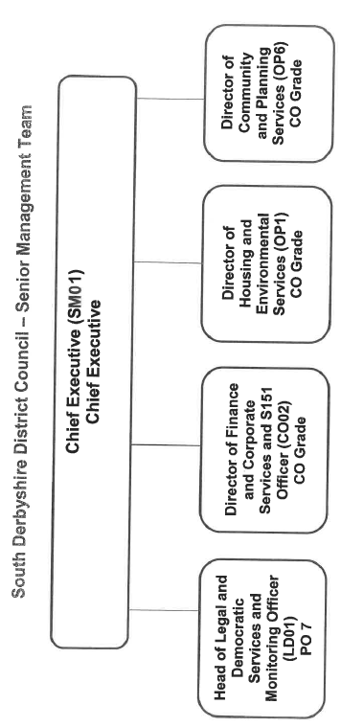

Figure 31 SDDC Senior Management Team as at September 2017

Beneath the directors are the Heads of Service and managers.

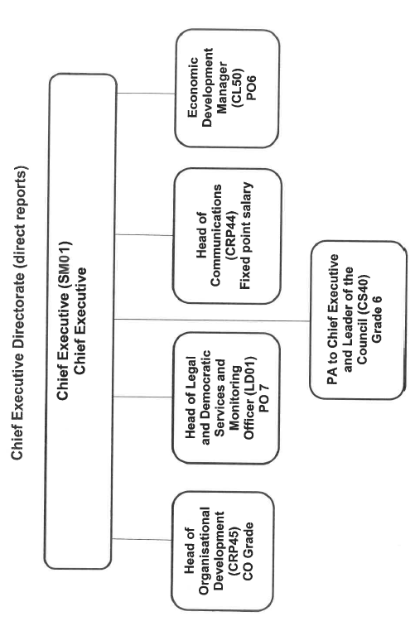

Figure 32 SDDC Chief Executives Direct Reporting Staff

As you can see from the above structure the CEO has a very hands on role and is not just a figurehead looking at the overall strategy but also is heavily involved in Human Resources, Legal and Economic Development departments.

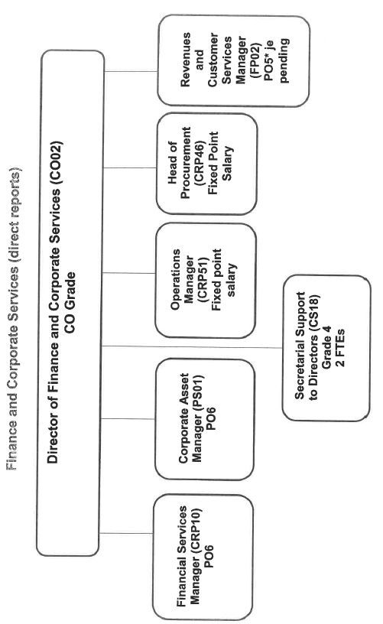

Figure 33 SDDC Finance and corporate services structure

The Director of Finance is now responsible for the services coming back from the external third party organisation that SDDC out sourced to, previously.

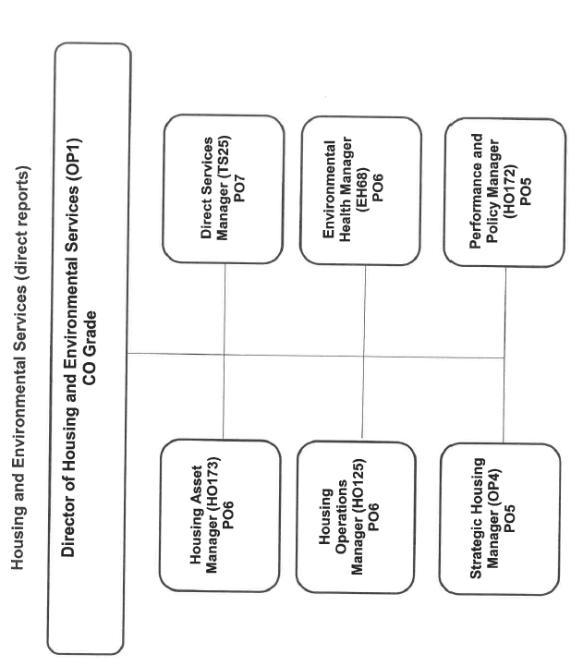

Figure 34 SDDC Housing and Environmental services structure

And finally;

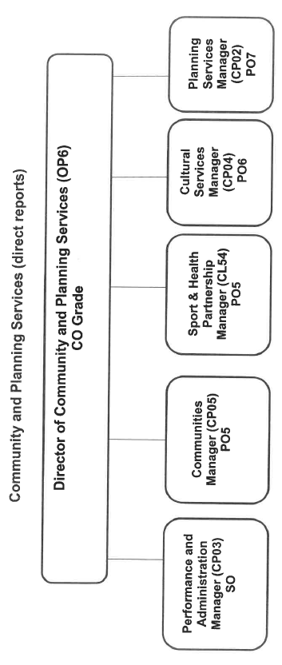

Figure 35 Community and Planning Services Structure

Is this level of staffing appropriate for the size of the council?

“When I started here we had, I think we almost had, double the number of directors than we have got now and heads of service were in high demand at the time so there’s an awful lot of people you could turn to when you needed … we have the corporate management team at the top and the unit managers underneath and there is a big gap between those two at the moment and it is how you try and bridge that gap a little bit more to make it more meaningful” (Head of Service SDDC Transcript p333, l4-17).

Members have also supported this view and commented that at present it is a little thin on the top. There have been times when senior staff have not been available to members.

“Because of the funding cuts it has been a necessary evil I guess, but the difference, the change has been substantial and at times you can see that. They have managed to paper over the cracks very well” (Head of Service SDDC Transcript p333, l21-23).

In order to keep the council as relevant and fit for purpose (a favourite saying of the CEO) then the structure needs to change to ensure that those cracks are covered properly. At present the council is about to start a process with the Local Government Association to review the structure that is needed. The focus will be on where the decisions are made and is there anything preventing staff from doing their jobs.

The council has also changed its constitution over the years;

“are you ready for this we had 17 committees and I said look you know the alternative method isn't about doing the same always done it's about bringing them down and I took 17 down to five, three promissory and two statutory committees and that's how we operate now” (CEO SDDC Transcript p379-80, l31-33, 1).

Looking at SDDC from an internal point of view shows that leadership is a key part of the drive for the strategy. Any kind of change programme cannot be achieved without a strong leader. The leader must be willing to adapt and change as if they are stuck in the past then this becomes what Greiner (1998) calls the crisis of leadership.

“I'm still fairly active in appreciating new methods of delivery I'm not stuck in the sort of always doing what I've always done and getting the same results. Step change is something I'm just engaged in again now and I've got great hopes for us taking us to an even better place” (CEO SDDC Transcript p365, l1-4).

Contingency leadership styles are needed, a different style of leader for a different situation. However the CEO of SDDC has been in post for 18 years (In total over 42 years at SDDC) and will have seen a great deal of change over this time.

“I've been here so long I'm part of the establishment I do care passionately about the place” (CEO SDDC Transcript p364, l10-11).

It has also been the CEO’s drive that has reduced the hierarchy which has resulted in a lean management structure with only four directors at the top table. The risk to the organisation is what happens when he retires or indeed if any of the directors leave. This again is another reason for the structure review to ensure that the council is resilient in its leadership team.

The CEO has been a proactive leader and has driven the changes through. Anecdotal evidence shows that the CEO is not afraid to make tough decisions (A previous life as a prosecutor has perhaps helped this). The CEO comments that he has “cut down the jobs and carried out formal interviews and tests and has saved £1.6m over four years”. Carrying out a clear programme of redundancies within the senior management team previously had not been easy and a task which other, more consensual leaders, may have avoided. Nevertheless this has meant that SDDC had a lean and flat management structure which is ready to adapt to the changing environment. The new structure does not envisage putting in anymore highly paid staff but more of a focus on keeping the hierarchy flat to ensure faster decision making.

The CEO has also used a transformational leadership style as he has empathy and support for his followers and builds their confidence to succeed. The success then leads to belief that they, the followers, are capable and in turn they feel they can do more for the organisation. It is a style of leadership that encourages people to look further than their own self-interest and work hard for the good of the organisation (Dym & Hutson 2005). The CEO commented that he has “asked everyone on his senior team to do more and offered them no extra rewards. All have accepted the challenge”.

A senior member believes that SDDC are performing well and this is supported by the excellent external assessments. The member believes that the key driving force for success is the strong leadership of the CEO. “The CEOs skills and abilities in land and property deals are the envy of other councils”. In his opinion a weak CEO could not make this work.

The political leadership is different. It follows the basic manifesto of the controlling party’s national aims but the detail is often left to the officers. There is evidence of this as so few members responded to the action plans and the corporate plan workshops. Yet the CEO feels that he has a very good relationship with the members and also feels that members are involved;

“unless the hands go up at committee you're not doing anything because it's got to be voted in ,your certainly, the important decisions that are not delegated to officers, I've got to be voted in by members and that's the, the pleasure and the risk of of, of a job like mine if I don't take the members with me and if I'm waiting for a decision on the night not knowing which way it's going to go I'm really not very good at my job” (CEO SDDC Transcript p367, l18-22).

“So it has to be a partnership and the good way of dealing with that is using the ability to talk to members outside of committee on a regular basis that I've said earlier in this interview it's much better and more stimulating to be challenged by members off piste before you've got that report in front of you before you're sitting in a formal committee or council process and I welcome that and I would be sad if some of that dare I say talent from members is not put up front central because it does not make me a better person it makes me believe in myself a little too much that's not a good thing” (CEO SDDC Transcript p367-8, l26-32, 1).

The author can corroborate this having been in over one hundred meetings with the CEO. The discussion between the CEO and the Leader and Deputy Leader happens on a weekly basis.

However if both political and officer leaders were dynamic would this work or would there be clashes? A potential topic for further research.

As well as the leadership at the executive level there is also the issue of middle management. The middle managers are the people that get the messages out to all the staff.

“There's a saying isn't that you, you know, you pay peanuts you get monkeys that's true to an extent but you also get ,if you get it right at middle management, people who aspire a to be where they are which is why they're here because they believe they can do something to improve the service and I tell people all the time in my middle management team it's not doing it to people it's doing it for people and if you believe that then you take that self-starting motivation to make a difference for people at middle management level. They are the engine room if I'm on the bridge shouting you know for more speed now, don't get it down on the engine room, I'm still looking at the same horizon so I know the value of the people down below” (CEO SDDC Transcript p371-2, l30-33, 1-5).

It is tricky in the public sector as you cannot reward staff with monetary incentives in the way you can in the private sector. So there have to be different “carrots” and incentives;

“so what I'm trying to say to my middle managers is you will gain more experience working for a small multifaceted Authority where you've got more than one job to do you might not be paid as you would in the larger Authority where you've got less to do in terms of variety but you'll get that experience you'll either then be rewarded within the authority where we can do and I'm not talking about dead men shoes I'm talking about restructuring opportunities for successful middle managers or you will be equipped to move on to bigger and better things” (CEO SDDC Transcript p371, l14-20).

This will work for those officers that are motivated to improve and forge ahead with their careers but what about the other managers;

“There’ll always be those people who just do what they do and go home. Let's first of all get them down to the minimum and one of the things about successful management is sharing success and the only way you can lead somebody, because I'm not sitting in their office now as you're not, so whatever they I think they're doing they're doing whatever they're doing alright so you have to encourage you have to try and expose a better place for those people to go by complying and by encouragement and by sharing the success of those who have done that and that's something I always aim to improve on within the organization” (CEO SDDC Transcript p372, l6-13).

So in other words trying to show the excellence of the good managers and try to inspire the others to follow or that they are worried so they will follow. The CEO quotes the Japanese tradition of all businesses effectively being a family;

“in Japan it's like that everyone has a role they know they're going to be looked after as long as they answer to the main product and if we can get local authority to be totally like that I'd be delighted if we can get it very close to being like that and that's probably the best we're going to be” (CEO SDDC Transcript p273-4, l32-33, 1-2).

The social pressure of the “family” makes you pull your weight as you do not want to let anyone down. This is the aspiration of the CEO. If this does not happen he is not averse to sorting it out;

“now there are always exceptions and they are highlighted easily on a long table around the room I point to everybody, bit like Alan Sugar, and say how is it for you and what I'm really saying is, you know, how is it happening tell me, convince me here on the money. There's a measurement that I've got in front of me when I'm asking that question but I want more than that I want to know they understand the plan you sat in a room with me with 15 -18 officers and there's been hit hit hit miss hit hit hit miss … some officers I think surprised you and delighted you with how much they're switched into it. It's a constant need to engage and improve and encourage those doubters all those, shall we say, those people who pay less, less heed to it, the need to do it and by sharing the success from the table of those who do and rewarding them visibly rewarding them I'm encouraging them. If it gets to a point where it's not going to happen certainly by a third quarter I'm knocking on the door I've just done that this morning with my managers I don't go to the director I've got straight into the manager and by 3.30: … this afternoon you'll see some improvement in one particular area as a result of that and sometimes a short sharp shock of the chief executive springing you a visit is what's necessary. Unfortunately it happens but fortunately not very often” (CEO SDDC Transcript p375-6, ’29-31, 1-14).

On the other hand though there are some officers that are restrained about coming forward and speaking out;

“I think there’s, it’s a cultural thing I think Hilary in terms of people are a little bit scared to speak up and they become a little bit reticent to speak up and they feel, rightly or wrongly, it will be used against them further down the line in some shape or form or that it will be shot down” (Head of Service SDDC Transcript p335-6, l34,1-3).

At some point the issues of leadership will be included in the staff surveys that are carried out periodically. This has been promised for a while but has not yet been achieved;

“There’s always been something that’s going on at that moment in time so for example the most recent one was pay and grading so it’s not the right time to do it because we have got pay and grading going on. Before that Northgate partnership contract, that’s going on before that there’s a restructure going through. So there’s always a reason why we can’t look at that in more depth and detail. And what we’ve always been told is that at some point there will be this wider reaching over arching survey that will be done and it’s never quite come to fruition” ( Head of Service SDDC Transcript p334, l5-11).

The work that the Local Government Association are going to come in and do for the council will address some of these issues as they will be asking staff what stops them from doing their job and if this is the fear of trying new things or speaking out it should come out in that piece of work. Once the scale of the issue is known it can then be tackled and improved.

“I think that's a cultural thing and but I think there needs to be that little bit of a steer to people to just say you have got a voice here you can make a difference if if you're willing to do it you're willing to go that extra mile with it then let us know” (Head of Service SDDC Transcript p356, l28-361).

The analogy that the CEO often uses is “cut me open and I am SDDC through and through like a stick of rock”. This is what he would like for everyone that works there.

## **4.12 Theme 4 - Transparency & External Perception**

Most of the staff that the author has worked with and spent time in meetings with believe that the council is a successful organisation.

“I think for a council of its size, if I can use a fairly generic term here, it bats above its weight I think in terms of aspirations and in terms of challenging itself to do things differently” (Head of Service SDDC Transcript p354, l32-34).

Seven years ago they took a risk to outsource the back office activities to save money but also to improve the service by recruiting the expert skills in from a third party supplier.

“You look at the outsourcing contract with Northgate as an example and I know people have different perceptions of that but as far as I'm aware we're the only council that really did something like that to that kind of level, and it, and it did what it needed to do. It had problems in between completely accept that but it ultimately, they've made those 2.1 million pounds worth of savings and have been 1.9 million pounds worth of investment in IT so that for me is something that's outside of the box and you're challenging yourself to do something differently. I think they were on another side of things I think perhaps where unit managers look at this and this is what was coming back at the workshops is do we have that desire and do we have that ambition to really almost invest to save to take a risk to go in a new direction” (Head of Service SDDC Transcript p355, l1-10).

The council has now come full circle and the back office contract is now back under council control as the contract to outsource has not been extended or renewed. This was a tough decision to make however the need to be able to control the costs and not be fixed to a huge commitment was the driving force behind this. This also link to the theme of austerity.

These decisions are made by the committees and then ratified by full council however;

“people want to know how decisions were made, now that just didn't mean committees that also meant corporate management team as well” (Head of Service SDDC Transcript p361, l6-8).

The staff are becoming interested in who is making the decisions and how and when they are made.

“If they could see that their issues their worries their concerns where they see opportunity have been discussed and being looked at in more detail it makes them feel more valued as employees” (Head of Service SDDC Transcript p361, l10-12).

As yet the discussions of the management team are not made available to the staff. However the committee decisions are as long as they are in open and not in exempt.

With regards to transparency with the public consultation could be;

“Wider it could be deeper as it’s balanced up against times cost pressure” (Head of Service SDDC Transcript p345, l33-34).

As with all data collection there needs to be a cost benefit analysis to confirm that it is worthwhile collecting the data and feedback and that the council is going to do something constructive with it.

The CEO is passionate about the authority but also realistic;

“We are an excellent Authority, we know we can improve” (CEO SDDC Transcript p371, l16-17).

The public need to be happy that they are receiving value for money.

“I always say this to my staff we take the money from them unlike a shop where you can go in and choose to buy we take it before you even got through the door “(CEO SDDC Transcript p382, l26-27).

The public need to trust in the council and also work with the council in a kind of partnership. In other areas councils have lost the trust of the public and it becomes damaging to the council. For example Birmingham City council and the refuse collection dispute. The public are demanding that the leader resigns due to the mountains of rubbish piling up in the streets which has arisen from the workers striking. Indeed this pressure has worked and a new leader is in place (Barej 2017).

So for SDDC we need;

“the next place which is doing it for people in a way that they appreciate for a cost that they are prepared to pay which is a reasonable amount of council tax and for an improving service” (CEO SDDC Transcript p374, l8-11).

The council also needs to help the residents to get the information and services they need. It needs to be transparent and open. At the time of writing a new website is imminent;

“if you don't change your shop window from time to time they'll walk by because they know what's in there they don't even glance because they've walked past last week and it was the same, same, same our website is our shop window” (CEO SDDC Transcript p381, l16-18).

When the author attends meetings with the public the general feeling is that the council does do a good job and the public are happy. Except when it comes to planning and the author has yet to address a room who wants 500 new houses built in their back yard!

## **4.13 Theme 5 - Austerity, Resilience & Business-Like**

Significant cost savings have been made to enable the council to survive with the budget cuts. The governments’ budget has been the key driver for the change but rather than waiting and reacting to the cuts the CEO has been proactive and enabled the organisation to positively move forward. This links into the dynamic capabilities of the organisation. SDDC wants to do more than just survive so the management team are proactive and ensure the organisation has the capabilities to do well within the constraints of the environment (Johnson et al. 2011).

All of the officers that have worked with the author are very much aware of the financial pressures that all of local government are under;

“It’s a completely different environment to the one I joined here. I think when I first joined you had people to spare, there was budget to spare it was a very different environment different world. Whereas now everything's being tightened, everything's being streamlined, everyone's working with less at the moment and still there's a perception that they should be doing more and more with it and I think the thing with sometimes I just go do you know I can't do anymore” (Head of Service SDDC Transcript p356, l17-22).

The CEO realises this;

“so I know the value of the people down below and it's about rewarding them yes financially if I can from, from the restraints and budget issues that we have but incentivizing them to, to learn in a small Authority more work than they would ever learn in a larger authority” (CEO SDDC Transcript p371, l5-8).

The offer of experience and opportunities to learn will only hold good staff for so long until they move on to more lucrative roles. The CEO knows this and with the flat structure this is inevitable as there are few chances of promotion.

Leadership is a theme that has come through in this action research and has supported the literature review in that there is a need for an “entrepreneurial” leader in todays’ environment. The CEO of SDDC does show these characteristics especially when it comes to making the most of the property that the council owns.

Utilising the assets of the council in the most value creating way. There are numerous examples where poor quality pieces of land have been converted into leisure facilities such as a dry ski slope and a community centre and football pitch. The latter involved a deal to sell off a poor quality piece of land to developers for housing on the basis that the developers improved the quality of the playing field and also built a community centre. This improves the prosperity of the area.

The CEO’s working style supports the literature that no longer can CEO’s just dish out benefits and collect council tax, they have to be more “business like”.

“My drive is now to encourage further investment” (CEO SDDC Transcript p366, l1-2).

The CEO is heavily involved in the economic prosperity of the area and is not waiting to see what happens with central government but trying to be proactive and mitigate any loss of income with other income streams;

“we need to look now where that investment might come from in the future I attended a meeting two weeks ago with the Chinese delegation at a company right in the heart of South Derbyshire and we have achieved a massive Chinese inward investment I've kept them under the radar at the moment until the company are happy for that to be released that isn't us driving over to China and, and, and having a few noodles with people it's about China coming over here because they've recognised in the South of Derbyshire there is great investment already and great opportunities and they want to return on their money and the company that they've invested several millions in has given them an opportunity to put a foothold in South Derbyshire and nothing spreads better than success” (CEO SDDC Transcript p366, l6-15).

“I steered them into expanding their Factory and purchasing other factories of the basis of the success will come the employment will increase by 200 people almost overnight by October” (CEO SDDC Transcript p366, l18-20).

Improving the local economy is now a huge goal for the council as this will improve the lives of the people in South Derbyshire.

However local authorities are slow to move away from just completing the statutory tasks they provide to expand out into “anything that is legal” as described by the localism act.

“What we must do by law means it’s unlawful if we don't do it where the change in legislation has happened step change in legislations happened under Eric Pickles when he produced the Local Government Act 2011 when it was clear from that that we can now do anything that isn't illegal previously we can only do that which statute allowed us to do we could not make ice cream because it doesn't say in law we have to make ice cream now we can make ice cream if we if that's what we want to do because the law doesn't say we can't that's a major step change localism has brought” (CEO SDDC Transcript p373, l19-25).

“We haven't fully embraced that because we are risk averse by Nature” (CEO SDDC Transcript p373, l29).

There is some talk amongst councils about buying hotels and investing in other areas to attempt to secure a level of income that takes away the worry of not having enough money to survive. However in SDDC there are many members that are uncomfortable with this so change will be slow as the committees need to vote all activity through. Councils are naturally risk averse so it will take time. It is then vital to have a “Business Like” leader with these skills.

## **4.14 Theme 6 - Balanced Measures & What Measures Are Chosen.**

Another theme appearing is what do we measure and how have we chosen what measure? During the two years of this action research the only time when members have vocalised their views is when one of the strategic targets appeared that said “recruit a town crier”. The performance board was reported to committees in autumn 2016. After some discussions it was agreed that it was not a strategic objective to have a town crier (SDDC did have to advertise three times to be able to recruit one). However officers then hid behind the auditors and said they couldn’t change it because the auditors would question why that measure had been removed. This goes to support the view that the corporate plan is viewed as a one-time creation that cannot be changed. Also this plan is for the use of SDDC and it is not a statutory document so it can be changed at any time. Perhaps it was embarrassment that caused officers to adamantly defend this choice of measure. However the idea that this is a document that keeps evolving does not settle well with members or some officers. The general feeling is that the measures are set for the year. The communications officers that are leading on this project are keen to change it and constantly improve it but it is hard for them when there is very little engagement from members.

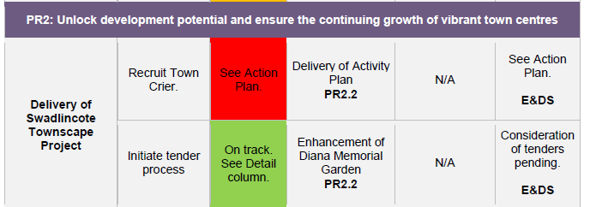

Figure 36 Extract from the Performance Board for Quarter 1 2016 (SDDC 2016b, p13).

The fact that the Town Crier example was a red indicator meant that members saw it and commented on it.

“I think that gone for as a green… I said no one would have given it a second thought” (Head of Service SDDC Transcript p353, l8-10).

However this example has been used many times in many discussions across the council and has;

“Helped to tighten up the process as part it's a real life example people can understand” (Head of Service SDDC Transcript p353, l23).

An issue that Internal Audit are interested in is the quality of the data that is collected. On the 31st August 2017 a report came to the Finance and Management Committee regarding this. They chose four key indicators from the Corporate Plan. They are the ones that the council has chosen and not those that are sent up to national government. From this the auditors made 19 recommendations. Some of the recommendations linked to indicators no longer used. The action details state:

“No longer applicable. Indicator is no longer included as a strategic measure. Will continue to be reviewed during 2017/18” (CMAP 2017, p3).

So this again is evidence that the data collection performance measurement can become an industry. Why were the figures not collected robustly in the first place? Why did it need an auditor to come in and check them? This is an example of an authority and its’ partners not being able to let go of the indicators that they calculate. Even though they are not used and not deemed to be a strategic issue any longer. This is also an added cost that would reduce if there were fewer indicators to report. The audit recommends that the calculations are checked by a more senior officer. This is a prime example of command and control management (Seddon 2008) and a lack of empowerment of staff. This indicator related to the energy consumption in public buildings. Just collating the costs and nothing will change just because it has been measured.

The other challenge to make is the “so what” challenge and also about the quality;

“So we've held a Swadlincote jobs fair brilliant great that's lovely but what did we achieve from it? How do people got offered by? How many attended? How many got offered jobs? How many got into interviews as part of it? What was the feedback from companies? What did they get from it? You know all those sorts things which we do collect but weren't being reported back as part of that process now again it's not perfect but slowly but surely that added commentary is there” (Head of Service SDDC Transcript p354, l16-21).

This is an example that the author chased up as to deliver a jobs fair was the measure and the tick was put next to it. But was it worth doing? It turns out it was and the council even offered some attendees roles but that information was not being passed up the chain to the members. Without the question of why are we doing this we did not see the full benefit that the jobs fair has brought to the area.

There is a mixture when it comes to who chooses the measures;

“You’ve got unit managers who are perhaps getting information from their staff and they know it day in day out and they know they know the opportunity, they know the constraints better than anybody. Then you've got the corporate management team who perhaps looking at it from a more overarching bigger picture point of view and then you've got elected members who obviously are looking at it from it from a ground level as well in terms of their constituents, in terms of their residents, in terms of what they may be looking for in terms of what they're hearing may or may not quite be right from the council perspective so the thing we have to do, you've got very good experience of this Hilary, we have to try and balance this between all three of them so as I say sometimes just to use this year as an example we very much wants to look at the outcome side of things and make the outcomes very meaningful because the people place and progress are all-encompassing they cover all manner of sins but the outcomes really should be the what do we want to achieve? What do you want to get out of this? And we felt that the first year of the corporate plan was a good start is a step in the right direction but we didn't feel it quite, they've gone deep enough at the time and we felt they need to be a little bit more streamlined so we got the feedback from unit managers in the original workshops and elected members in terms of what they were looking for and we put in their suggestions as part of it. Then at that point it was looking very bloated there was even more in there than there was the previous year so we said to the corporate management team look we really need to sit and have a discussion about this in terms of where ever you want to go because we think it should be a lot more streamlined” (Head of Service SDDC Transcript p346-347, 25-34, 1-12).

The officers had several discussions about the measures and had several heated debates about what to include and what not to include. The focus group showed that not all officers were involved and it tended to be senior officers only. Also members were not involved at this stage.

“Ultimately I say it, it should be elected members who own that and are driving it moving forward” (Head of Service SDDC Transcript p348, l12-13).

The officers in the communications team who are the lead for the measures end up discussing them with many different teams of staff and would prefer;

“everybody's sitting around the table and having those debates at the same time rather than we go and have those debates with three different groups and then feed it back up the chain accordingly” (Head of Service SDDC Transcript p348, l17-19).

The senior leaders from the controlling political group and the directors and CEO meet every fortnight and the corporate plan was brought to one of these meetings early on in the process.

“I came in a sat on a couple of those and my perception was very different to the reality. I was expecting to come in here say to people what works what doesn't and have a really fulfilling discussion and take away that information and use it to go off with and I can remember asking the question and the best way I can describe is it's like tumbleweed blowing through the office like no one kind of really wants to put the head above the parapet no one really wanted to say anything and I came out of that meeting so I'm a little bit mystified that's the only word I can think is kind of like okay” (Head of Service SDDC Transcript p348-9, l29-34, 1-2).

It is difficult to say why people are not engaging with the process;

“people happy with it and they don't want to change it or do they not understand it enough to be able to influence it which is what the conclusion I eventually came to with it in fairness or is it just apathy and people aren't really that bothered about it you know I say perhaps you might say the right things in public and to the wider world but you know it's the reality somewhat different to that and they say it gave me a bit of a wake-up call that did that actually people aren't as engaged with it as perhaps we are you know we live and breathe it it's a huge part of what we do but for other people it's a tick box exercise” (Head of Service SDDC Transcript p349, l3-11).

This political term was the first time the council had held workshops for the corporate plan;

“I think the workshops have been very good I think that's been a big plus a big step forward something we didn't have previously” (Head of Service SDDC Transcript p349, l15-17).

They try to focus on the strategic issues but sometimes they are caught up in each members’ pet project;

“it’s that wider vision where do we get what do we want to be known for in four or five years’ time how do we get there and how do you make it as I think sometimes we get very caught up on the the issues that might be in our head at that moment in time” (Head of Service SDDC Transcript p359-50, l34, 1-3).

However this has been a huge improvement on previous years according to the CEO;

“I think the plan is the best I've seen and I'm saying that truthfully and there might be some people offended by that over previous regimes and both in, in both parties but I don't care I'm just saying as I see it” (CEO SDDC Transcript p369, l22-24).

The service plans, are the more detailed versions, and tend to be produced for the year and are not adapted or changed during the year;

“it tends to be we set them in stone it goes to committee and then that's it and then it would be year down the line and they'll go back to committee and we'll reset them again” (Head of Service SDDC Transcript p351, l22-24).

“The data is there and it gets reported back to the director management team meetings and they regularly update against it but then it doesn't go to that next level which is to feedback to elected members and that's where that's why it falls down at the moment” (Head of Service SDDC Transcript p352, l1-4).

However the CEO has a different opinion regarding the reporting of the performance of the service plans to members;

“you do you see them in a different form you see them in the form of the quarterly measurement of the progress against the corporate plans aims and objectives and that's basically taken from each quarters research of where they are in their corporate and in their service plans so you do see it but in another format. We used to present service plans more regularly people and members just yeah move it, second it, we didn't even my officers were feeling really deflated I dragged them along through an evening meeting and it is move it second it” (CEO SDDC Transcript p375, l2-8).

The Head of Service would still like to see them presented to members more often;

“I think you have to do it on that six monthly basis and people say okay halfway mark this is where we are and this is how we performing it it's a really good stop check exercise to make sure it's going in the right direction” (Head of Service SDDC Transcript p352, l17-20).

Service plans cover the majority of the statutory duties that are carried out by the council;

“Any manager any director that doesn't perform his duties, he's going to get into trouble” (CEO SDDC Transcript p374, l25-26).

“Right it's each service plan is aspirational of both the statutory level because it absorbs its part of the corporate plan we have regular meetings now you've attended some of them with my senior managers to make sure that they are not only giving to Caesar what Caesar requires i.e. lip service to the corporate plan that they're actually still engaged still, still fully focused on over and above the statutory provision of their service” (CEO SDDC Transcript p375, l23-28).

The CEO encourages managers to strive to do more than just meet the statutory requirement.

The CEO feels the members are served better by looking at the higher level targets rather than the detail. The CEO feels the members do not challenge enough;

“I would love it when members say well why is that not quite there and then we would give a reason for that” (CEO SDDC Transcript p375, l13-14).

Unless the measures are challenged progress will not be made according to the CEO;

“nothing ever gets bigger by measuring it, you just measure it record the measurement and all the way and then measure it again no no no you have to find out when you measure it where it can go where you can extend it to where you can strive for stretch targets” (CEO SDDC Transcript p369, l15-18).

Then allowing staff to fail in order to learn;

“it's carrot and stick, you need the threat of you know we'll find out what you've done and so make sure you do it that that works to an extent when you find out it's not happened and the way it is what you do about it? Do you inspire people to do better next time or do you punish them for the failure in the hope that that fear of more punishment will drive them on to better things” (CEO SDDC Transcript p369-70, l31-32, 1-3).

“And it's never over until it's over so all measurement has got to be followed by encouragement and realistic achievement based on why it is where it is I've had previous the deputy chief executive here who measured it and held it in front of people as success or failure without any encouragement for those that have failed and what happened they continued to fail and those successful could have started to plateau because when you're successful and you don't have to strive to be any more you need the equal amount of encouragement to success and failures” (CEO SDDC Transcript p370, l16-22).

So how do you know what makes a good measure? What makes a measure strong? What can we achieve with current resources and what we can aspire to and stretch to over time. The CEO looks at the past and then projects forwards. In 2000 the council was “bust” according to the CEO. He was given the opportunity to be CEO and had six weeks to prove he could do it. He looked at the financials strengths and weakness and also the delivery arm, the organisational structure and expertise. “What do we have? What do we want?” (CEO 12/09/16). This will vary in each council. The CEO compares it to a “Personal best at the Olympics” (CEO 12/09/16). All authorities are not the same and they shouldn’t be,

“The strength of local government is to deliver the demands, aspirations and desires of local people” (CEO 12/09/16).

The CEO calls it the “Brand standard” in that the same standard should be delivered at all levels. Good customer satisfaction, rate of response to requests and getting it right first time makes a huge difference. The CEO believes that this is the best corporate plan the council has completed and says it

“Has attempted to be cross cutting, cross fertilising rather than departmental. What are you going to do to make it better? People, Place and Progress. We are walking faster than we were four years ago” (CEO 12/09/16)

## **4.15 Summary of the first case study**

To conclude the themes of the action research project it is clear that there are many improvements that can be made with the process of performance measurement and the choice of measures. It has become clear that some officers are choosing the measures and members are accepting these with very little challenge. Staff are subjected to a mixed level of communication from their managers with some being very proactive and engaged and others not bothered with a “you do not need to know attitude”.

There are good intentions and the commitment of the officers is very visible. However guidance is needed regarding what to focus on. A clear understanding of each group of stakeholders is needed and what they want from the council. This then needs to be prioritised.

The officers then have so many targets to think about and also where these targets come from. Do they look at the:

* Corporate Plan
* Service Plan
* Numerous policies
* Appraisal targets
* Job description?

With so many sources of targets staff will become confused unless they all sit together. SDDC have not yet compiled a comprehensive list of all the policies there are so these were not fully considered when the corporate plan was devised. Ideally the corporate plan should come first and the policies later but in practice the policies already exist. The policies are on a rotation system to be reviewed but this is done in isolation from the corporate plan. It could be argued that the senior officers understand the policies and helped to guide the corporate plan within them. However there are many policies and it would be very difficult to remember them all. As they come up for review on rotation they should ensure they fit in with the aims and objectives of the corporate plan.

The structure of the officers is to come under review again as a major restructure is about to commence at the time of writing. The flat, lean hierarchy is subject to both admiration and scrutiny. It is good to keep costs low and also encourage faster decision making yet at the same time it leaves the council vulnerable to a lack of skills and resources and also a lack of promotional prospects for the officers.

The council has a good reputation with the public and partners. The South Derbyshire Partnership is often held up as an example of good practice across the county and the Safer South Derbyshire Partnership has recently won an award for their good work. However there is still a question around whether the communications mix is ideal. More quality feedback from partners is needed to ensure the council is delivering to their needs and requirements.

Austerity is a word that officers know too well and the issue of finance is always on the agenda. The need to find more savings to balance the budget in future years to enable the council to survive is vitally important. The need to move with the times and to generate income is equally as important. This is a new area for councils to venture into and this warrants a different leadership style that is more business-like. Yet how can a council behave like a business when they are constrained by a group of members and policy documents to give guidance on everything that they do? Although they want to become more business-like businesses do not have these constrictions.

Measurements are prolific and the desire to keep all the targets and KPI’s is strong. Comfort is gained from measuring but does this drive the organisation forwards towards their goals in the corporate plan? Do they feel confident enough to drop measurements and move on? They are trying but the internal audit recommendations to continue with the measures just in case they are used again does not help with this progression. So again the conclusion becomes good intentions but not a clear focus. The fog of many measures is clouding the clear view of the goals.

So is this normal for a local council or is SDDC different? Two further case studies of similar councils will now be discussed with semi structured interviews based on these themes

# **Chapter 5 - Case Study Two & Three.**

The next step was to take the learnings from the action research and take them to two other councils.

## **5.1 Background to Councils Two and Three.**

These councils are in the Midlands due to the accessibility of the data. One of the two councils wished to remain anonymous thus both councils shall remain unnamed. They will be referred to as council/case study two and council/case study three.

They are both district councils in rural areas with a mix of towns and villages and so are comparable to the first case study.



Figure 37 Data for the three councils in the research

The above data has been collected from the Nomis website but for confidentiality reasons cannot be identified. All the data was the current data as at 25th August 2017. The data is useful for comparison purposes. It shows that the three areas have similarities. They have many very small businesses in the area accounting for around 90% of their total number of businesses. All three are rural with Council Two being larger than the others but the mix of rural and towns and villages are the same. All three areas are deemed to have tourist attractions which means visitors come into the area. They all have very low black minority ethnic residents within them and are mainly white. Unemployment is low in all three districts as well. The political mix is two conservative and one labour led council. It is important to see whether the choice of political party has any impact on performance measurement.



Figure 38 Remuneration details and gross budget 2015/16

All the data in the figure above was collected from the Annual Accounts of each council for 2015/16.

We can see from this data that case study one pays their staff higher wages and this includes the remuneration of the elected leader. The leader of case study three is paid less but has a larger budget to work with and the rest of the members are remunerated more than case study 1.



Figure 39 Gender of members across the three councils

The data for the above figure came from the authors’ primary research and from the council websites. Case studies two and three have a reasonable proportion of women but case study 1 has very few women compared to men with regards to members. Case study one has both male CEO and leader and both case studies two and three have one male and one female for CEO and Leader. None of the three councils have two women. The lack of senior level women in the public sector is a current topic of discussion that is interesting although out of the scope for this project. Nevertheless the proportion of women does have an impact on style of leadership and performance measures chosen (Bochel & Bochel 2004).

The proportion of staff that live in the area and are also citizens of the area is 55% for council two and 58% for council three. So there is a ready-made and easy accessible “citizens panel” or focus group.

Council Two have a performance management handbook and a performance management cycle. The theory looks good however only the Head of Service referred to these. No one else mentioned them so this indicates they are less significant and they are not embedded into the procedures.

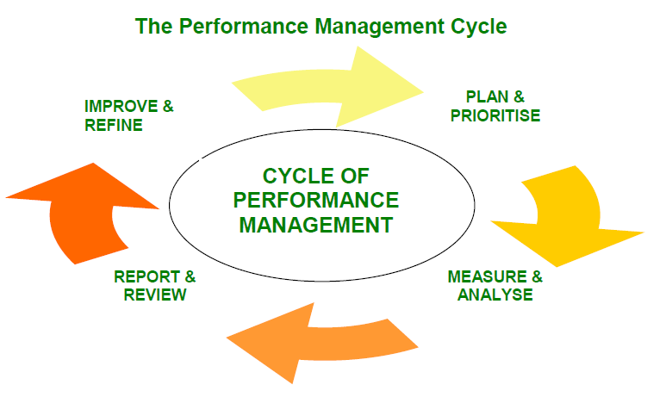

Figure 40 The Performance Management Cycle (Council 2 2016, p1)

## **5.2 Data Collection**

Between March 2017 and April 2017 19 interviews were undertaken at the various offices at the two district councils in the Midlands. All interviews were recorded and transcribed into 152,844 words. This has provided a rich database of comments from a range of personnel. Some having only been at the authority for a few months but the majority of staff having been there for more than 10 years.

|  |  |  |
| --- | --- | --- |
|  | **Length of service** | **Grade** |
| CEO (Interview with Leader) | 4 years | > £100k |
| Leader (Interview with CEO) | 30 years + | N/A |
| Officer Grade 6 | 10 years | 6 |
| Officer Grade 4 | 10 years | 4 |
| Senior Manager Grade 10 | 20 years | 10 |
| Officer Grade 9 | 10 years | 9 |
| Supervisor Grade 6 | 18 years | 6 |
| Senior Officer | 10 years | 10 |
| Head of Service | 19 years | >£50k |
| Apprentice | 2.5 years | Apprentice |
| Member of the controlling group | 6 years | N/A |
| CEO | 18 months | > £100k |
| Assistant Director | 12 years | >£50k |
| Officer Grade 5 (Joint interview) | 9 years | 5 |
| Officer Grade 5 (Joint interview) | 9 months | 5 |
| Officer Grade 5 | 16 years | 5 |
| Assistant Director 2 | 19 years | >£50k |
| Officer Grade 8 | 18 years | Est. 8 |
| Manager Grade 10 | 3 months | 10 |

Figure 41 Summary of interviews undertaken for case studies two and three

The grades and salaries indicate that there is a wide range of levels of staff interviewed along with two elected members. The choice of who to interview was left with the CEO of case study two and the Assistant Director of case study three. It would have been difficult for the author to have chosen the interviewees not knowing the staff or availability. The author requested a range of levels and a range of functions to try to obtain as broad a picture as possible. Due to the length of service most staff were very happy and supportive of their council all bar one who was not happy at all. Both councils were very supportive of this research and were very helpful to the author.

## **5.3 Theme 1 - Stakeholders & Communication.**

One of the issues with analysing strategy and performance in the public sector is finding out who the stakeholders are, what do we know about them and what do they want? How do we know what they want and when did we last speak to them?

The CEO of Council Two says;

“We do a lot of survey work on the public we have what used to be called a citizens panel but it is an online panel…that we regularly consult on various things any changes we are making to services, erm any changes we make to a service like we recently consulted on the opening hours of the public loos at the station, the bus station. And we tried to consult users that we actually know used the facilities rather than just a general panel so we will tailor consultations so they are relevant. We do general surveys” (Transcript p4 l 18-25).

The Head of Service supports this view;

“It [the corporate plan] was developed on the basis of an extensive consultation with with residents I think we had about 1,500 residents involved through a mixture of surveys and sort of focus group workshop type thing … what would your ambitions be if you could write the headlines […] in five years” (Head of Service Council Two Transcript p149, l4-13).

The CEO of Council Three likes the smaller districts than the large unitary authorities;

“Districts know the communities” (CEO Council Three Transcript p209, l25-26).

Council Two go even further and ask the public how they would spend the funds;

“We also did an exercise with the budget showing that these are all the different services how much do you think should be spent in each area then we showed them how much was spent in each area and they say and it didn’t match at all what people wanted to spend in each area so you know that that gauge improves as well” (Head of Service Council Two Transcript p149, l18-22).

The citizens’ panel consist of about 1,000 people and the surveys are either emailed out or posted to them. On the survey for the corporate plan, for Council Two the survey was sent out to over 4,000 people, over 1,000 people responded to the survey that received it and this was approximately a 24% response rate. Although this is low it still provides some very useful information. Council Two invested in consultancy services to collect this feedback thus showing their commitment to wanting to understand the views of the public.

Recently the citizens’ panel for Council Two has been changed to an online panel because it is free “rather than paying 4,000 quid a go for consultation” (Head of Service Council Two Transcript p151, l27-28).

Council Three also use a citizen’s panel of about 500 people;

“We still have a citizen's panel which is, it used to be a thousand people on the panel and we split it between ourselves and [the] County Council. [The] County councils has now pulled out […] we've still got our panel but it's now reduced to 500” (Assistant Director Council Three Transcript p236, l12-20).

As well as the surveys Council Two also have focus groups and community forums. Community forums are;

“Not always at the same venues but somewhere in that area and the public are invited and we have a certain number of topics that we present in a consultative formal information form and at the end we always have a free for all and by that I mean they can ask any questions they like and we endeavour to answer those questions and that involves our partners” (Leader Council Two Transcript p5, l 6-10).

“I mean they are an, a totally excellent way of trying to communicate with our constituents” (Councillor Council Two Transcript p186, l18-19).

Around 40 people attend these meetings and again Council Two will tailor them to the needs of the community by taking them out to villages so they can find out the village view rather than from just the main towns. They also carry out a local member briefing session before the meeting so the councillors are up to date with everything that is happening in the area. So Council Two are very keen to keep in touch with their public. However the issue is getting people to attend;

“The major problem is getting people to go along to them it only really if there's a topic that's likely to be at all controversial that people will come along … but unless it's a topic that is dear to people's heart they won't give up an evening to come” (Councillor Council Two Transcript p186-7, l19-21, 1-2).

Council Three also consult with their stakeholders quite extensively;

“I mean in the past we used to send it to all the other district councils and county councils in … as part of a consultation but we ceased doing that I think you know after CPA went there wasn't say need to have a corporate plan” (Assistant Director Council Three Transcript p239, l6-8).

“Our newspaper our magazine that goes out three times a year and we need a big back page spread on give us your views on what, what you think about our proposed priorities and did it that way the time before we had loads of public events and actually did you know sort of forums and workshops” (Assistant Director Council Three Transcript p233, l23-26).

However this consultation to every household did not yield very much feedback;

“I think we probably had a hundred back and we sent out 34, 000 we also went to parish and town councils and sent it out and we've got strong partnerships local partnerships and we did send it out to people and you know took on board any feedback that they'd got us just as stakeholders but no not a lot of feedback last time I think it was somewhere about 100 no more than” (Assistant Director Council Three Transcript p233-4, l30-31, 1-3).

So it could be apathy on the publics’ behalf or it could be the topic areas in that there is nothing in there that excites the public into action;

“I think unless it's a planning issue if they as you know I mean you know we've had people queuing down this lane here to attend planning meetings but you know there's not there isn't a lot of interest I think it's deteriorated over the years but but we did the exercise and there wasn't many” (Assistant Director Council Three Transcript p234, l6-9).

“Some of it is apathy is now, I think it’s only things that get them hot under the collar isn't it that the, they bothered about now that's when they do turn out otherwise it's well you just expect your bin to be collected and you know everything to be run smoothly” (Assistant Director Council Three Transcript p234, l13-15).

Council Two also like to know what their staff think;

“We do staff surveys every two years. We do consult them on the corporate plan when we consult the public we will hold a staff focus group as well”. (CEO Council Two, Transcript p6, l 24-26).

“Yes I have regular core briefings sort of every four months where I and my management team go out and talk to them about various update them on things that are going on and what-have-you. We have an employee group which I go to which is a group of representatives from all over the council which raise issues and we also use it very much as a consultative forum on things like the corporate plan, policy changes, if we change the sickness policy and things like that … Also we have held, which was very popular, a question and answer session where we allowed them to, anyone to, put anonymous questions into myself and the corporate director and that was really popular and we have over 60 questions and quite hard hitting questions which we then answered we held a session where we sat down and answered them and gave written answers to them as well and they want to repeat that. They liked putting us on the spot” (CEO Council Two, Transcript p7, l 2-13).

The CEO for Council Three also does briefings quarterly. There is positive feedback from the staff and the view that the CEO tailors the talk to each group individually;

“[The CEO] tends to do it for the whole, you know whole of the council so [the CEO] probably does a section at a time like they did all the customer service perhaps together and they'll show us you know what they’re concentrating on how we've done spending you know all that kind of stuff and just gives us an update of what, what they're working towards basically it was quite good actually yeah yeah yeah because we've had them in the past with different CEOs that have been a bit all numbers and we sit very glaze over but [the CEO] was very, just a bit more down to earth” (Grade 5 Officer Council Three Transcript p259, l11-17).

The CEO, of Council Two, wants to be open and transparent and comments that there is not a hidden agenda;

“There are still going to be corridor conversations that go on that things are going on that they don’t know about. Staff always think that something is going on but actually it never is. They think you have an agenda and you haven’t. Sometimes I wish I had but I haven’t”. (CEO Council Two, Transcript p7, l 29-30 – p8 l 1-2).

Council Three also want to know what their staff think;

“We did massive thing on the intranet I think we put it on there and did a survey and they could feedback free text or tick boxes to say we did focus groups as well with managers different groups levels of staff and the unions were invited to that as well” (Assistant Director Council Three Transcript p235, l17-19).

“Our employee survey we do ask questions about how your job links and things like that so it is all there I just think it's probably not as strong as it was a few a few years ago but that is a reflection on you know you've taken jobs out of we've taken posts out we've got less people there's less messages going out you know you haven't got that same sort of push” (Assistant Director Council Three Transcript p246, l10-15).

There is also a weekly bulletin which goes out and officers look at that. How useful it is depends on the content;

“Well this one you can buy a bunk bed or you can just talk about the race that's happening or the walks or more important stuff about parking at the [council offices] because it's a nightmare, the bottom road’s blocked because we can't get through, it’s just communicating to ourselves really about obviously a bit of a chat page within some important stuff thrown in from obviously what's been coming from the directors” (Grade 8 Officer Council Three Transcript p304, l2-6).

However communication to staff is an issue at Council Three;

“I think I get frustrated with like communication through the council we do our side of things and then it's, it's passed on to another department and then the delay getting back to the customers” (Grade 5 Officer Council Three Transcript p256, l16-18).

“You know as things happen or change within the business again it's not always fed down to us I don't think I think it tends to stop around about middle management and then not necessarily sent down to us and you know we're not always kept in the picture I don't think” (Grade 5 Officer Council Three Transcript p270, l11-14).

Council Three have recognised this and set up “Team Innovate” to improve communication. Several officers have volunteered to be part of a team to improve communications. They are also trying to improve the language used and reduce the amount of council language used;

“They did that plain English training they're trying to get people out of talking in jargon and that kind of thing that was one of the things that came out of it and then they do not back to the floor exercise aren’t they some of the senior management team coming into the contact centre with us to like sit with us perhaps on telephones and just get back to basics” (Grade 5 Officer Council Three Transcript p271, l3-7).

The commitment from the senior managers to spend time on the “shop floor” as such was met with enthusiasm from the staff. It means that their voice will be heard.

Minutes of the Heads of Service meetings, at Council Two, are posted online for staff and members to see. The leader is happy with this as the members feel informed and involved.

Council Two also work with partner organisations, groups like the District Councils Network and the special interest group of small rural councils as well as lobbying their Member of Parliament.

“On a formal basis when consulting for the corporate plan with you know the public and members and […] in my own role I obviously do a lot of partnership working so the local strategic partnership the we've got a kind of economic development partnership […] with work a lot with County Council on economic development issues” (Head of Service Council Two Transcript p158, l14-19).

Council Three also have a parish council liaison group, the old local strategic partnership, the links with their county council and they also link into the business community;

“We did specifically have a session for businesses, so we're like have a business breakfast meeting and we took the growth strategy through that business breakfast meeting […] and got feedback but again we didn't get an awful, an awful lot” (Assistant Director Council Three Transcript p235, l10-15).

As a new and incoming CEO, the CEO of Council Three;

“I went to County Hall and I met the chief exec and I met the leader and I said what can I do for you? What can you do for us? You know that was the reality of it. I'm an incoming chief exec I want to make sure we have a positive working relationship with the county, you are the provider of the upper tier services, you provide services for our most vulnerable adults and that's vulnerable children what do you want to keep you sweet but then likewise I'm not always going to agree. I will act as an honest broker between the two” (CEO Council Three Transcript p209-210, l31, 1-6).

The CEO of Council Three was keen to understand the agenda of the upper tier authority as one of the stakeholders. Council Three undertook a very comprehensive programme of consultation with their stakeholders. So would they do this again?

“I'm not convinced that we will be doing as much consultation if we change it this next time because one we've got less staff two we've got less budgets to do it with as well” (Assistant Director Council Three Transcript p235, l28-30).

Although Council Two has made a conscious effort to communicate the strategy it does not seem to reach all staff.

“What’s our strategy? Er no […] I don’t know what the specific strategy is. It’s all about saving money and cutting costs where we can” (Grade 6 Officer at Council Two, Transcript p 22, l14-19).

“Core values and stuff. I know some of it. I don’t always listen to be honest” (Grade 4 Officer, Council Two, Transcript p38, l18).

“I suppose I know our mission statements you know that we're green and clean and affordable housing and encouraging economic expansion I also know that most of the time we're spending our time looking at cutbacks because we have very little money coming in and that basically that has been the case all the time that I've been a councillor” (Councillor Council Two Transcript p183, l5-9).

However when asked about whether they had seen the corporate plan;

“I’ve seen it up in the toilets […] I think others and me would say because they do it every year you look at it and think I’ve seen it once so you probably don’t look at the changes do you see what I mean that’s probably the problem” (Grade 4 Officer, Council Two, Transcript p39, l18-20).

“Broadly aware of it but not sure where my role fits in in the delivery of that” (Grade 9 Officer, Council Two, Transcript p85, l27).

“I can’t reel it off, off the top of my head. Because we work from a depot not from here it’s sort of not, you are not confronted with it much” (Grade 6 Supervisor Council Two, Transcript p104, l7-8).

Again the theme of the quality of staff comes through and how much effort do staff want to put into to find out what is going on;

“I mean probably the best example is you know last night I was at committee community Environment Committee presenting papers there senior management team obviously is quite involved with some of the decisions that are made around the values of the corporate plan and things like that which a lot of the team even you know in services are involved with that but then you know I myself I go out to leisure centres and we do workshops with staff to help them shape what the future looks like as well so it's not you know I don't you know specifically at the top or at the bottom is it's about working through that both ways really you know making sure that communication goes both ways as well so we'll go to corporate leadership team present papers or business proposals on certain things but then those ideas often or come from the staff I work in in our team anyway so it's kind of that role to be you know that link I guess between corporate leadership senior management and the shop floor where all the good stuff happens” (Grade 10 Senior Officer, Council Two, Transcript p123, l8-20).

How far down the organisation does the strategy and corporate plan information cascade;

“Not as much as it should but probably more than people might expect so there's pockets across the organisation who are quite wedded to performance because it affects for instance their their funding or it effects which is the case say with with housing or it might affect their you know whether they get put into special measures by the planning inspector for instance as it might do with the planning indicators and it might affect their service level agreement has as the revenues and benefits one might do so there's there's different parts of the organisation who are quite up on performance stuff there's other parts who who who aren't and and either see it as a chore or because they haven't got any indicators they kind of ignore it all together so yeah they're it's it's it's a mixed picture” (Head of Service Council Two Transcript p153, l4-13).

Staff are aware that the council has improved the communications;

“Yeah they have tried to improve communications but we just don’t know what happens in other parts of the council” (Grade 6 Officer at Council Two, Transcript p 22, l1-2).

However not all staff feel this way;

“That sort of information isn’t passed down readily to people below the corporate leadership team” (Grade 9 Officer Council Two Transcript p85, l7-8).

Still it does depend on how motivated staff are to find out any information;

“There's no excuse for him to say we never get told anything because they do and and you can ask [the CEO] has always said I have an open-door policy so they can’t say we don't know about the structure because we never told they are then they just choose not to be interested” (Grade 6 Supervisor Council Two, Transcript p113, l5-8).

Also it does depend on how diligent and accurately managers want to pass on the information;

“I think our manager takes reasonable notes but I suppose it’s reliant on people at CLT entering into discussions and taking accurate notes and feeding that information in its entirety down to department managers […] so we are reliant on … our manager, sitting in departmental meetings with the head of service taking notes himself and he will just bring those notes with him and say oh yeah we discussed this, I mean last week he said something like “Oh by that time I weren’t really listening” and I think that reflects really how the information is filtered down to us” (Grade 9 Officer Council Two Transcript p93-94, l26-28, 3-7).

This officer admits to being disengaged so whether they are not looking for the information or whether it is really not there is hard to tell. On one hand this officer says;

“What would be useful is that this is our strategy and this is how as a department we are expected to sort of help deliver and meet the councils’ objectives but we don’t get that” (Grade 9 Officer Council Two Transcript p86, l3-5).

Yet on the other hand they state that;

“I feel disengaged I think, It’s the fact that I think well, what’s the point?” (Grade 9 Officer Council Two Transcript P93, l13),

“I’ve got no loyalty with the authority at the moment” (Grade 9 Officer Council Two Transcript p95, l14),

“I haven’t attended the last few [core briefings]” (Grade 9 Officer Council Two Transcript p93, l11),

“I think people are naturally a little bit selfish in that they are only concerned about something that might affect them I must admit that I am not personally interested in the rest of the council I am only interested in my area of work” (Grade 9 Officer Council Two Transcript p96, l15-18).

These comments support the theory that when a member of staff is unhappy it colours all their thoughts and they struggle to be objective.

So how good are the messages going up the hierarchy? Does the communication work upwards?

“Probably not as I don’t really, erm I’m quite low down compared to a lot of other people […] but in my specific role I don’t know really if my voice gets heard if I am honest” (Grade 6 Officer at Council Two, Transcript p 21, l23-26).

This officer did appear to lack confidence about whether their voice would be heard up the hierarchy.

The senior manager interviewed at Council Two has always had confidence that the message will go up the chain as well as down;

“They both [previous and current manager] take their timeout to listen to what you have got to say. I can’t say that I always get back what I want to hear but that’s part and parcel of it” (Grade 10, Senior Manager Council Two Transcript p59, l1-2).

The officer is also realistic enough to know that although the hierarchy may listen they may not react as you want them to.

At Council Two a senior manager summed it up when saying it is his responsibility to understand what is going on;

“I think it's my it's my job and every other departmental manager as a leader for that department is their job to make sure that their staff and their team their voices and their ideas and their good work is gets to the top through that channel because that's what our role is yeah we're we're a service manager but we we're also a voice for our service to make sure that you know corporate leadership chief exec and the corporate director know what's happening on the ground otherwise you know that whole structure from top to bottom doesn't work communication doesn’t work” (Grade 10 Senior Officer Council Two Transcript p128-9, l29-32, 1-3).

“It should be a bottom-up approach not a top-down approach” (Grade 10 Senior Officer Council Two Transcript p126, l12).

Most officers that were interviewed from Council Two did like and appreciate the CEO core briefing. However how much of that briefing was taken on board within their roles and how much was parked and left as a separate event?

“But then after the core briefing we all go back downstairs back to our normal jobs and don’t think about it until the next core briefing so you know it does kind of get lost a bit” (Grade 6 Officer at Council Two, Transcript p 31, l12-14).

“I find it interesting but sometimes I don’t think a lot of it relates to me … not meaning it like selfish but you know what I mean. I find it interesting and I like to know what’s going on but I don’t think I really take it with me if you see what I mean. I’m sort of in the moment person - doing, do you know what I mean?” (Grade 4 Officer Council Two Transcript p45, l11-16).

“They are far more interesting than they used to be because it was very much as you used to sit almost theatre style in rows. … so different managers speak and cover their topic that is relevant at that time. I think they are beneficial because people get it first-hand. … Everybody has an interpretation of something and I do think things can be misconstrued quite easily so I think the core briefings, provided that the people that go listen, you are hearing it from the horse’s mouth, within reason as there is obviously different sessions but you are all hearing it at the same time so there is still that element of misinterpretation but you’ve all been told in the same way rather than [the CEO] telling me and I might have a different take on it and go and tell my guys and then they might talk to someone else in a different section and they might say “oh I was told this oh no that’s not what I was told” so I do think that it stops some of that . … I don’t take everything on board and think oh yeah I’ll factor that in but I do think it’s dependent on the topic itself” (Grade 10, Senior Manager Council Two Transcript p69, l9-24).

Officers at Council Three appreciated the tailored briefing so it was relevant to their roles and they did use the information in their jobs.

“Have that customers coming up to us with queries so we can relate the queries to what [the CEO] said and that informs us better with the customers” (Grade 5 Officer Council Three Transcript p259, l23-25).

The core briefings, for Council Two, were held at the Depot as well where the staff that do not work in the main office start their day;

“They make allowances for that and they do them at 7 in the morning when we start so everybody is at the depot together” (Grade 6 Supervisor, Council Two, Transcript p105, l19-20).

One of the issues that came out of this discussion is the lack of modern online connectivity to the Depot;

“The thing with the the Internet is the certain literacy issues at the depot so that option is not open to people … There’s forty men there there's two computers in the canteen quite old things I can't have forty men all hauling back one day just because they want to look at something” (Grade 6 Supervisor Council Two, Transcript p113, l21-26)

The supervisor at Council Two also does not have a smart phone so when officers were asking why have you not read your emails the supervisor commented that;

“I’ve no access where do I read them up oh they're just assumed it everybody had access” (Grade 6 Supervisor, Council Two, Transcript p114, 23-24).

So through all the communication methods did the strategy appear to be understood by the staff?

“Ok the vision generally because it doesn’t sit with me as parrot fashion because the vision as we layout on the website actually refers to different areas that I am not involved in so I would generally say that from my point of view and from my service area it’s about providing good customer service but the vision of the council I think is to be seen as dealing with things transparently. Providing a good service whether it be bins or illuminations or really generally to have a good ethos that yeah makes it known what we are doing and why we are doing it and I think we are quite good at that as a whole we try to, we do communicate to [our residents] on a regular basis with as much information as possible. Don’t get me wrong there are certain times where things fall down and the message doesn’t come across as it should have done but I would say 80% of the time we are telling people … We have the community forums and the likes and we ask people what they want and we do do quite a bit of that. Getting people in and to ask what they want. Quite bizarrely it is generally different to what is real. One of the prime concerns was the safety and I know I remember looking into it at the time and we had senior managers get together, I think its quarterly, and we discuss the forums that they’ve held and one of them was you know what would you prioritise? Where do you think the public have come back to? And one of them was the community safety aspect of policing and that that was really important but then you looks at the stats and [this area] is like wooooh off the paper [i.e. no crime at all]” (Grade 10, Senior Manager Council Two Transcript p 59-60, l16-30, 1-5).

This is an issue when trying to deliver your stakeholders needs. In the example above the public generally want to see more police out on the streets and it makes them feel safer. However the crime figures are so low the police cannot justify putting their officers there. So how do you satisfy your stakeholder?

“It’s quite difficult to strike that balance that you are seen to be listening and taking on board what they are saying but obviously balancing it as if you have got to put funds into these areas it’s actually there isn’t that much funding required there as there not much need but you have got to be seen by the public that you are spending their money, obviously the council tax and the likes, that you are spending their money transparently and fairly and addressing the issues that they want addressing” (Grade 10, Senior Manager Council Two Transcript p60, l8-14).

A senior officer at Council Two is very loyal and believes that the council fulfils its obligations very well. Although there is a lot of outsourcing there is still the ambition to run services in house for the best service to consumers and thus satisfy stakeholder needs;

“We've become more of a commissioner organization but I do think whenever that topics arisen I think there is a still a desire to actually you know we are a council we do deliver services to the community we deliver good services and I think there's a you know there's an ambition where we can to try and retain that because we need to do something really well we could argue do we do it better than the private sector in some cases” (Grade 10 Senior Officer Council Two, Transcript p127, l19-24).

When it comes to members as stakeholders and officers as stakeholders both councils respect each other. Members respect that the officers are there to give advice and complete the operational tasks and officers get on well with members when they have contact with them;

“Some people tend to tiptoe around them, they’ll just talk to them as normal people” (Grade 6 Supervisor, Council Two, Transcript p109, l11).

“The officer member relationship is good, the member member relationship is good across parties they're very respectful and appreciative of each other and at the same between officers and members too so the working relationships are good” (Head of Service Council Two, Transcript p146, l16-19).

The senior officer interviewed for Council Two believes that the council works in a cross party way for the benefit of the district. Although there is some political posturing the main focus is on the community;

“I think that there is a drive definitely about members being champions in communities and for them to be active in communities supporting championing not just picking up the complaints and sending them through to an officer I think it’s about how can members support the process and enable the process to be better whereby communities are coming forward with what their priorities are how things should run locally” (Grade 10 Senior Officer Council Two Transcript p125, l16-21).

The champions then report back to council meetings and the champions represent all groups and are not just from the controlling group which does support the above officers’ view.

“I get the impression that everyone’s pulling in the same direction yes there’s difficult decisions to make even more so now than ever but I do get the impression that people want to make the right decisions for the right reasons whether they’re a member whether they are someone in corporate leadership team or whether it’s a person doing the job I really get the sense of that from this council” (Grade 10 Senior Officer Council Two Transcript p126, l1-6).

This view is supported by the councillor;

“Both staff and councillors really good at working together you know although it although we are political we're not aggressively political we all really seem to be singing from the same hymn sheet in that we're all trying to do the best for our constituents” (Councillor Council Two, Transcript p193, l27-30).

However in some areas where data protection is needed officers are trying to coach members into a different practice as they cannot tell members confidential details about residents;

“I shouldn't really be telling you it's confidential in its data, that’s so they should be asking for it for a reason you know so we now have a form that councillors should fill in. They don't, they won't fill it in - what is your reason for wanting this information because it's very protecting our data protections there now for everything we do and like I say you can't just keep telling someone that knocks on your door” (Grade 8 Officer Council Three Transcript p299, l24-29).

This has knock on effects for the member to officer relationship in those areas and;

“So the relationships changing it's a bit more distant than it used to be” (Grade 8 Officer Council Three Transcript p300, l4-5).

There is a focus from both councils on the public and employees. With each stakeholder group responding in different ways and with differing levels of interest.

## **5.4 Theme 2 - Strategy & the Corporate Plan**

Most councils have a corporate plan and all three councils in this study have their version of a corporate plan.

“I think the thing is we love authority corporate plans and they tend to follow a rather stock approach so the most corporate plans that I’ve seen will be clean and green and cost-effective services and you know involve people in making our decision an excellent customer service um and what happens is local authorities write a corporate part and stick it on the shelf” (CEO Council Three Transcript p200, l1-5).

“we've always had corporate plans so ever since I've been there …so we've had one for about 12 years and they usually run for four years and they follow the Civic pattern” (Assistant Director Council Three Transcript p231, l9-11).

The danger is that the corporate plan can turn into an industry of its own;

“I think sometimes the plan turns into a process within itself because my my challenge would be to any officer is how many people in the community will read this, it's not particularly easy to understand. When I was at … we turned it into a plan on a page, we've got it on a page and we've got three objectives and three actions and a delivery of those objectives and that was easier for us to go back to because actually what you end up reflecting in the corporate plan, if you're not careful, is your day job so our corporate, corporate aspiration is to provide our customers with excellent service. Well that's industry standard isn't it? It's local government, is public sector these people have no choice where they go for planning, they have no choice where they go to rent, there's no choice where they go for benefit so we should always be providing excellent service so do we really need you know” (CEO Council Three Transcript p200, l8-18).

The CEO of Council Three is very honest about what their thoughts are of the corporate plan they have inherited;

“I don't like this. I inherited it um I don't think it's particularly good, each document, because it's not sharp enough there's a bit too much waffle in there” (CEO Council Three Transcript p200, l23-25).

The officers of Council Three are clear that the CEO is not overly impressed with the current plan:

“We've always gone with a theme so that we've got then consistent graphic messages coming out so this is used then in other sort of publicity when or if we're doing things with a public you know we're talking about customer services would use some of these images so that runs through the, the four years what I would say about our corporate plan is it is a mixture of performance indicators and of more project plan sort of stuff longer-term bigger projects that it's always worked for … we've got a new chief exec [who] doesn't particularly like that approach [and] prefers performance indicators so I think it is one of personal choices isn’t it but the members have liked this …and that's why we've continued with that sort of approach” (Assistant Director Council Three Transcript p231, l17-26).

So do staff know where they fit into the corporate plan and the strategy of the organisation?

“So everyone has an action plan from their PDR and some probably not all the actions will relate back to the corporate plan and stuff certainly relate back to what's in people's individuals departmental service plans … I don’t think we are quite at the stage of like NASA where you ask … what do you do we put a man on the moon” (Head of Service Council Two Transcript p155, l9-16).

“There’s obviously a corporate plan that goes out and then they'll be like a service plan for each service area I presume and that gets fed down like through our appraisals” (Grade 5 Officer Council Three Transcript p258, l4-5).

“I think we fit in every little bit of it because, because the main roles is obviously customer satisfaction well I'm a frontline officer so I deal with customers every day” (Grade 8 Officer Council Three Transcript p299, l2-3).

A discussion that occurs in both councils regards the length of the plan. How long should it be? The Corporate plan for Council Two consists of two pages only;

“So it is short and easily pick-up-able and it's got some high-level things that people can recognize but you know there is a lot of detail in the service plans and and if you hunt on the website you'll be able to find them as well” (Head of Service Council Two Transcript p156, l7-9).

“I think we're we're just stymied into what what we can do so what is the point in trying to achieve a lot of things if there is not the way you know if you know you're not going to be able to achieve them so yes good a short plan that perhaps things that we are going to be able to achieve” (Councillor Council Two Transcript p184, l3-6).

“That's [the corporate plan] also changed quite radically over 18 years because it used to be quite an heavy document lots of phrases but it's now quite bullet pointed” (Grade 8 Officer Council Three Transcript p298, l23-24).

The issue that a council has is that every four years the administration could potentially change depending on the election result however in reality;

“The colour of the flag may change but the personalities within the castle very rarely are different that's the reality of it and that doesn't necessarily you don't find because you have a conservative administration that immediately they privatise everything” (CEO Council Three Transcript p226, l6-9).

Also there is the question of what should be in the corporate plan and should statutory duties be in there as well as aspirational ones?

“it has got some of the stuff that you would expect from a governance point of view or a strategy point of view but not everything so it doesn't say in here that we will you know deliver the medium term financial plan by X cuz we've got to do that anyway but anything new so we've got the Boundary Commission for instance electoral changes as a result of the Boundary Commission by December next year so we knew that that we've got to do it but that was new and it was going to take work so we have put that in so not everything that’s statutory is in in here by any means but it is more the development sort of stuff all the stuff that members of really want to buy into” (Assistant Director Council Three Transcript p248, l14-22).

Council Three is also keen to show that it can adapt and react to changes in the environment and not have to stick rigidly to the plan;

“We're setting out our vision this is what we're planning to do in the next sort of four years but the growth strategy was actually an add-on to this because we realized you know when you started talking about taking business rates out and how are we going to survive with no business rates and stuff like that as a district council that's why we did the growth strategy because we realized that financially we were becoming we could become unviable and therefore that sat at the side of this corporate plan for the first time in 2015 as another approach to how we are going forward and taking our vision you know and what we did so the growth strategy is a separate document but what we actually did was take the three themes from the growth strategy and make those the this aim for the the corporate plan so they are very interlinked” ” (Assistant Director Council Three Transcript p249, l9-19).

One of the ways of communicating the corporate plan to staff is through the setting of targets and the appraisal system. Some officers think this could be improved;

“I think it could be clearer myself I feel like when we have an appraisal obviously they've got the aims down that you know they know it's been trickled down to them obviously I think sometimes how its put across to us could be better I think and I think we kind of say oh it's to do with service plan or corporate aims and it's kind of bit glossed over but that's how I would describe it I think perhaps it ought to be communicated more and more often if that makes sense so we are more aware of it yeah do you know what I mean and I think it comes out with the appraisal but other than that we're just carrying out our role that's how I feel personally I don't think we perhaps tie into it enough I think it could be perhaps at team meetings or whatever via email how are we going to communicate it but I think we could refer to it more” (Grade 5 Officer Council Three Transcript p265, l6-15).

Later on we will see how appraisals are often written and then forgotten about so the suggestions above are sensible and practical to keep the messages alive and loud and clear to the staff.

## **5.5 Theme 3 - Leadership**

The structure of Council Two has a CEO, a corporate director and then several heads of service.

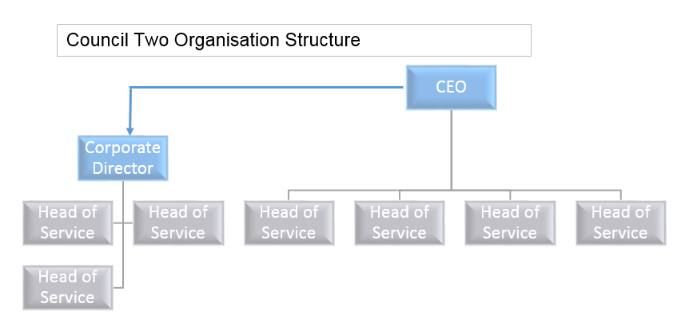

Figure 42 Council Two Organisational Structure

Council three is slightly different as they share services with another council. This structure does appear to be very top heavy but it does cover two district councils.

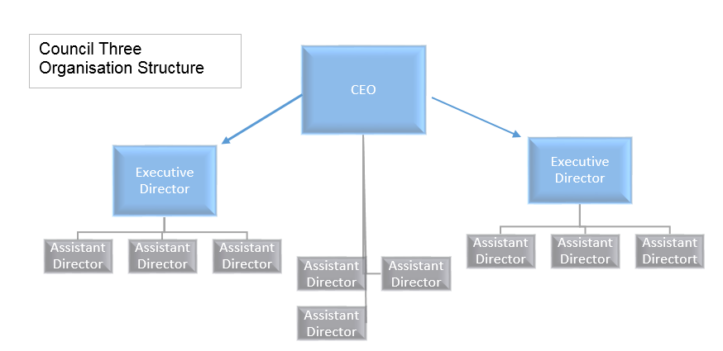

Figure 43 Council Three Organisational Structure

How do officers find the structures and do they work for them. At Council Two a grade 6 officers feels it can be a little unbalanced and unfair at times

“Some people have got lots to look after and some people haven’t got so much and some people have got whatever’s swept at the end” (Transcript p21, l14-16).

Yet another Grade 6 supervisor from Council Two is happy with it;

“From my point of view yes. I mean when you look at this some heads of service deal with a lot” (Grade 6 Supervisor Council Two, Transcript p101, l25-26).

Also another officer is aware that one of the Heads of Service has left and also a potential outsourcing event so comments;

“It will probably need restructuring if or after leisure go” (Grade 4 Officer Council Two, Transcript p37, l24).

A senior manager believes it has changed for the better since the new CEO has joined

“How do I feel about it? It works, erm I am relatively new to it mind you so are we all. Because I’ve been here for such a long time our previous chief exec had a very different work ethic in that … he was more er what’s the word I am looking for, wasn’t dictatorial but he had a set way of doing stuff and knowing what he wanted cascading down whereas the balance now has changed where it’s more diplomatic and cohesive in that they all give their thoughts to whatever gets raised at the Corporate Leadership Team (CLT) and they all give opinions to arrive at a decision which is completely different to how it used to be. It used to be a decision was made and this is how we make it happen and you go away and make it happen whereas now the managers, or service heads rather, have an opinion within that and the decision is made within that team or section. Whether it’s top heavy …possibly but I think that’s more of a reflection of what’s beneath it. What’s beneath it changes regularly” (Grade 10, Senior Manager, Council Two Transcript p57, l14-28).

“I personally really like the way that it works I mean I have worked at other local authorities before this one and I like how officers are left to do their job members don’t get too involved with the day-to-day business and running services” (Grade 10, Senior Officer Council Two Transcript p124,l24-26).

“I think it works quite nicely the thing that I really like about the structure its whether it’s the structure or whether it’s the people or does the structure enable the person to be able to do something but I really like how the chief exec and the corporate director are both visible whether that’s because I have the opportunity to go to corporate leadership and present papers and all that kind of stuff but you know they given the fact that they are you know extremely busy they do they do try to be as visible as possible and I think people that appreciate that I think they spend time to try and do that” (Grade 10, Senior Officer Council Two Transcript p126,l22-29).

“It is very much about being in touch with the workforce and who’s you know who were the people day-to-day running the services so I like the fact that this structure allows that to happen I think sometimes you know when you get a huge organization often people don’t know even who the chief exec is never met them never even have a conversation with them I do think that it creates a tighter more coordinated an organization” (Grade 10, Senior Officer Council Two Transcript p127,l5-10).

“It’s difficult to say … what's the right structure one year might be wrong another year as things as things change … it's a perfectly good structure for for the for the time being whether it is it going to be fit for purpose always, no” (Head of Service Council Two Transcript p147, l4-9).

Another senior officer at Council Two feels that there are too many managers and not enough people to actually do the jobs

“You have got quite a lot of people in head of service sort of positions and you will find that the majority of their time is spent in meetings discussing various issues some of which are not relevant to what their line of work is so it’s not really a good use of their time” (Grade 9 Officer, Council Two Transcript p84,l13-16).

This view is supported by the councillor of Council Two who agrees with the fact that there needs to be more people to do the jobs and they are concerned with the salary bill of the management team;

“I'm concerned that the sort of this level there aren't enough people so I suppose you know I do think possibly it is a little bit top-heavy now” (Councillor Council Two Transcript p185, l6-7).

However the officer quoted above was not happy at the present time working at the council as they felt that they had been taken advantage of and this has coloured their viewpoint.

“I think you need a chief exec and you need a deputy chief exec to provide that strategic oversight but underneath that I am not so sure if you need a leadership team that discusses all council matters” (Grade 9 Officer, Council Two Transcript p84,l13-16).

The author felt that if this member of staff had been recognised and praised more often then this would not have been the view taken. This officer was the only one interviewed from Council Two that was upset with the council and not really happy to be there. However the officer did seem to want monetary bonuses and this does not usually happen within local government.

The CEO of Council Three has an interesting task of being a CEO to an alliance of two district councils and is thus a joint CEO. The CEO is still fairly new having been in the role for 18 months;

“There are two elements to a local authority local authority structures quite often it's how the portfolios are aligned and where areas responsibilities sit but what's more importantly is the people in it so I've got two issues to resolve as an incoming chief exec if you're not on the back of a government commissioners intervention, if you're not on the back of a stinging cpa rating as was, if you're not on the back of some dysfunctional relationship between officers and members then you need to take stock. If you kind of come in when the authorities in a bad position you kind of charged with sorting it out if you're coming when the authorities is generally okay but there were some issues that need to be addressed you've got to develop a plan and my plan is to look at how those portfolios are aligned because if you look I think what has happened is that they've just occurred because the circumstances without any real material planning” (CEO Council Three Transcript p198, l20-31).

In reality the CEO of Council Three has inherited a structure that has taken its shape from not replacing staff after people have left and the remaining officers taking on more duties without any clear strategy;

“Patch management. It's just who's patched it and the challenges that we’re facing now are so significant that we need to get the right skills in place” (CEO Council Three Transcript p208, l31-32).

“Over time you absorb things in don't you get less senior managers you end up absorbing something else in … it's working it's tough because I used to do this job just for one authority and now I'm doing twice as much work for two authorities” (Assistant Director Council Three Transcript p230-1, l23-25, 1-2).

The CEO of Council Three is also a supporter of having a deputy chief executive especially having undertaken that role in the past;

“As a deputy chief exec quite often you are the chief exec by default in many ways because what you end up doing is running the organization and dealing with the not-so-good stuff on a day-to-day basis while he or she is out doing the stuff, the strategic stuff which is what which is actually what you what any chief exec I think needs is he or she needs a deputy who is actually better than them at it because it's so what I found when I was in my previous job is the members always came to me and the chief exec it used to get a bit why are they always coming to you as well one I’m here yeah you know that's quite advantageous but there's that trust and confidence and I am monitoring officer but you should take some confidence from that because actually I'm not plotting and scheming against you I'm enabling you the time to fly, you can get out there, you can meet the developers, you can lobby government, you can do some of the stuff on the skills agenda you will have time to shape [the combined authority] you will have time to lobby you have time to represent you have time to breathe” (CEO Council Three Transcript p217, l2-15).

Officers at Council Three are happy with the structure but feel some senior managers are over utilised;

“I wouldn’t say it was top heavy at all I don't know but so … for instance it seems to be very thinly stress, stretched sorry, stretched in my eyes is you know he's got a lot of people reporting, I suppose, into him so I don't know where his focus you know what I mean like people can only focus on certain things” (Grade 5 Officer Council Three Transcript p268, l20-23).

Also one of the issues for staff at both councils is the flat structure creates very little opportunity for promotion and career progression;

“I thinks it’s flat because obviously doesn't leave room much room for obvious promotion … there's obviously positives and negatives for that in there because I've seen this works because you can get your word down quicker I guess because there's not too many chiefs I just mean for personal you know to actually develop your career I think it's a little not much movement” (Grade 8 Officer Council Three Transcript p297, l19-30).

On the other hand the path to the CEO is shorter and this is an advantage;

“For my perspective at least is that we are quite close to … as chief exec and I think that reflects importance of growth in this district and also that's almost a direct line” (Grade 10 Manager Council Three Transcript p317, l5-7).

The leader of Council Two reiterates the view that Cartwright (1975) had regarding an officer led council “political criticism of them having a throwaway line “This council is officer led eugh” (Leader Council Two, Transcript p3, l 15-16). Both the leader and CEO of Council Two feel that both the officers and members jointly lead the council.

“I would say we are a bit of both respecting each other’s roles as best we can. Making policy decisions but we don’t deal with the operation decisions” (Leader Council Two, Transcript p3, l 8-9).

At Council three the CEO is very clear about who runs the council;

“They [members] say the what and I do the how, that's basically how it works. They, they tell you what their priorities are and you and you in effect deliver that um I don't run the authority I administer the authority’s business I think is the way I put it. They in effect run if you mean run well they lead and they trump me, they trump me. They don't trump my advice so I give advice but I'm there an advisory capacity and on occasions that advice will be stronger than it is in others but ultimately and, and if we ever got to a point where we weren't in agreement and I thought that the fact that we weren't in agreement was going against the principles of common sense or legality then that's when a chief exec moves into the position of making a formal, you know a formal representation is when that doesn't only happens if you are in a very unfortunate position but yeah they said, they set the direction so they do the walk and I do the and I do the how” (CEO Council Three Transcript p204, l9-20).

“I think what a chief exec has to do is make sure that the members are effectively assisting the chief executive in the organisation” (CEO Council Three Transcript p208, l15-16).

“The members at [Council Three] are very, are strong, are vocal and you know if they believe firmly in something because the strength of the … group that will happen yeah but obviously as officers we've still got a duty to come up with the plans point them in the right direction but ultimately they will have that last decision because historically that's what they are the position that they're used to being, being in you know and because of the strength in numbers of the … group you know if … group says this is happening a lot of the time it what that will happen” (Assistant Director Council Three Transcript p237-8, l28-31, 1-3).

The members at Council Three spend a lot of time at the council and treat it as their employment;

“But they are there a lot of the time and the meetings are during the day you see and not many of them actually are in employment so they kind of like that, Council Three historically that's their employment they are there a lot of the time on site” (Assistant Director Council Three Transcript p238, l13-16).

The Officers do have to treat all members fairly however there is a majority group at every council;

“I serve a ruling administration. I, I am here to engage with all members fairly and objectively but I do have to serve the ruling administration” (CEO Council Three Transcript p210, l25-26).

However members can have a multitude of different backgrounds and are not professionally trained to work at the council;

“And in fairness I'll defend the members you’re paid a lot less than us and we are professionals employed to be professional local government officers you know you are lay people you're professionals in your private life but you can't get a degree, where you can't get a qualification but you can't get a degree in being a councillor” (CEO Council Three Transcript p224, l1-5).

The Chief Executives and all other officers have to remain neutral politically. This is often quite difficult as it is easy to quickly label an officer;

“Apolitical ones always difficult as well because you will find sometimes opposition members will, the kind of moment that the ruling group make a decision that there's not rights and chief exec or monitoring officer offers impartial objective advice in line with the Constitution of the law immediately attach a colour to the officer giving it” (CEO Council Three Transcript p210, l19-23).

The danger the officers have is if the opposition think you are not supporting them and you are politically supporting the controlling party then if they are returned to power they will automatically see the officer as not their political colour and remove them;

“I would sooner occasionally upset everyone then just upset a few you know because I think so, so what I mean is if I offer advice at council the conservatives might not like that but actually what the conservatives don't see is actually the leader tore me a strip of afterwards cuz some of the advice I gave negated his cabinet members for finance ability to speak” (CEO Council Three Transcript p211, l13-18).

The CEO of Council Two has only been at the council for around four years and the feedback from staff is positive;

“But especially since … has been here it’s improved” (Grade 6 Officer, Council Two, Transcript, p33, l3-4).

“[The CEO] does try and include us all in anything that she can that is not confidential. Anything she is allowed to talk about she will” (Grade 4 Officer Council Two, Transcript p49, l6-7).

Communication at the Heads of Service level is good according to the Head of Service interviewed;

“Communication within CLT is good obviously we meet weekly and we formed you know pretty good relationships amongst amongst all of us on the on the team there you know the seven well it was eight of us there is now isn’t there and I you know do do do work together pretty well” (Head of Service Council Two Transcript p147, l15-18).

There are managers that do include their staff in discussions about what is happening in the organisation. The staff feel that this is useful and when asked if they liked this one officer said “Yeah because you’ve got an idea of what’s going on then” (Grade 4 Officer Council Two, Transcript p39, l11).

There are also other meetings and groups that happen that are not formally documented;

“But there are various sort of corporate working groups and hubs which different people are involved in so there's a like a communication hub from one of my members of staff is on that there's a IT user group on one of my members of staff on that so there's various other cross departmental working mechanisms as well” (Head of Service Council Two Transcript p148, l4-7).

The discussion of leadership should also include the middle managers. Those that are stuck and sandwiched between the workers and the executive.

“Senior managers in any organisation tend to be both the facilitators and blockers of things” (Head of Service Council Two Transcript p154, l7-8)

It is accentuated even further when a member of staff rises from the rank and file to become a middle manager. The senior manager at Council Two did just that and commented that having been a member of staff for 16 years;

“It has help to understand what they are feeling and sometimes it also helps for me to put that across as it was a bit of a double whammy as it works well because I have that understanding but there was also a time, and I’m still going through it now, where because I have been at that level an acceptance that I am now not that level and I now manage them so I am not autocratic in my leadership in style in any way so that helps but there’s still the element of “Oh you used to be one of us” and it’s quite hard to you have to earn your stripes the hard way” (Grade 10, Senior Manager Council Two Transcript p66, l19-25).

Another senior officer commented;

“For me it's about how you get people involved in encouraging more of the values and the behaviours that we expect within the organization and then all of the good stuff that that breeds how do you then get it out and and share that with people and how do you get staff involved rather than policy officer saying to a department head right I want your I want your service plan done by 1st of whatever here it is and that’s set for ever on report to Council we’ll update at half a year you know it's not about actually doesn't do anything it doesn't it doesn't grow the organization it doesn't grow people it doesn't show people it doesn't do anything in my opinion” (Grade 10 Senior Officer Council Two Transcript p142, l21-28).

This brings it back to the leadership style and also being more business-like and empowering your staff rather than wrapping them up with policies and procedures.

However if the members do not challenge the officers the officers will carry on and do their job as best they can;

“If they're [officers] not challenged they'll do what they think is correct it might not be right but then that's how they've done it and they've not been challenged on here previously so they just carry on but the skill I would say the skillset of senior local government officers it's very different than it was ten years ago” (CEO Council Three Transcript p208, l20-24).

All councils are different and the CEO of Council Three sums up the question of leadership in a council as the;

“Authority should always be member led and officer informed. Yeah so it is, it is difficult but some I’ve worked in a number where it was the officers that were running it in and I’ve worked in a number where it was the members who were running it without ever giving regard to all the officers were telling them and I've been in a couple of others well nobody seemed to be running it in reality you see just seem to kind of muddle on who's in charge you don’t really know” (CEO Council Three Transcript p225, l9-14).

With regards to the leadership of the corporate plan and the performance measurement system there needs to be someone that drives the system forwards and takes accountability for delivering it. At Council Three there is such a person;

“I would sooner say it's because we do hold ourselves to account but you've got to have somebody doing that haven't you? You've got to have somebody that drives that and that's been driven by me and my department you know and that could easily slip couldn't it? If, if somebody didn't drive it and the members weren't that bothered then you know it that could quite easily go” (Assistant Director Council Three Transcript p247, l10-14).

## **5.6 Theme 4 - Transparency and External Perception**

All staff and members interviewed were asked if they thought their council was successful. All staff, even those not very happy, were fiercely loyal and said yes they believed they were successful.

The leader of Council Two commented that “Well we think we are but how do we know?” (Transcript p16, l21). After thinking for a few minutes the leader continues;

“Generally the public are pretty satisfied. I mean you had some people say that on Tuesday night” (Transcript p17, l4-5).

The leader was referring to the community forum meeting where the CEO, Leader and senior officers go out to see the public about various local issues.

The CEO also comments

“We’ve tested ourselves externally with peer reviews. We’ve used the LGA* peer review process” (CEO Council Two Transcript p16, l22-23).

This is quite a proactive thing to do as the sector at the moment are bemoaning the fact that one out of three councils have yet to sign up to this and the initiative has been running for over six years (Peters 2017). (*LGA in this context is Local Government Association).

Another method to gauge how satisfied the public are with a council is to monitor how many letters of complaint are received;

“We report to members on the number of complaints we get every year through our formal complaints process” (CEO Council Two, Transcript p17, l8-9).

The CEO was pleased that this year the ombudsman did not accept any of the complaints “That to me from my point of view tells me that at least we are getting things right” (CEO Council Two, Transcript p17, l16-17).

However in the arena of Environmental Health one officer states that;

“The bulk of our work is people contacting the council asking us to look into problems with noise or abandoned vehicles yeah so if it wasn’t for the public making complaints I wouldn’t have a job” (Grade 6 Officer, Council Two , Transcript p23, l9-11).

However the same officer is very realistic regarding the public’s perception of the council;

“Often you can’t really satisfy anyone. People will ring up and say why have I had this letter about noise and then the other side say why are you not doing anything about my complaint, it’s barking again that dog so you know often we can’t satisfy both parties” (Grade 6 Officer, Council Two, Transcript p23, l25-28).

The senior manager of Council Two also comments that the public are starting to see a reduction in services;

“For quite some time [the council] have provided a gold service in the majority of things that they did. Don’t get me wrong not all the time far from perfect, I am not building them up to that length, but members of the public did generally receive a gold service and I think now it’s for financial reasons and that being the main one really and probably facing between a bronze and a silver but it’s still a good service and I’ve found that internally as well so especially from becoming centralised with the admin some sections had platinum, somebody to take the minutes, somebody to attend meetings to make them a drink it was just beyond and then you go to another section and they didn’t have any but the ones that had got this super service were thinking oh no” (Grade 10, Senior Manager Council Two Transcript p73, l19-28).

“Members of the public see it through the news that we are facing cuts but don’t actually put that into the realisation that means some things we can’t actually do now” (Grade 10, Senior Manager Council Two Transcript p74, l4-5).

“I think people’s opinion is very very valuable so do we ask the public’s opinion you probably know what but most of the public think we’re paying too much and we’re not getting enough but I think we are successful yeah yeah the streets look clean when you drive around grass still gets cut not as often” (Grade 6 Supervisor Council Two Transcript p115, l23-26).

The senior manager of Council Two feels the council is more open than it used to be;

“I think we probably know far more than we ever did. I think they are quite a lot more open than we used to be as an authority and I think some of that is circumstance that we’ve got to be for everybody to understand what we are facing” (Grade 10, Senior Manager Council Two Transcript p70-71, l28-30, 1).

From the members point of view;

“At the end of the day our test is in the elections and whether they are prepared to give us another shot and they have for the last x years. I think in general terms the public think the council is well run to their benefit and accept it” (Leader Council Two, Transcript p17, l19-22).

The leader continues to discuss a well-known issue with a council in the area and that everyone sees that as a “Basket case” (Transcript p17, l28) however their council is “basically regarded fairly well” (Transcript p17, l29-30).

Being successful is all about working with the communities;

“I think it's more about the way then you go about doing that isn't it so if the certain communities that are more deprived or you know they have certain issues affecting them it's about working with them rather than imposing stuff on them” (Grade 10 Senior Officer Council Two Transcript p134, l23-26).

Staff believe the council is successful;

“I think you know statistics prove that it's a great place to live and work I think and visit you know thousands to millions of visitors every year” (Grade 10 Senior Officer Council Two Transcript p134, l12-14).

“I think as a whole I think it's quite successful yeah” (Grade 5 Officer Council Three Transcript p269, l9).

There is also the transparency in the officer core and the whether they can act in an independent way irrespective of their politics;

“There is a new skill of senior officers to be able to throw themselves into that tangled web of politics but not necessarily get caught in it” (CEO Council Three Transcript p210, l15-16).

“The reality, it is successful but it's not as successful as it could be and, and, and it's not releasing the talent” (CEO Council Three Transcript p216, l15-16).

Council Three feel that their corporate plan has been a quality document over the last decade and that the public like it. The plan has;

“Had a lot of credit to it you know when we've had external assessments people have said all really like how you do it how you keep the themes going you know so it's had a lot of credibility” (Assistant Director Council Three Transcript p236, l2-4).

The councils do use many policies to set out how the council should work. This can end up being very confusing for both officers and the public;

“We had a grass cutting policy, we had an hedge cutting policy, a tree pruning policy, we had a this policy, that policy, we had a bulky policy, we had a larger bin policy, we had a waste collection policy, we had a recycling policy, … so all I've done is, is just condense them all into one so the waste joint waste collection policy now contains everything, sets it all out so if I'm updating I’m only updating one” (Assistant Director 2 Council Three Transcript p290, l12-19).

The officer also talks to members;

“But before I do with that I sit down with my members yeah, yeah this is where I want to go with this is what I want to know yeah fine that's it yeah work closely with them” (Assistant Director 2 Council Three Transcript p290, l24-26).

All the officers at Council Three confirm that they have a strong group of members that are very hands on and involved.

Everyone interviewed, with the exception of one, were happy and proud to work for their council;

“It’s a really nice council to work for I think people care about the districts I think that's massively important” (Grade 10 Manager Council Three Transcript p329, l16-17).

“I went down the mines for seven eight years so I do know hard working conditions then they all closed down, went into factories just as bad so when obviously you feel like you mature and you learn new skills you do recognize how nice the company is like this” (Grade 8 Officer Council Three Transcript p295, l15-18).

“I can’t think of a better place to work” (Grade 6 Supervisor Council Two Transcript p100, l2).

## **5.7 Theme 5 - Austerity, Resilience & Business-Like**

All staff and members interviewed were very much aware of the financial constraints that are currently affecting local government.

“I was running a workshop with staff this morning and we were saying that the financial stranglehold that’s getting tighter and tighter may force us to visit our priorities again” (CEO Council Two, Transcript p15, l19-21).

The knowledge of the financial constraints is a theme which has truly reached everyone in all of the councils. A grade 6 officer in Council Two comments;

“Each team has to look at how you can save money you know in the long run we can’t waste it any more … Not that we ever did but you know” (Transcript p30, l13-17).

“[The CEO] also keeps us quite informed with the budget you know and the cuts and everything. That was a big thing in the last core briefing so I know quite a bit about that that we might have to change or save 2% or 10% all the heads of service had to do a what if for that if you know what I mean to look at savings” (Grade 4 Officer, Council Two, Transcript p38, l22-26).

“Obviously restricts enormously what we can do I mean that again it is coming down to only being able to provide a lot of statutory obligations as opposed to enhancements” (Councillor Council Two Transcript p183, l12-15).

“It’s very, very tough at the minute. It’s, when I started it was nearly perfect. There was money available now it’s quite tight and we can’t, we can’t really do what we’d like to do because of budget restraints. We have to cut back on a lot of things and from seeing how it was to seeing what we have to do now it’s quite disappointing but I understand that’s what we have to do… one example is grounds, grass mowing is not done as often and to the same standard as it was.” (Grade 6 Supervisor, Council Two, Transcript p100, l4-11).

“I don't love my job as much as I did. I think that's the, the climate in which we are find ourselves in local government” (Assistant Director Council Three Transcript p230, l9-11).

Clearly officers are now starting to feel the impact of the austerity:

“Well we’re always busy and I think now when people leave we don’t always replace them. We are busy and I don’t know if we could cope with any less staff but they are always looking I think they want to save another 10% at least but I think how can we save more money?” (Grade 6 Officer Council Two, Transcript p 29, l5-8).

“I think it gives you something to think about because our head of service … she got us all involved in it so we all had to think of ways” (Grade 4 Officer, Council Two, Transcript p39, l1-2).

“It’s become leaner over over recent times” (Grade 10 Senior Officer Council Two Transcript p127, l12).

“Everybody I talk to are envious of housing staff it's obviously we're in the HRA fund and everybody else is in a corporate fund that is really tightened down and you can't spend a penny” (Grade 8 Officer Council Three Transcript p313, l4-6).

At the moment the officers are comfortable with the cuts but it cannot be said it will remain so;

“We are having to cut a lot and people have really been hit hard whereas we can do our job at the moment. We do not have to cut corners we are still doing everything as thoroughly as we can”. (Grade 6 Officer Council Two, Transcript p 33, l24-27).

However the CEO has been very positive and reassuring for the staff;

“[The CEO] has said that we are in a better position than some councils and that we’ve got reserves and things where we have saved before so that makes you feel a bit better if that makes sense” (Grade 4 Officer, Council Two, Transcript p47, l21-24).

As well as cutting costs both councils are on the lookout for investment opportunities and ways to generate some income;

“We have been asked how can we create, can we start charging for more the services we do” (Grade 6 Officer Council Two, Transcript p 29, l 11-12).

Council Two are continually reviewing areas and some staff seem to get weary of this however;

“Why we review things so regularly and you can see people go “oh not another review” but actually yeah we need to because we need to make sure we can keep on track and see if there’s a better way of working or earning more money or cutting something that we don’t need to do out” (Grade 10, Senior Manager Council Two, Transcript p70, l2-6).

A popular buzz word at the moment is resilience and how well placed are councils to survive the austerity cuts. In order to save money and increase resilience Council Two pooled their administrative people into a central team a few years ago;

“We’ve created a team of really quite high resilience” (Grade 10, Senior Manager, Council Two, Transcript p55, l6-7).

“We managed to do this without any redundancies throughout this period we made £230,000 savings by what we did” (Grade 10, Senior Manager, Council Two, Transcript p78, l1-2).

“So yeah we’ve created far, far more resilience. Yeah we should be proud of that we have created a lot of resilience where there was none so we can continue to provide a service that in some instances will have stopped but it has watered down the ownership and the expertise in certain areas where one person would know the particular section inside and out and obviously that is really quite diluted now as there will be four or five that deal with that section that haven’t got that intensity of knowledge” (Grade 10, Senior Manager, Council Two, Transcript p79, l6-11).

Council Three is part of an alliance of two councils;

“Come a long long long long way in terms of meeting that I say financial climate … and you're talking about 1.7 million pounds worth of top slice savings” (Assistant Director 2 Council Three Transcript p291, l17-21)

The officers are very keen to be able to be ready to expand when it is necessary. More houses are coming so for example the bin routes have been set so they can cope with the extra activity without having to rearrange them at the last minute. Staff are being spread across two authorities which provides more resilience and flexibility. Expensive equipment is being shared. Everyone is focussed on surviving the long term. Even with making all these changes the customer is happy with the service;

“We’ve got high Customer satisfaction ratings for front line services … we have got very good Customer satisfaction ratings and that's pleasing because when you start making big service changes and moving things about” (Assistant Director 2 Council Three Transcript p293-4, l29-32, 1-2)

In the non-statutory areas the need to procure funding has been around for a long time.

“Obviously we're all non-statutory our department so there's kind of that whole understanding of the fact that we are not statutory and you know as the budget in the bigger picture gets tighter non-statutory services are you know the ones that are naturally going to be scrutinized” (Grade 10, Senior Officer, Council Two, Transcript p132, l7-10)

“We've got one funded core funded officer who's a health and sport development officer the rest of the team we were all of the six or seven staff they're all externally funded” (Grade 10, Senior Officer, Council Two, Transcript p132, l15-17)

Here the senior officer is proving the worth of the investment of one core funded officer. Buy one and get six free in effect. The amount of impact a team of seven can have against a team of one will help them to continue to secure the funding for the original officer. The team have a good track record in delivering services which provides evidence for funders to part with their cash. Once in the funding cycle it is easier to keep the money coming in. The commitment of Council Two funding the first officer in 2007 has driven this income generation. The senior officer comments that it is about;

“It’s keeping that in mind for a council when the savings agenda is so aggressive” (Grade 10, Senior Officer, Council Two, Transcript p137, l31-32).

“Being a little bit more commercially savvy I think and running things in a more commercial commercially minded way” (Grade 10, Senior Officer, Council Two, Transcript p133, l5-6).

“I think it's just I think it really is about how a leadership that encourage it that are really open and encouraging of people to try new ideas to think what business like to be smarter in the way that you work and help to put a framework in place for that to happen” (Grade 10, Senior Officer, Council Two, Transcript p134, l1-4).

Every person interviewed was aware of the financial stress that councils are under at the moment. A year is a long time in the scheme of things and often targets will need to be reviewed during the year;

“We're going to have a members workshop this September to review the future priorities and direction of the council in the light of our ever tightening financial position so current climate the likelihood is there'll be fewer things in the corporate plan going forwards not not additional things added I think that’s about being realistic” (Head of Service Council Two Transcript p162, l18-22).

So along with being resilient and having to find monetary savings another change in councils is that they are becoming more business-like. Staff are using the term business-like more often;

“You have a council procedural section within your constitution you have rules of debate the rules of the debate are there to provide a political debate but also ensure that it's business-like” (CEO Council Three Transcript p211, l28-30).

Staff are also being asked for their ideas about how to improve the organisation;

“We are always talking to staff as my manager talk to me about ideas for growth for transforming the organization just to make it better basically make it more more accountable” (Grade 8 Officer Council Three Transcript p299, l6-9).

There is a view from some staff that the organisation is open to suggestions and supports the creation of new ideas;

“You know we are doing a job we use our initiative and we are thanked for it we do get praised” (Grade 8 Officer Council Three Transcript p301, l12-13).

## **5.8 Theme 6 - Balanced Measures & What Measures Are Chosen.**

Most local authorities are fixated by measures and targets, a throwback from the CPA and the national indicator set. Today there are no rules and

“We’re no longer measured on CPA why do you need so many indicators government inspectors aren’t coming. They aren’t interested any more” (CEO Council Three, Transcript p220, l22-24).

When asked if performance measures are really needed and if we had the right staff in the right roles wouldn’t that be enough the Head of Service at Council Two replied “how do you know you've got the right people in the right jobs” (Transcript p160, l25).

“I think we've got it about right from going from having hundreds of national indicators to go into it we've got about you know 20 of which nine are corporate targets that change every year because that's what members make the promises to residents about and 20 are measures which measure what's relevant just to check on the whole just to check we're doing all right as an organization I think that's about right you know in ten years ago I had a full-time officer doing performance management for me now I have a one day a week person do performance management and I think that's about right it works if there was any less than that we wouldn't do any at all but I think that's about right” (Head of Service Council Two Transcript p161, l1-9).

When asked how do you decide what to measure the CEO of Council Two explains;

“What we do as officers is we have got we take these and we debate particularly the heads of service who deliver the priority issues we debate with them what are the key targets we need to achieve on an annual basis to say that we are succeeding on these priorities. So for example under the affordable housing we have a target of delivering so many affordable housing units during the year. I have to say that when I reflect on that I don’t thinks it’s a particularly stretching target because we generally know what affordable houses are coming on stream over the next few years though we put them in because it’s almost a measure of how on top of it we are the programs do slip [[[...]]] So the heads of service will sit and think about these targets and think about how can we measure and we do actually have quite painful discussions about what can we really measure? Is that an outcome or an output? And then we will put those targets and measures to members and members will agree or not. I have never known them not to agree” (CEO Council Two, Transcript p9 l21 – p10 l11).

When probed further on the issue of members challenging the officers choice of targets;

“We challenge as to why a particular measure has not been met but to be fair the officers usually have an explanation” (Leader Council two, Transcript p10, l13-15).

“But I’ve never known a member challenge us in terms of the targets and measures” (CEO Council Two, Transcript p10, l23-24).

“That's what members wanted in here so we've accommodated that wherever possible that if that is a strong preference then we've put that in” (Assistant Director Council Three Transcript p232, l8-10).

For Council Three members make sure their favourite targets such as dog fouling still make it into the corporate plan. For Council Two the officers are choosing the targets and the members are happy with them and are not challenging or asking as to why they are a target. The leader of Council Two was not overly clear that this could be challenged and asked the question;

“We could ask why are we measuring this.” (Leader Council Two, Transcript p10, l25).

The CEO was happy to accept challenges and in mitigation for the members the leader commented that the measures link to the corporate plan that the members have set. However underlying tone from the CEO is that they would welcome more challenges from members.

“Officers don't just decide on their own to do this it has to come to a committee first as to what our targets are going to be then how we're going to try and engage” (Councillor Council Two Transcript p188, l12-13).

In Council Three it is “generally officers” (CEO Council Three Transcript p206, l24) that choose the measures. However Council Three have a very strong set of members with certain measures that they want to see on the corporate plan and that they will not relinquish such as dog fouling and clean streets. However the CEO disagrees with having a strategic focus on these areas;

“If the streets aren't clean here I'm pretty sure you'll [members] tell us so why do I need an indicator on the level of street cleaning” (CEO Council Three Transcript p206-7, l31-32, 1).

“Do you really want to be managing you know, you don't want to be having performance reporting on dog fouling and detritus” (CEO Council Three Transcript p218, l17-18).

The CEO of Council Three tries to guide his members into looking at more strategic indicators;

“Wouldn’t you be better than knowing about how much income we've got coming in” (CEO Council Three Transcript p218, l20-21).

The CEO of Council Three would like it if members would challenge more. Cabinet members often sit in on meetings and the CEO does not feel there is enough challenge;

“Have a member sitting on them generally a cabinet member sitting, said cabinet member looks bored to tears in reality that's the honesty of it you know and he’s not necessarily giving a great deal of challenge” (CEO Council Three Transcript p203, l17-20).

“They are interested and they are engaged and they they participate I don't think they participate so much in the performance management perhaps as much as I'd like them to because as a chief exec it gets a bit tiring having to challenge your own officer core sometimes you think well actually I would like the members to do a little bit more of this because they are the community advocates you know and I'm just seen constantly as a bit of a bad boy well why sickness up you know I want you to resolve it so why is this the problem why we overspending why aren’t we delivering why have we got long queues in the customer service centre you know why can't we get any parking spaces but you know but that but that but but and I think the problem is is that they've created a system which was well intended at the time but no longer really fits the purpose” (CEO Council Three Transcript p204, l22-32).

The CEO of Council Three wants members to pick up on results and ask questions rather than just be satisfied with the explanation or even excuse;

“One of the indicators through a program of targeted refurbishments, bring 15 empty private sector properties back into use and then let’s have a look one target has been flagged up as an alert target not met nine units brought back into use. The reason why we didn't meet that target is because we had a vacancy on the empty properties officer and you know the disappointing facts on that is that the members didn't really push you know but then again how satisfactory is that as a comment … so what I would have wanted is alright then so you've only got nine so what you gonna do about it? Is 15 too much?” (CEO Council Three Transcript p205, l9-18).

Moving on from this and discussing more about the choice of measures the question is posed of how are the measures calculated and do they choose measures which are easy to calculate or already have the measure in place. The CEO of Council Two comments that;

“Certainly at officer level we have had discussions about how do we measure that and so what we have tried to do is to come up with targets that we can actually measure as opposed to intangibles. So we have had that difficult conversations of is that really a measure, have we successfully invigorated market towns? Then we think well what else could we measure so we do have those conversations”. (Transcript p12, l1-5).

The CEO of Council Three feels the way the indicators are calculated should be very clear;

“I think one of the biggest problems I would say on the performance management framework quite often is um how is the target, what is the target and why and how is that target calculated … we used to have one and we to this day at [previous council] we used to laugh about it cuz it was in the corporate plan and we didn't really know what it meant so we used to think well you can just put any figure down nobody would know and one member actually with some savvy after I said well member said well hang on a minute how is that figure calculated what does that figure mean?” (CEO Council Three Transcript p205, l21-31).

The CEO of Council Three has come across examples of difficult to understand measures;

“And some of these in here are absolutely for me but absolutely unclear. We have one, so economic growth is a priority area to us, fundamental to our survival and is fundamental to our financing, so we've got in here process all major planning applications 10% better than the minimum for special measures per annum. First thing I said is what does that mean? What I would want to know is process all major planning applications within eight weeks yeah percentage of planning applications [...] as that's a bit like this is only any use to if you, if you are steeped in local government and what I would say how fair is that a measure to enable the community but more so the elected members as community advocates and laypeople to understand how well we are delivering or is that written in a way that actually nobody truly understand what it means because this is a challenge. I thought it, I don't understand what that means and I’ve got 30 years of service I don't know what special measures mean all I know is that if there's a minor planning application that's my understanding it should be dealt with within 8 weeks if its major should be dealt within 13 weeks if it's beyond 13 weeks and we don't reach agreement with the developer we can get into trouble for non-determination. Now what I want to know is if we're not turning major applications and minor applications round in those timescales what other reasons do I need to investigate, have I got lazy planners? Have I got policies which aren’t fit for purpose? Have I got members who are frustrating that process unnecessarily? That's what I need” (CEO Council Three Transcript p206, l1-22).

As we have seen in the stakeholder section Council Two are very active in seeking the views of the public however there do not appear to be any customer satisfaction targets in the measures that are reported to the members. When asked why not the CEO of Council Two said;

“I don’t know to be quite honest …I think those distilled out of the best value performance indicators you know when there were 220 indicators we had to publish, I think those key performance indicators have been distilled out of that. The government also had the public survey that you had to do every year and that’s gone and we have replaced it with our own public survey and then we have got these which are showing how we are trying to deliver our corporate priorities and I don’t think there is any particular reason or thinking about why we haven’t joined them all together we just haven’t” (Transcript p14, l13-23).

“All the KPI is the the 20 odd KPI is probably are and they are largely vestiges of the old national indicators performance indicators that they were then and they tend to be we try to get them to cover the the high-profile public facing services but they are also what's practically measurable so that you know they cover revenues and benefits they cover planning performance to cover invoice returns and and so on and they are things that are quantifiable and they do measure the health of the organization as well you know in fact we pay our invoices on average within seven point eight days at the moment is it shows I think that we are a healthy organization we treat suppliers well the fact that our sickness levels are above eight days at the moment we want to be below eight days shows that we need to perhaps work a bit harder on that” (Head of Service Council Two Transcript p151, l5-14).

Council Two gain very positive scores from their customer satisfaction surveys plus they carry out refuse surveys every six months. If anything was going wrong they would know about it as officers but would members? The service plans are also very detailed with operational targets. Members get to see these when the targets are chosen but do not get to see how the performance is tracking as results do not go back to the full council.

Further down the hierarchy in Council Two a grade 6 officer is asked about targets;

“I know what you mean but it tends to just happen as we get complaints coming in week after week and we have to get and we know we have a duty to do it” (Grade 6 Officer, Council Two Transcript p25, l14-15).

When further asked about what targets are put on the individual appraisal the officer said;

“Yeah but it’s generally just to try and organise your workload a bit better and maybe a couple of courses that might be beneficial if they come up, to train and get more knowledge. Er targets, yeah there are targets set every year but we tend to do the same every year really” (Grade 6 Officer, Council Two Transcript p26, l10-13).

When asked about whether the officer had thought about how to improve their performance;

“Do we look into how to improve, I guess we don’t really look into how can we improve things and look into complaints more efficiently. It might come up every now and again if something is taking a lot longer can we do it things quicker but we don’t really look at it much if I am honest” (Grade 6 Officer, Council Two Transcript p25, l26-29).

The officer went onto discuss how it is hard to evaluate performance in this area. If complaints are resolved amicably then there is no formal notice issued.

“Yeah I think it’s quite hard to rate our performance in a way as we can get a good result but it might not get flagged up as like oh yea that notice was served and it was complied with. We just asked them to do it nicely and they did it, you know but it might not flag up as a notice served you know so. We get a lot of freedom of information requests to see how many notices we have served and we think well we’ve not served that many because we’ve not had to we’ve solved it without doing it you know. So sometimes it can be quite hard to really prove our performance we can only possibly do it on going into a lot of detail on our workload maybe” (Grade 6 Officer, Council Two Transcript p27-28, l27-30 1-4).

So this area of work does bring some interesting questions in regarding how to measure the performance. The officer does know the KPI’s exist due to the core briefing but is not sure what they consist of;

“Our head of the team … is always talking about performance indicators as he has to do a lot of reports and things. He might do a lot more than I realise he is doing you know” (Grade 6 Officer, Council Two Transcript p32, l20-22).

On the other hand an officer is very involved in producing information for their managers’ targets. When asked if the officer knew where they fitted into the corporate plan the officer replied;

“Well probably not me personally but I’ve got me own little ones but I am helping towards [my managers]’ if you see what I mean like one of hers was to bring sickness levels down so I’ve helped towards that as I do all the paperwork for the reviews” (Grade 4 Officer Council Two, Transcript p41, l13-15).

Council two are very keen for all officers to have appraisals and the information as to who has completed them is collated;

“Like log them and then chase heads of service. I have to calculate a percentage of how many are back and stuff like that … casual workers are offered one but they don’t really. I think last year something like 80 something percent came back but we are getting better every year” (Grade 4 Officer Council Two, Transcript p42, l5-10).

However are appraisals a good way to ensure targets are met over the year as;

“I am nearly ready for a new [appraisal] one so it’s hard to remember as you don’t look at it do you after you have done one” (Grade 4 Officer Council Two, Transcript p42, l17-18).

“I mean having not seen one for a year now. Yeah basically my goals should relate to that stuff on there. I can’t remember what I put for my work related goals to be honest” (Grade 6 Supervisor, Council Two, Transcript p105, l1-3).

“Yeah I’ve got it printed off in a drawer, I’ve just not looked at it in a while” (Apprentice Council Two Transcript p170, l16).

Also it does depend on how managers use the appraisals;

“It was so generic last time that our manager that conducted it all and carried out the appraisal he just scored everyone the same because he didn’t want people to think that anyone had performed better than anyone else. So it was a totally pointless exercise” (Grade 9 Officer Council Two Transcript p91-92, l27-28, 1-2).

“A mixture of six month and an appraisal …but the risk of being critical and much of it is just seems to be a copy of the job description in this sense” (Grade 10 Manager Council Three Transcript p324, l23-25).

The appraisals at Council Two now appear to be graded from 1-5 overall, which explains the above comment. When asked if this methods works;

“Probably not. I am sure that people will always think that they have done better. I think I got 3 which was either good or very good and I did think to myself at the time well that night I got called out at 2 in the morning when the alarm was going off I can’t say I want that score” (Grade 6 Supervisor, Council Two, Transcript p108, l4-9).

Interestingly the senior manager at Council Two has not been involved in the choice of targets for her team. She is happy with them and the evidence suggests that because she was new into the management role when the team was set up that the manager above set the targets. They are soft targets based on customer satisfaction. The customers are often internal members of staff as well as residents contacting the council.

There are some hard targets such as answering the phone within 10 seconds at Council Two. Interestingly Council Three have to answer within 30 seconds and are considering moving it to 40 seconds.

“Actually, the most people will wait longer than 30 seconds … so the reality is are we beating up ourselves unnecessarily” (CEO Council Three Transcript p207, l9-12).

There is a discrepancy here in the data as the officers with the telephone targets in their appraisals comment that;

“We’ve got to achieve 80% of answering our telephone calls within 20 seconds” (Grade 5 Officer Council Three Transcript p261, l6-7).

Although this is a good aspiration to have, to not keep the customer waiting, it is the answer provided to the customer that influences the customer satisfaction rating.

“The problem with that is that people are quite focussed on the purpose of their call so I am trying to establish whether the service my team are providing is a good one, the people that we speak to that are completing the questionnaires are responding on the service that they are directing it at. Whilst my team facilitate that the majority of people, just for an example planning, somebody rings up and wants to check on their planning application and it’s not going as they want it to go so they ignore all the run up to speaking to planning, they don’t take notice of how they were dealt with their focus is on the actual outcome” (Grade 10, Senior Manager Council Two Transcript p62-63, l25-30, 1-2).

So the difficulty here is splitting the customer satisfaction rating over the different departments of the council. To the consumer it is all one organisation.

The telephone statistics will identify those staff that are working hard and taking many calls compared to those not working as hard. However it doesn’t account for the quality of the calls. However the CEO of Council Three likes the hard targets;

“What we ought to have on there is how quickly we answer the the phone, how quickly we respond to letters, How quickly we deal with benefits claims you know those are the kind of things that I think we need more of” (CEO Council Three Transcript p201, l23-26).

However the customer services team at Council Three do have a subjective target to achieve;

“We get assessed on customer excellence in fact it’s due isn't in April so and in an external body comes in and we provide information for our department evidence of exceptional customer service it could be emails it could just be a scenario that we've dealt with that we've reported back so each department so including benefits all the way through the Council they all have to submit similar or different types of evidence and the independent person looks at all that information and they award us with like a customer excellence” (Grade 5 Officer Council Three Transcript p261, l17-23).

When asked if this makes them consciously deliver a better service;

“It’s just what we are used to, to be fair. I’ve never really, it's just kind of one of those things that happens every year because we have to maintain because we because we are an excellent, we, we do have to maintain that so he comes in each year so all year round we are conscious of gaining evidence to prove what we're doing you know to go that extra mile or whatever” (Grade 5 Officer Council Three Transcript p261-2, l28-29, 1-3).

“It’s the person you are if you want to do a good job you'll do it anyway and this is just evidencing what we've done” (Grade 5 Officer Council Three Transcript p262, l9-10).

This supports the comments that the quality and motivation of staff is vital to deliver key services.

However quality of service does not appeared to be measured for areas like grass cutting;

“How we are measured is, my grass verges required 13 cuts this year how many did we do yes it's measured like that … nobody goes out with something like that and says well this should be a five or I'm on a given you a one you know if if me or one of the supervisors just drives past or manager drives past and it's cut neatly and grasses swept off the path that's good if they've got grass all over the path or not to swept well …” (Grade 6 Supervisor Council Two, Transcript p116-117, l28-29, 2-5).

At Council Three previously there were issues with the performance of the grass cutting services;

“So we've introduced a measured scheme of works into [Council Three] so all the grass cutting roots are pre measured using a work-study time approaches. There's a lot of issues when we first came to work in [Council Three] about the guys were on a 10 day mowing route, if they, in actual they got 14 days’ worth of work and it's why they couldn't achieve so we came in measured it and set the targets a smart target yeah so it was realistically achievable” (Assistant Director 2 Council Three Transcript p277-8, l28-32, 1)

Also it is great if the targets are achieved but what happens if they are not achieved?

“We say oh look with one of our targets is to carry out 99% of emergency repairs within within six working hours. What it doesn't tell you is what happens to the 1% and actually they don't meet that target so if the if the if they meet if they maintain 89 to 95 percent or 99 percent of emergency repairs within 6 hours ok fine you’re meeting the target, why were the ones that you didn't meet what happens to the ones that you didn't meet? Because actually that's where the most impact would be what are the reasons why you didn't meet it” ” (CEO Council Three Transcript p201-2, l28-32, 1-2).

However with these sort of statistics there is always the opportunity to manipulate the data as what would be classed as an emergency repair?

Some areas still have national targets that need to be reported back to national government like the planning department;

“So key performance indicators like making sure we deal with minor and other applications within a certain period of time because that’s a national indicator for us. If we don’t determine a set number of major applications within 13 weeks then we might get put in special measures so” (Grade 9 Officer, Council Two, Transcript p87, l5-9).

“I think in planning in particular it's very easier in’t it to sort of look at things that can be measured easily, say performance against deadlines that's an easy measure …60% of majors in time and win 80% of the appeals” (Grade 10 Manager Council Three Transcript p325, l9-14).

The officers do not have a choice regarding these measures but most would argue they are sensible and give a feel for whether the department is performing or not.

In some areas officers feel they are juggling too many issues to be really challenged on their targets;

“The targets are like I say I think they're quite achievable because we've got so many different hats to wear I don't think you could over stretch us to the fact that you must get all these 100 lifelines fitted this week and your, your team must do this … you can't set unrealistic goals so I think the goals are quite, they'll keep everybody happy and we do it that's what I'm saying we exceed them but that's only because I think if you direct you just job on one you could get a better performance on one but the trouble is you're juggling too many balls” (Grade 8 Officer Council Three Transcript p305-6, l30-32, 1-5).

So if officers could focus on one area they could be pushed to do more but when doing many different tasks the danger is if pushed too hard they may start to fail at some of the tasks.

In other areas there is a clear link from the thinking of the corporate plan to the targets;

“The context comes from the the corporate plan and it comes from our strategy so we have a health and well-being strategy that identifies broadly what target groups we should be working with to benefit health and well-being the most in our area so all of our plans and work programs are all tuned into that strand so straight away we can see how we connect from top to bottom I’m very much a believer that the staff that are doing the job you know they’re the professionals they’re the experts in their field they know what needs to be done through the work that they’re doing with communities with partners you know they know at the best let them set their targets in their frame you know their milestones and what they’re going to do to achieve our overall objectives” (Grade 10 Senior Officer Council Two Transcript p138, l4-13).

Staff in this area are very focussed about what they should and shouldn’t do and it’s not just about grabbing any old funding;

“Whenever we’re applying for money and we know that there’ll be strings attached almost in outcomes as long as that achieves our core objective and we can be good at it then we’ll go and do it whereas if it doesn’t achieve that core objective we can’t be very good at it won’t do it so the thing that’s being smart about that really not just saying all we need money to continue let’s go for every grant possible and then just spreading ourselves too thin and not being really great at what we do” (Grade 10 Senior Officer Council Two Transcript p138, l17-22).

With these project based externally funded roles the officers can be creative about what they do and what they can achieve. Often it is this creativity which sets them apart from the crowd and enables more funding to be procured;

“If we’ve got new member of staff starting on a particular initiative you know there’s your program it was a blank piece of paper, for two weeks go and chat to people and come up with some ideas and let’s develop it together and that’s the way that we do it” (Grade 10 Senior Officer Council Two Transcript p138, l17-19).

Some of these projects and initiatives are more complicated to measure the outcome. The measures that are quantitative are often not enough;

“We’ll have you know we’ll have our outcomes that we have sometimes driven by sometimes it will be more softer outputs than anything else sometimes it will be you know we’ll use a case studies just a mixture of different ways to evidence how successful we are I think the good thing about working here as well you know sometimes I’ve I’ve worked with the council I think we were maybe guilty of it in the past you know is all about facts and figures it was all about the percentage increases well yeah there’s a place for that that actually doesn’t tell the story it doesn’t say how you change people’s lives and improves people’s lives if that’s what we’re about as a council you know working with communities if that’s one of our priorities in the corporate plan then a figure and a number doesn’t tell you how we’ve done that you know we’ve got to bring it to life a little bit more and as well I think anyone other than policy people don’t give a monkey’s about numbers they want to know how people’s lives have been improved through the work that you do” (Grade 10 Senior Officer Council Two Transcript p138-9, l22-32, 1-2).

Council Two have been nationally recognised for their work with the community through leisure. Case studies and video case studies have been used to showcase their work. The officers believe this is a better way to prove they are achieving their targets than reporting on some hard numbers. However there is still the appetite to do more of this and improve at selling themselves to the community. The nature of this work lends itself to a more creative approach. The officer dislikes the use of service plans as;

“Having a service plan constricts, it doesn’t encourage creativity” (Grade 10 Senior Officer Council Two Transcript p141, l22-23).

The plans are set once a year and reported to council but what happens if something good unexpectedly happens during the year? The service plans are rigid and unable to be flexible and adapt.

So overall for Council Two there are 23 targets. Nine corporate plan targets and 14 KPI’s.

“So the 9 corporate plan targets relate to these aims basically so each of those job creation affordable housing market towns and clean and safe they’ve each got a couple of targets underneath but and they are featuring in their somewhere and they’re drawn up on a mixture of bottom-up what comes up through people’s service planning process and top-down this is an ambition that we really like to be able to do this big thing so it’s a mixture of both of those and then setting targets so for instance if there’s a target area which what we tend to do is go to council in November saying these are the proposed target areas for next year do you do you agree with these or not so that might be build more affordable houses and then when it comes to March actually setting the corporate plan targets it be okay let’s build 30 more affordable houses so members set the areas for the targets in November” (Head of Service Council Two Transcript p151-2, l22-31, 1).

What is the key difference between the corporate plan targets and the KPI’s?

“The corporate plan targets that’s partly because you know we make specific promises to residents each year so corporate plan says we will build 30 homes this year because our top priority is is building more affordable homes or whatever so you know then we can report back and the public can judge us whether we’ve done that or not but that’s something that’s it’s a smart target is specifically achievable whereas setting a satisfaction indicator they might be specific and measurable that is achievable” (Head of Service Council Two Transcript p152, l15-21).

So this is where the council are being open and transparent about what they have promised the public that they will do and how they are performing, whether they are achieving it or not. However this approach will affect what measures are chosen because;

“Would we make promises against them [targets we couldn’t achieve] well … I don’t think we would” (Head of Service Council Two Transcript p152, l24-25).

So this this attitude only targets that could be achieved would be set and this has been comments on by the CEO of Council Two earlier that the affordable homes target is not really a target as they already know the answer.

Many of the staff interviewed were not sure about which of the targets were reported back to members;

“I don’t know what gets reported back or not, I’ve no idea” (Grade 10, Senior Manager Council Two Transcript p68, l11-12).

When discussing what measures are used several officers just have not had the time or thoughts to reflect on it or challenge it;

“I’m sure that there’s other ways at the depot we could measure performance better but it’s the time its resources” (Grade 6 Supervisor Council Two, Transcript p118, l15-16).

“Sometimes it’s forced upon us litter bin emptying for example for some reason people are choosing not to empty certain litter bins when they should so we have had to put a very basic performance measure in place which is you will now have to tick a box and sign this bit of paper when you’ve emptied that bin because they’ve been missing it and if you sign and check that and then we get a call to say you haven’t done it then disciplinary procedures will follow so our very basic performance metric but not a performance measure for the right reason” (Grade 6 Supervisor Council Two, Transcript p118, l20-28).

Again the view comes through that jobs are precious and how could you go around not doing your job. However some people do hence the introduction of measures like the one detailed above to check up that the work is being done coming from a negative view rather than one of motivation to perform better.

Satisfying members’ needs is another interesting influence on the setting of targets.

“The main statutory things like emptying bins as well recycling rate is on there and members are the first to hear if the bins aren’t being emptied properly” (Head of Service Council Two Transcript p162, l27-29).

So there is the argument as to why these would need to be on a report to members at all as they would know anyway.

“it will be finding that balance between members thinking that they’ve got things in there that means something to them and you know and that balance of us as officers saying okay well we accept that that’s important to you we will leave that in and I’ve always done that yes even though I might have thought what waste of time put in that P I in I’ve respected members wishes and I suppose that’s why I’ve had a good relationship with the members” (Assistant Director Council Three Transcript p248-9, l32, 1-5).

Overall both councils do appear to like their targets and measures;

“Numbers are just a means to an end for this performance management is good management and the organisation should know what it’s doing and how its performing if it doesn’t then you don’t know what you’re wasting and what you’re doing well so performance management is just good management but if you are wanting to improve if you are genuinely wanting to meet some aims and objectives and it’s a means to an end so yeah keep it simple rather than focusing on national indicators and quartiles and what have you try to make it meaningful” (Head of Service Council Two Transcript p154, 11-18)

“the balance here is about right you know it’s we do performance management because it’s good management not because it’s an industry of getting figures that no one here is interested in we the measures that we measure are ones that are useful to to us on the whole some of them are just to measure that the or the organization isn’t slipping but we’re never going to want to improve the the targets particularly on turnaround on planning applications because it improve it would mean extra resources and we are not in that game at the moment we do make sure that we’re not you know dropping off and doing badly” (Head of Service Council Two Transcript p161, 121-29).

However although the CEO of Council Three does like KPI’s;

“In the reality of it is I find the performance management process at the two authorities somewhat tiresome um and made a kind of conscious effort kind of stay clear of it unless somebody’s decided that they needed to involve me so I just take a stick at it when I want to and I get and I get frustrated about particular bits because because what they’ve done is they’ve created a whole industry” (CEO Council Three Transcript p202-3, l30-32, 1-3).

There is a fine line between having the information you need to make decisions and to having information overload and there being significant costs to running the performance measurement system.

There does appear to be an extreme amount of measuring happening at Council Three;

“If you’re not careful you’re measuring the shadow what is cast by the shadow that you and I think you can get obsessed with but yeah I am a big believer that if it cannot be measured it cannot be managed and I like, I like to have a measure on things especially when I’m talking about making decisions on investing on vehicles that are costing upwards of two hundred thousand pounds and when you’ve got two hundred staff across two authorities that yeah and I want to make sure that they are receiving a fair day’s work for a fair day’s pay wanted that way . so yes so the majority of our service delivery from a functional planning and program point of view is pre-planned pre-measured so from a labour profiling measurement point of view I’m more accurately to predict how many staff I actually need how many vehicles that I need” (Assistant Director 2 Council Three Transcript p282, l18-28).

On the one hand the director was saying that there is too much measurement but actually the director was driving the measurements as it is their way of understanding the organisation and managing it. Some examples of what these measurements are;

“Things like cost per household, cost per hectare, your staffing ratio, your productivity per hectare, the cost of waste collection per household, all the recycling performance per head per household” (Assistant Director 2 Council Three Transcript p282, l11-14).

These are just for one area of the council and there are many more areas that also like to have the comfort of measuring a lot.

When asked about what information is needed the CEO of Council Three did not receive what they wanted when they first arrived at the council;

“Internal performance management that comes to the senior management team is, it’s for me short of the marks, as I think I said on the phone to you, I had to ask for them to give me information, what is corporate sickness at? What are the number of days lost for accidents? What is the level of income that we expected at this time, at this time a year on on business rates? Where, so what was the level we expected? What’s the level were at you know all that all that kind of thing because if you’re managing the business you’re gonna wanna know what the amount of money that’s coming in and and and and what your staff are doing and you don’t get that and that interesting in a lot of authorities you don’t necessarily get that level of detail at senior management and a senior management team because what we rely on is the mechanism that’s done for managing and reporting on delivery of the corporate plan now that’s not always the information that you need to manage your day-to-day business” (CEO Council Three Transcript p202, l15-27).

Has the distinction been made about what senior officers need to run the organisation and what members need to monitor and make policy decisions? Council Three has three scrutiny committees which means the back benchers get a lot of access to data and can be involved in the decisions of the council. On the downside;

“Three scrutiny committees they get one and then quarterly reports to the executive pulling them all pulling them all together so you can see it’s a bit it’s a bit of an industry what is interesting is that nothing ever comes to this body of management which presents a composite representation of performance across the authority” (CEO Council Three Transcript p203, l10-13).

So here the CEO is frustrated at the piecemeal way the information is fed through. This produces some corporate concerns as who is looking at the whole picture and who is taking responsibility for the corporate areas. There are numerous meetings where;

“I worked out that it was over 360,000 pounds worth of salaries sat down for three hours” (CEO Council Three Transcript p203, l23-24).

Again this supports the idea that the CEO believes there is an industry just for performance measurement.

“What do you find though with, with performance management systems is they end up dictating the performance management of the authority and it’s system driven rather than what we need to manage …also it turns into an industry so every month an officer has to go in and update there, the slideometer from amber to green and it just gets tiresome” (CEO Council Three Transcript p219, l11-17).

“Start again and you’ve got some flexibility do something to manage your business. Don’t create an industry about it, don’t performance manage things that don’t need performance management” (CEO Council Three Transcript p220, l26-28).

In a previous role the CEO of Council Three recounts the impact of not calculating and reporting certain measures;

“The risk register would be amber green red and it would have a slide-o-meter and every month you have to update the slide-o-meter and I just used to say as a deputy chief exec sometime I’m not doing it and the risk manager said well you can’t do that, let’s see what happens, let’s see what happened. You haven’t moved the slide-o-meter, I don’t care let’s see what happens, oh look nothing’s happening what a waste of time that was” (CEO Council Three Transcript p221, l13-18).

The CEO of Council Three is slowly trying to change things but there are still many meetings, “officers love meetings” (CEO Council Three Transcript p222, l23). The CEO comments that “I just get frustrated sitting in meetings I think are meaningless” (CEO Council Three Transcript p222, l13-14).

“You know I’ve stopped going to the growth one and they said you don’t go to the growth of directorate performance and I said I’m sure if there’s a problem you’ll tell me, I read the papers but you know I’m not gonna spend three hours sat in a meeting as chief exec paid at the rate I am across two but I don’t think it’s appropriate” (CEO Council Three Transcript p222, l16-19).

In summary the feeling from the CEO of Council Three is that less is better;

“If that’s better and sharper more focused and more succinct then you would have a performance management framework within which you could work” (CEO Council Three Transcript p215, l21-23).

Rather than reports going across three scrutiny committees have one committee that deals with all performance measurement and keep it simple;

“Take it to one scrutiny committee was charged with performance management and then to cabinet rationalizing it” (CEO Council Three Transcript p216, l1-2).

The CEO of Council Three has a very clear vision of what a performance measurement strategy should look like;

“What I would want is a simplified plan on a page. What I want is three strategic objectives, sorry three strategic objectives, three big projects to deliver under those strategic objectives and then a series of performance indicators to show how are you delivering those projects and also how are you delivering those objectives probably a suite in total of about sixty PI’s, is fifty to sixty PI’s that get reported to one scrutiny body on a quarterly basis” (CEO Council Three Transcript p217-8, l28-32, 1-2).

However this is not what happens at the moment. The CEO of Council Three is not sure that this will happen in the short term as the people are not in the right roles and it will need somewhat of a culture change;

“I think what you get a siloed entrenched behaviour tradition people feel comfortable with it” (CEO Council Three Transcript p222, l9-11).

“You’ll find that as a community I think it’ll tie you up. If you ever watch it just watch Yes Minister, that’s the thing just tie them up and the officer speak you know, so what does that mean? I don’t really understand what you’ve just said? But you look at sometimes, they look at me gone out as the chief exec. They say well that’s fine but I don’t understand what you said and they, they think is [the CEO] stupid no I just don’t understand legitimately, I do not understand what you said. I think the other thing as well as where there is a need to change behaviour both at officer level and at a councillor, is being crystal clear on what the outcome of a meeting is because where we fall foul in this industry is we will meet we will discuss we will agree we will not do, mmm, there’s nobody remembers what they’ve agreed and what I found is the best chief execs and the best leaders always say at the end of the meeting right then chief exec you are going to provide us with I’ve got a note here you’re going to provide us with the report on the hard to let scheme that report will come in six months that will set out the investment proposals the need you know why that investment proposals so how’s the are the demand where it’ll be funded from both you know from HRA as you know whenever all that kind of stuff but often, often they just I said ooh that was good, bye” (CEO Council Three Transcript p222-3, l25-31, 1-10).

“I mean there’s a lot of waffle there’s a lot of fog there’s a lot of white noise “(CEO Council Three Transcript p223, l19-20).

So although there is no direct need to have a corporate plan with all the measures and targets there is a need to show your strategy in the annual report.;

“There’s no need to have a corporate plan there’s no need to have performance indicators you don’t need any of it you know but the the one thing I have to say is we have to do the annual governance statement each year you know that’s linked to our finances and we have to prove that we’ve got good governance as part of our or finance or financial audit and you know that’s it is still one of the questions in there you know what’s your strategy how how is this documented so there is still a need for it to achieve that but technically it could just you could go back to having one loose piece of paper which is where I came from 13 years ago” (Assistant Director Council Three Transcript p239, l21-28).

Council Three have a dedicated database for performance measurement and it holds very detailed information. It holds targets and explanations of where the actual performance is against the target. It holds policy documentation plus appraisals. Status codes are applied so it can be instantly seen if data is missing. The benefit is that the information is only requested once and many reports can be pulled through from this. The disadvantage to it is a lot of information is requested and involves many staff in the collection of the data;

“We do reports to scrutiny committees on a quarterly basis and then a report to informally Council Three they have an informal cabinet and then the committee meeting that it goes to is the executive so informally it’s called cabinet but the actual formal meeting is the executive meeting so we we go in formally and give them updates but then the actual reporting is through to exec so to scrutiny exec and then on an annual basis we do annual report on the progress to date on all of the the targets” (Assistant Director Council Three Transcript p241, l5-10).

Council Three also subscribe to APSE Association of Public Service Excellence.

“They have a thing called performance networks so we subscribe to that you know like you got your CIPFA benchmarking etc. but the authority is put into family groups where they’ve got commonalities so you’re measuring apples with apples” (Assistant Director 2 Council Three Transcript p282, l2-5).

Below is an example of one of the detailed reports that APSE provide. The detail of the council has been hidden for confidentiality.

Content removed for copyright reasons.

Figure 44 APSE Refuse Performance Indicators for Council Three (APSE 2016)

Council Three are proud of their achievements as they have won awards for their performance and it also gives them confidence that they are doing the right things.

That is an awful lot of reporting so it is clear to see why the CEO of Council Three wants change and a more simplified system. However as the members are very hands on will they be able to let go of any of it? In the past they have not been very welcoming of any change;

“We’ve reduced it all down obviously over time and they’ve not liked that at all they’ve not took that well” (Assistant Director Council Three Transcript p241, l17-18).

There is also very little change in the members;

“We don’t have much turnover of our members at Council Three” (Assistant Director Council Three Transcript p242, l2).

This is very tricky to communicate to the public so a simple one page scorecard has been developed for that purpose;

“Started doing a customer scorecard which we do put on the website it’s in much more of a graphic format but these are the sort of ones that would put out to the public as well so that they’re aware of you know what we what we are doing” (Assistant Director Council Three Transcript p244, l4-7).

Also if done properly the Corporate plan process takes a long time;

“When you are doing a new corporate plan it takes about a year to run from start to finish if you’re doing it properly” (Assistant Director Council Three Transcript p236, l29-30).

So with future cuts in funding to councils expected can Council Three maintain this depth of information gathering? The Assistant Director would like to think so;

“I’ve been trying to convince them not just to abandon this because I don’t know how members are going to react because as I say they are used to seeing in scrutiny, they used to seeing it in exec so that’s all you members that’s all 37 are seeing this detail you can’t just take that away and expect them to go yeah that’s fine” (Assistant Director Council Three Transcript p251, l2-6).

However it is part of the make-up of the council;

“If you look at our Constitution and you look at the role of the scrutiny committees its performance is embedded into that Constitution as part of their function for scrutiny and that’s why it will be difficult to change it and you know I think for me though you know we are in different environment you know we have got less officers we’ve got to make more savings and it’s a shame in a way isn’t it because it’s more about survival these days isn’t it” (Assistant Director Council Three Transcript p252, l13-19).

“I think some of these have been aspirations and good aspirations you know but it’s whether we will have the resources to do that level of aspiration in the future or or will we would be focusing more on things like that growth strategy you know is it that that we’re going to be focusing on because actually that gets the money into the authority” (Assistant Director Council Three Transcript p253, l22-26).

With regards to officers really thinking about their targets the further down the hierarchy the less they think about it. As we have seen above the CEO’s, Assistant Directors, Heads of Service and Senior Managers have thought about the targets and what they are achieving. Further down it is less so;

“I don't really sit thinking about targets of figures whatsoever I'm an operational person I react to a family, a person coming in I get on with my job do the best I can with them and then at the end of the day if I sit back and I do the boring computer work” (Grade 8 Officer Council Three Transcript p306, l27-30).

If an officer has to deliver bad news to a customer for example no they can’t have a council house or no they will not be allowed the planning permission the public are unhappy whatever the level of service they have been given. A target for customer satisfaction would not be appropriate in these circumstances because it becomes personal.

However it sometimes helps to have new officers who bring experience of other organisations with them;

“We started at the … talking about speed of decision rather than the deadlines which is how long it takes you from the point that is validated to the point you make the decision because when you can report in these sorts of figures you include all the extensions of time so you might say I’ve done 100 percent of all our householders in a deadline or agreed extension but it might be 50% within 8 weeks some 50% were done in however long yeah. I think you going back to what we were saying about key objects if that has to do with customer service excellence is that you know I think people shouldn't be waiting for this decision” (Grade 10 Manager Council Three Transcript p326, l11-18).

Looking at the measures in a different way with more of a customer service lens means the department is more likely to deliver excellent customer service.

“If you want better speed of decisions and maybe it's a big issue I think you got to understand why, why what's causing all the delay” (Grade 10 Manager Council Three Transcript p327, l7-9).

# **Chapter 6 - Discussion of Case Study Results**

## **6.1 Summary of results.**

With over 150,000 words of transcript it is necessary for a summary to be pulled together to analyse the themes across each of the three case studies. This is one of the ways to reduce the data and come to some meaningful conclusions. The similarities are clear to see across the case studies. The main thrust of the data is that all the case studies have good intentions and try to do their best however there are so many other distractions that cloud and fog the view. The tables below show the key points that arose from the data gathered over the course of this research. These will then be discussed further later on in this chapter.

|  |  |  |  |  |
| --- | --- | --- | --- | --- |
| **Theme** | **Case Study 1** | **Case Study 2** | **Case Study 3** | **Patterns Emerging** |
| Stakeholders & Communication | * Good intentions, * Afraid to ask what the public wants. Defensive * Not hearing * Not engaging * Stakeholder requirements vague * Consultation Process but not really believed in. Shallow not deep * Members- no unity * Proactive partnerships * Do not use their staff that live in the area to either gain information or to disseminate the information | * Attempt to contact public- survey, focus groups, and citizens’ panel – Robotic? Not in depth * Some focussed surveys – do they use the data collected? * Consultants used to collect the information * Best engagement of the three case studies but still not enough * Internal marketing an issue * Do not use their staff that live in the area to either gain information or to disseminate the information * Want to communicate with staff | * Not engaging * Totally committed to consultation of the public – can’t understand why the public are not responding * Communication mix not right yet * Trying different ways to communicate e.g. Business Breakfasts * Internal marketing * Do not use their staff that live in the area to either gain information or to disseminate the information * Stopped sharing information with other agencies * Want to communicate with staff | * Apathy of the public, the citizens * Need to seriously research the needs of citizens * How to communicate – old methods of newsletters and leaflets not working. No one mentions social media or two way social media * Internal marketing not 100% * None use their staff as example residents to promote key messages * Need to use their staff that are citizens of the area more |

|  |  |  |  |  |
| --- | --- | --- | --- | --- |
| **Theme** | **Case Study 1** | **Case Study 2** | **Case Study 3** | **Patterns Emerging** |
| Strategy & The Corporate Plan | * Comprehensive plan. * Initial member engagement with workshops then apathy. * Cultural change needed to business like? * Too many strategic measures * Confusion with service plans (tactical) and corporate plan (Strategic) | * Short plan. Focused on funding – no point having a long plan that is unachievable due to lack of funds * Ignoring stakeholder requests e.g. more police * We know better attitude * No member challenges * Lack of engagement * Desperation about funding cuts | * Formulaic way to approach the strategy * Overload of measures * Measures are an industry of its own * Led by members * Over engagement of members for pet projects like detritus. * Conflict between senior team on amount of measures * Politics don’t really change the plan | * Too many measures * Lack of engagement of staff and members * Issues with communication * Does it make a difference? * What is the optimum number of measures? * If day job not in corporate plan then who will do the corporate plan? |

|  |  |  |  |  |
| --- | --- | --- | --- | --- |
| **Theme** | **Case Study 1** | **Case Study 2** | **Case Study 3** | **Patterns Emerging** |
| Leadership | * Dominant CEO * Hierarchical command and control * Major restructuring * Leaner structure – too lean? * Cost focus * Proactive management of members * Need to move from command & control to team based * Mixed quality of middle managers | * Gentle CEO Hierarchical command and control * Senior team visible * No challenge from members – too amicable? * Senior leadership officers do not meet with senior members just CEO and Leader | * Members lead very strongly * CEO administrates – can be strong * Hierarchical command and control * Patch management – need to review and see where the skills deficits are * Complexity of leading two authorities * Structure not balanced * Needs an individual to drive performance measurement | * Very hierarchical command and control style of leadership * Skills needed for leaders are becoming more entrepreneurial * Good quality middle management vital |
| Transparency & External Perception | * Partnerships vital * Not sure if communications mix works * Positive feel from community and partners | * Senior leadership team minutes are available for all staff to read * Ad hoc comments from the public to confirm success of the council * No complaints classed as good | * Officers non political * Reputation for quality corporate plan over the years * Number of policies confusing for the public | * Public opinion is important * Staff recommend working there * More work needed in this area by the councils |

|  |  |  |  |  |
| --- | --- | --- | --- | --- |
| **Theme** | **Case Study 1** | **Case Study 2** | **Case Study 3** | **Patterns Emerging** |
| Austerity, Resilience & Business-like | * Not moving quick enough, * Appetite for business like but barriers like members & policy * Process re- engineering & continuous improvement * Outsourcing & in house strategy * Strong financial position with reserves | * Worried focus on the future lack of funds * Cannot waste money – Could in the past? * Statutory obligations only? * Leaner * Strong financial position with reserves * Looking for investment opportunities to generate income * Administration central team to improve resilience * Non statutory areas are way ahead on sourcing external funding | * Senior officers workloads doubled with the two authorities * Saved money with two councils * Resilient? More staff across two councils but fewer leaders * Making sure the debates are business-like * Looking for ideas for growth | * All very aware of austerity * Some defensiveness – scared? * Taking steps to be more resilient * Understand the need to be more commercial * Do they have the business skills? |

|  |  |  |  |  |
| --- | --- | --- | --- | --- |
| **Theme** | **Case Study 1** | **Case Study 2** | **Case Study 3** | **Patterns Emerging** |
| Balanced Measures | * Not 100% sure they have the correct measures * Struggle to just have a few strategic measures * Not clear between tactical & strategic measures * Does the appraisal system work to generate the performance? * Need for internal marketing | * Distilled national indicator set * No subjective measures to members * Officers decide on measures * No member challenges * Log of all appraisals but they end up in a drawer * Focussed on process rather than outcome | * Members input to measures – pet projects * CEO wants members to challenge the results * Too many measures * Is it clear how they are calculated? * Local government speak – how will the public understand them? * Lots of waffle | * Do all the measures tie up together? Corporate plan, Service plan, Job description, Appraisal targets, Policies? * CEO’s happy for more challenges from members * Who chooses the measures? * Easy to calculate measures or the right measures? |

## **6.2 Stakeholders & Communication**

All three case study councils are keen to keep in touch with the people that use their services but there is apathy from the public in all three case studies. What’s in it for the public to respond? In todays’ society organisations are constantly asking their customers to complete surveys. Council three sent a newsletter out to all households which is over 30,000 yet only received 100 responses. Council three contacted all their households these were very disappointing results which has made them reflect and rethink the process for next time. They had used a newsletter and does this now suggest that a newsletter is not a way that the residents of the district want to communicated with? Is this old style and do people have the bin next to the post box ready to dispose of all the junk mail and does the council newsletter fit into this category? Council two regularly get feedback from their residents and they try to deliver what their residents want within reason. Council one consults widely but only on policies and procedures. All councils have good intentions but the results are unclear. The consultations are all very surface based and shallow. Questionnaires and surveys can only go so far. The research on the public is only at the first stages of the Cooper & Branthwaite (1977) model. More in-depth discussions and interviews are needed to find out what the public really wants.

There is a clear need in all the case studies for a better definition of stakeholders and their requirements. The processes to gather this information are formal and repetitive and lack depth. There is a lack of qualitative information that is persistently fed back. This could come via members and officers that are on the front line. At present members are not asked to feed back any information to the officers regarding the residents in their wards. The only information that reaches officers are complaints.

This also links back to the points made by Besley (2006) in that he feels that there is a need to work with stakeholders and citizens. Citizens and voters have delegated their authority to politicians and councils but this does not mean they can sit back and do nothing. They need to engage and play a part in the local governance of their area to get the best from it and to be happy.

So why are the public not engaging? There appears to be a real detachment with the stakeholders and the councils. Should the information gathering be more focussed? Target segments of the community for specific issues. For example to gather information on housing the councils should be targeting their tenants or the tenants of the ALMO’s (Arm’s Length Management Organisations). If the tenants feel they are likely to receive something back for their time they may engage with the feedback process. At the same time the councils need to show that they will use the information and take action. If nothing is ever actioned out of the feedback then the word will soon spread that it is a waste of time completing it as nothing ever happens. A very current and tragic example of this is the Grenfell Tower where the tenants had been raising safety issues for a long time and nothing had been actioned (Heffer & Rizzo 2017).

Could councils start to gather information in a different way and use the officers that are working on say repairs and maintenance to gather the views of the tenants and the general mood? This would be useful intelligence to feed back into the centre. This would involve the training of staff to spot the signs. Councils are already starting this for safeguarding reasons so why not for gathering intelligence about how they can improve their services.

So if the councils all believe that the performance measurement framework drives performance how is that view communicated to all staff and also to the stakeholders? Managers thought they were good at communicating but staff disagreed (Bourne & Franco-Santos 2010). This was the case in all of the councils. The message transference slowed down as it went down the hierarchy of the structure. This is supported by (Bourne 2008) who comments that the information becomes less clear the further down the organisation you go.

Ideally this information should be communicated through the performance appraisal system (Pavlov et al. 2017) and the links with Human Resources are clear however we have seen that appraisals are seen as a one off tick box exercise then filed in a drawer for the best part of a year before being dusted off and reviewed. This process will not drive any change or performance as very few employees are looking at their targets here.

The literature has suggested there is not systematic approach to communication and implementation and it depends on individuals (Jääskeläinen & Laihonen 2014). This viewpoint has been shown in the case studies as the communication is patchy and does depend on the commitment of the individual middle manager.

This indicates that there is a need for improved internal marketing as the staff are not aware of the strategic measures. Posters are viewed as wallpaper and are bypassed. Briefings are good to go to but forgotten as soon as they are over. Appraisal forms are put in the drawer for the year and dusted off just before the next one is due.

If employees are not involved they will shrink back and work to rule (Antonsen 2014) and this has been evidenced somewhat by some frustrated comments that staff are not told things so feel they cannot do their jobs. However all but one member of staff interviewed loved their jobs and even with the frustration of not knowing what is happening they all still were very committed to serving their customers and providing a service. Not once was there a hint of a work to rule from anyone interviewed and not even the unhappy member of staff as they were still working over their hours.

## **6.3 Strategy & the Corporate Plan**

Trying to satisfy all stakeholders with the choice of strategy is a thankless task. Technically the manifesto of the controlling group should be the way to affirm the views that the public are happy with the vision. All three councils have had the same political administration for the last decade so there must be some truth in that. However in the case of council one there was so little in the manifesto that this is difficult to believe. Perhaps the public were happy with the service and did not want to take a chance on changing it. On the other hand the public could have been swayed by national politics as at the time of the elections for local government it was also the general election for the national government.

All three councils have a corporate plan which sets out the aspirations and vision of the council. The things they want to be remembered for. All three are focused on austerity and at times this is the overwhelming feature and the cost cutting becomes the focus and not what the stakeholders want.

## **6.4 Leadership**

It is imperative to have a strong leader to drive the vision. Woods & Grubnic (2008) feel that without a leader any drive for performance measurement will be fruitless. Leadership is key with all three CEO’s respected highly by their staff. All want their respective councils to be successful.

Inspiring leadership is needed at all levels within the officer core. More so perhaps within the middle management where the messages seem to get lost and stuck. There needs to be a team supporting the CEO to deliver the corporate message.

So who decides on what to measure? Who is in charge? McGuinness (1978) believes that in many cases officers have too much control and councillors are not taking enough interest. Plus the standard of elected members is challenged and the question is asked do councillors have the right skills? This still rings true today and a mixture appears in the case studies. Council three have a strong group of members who manage to still keep their pet projects in the corporate plan but the officers make the suggestions of the measures and these are accepted. The same for Councils one and two. The officers are taking the lead on the choice of measures with very little challenge from members.

Cartwright (1975) believes that there is a need to set objectives for the long term, allocate scarce resources and give members options. This is how the CEO of council three sees the running of the council in that officers advise and administrate and members make the decisions. The other two councils believe they work in partnership but in reality the members do not challenge the CEO’s. Even though all three CEO’s interviewed said they welcome challenge and wished the members challenged more often.

Ritz (2015) believes that members should be accountable for implementation. That is a tricky issue as at SDDC the new structure has still not been delivered after nine months. The majority of members take a back seat and leave it all to the CEO with very little challenge. However at council three it is hard to envisage the members there letting anything go as they view their roles like jobs and attend regularly.

This links into the pessimistic theory that Besley (2006) has regarding the motives that politicians have for standing for election. He argues that few do it for the right reasons and many do it for their own goals. This quality of members will affect the organisation as they may not have the skills or desire to be leaders.

## **6.5 Transparency & External Perception**

All the case study councils are viewed in a positive way by their public. Hence there has been no change of political leadership in the last decade. This shows a strong level of trust from the citizens and voters to the politicians.

Council Two are keen to be open and transparent and publish the promises made to the public. Most politicians will want a vague manifesto that can be manipulated at the next election (From the authors’ personal experience!) and the SDDC manifesto is an example of this. However do the councils really know what their stakeholders want? Each council is attempting to find out and coming up against the apathy of non-participation from the public. How do they measure the relationship that they have with their stakeholders? For some stakeholders no news is good news for others it could mean discontentment festering and waiting until the times comes to explode.

Transparency is slowly improving. Freedom of Information rules have meant that people can find out more about the decisions the councils make. The councils are trying to pre-empt some of these questions by publishing more information on their websites. Council two are happy for all employees to read the minutes of their senior leadership team meetings. This is a huge step forwards one that the other two councils have yet to make. The councils and members still have more information than the public but with modern technology this is slowly changing and more information is being released to the public.

So even though the public sector should be more transparent than the private sector there are still areas where the councils are not forthcoming and the information has to be extracted by Freedom of Information requests.

## **6.6 Austerity, Resilience and Business-Like**

Each of the councils in this study are classed as rural councils and rural government needs to have partnerships to survive (Pemberton & Goodwin 2010) and this was clearly seen in all the councils. Importance was placed on working with many other agencies, voluntary groups and local businesses. Another issue for rural areas is the speed of growth. Rural areas are subject to huge growth (Pemberton & Goodwin 2010) and this is especially true for SDDC who are one of the fasted growing councils in the country. This has impacts on the sustainability of the services they can provide.

The concerns over the lack of future funding runs clearly through all the case study councils. The need to be more “business like” (Dreveton 2013) is very apparent. Each council is looking for ways to increase income and cut costs. The aims of the government for the “elimination of over government” (Jackson 2014, p271) are still true today and councils are having to reduce staff to cope with the cuts. As yet the public have not really linked this to the fact that some services will start to decline and eventually disappear. To avoid this councils are having to think of new ways of working and are continually asking their staff to do more with less. The downside of the councils doing this and coping with the cuts may mean that further cuts will come as the government knows that local government can be creative and survive (Jameson & Hailstone 2017).

This results in the term “resilience” being used frequently. All councils are looking for ways they can utilise their staff and train them to be multi taskers so they can cover more roles with fewer staff but not be left vulnerable with a lack of skills. However there will come a time when some services have to be dropped through lack of staff or other resources.

## **6.7 Balanced Measures**

Councillors think they are choosing the targets but in reality they don’t challenge in Council Two and in Council One the officers suggest the targets and councillors have had to fight hard if they want to remove or change any. In Council Three councillors very clearly demand to have the targets they want along with the ones the officers want. There is a mutual agreement and consent of each other’s targets.

Although there is very little empirical evidence to support the argument that having a performance measurement system improves performance the general view from all of the councils in this study is that a system is needed. Goals are needed to drive on the changes and improvements to the administration of the councils. All felt they would stand still or decline if there were not any goals.

However there was not agreement on the depth of the measurement with some officers wanting many very detailed measures to some wanting just a handful.

With regards to performance measurement the literature suggests that it can become an industry of its own (Micheli & Manzoni 2010) & (Arnaboldi & Azzone 2010) and council three has seen this and provides an excellent example of this. The other two councils still like their measurements but not to the extent of creating a purpose built database.

Baranova (cited in Longbottom & Lawson (2017) discusses service blueprints and how a process can be mapped out. There is potential to map the corporate plan like a service blueprint however this may end up creating a very complex document and in turn complicate the process.

Franco-Santos et al. (2007) comment that the performance measurement system can be manual and simple or can be complex and sophisticated. The evidence gathered has seen aspects of both. Complicated collection of data from council three where everything that can be measured is and is kept in a database to simply following parts of the old national indicator set at council two. Complicated solutions to simple problems is often the trademark of the public sector (Evans 2017) and the evidence is there to support this view.

Performance measurement should provide focus and direction (Pavlov et al. 2017) and all councils took comfort in having a set of measurements to follow. SDDC commented that without a focus like this they could lose their way like “Tumbleweed blowing through” (Head of Service, SDDC, Transcript p340, l12-13).

However does performance measurement have a positive effect on business? Or when does it have a positive effect? (Bourne et al. 2004). All councils believed that a performance measurement framework was needed and necessary. All councils have a performance measurement framework so how they would perform without one can be speculated but not confirmed as no council will relinquish their measurement collection.

One of the criticisms of local government is that they focus on process and not results (Balabonienė & Večerskienė 2015) & (Nath & Sharma 2014). There is evidence of this for example SDDC jobs fair. The target was to hold a jobs fair and not to look at the benefits a jobs fair could bring to the area. It is easy to say yes we have completed a jobs fair but much harder to report the impact that fair had. Another target is how fast the phone is answered. This is very much a process and the question that really should be asked is why are people calling? If councils can get it right first time and understand their customers then this is a much better service and output (Seddon 2008).

So again we come around to the issue of do councils just use the KPIs that are already calculated and just slot them into the equivalent of their Balanced Scorecard (Bourne 2008). Again the evidence is there that this does happen. Council two were very open about the fact they did this even though they had vast amounts of other data they could have used.

Bourne & Neely (2002) suggested their check list like the performance measure record and the evidence suggests that the councils do follow a process. A long one for council three who estimate that it takes a year to develop their plans. SDDC went through a process of workshops and evidence gathering. However there is more focus on creating the plan than implementing. There is scrutiny in the results but perhaps not as much attention is focussed on how the data is collected.

All of the case study councils know that times are being increasingly tougher with more financial constraints. All have good intentions on wanting to deliver good services to their stakeholders. However there appears to be a fog around this and it is not clear as to who exactly are their stakeholders. Are they residents, customers or citizens? Should the councils be looking to break the groups down into sub categories? This way it can be made clear who is the stakeholder and what do they want. Putting the “public” all in a pot together does not help clear the noise around the issues.

It links into the action research cycles as well. It can’t be a stand-alone event. There is a need to keep the stakeholder relationship going at all times. It’s not enough to do a survey once every few years. There needs to be a constant dialogue.

As many messages get stuck along the way down the hierarchy it would seem pertinent to keep them to a minimum. Have a clear goal and one or two aims and keep the message simple. That way it is more likely to reach the bottom. This in turn makes staff more focussed. With less money to do the “nice to have” tasks the focus needs to be on what will help the council succeed in their goal. So fewer measures but more emphasis on the measures chosen.

The measures need to be agreed on and chosen by both members and officers. Members in order that their goal will be focussed on and achieved and officers to ensure they focus on the strategy the members want and not a different objective. These need to be transparent and available for all staff and public to see. Measures that are chosen must be useful to drive the organisation in the direction it wants and also to provide information that is beneficial for decision making. Just because it was in the old national indicator set and it is easy to calculate does not mean it has a place in the current performance measurement system. Councils need to be ruthless and stop spending time calculating measures that no longer fit with the present goals.

## **6.8 The Model**

The model below sums up the themes that have emerged from this research. It was soon clear that starting on the measurements was impractical if the strategy had not been thought through and the stakeholders’ needs assessed and prioritised.

The purpose of this section is to explain the model and what the strategic bubbles mean. Each of the bubbles represents a strategic area that has been deemed to be important to the successful performance of the three councils in this study. In chapter seven there is more detail about the further research needed here to drill down to the operational and tactical levels.

The model is split into three sections. Leadership and Direction, Enablers and Performance Review. The model commences with the stakeholder bubble and moves to the right essentially but can come round again via the strategy and leadership bubbles. It can also revert back to the start at the left hand side should there be any changes in the environment.

Leadership and Direction

The model essentially moves from the left towards the right. It starts off with the stakeholders, then leadership then strategy. This has a circular effect as if the leadership changes for example at an election then the strategy will change and the focus on what the stakeholders want will be looked at differently depending on the political flag that is flying at the time and potentially what the national political parties are focusing on.



Figure 45 The public sector model for creating a meaningful performance measurement system (Authors summary)

Stakeholders Bubble

This is where the focus of the performance measurement system should really begin. It is key to know who the stakeholders are for the organisation. To detail out who they are and separate out the citizens into different levels. Those that are council housing tenants will require different services to those that own their own homes for example. Citizens with skills could also look to help and work with the council rather than just take from the council. Clear investigation of different needs must be carried out to enable the organisation to know what they have to deliver and what they would like to deliver.

The use of digital technology may pave the wave for initial discussions with feedback via social media to catch those citizens that do not want the face to face contact.

A way of completing this in a richer way would be to carry out interviews with a sample set of each of the stakeholder groups. In depth interviews will get past the surface comments to really find out what is required. Until it is known what the stakeholders want the organisation is working on a theory rather than working with evidence.

This links into the principal-agent theory of the citizens delegating their authority to the politicians. The politicians need to check back with their principals to ensure they are working on what the citizens wanted them to work on.

Leadership & Senior Management Roles bubble.

Once it is known what the ideals are that the stakeholders want it is then important to ensure the right talent is available to deliver these aspirations. The talent is needed in both the officer leadership team and also the political team.

For the officers the LGA (Local Government Association) offer a Peer review service that looks at the skills of the officers. A team that is chosen partly by the LGA and partly by the senior members and officers come in and review the organisation. The senior political peers will match the controlling group politically so as not to release any sensitive information to an opposing political party. This process will flag up areas of good practice as well as gaps. The LGA have promoted this service to all councils in the UK.

The next question is with regards to the skills of the members? How are senior members chosen? Are the right people chosen? This is a more difficult area to make an impact on as there are often hierarchies in political groups that mean the longest serving members gain the senior roles and not necessary those that are the best for the role or even have the skills for the role. If this is the case it is vital the officers are competent to deliver. The next level of research needed is to assess if this is the case is there still a need for elected members. Other public sector areas such as the National Health Service, Police and Education do not have elected members just Governors.

Once the senior teams are chosen then the question is asked how do the members interact with the officers? Does it work? In order for a council to pursue their strategy both teams need to agree on the strategy. If the teams are competent, with the correct skills to deliver then the strategy is the next step.

If the leadership is not competent then this will materialise either in the failure of the council such as Northamptonshire County Council, where national government have had to step in, or the loss of power for the ruling group such as Derby City Council.

Strategy bubble.

So once the leadership team is in place and the needs and wants of the stakeholders are known it is then down to the team to decide on the strategy. How is the strategy formulated? There will be different approaches depending on the style of leadership. Many statutory duties are covered in the service plans so the strategy becomes the aspirational goals of the organisation. The strategy needs to cover the aspirations of the stakeholders and the politicians whilst at the same time being feasible and affordable. This can either be created by a structured approach to the setting of the strategy or it can be left to emerge. There will not be one right way to approach this and it will depend on the organisation and the environment at the time. It may be that the strategy is just paid some lip service and not reviewed at all and the council are left to muddle through or it can be a formal approach. The controlling political party may have a manifesto that they want to achieve and this becomes the strategy. However it is created it needs to be reviewed to see what the critical success factors are for that particular strategy and then to choose measures to deliver the strategy.

Although this section does depend on having a strong leadership team a strategy can still emerge with a weak leadership even if it is a strategy of carrying on in the same way and not making any changes.

Enablers

The next section is about what enables the vision and strategy to be delivered. There are some hindrances here as well such as austerity but also some areas that can really help the organisation be successful such as resilience.

Balanced Measures bubble.

It is difficult to choose measures when there is no clear vision of where the organisation wants to go. If this is the case then often the measures are the ones currently in place and the easiest to measure. The key then is what action is taken with this knowledge. If there is not a common goal then this becomes an extremely challenging task.

Once a strategy is defined then measures can be chosen that drive the kind of behaviour that is required to deliver those outcomes required to satisfy the strategy. Some measures will be needed for the statutory duties and to report to national government. However old measures need to be discarded so the focus is about going forwards towards the goals and not just measuring everything that it is possible to measure.

Quite often new measures will be needed. Can the councils have the courage to throw out the old numeric ones and bring in more case study style measurements. Can some things be left and not measured? For example will the public tell you if you are not doing the right thing so there is no need to measure, like street detritus.

Measures need to be well thought out and not just added to the list because they are easy to measure and everyone understands them. Clearly ask the questions and check they are driving the behaviour that is required.

Transparency, Internal & External Perception

A more transparent organisation is generally assumed to be a more trustworthy organisation (Besley 2006). It is important to see how both internal staff and the public view the organisation. Although this research shows that councils are trying to connect with their citizens they only attempt it in a superficial way.

Are they open and honest with all stakeholders? How good do they think they are and do the public feel the same? Is the public aware of what the council does? Are the meetings streamed on the internet? Are all the papers and decisions easy to find or are they hidden behind 20 clicks on the website? What is the general feeling about the council? Is it positive or negative? What effect does this have on the performance of the council? Are people willing to help? Are the staff happy to work there? All key factors as to whether the council is successful and seen to be successful. Part of these critical success factors could be embedded into the strategy to ensure the whole organisation is aware that they need to be transparent etc.

Super Austerity, Resilience, Business-Like

Funding is reducing all the time and local government is being squeezed. Austerity is now regarded as the normal state of affairs rather than a one off scenario. How will councils survive? We are already starting to see failures such as Northampton County Council and the Parliamentary Secretary states that others will follow (MJ Thurs 17 May 2018). Will councils have to merge to survive and to become more resilient? This is the solution requested by the government in Northamptonshire. Is reform needed to change local government or make it partner with commercial organisations to raise money? Again the theme of co-production appears to source skills from volunteers to help the councils survive.

Another area of discussion is the business rates and the potential of councils keeping these and not sharing them out over the country. This is a good result for affluent districts but what about the others? What about areas with poor economies. There is not any “new money” so is this a sustainable option?

Local tax raising capability has been suggested but if you are in a poor area who/what do you tax? Can this bring in enough money as well? Should councils be seen as businesses? Do councils have the skills to be business leaders? Do they know what they are doing when investing commercially? This links into the leadership theme as well.

These issues make the performance of the council complex with “wicked issues”. The issues that are not easily defined or solved.

Performance Review

The final section of the model looks back at the process and the results and looks at the effectiveness of the process.

Review processes for communications and measuring effectiveness.

Communication is patchy across the three councils in this thesis. The challenge is how can this be equalised across an organisation? How can messages reach the staff at the coal face with the same passion and detail that the senior team issues them? Are there new tools that can be used for this such as social media and podcasts that councils are not tapping into? The model focuses the attention on the communication process to see if it is fit for purpose or whether it needs some changes.

Can councils be effective with the same old measures? Do staff become bored and know how to play the game? Do they just do enough to survive and not be noticed or are they passionate to move the organisation forwards?

In summary councils can only be effective if they know what their stakeholders want so the model goes back to the start to commence again. This is also not as easy as it sounds as the public sector is complex with many multidimensional issues. However using this model to look at the issues from a strategic point of view can start to help to break the issues down into more tame problems that can be approached with a process and a clear outcome identified.

# **Chapter 7 – Conclusion and Further Research**

This research journey started with the idea that there must be a better way for local government to measure their performance and perhaps there were tools and techniques that could be adapted from the private sector.

This research started off with the aims and objectives:

“To identify, review and evaluate critical success factors to use for performance measurement and strategic mapping for local government”.

1. Review literature on performance measurement in order to identify current themes and critical success factors. This review will be based on a comparison of private sector practices and local government practices.
2. Critically analyse the performance measurement currently in practice in three local government authorities.
3. Identify the gaps in the literature and knowledge in relation to performance measurement in local government.
4. Interpret and develop critical success factors for performance measurement in local government.

The literature review has revealed that although there is a great deal of literature on the subject of performance measurement and management there is a lack of literature that focuses on the public sector in the UK. There are only a few ad hoc case studies that delve into the arena of local government. Much of the public sector research sits within the remit of healthcare. Some international work has been completed but the story is the same. Case studies into one or two organisations with little scope for generalisations. There is a real need for longitudinal studies into local government and researchers need to “move deeper” into public organisations (Jackson 2011, p24).

The themes that have come out of the literature review and the case studies are:

1. Stakeholders & Communication
2. Strategy and the Corporate Plan
3. Leadership
4. Transparency and External Perception
5. Austerity, Resilience and Business-like
6. Balanced Measures

The literature review started off looking at the balanced scorecard. The corporate plans that the councils have produced are very similar to the ideology of the balanced scorecard. With aspirational goals and including many non-financial measures.

Hanne Norreklit (2003) has voiced her discontentment of the balanced scorecard and believes there are fundamental flaws in the design. However there are not any other authors that voice their concerns in a totally dismissive way. Many other authors see there are issues and try to overcome them with a new version of the framework. In fact Kaplan and Norton are now on the third generation of the scorecard and have realised there is still potential to improve it. The balanced scorecard still remains an important performance measurement tool.

The organisation has to have a clear view of their strategy and goals and be able to turn these into objectives for everyone to follow. The public sector also has its own set of issues with the complication of a multitude of stakeholders. Kaplan (2001) designed a scorecard to split out the stakeholders objectives however although the idea is sound there are many issues with the implementation of this and the prioritising of the objectives. Other authors have sought to create their own frameworks which build on the original first generation scorecard and fill in some of the shortcomings (Neely & Adams cited in Ryan 2012, Moullin 2011 etc.). However there does not appear to be any guidance about how to choose the measures.

A strong leader is necessary for a successful implementation of a performance measurement system in any organisation. Empirical evidence has shown that implementations will fail if not driven by the whole senior management team (Woods & Grubnic 2008). Andrews et al. (2006) support this with their CPA survey.

Communication is needed to ensure that everyone within the organisation knows about the goals and can relate the organisations goals to their personal goals and see how their contribution coincides with the direction of the organisation. This is very easy to say but in practice is increasingly difficult. As austerity hits the luxury of having spare time in a role decreases and many decide to “ditch” the information briefings or to attend but then forget them immediately as there is no time to ponder or discuss the issues.

It is also clear that there is strength in working with the citizens of your area. They have delegated their authority to the members of the councils and it is now up to the councils to go back to them to check they are happy with what is being delivered and also to find out if they would like to help and be part of the community. This in turn helps the councils perform with the voluntary support as well as the confirmation of the strategic direction is what the public wants.

The action research has allowed the author to become deeply involved in both the research and the effect it has on the organisation. The research into performance measurement has improved the corporate plan for case study 1 as the author was applying the academic research and using it to improve the outcomes of the corporate plan design. It is not until the researcher immerses themselves into an organisation that the real truths appear. Working alongside the officers meant the researcher could observe what was happening rather than being told what was happening. This makes the findings more robust.

These findings were then sense checked and validated with two other similar organisations. Then the emerging patterns were analysed and reviewed.

The research has changed over the course of the study. All the literature discusses the complexities of local government and how the many stakeholders make the design of a performance measurement system tricky. Which stakeholders do you satisfy and how do you come to the decision of which ones to prioritise? Kaplan and Norton state that their balanced scorecard is about “translating strategy into action” yet they do not tell you how to go about choosing the strategy (Kaplan & Norton 1996). The main finding from this research is that the organisations are really not clear about what their stakeholders want. All have good intentions but none in this research delved deeply into the needs and wants of their citizens. If this is not completed then how can they be sure that they are delivering a successful service? All councils consult but at a very shallow level with newsletters or surveys. The next phase for this research will be to pilot an in-depth study into the desires of the citizens of the area. Commencing with using the staff that work in the organisation and live in the district it covers. Not being afraid to ask the difficult questions and to confront the answers. There may not be the funding to deliver all that the citizens want but to understand their needs takes the councils a large step closer to becoming a high performing organisation. This will also engage the community to work with the councils to become a self-fulfilling prophecy. From a citizens point of view of that the council has taken time to understand what the needs are and so the citizens will work with them to achieve them. Austerity is a key factor and long gone are the days where the council could provide everything. New ways of working need to be found and becoming one with the community is a must going forward.

There are gaps in the literature and all scholars are commenting that there needs to be further research carried out within this area. However from completing an action research the depth of the understanding of the issues is far greater than just carrying out a survey or observations. More action research is needed to understand the wider issues of performance measurement and the choice of strategies.

## **7.1 Academic Lessons Learnt**

There is very little literature that delves deeply into what goes on within the local government sector. This project has provided empirical evidence from three councils and high lights the differences between local government and the private sector.

Local government has so many different stakeholders that a simple solution from the private sector will not just “fit in” and solve all the problems. Indeed there are still numerous problems in the private sector so this is not a panacea. The public sector needs a bespoke response and this is what this project has identified. Specifically for these three councils. The strategic framework provides a theoretical design of the steps needed to be undertaken to achieve a good understanding of the council from its stakeholder needs through measuring performance to communicating back to the citizens and other stakeholders. It means councils can take a helicopter view to see where they are and how they can improve their focus and ultimately their performance.

Each bubble on the model has identified a set of themes and critical success factors that have emerged from this thesis.

The framework provides a starting point to assess where they are in their journey to be a successful council, whatever success looks like to them.

## **7.2 Practical Lessons Learnt**

Having been immersed in the action research of the local authority it can be said that the amount of work completed by officers and the pace of this is now on equal terms to the private sector. The evidence in this thesis shows that staff no longer have the luxury of a large team to take time out to reflect and plan ahead. Quite often teams are stretched and do not lift their heads up from the day job.

This strategic framework provides a practical checklist for senior officers to look and check where their organisation sits. Have they just skipped to the measures without really understanding their stakeholder’s needs or do they have a well thought through strategy? It is a simple and high level framework that can be applied to all councils. Policy makers and decision makers can use it to practically review where their organisation currently sits and where they want it to go to. This is a bespoke framework for the public sector so will accommodate the specific needs rather than trying to squash the council into a private sector model.

The next level of practical lessons can then be added by drilling down into each bubble on the model to a more operational and tactical level.

## **7.3 Limitations**

The limitations of this research are that only three district councils have been reviewed. Currently there are 201 district councils in the UK as noted on page 17 Hemming (2015). This represents only 1.49% of district councils and is therefore not a significant sample. Also this research has only looked at District Councils in the Midlands. The data may be different in more or less affluent areas of the country and also in more urban areas. It also excludes the larger councils for example the county and unitary councils.

As with any case study analysis the benefits are in the detail and the limitations are that generalisations cannot be made due to the small sample size. However the strength in the research is the depth of knowledge covered especially within the action research council.

Further work is now needed to test the framework in a possible pilot council.

The limitation is also that this work has not yet been publicised or disseminated so that would be the next phase to publish articles to share the knowledge and also to continue to work on the model and drill down further into the bubbles. This thesis has delivered a strategic framework and further research is needed to fill in the tactical and operational levels of the model.

## **7.4 Future Research**

The future of this research now lies with starting off with the stakeholder bubble from the model in Figure 45 and finding out exactly what the stakeholders want.

More research needs to be completed to look at the practical and tactical issues that develop in the layer beneath the strategic model. Information for this can come from in-depth interviews to get the richer information. It can also come from freedom of information requests which can be used to gain basic data in a timely manner as all councils have to reply.

Stakeholders Bubble

The next step in this research is to carry out a pilot study to see what citizens and stakeholders want from the council. The first stage would be to map out the relationships the council have with each group and to evaluate the strength of these relationships. To engage with sample sets of each type of stakeholder and to carry out in depth interviews to really understand what the desire is. To also split out the “citizens” group further into different sets to look at the varying aspirations and whether there is any potential for citizens and the voluntary sector to work with the council on specific projects. To investigate the theme of co-production. Will the stakeholders ask for a utopian world or will they be realistic and provide some vital insights to help improve the performance of the council.

Leadership & Senior Management Roles bubble.

Understanding how the leadership of the officers and members fit together is necessary to understand where the leadership comes from. Who is driving the organisation or are they just muddling through on a day to day basis.

Senior officers are recruited traditionally by job descriptions and competencies. If they are not very good at their job there is a procedure for removal. The more interesting case is that of members. How are senior members chosen and what effect does this have on the leadership. Quite often members are chosen because of their length of service. Many colleagues of the authors, across many councils, have commented that the old councillors will not stand down and make way for new talent. How often is this happening and does it have a detrimental effect on the council or is there no real difference seen? Research across a number of council’s to investigate how senior members are chosen is the next step and to assess the impact of these choices.

Strategy bubble.

From this thesis the three councils all have corporate plans. So the next step is to see if this is usual and to see if all councils have these plans. To find out how they are created. Do they come from political manifestos or are they driven by the knowledge of the officers or is it a mixture of both. Do all councils follow a structured process or do some just muddle through and allow strategies to emerge. The research needs to cover a large proportion of councils to gain a wide view. Then to link the view to the performance and do these strategies have any impact or are they created and then put on a shelf to gather dust. Do councils feel they have the funding and opportunities to achieve anything they would put in a strategic plan or do they feel that all they can do is meet their statutory targets?

Balanced Measures bubble.

The research in this area links to the choice of measures. To investigate and find out what councils measure and why they have chosen these measures. A wider and larger cross section of councils need to be researched to get a general consensus. Do they just measure what they have always done and what impact does that have on their performance? If they are creative in their measures how does it show in their performance? Has any council dared not to measure anything?

Transparency, Internal & External Perception bubble

Some of the interpretations in this section can be extracted from the interview data in the first stakeholder bubble. Finding out what the stakeholders think about the council. Is it easy to deal with and can they find everything they need. Are they proud or indifferent of their council?

Again interviews will help gain the rich data however data could be collected regarding the filming of meetings, how accessible is the website etc. to support the interviews. Does being transparent with stakeholders increase the trust they have and what impact does this show.

Super Austerity, Resilience, and Business-Like bubble

How resilient are councils? What level of reserves do they have and how long can they last? What are the options that available that councils are considering to raise money to spend on their day to day revenue items? What business skills do they possess and what are they doing to survive? Are councils outsourcing everything to Teckal companies to be able to survive and make profits to fund other activities? Are they changing their structures to reduce wage bills? Do the leaders have the business and entrepreneurial skills needed for the future?

Review processes for communications and measuring effectiveness bubble.

Detailed investigation is need to link the types of communication to their effectiveness. We saw in Case study 3 that physical letters provided very little feedback and insights thus rendering it useless. What will work for councils to gain the information they need from their stakeholders and to promote their messages.

How effective is the council and has anything in particular helped the council to do well? Is it a strong proactive leader? Is it a vibrant voluntary sector? Have the measures driven any type of behaviours.

Communication to members needs to be investigated as well. Agendas with several hundreds of pages will not encourage participation. What is the average attention span of a generally ageing member? Can they process it all or are their better ways to communicate the decision information?

**Final words…**

The performance measurement journey will continue as everyone strives to find a way to define what performance measurement is and how local councils can not only survive but thrive in this austere climate. This thesis has provided some empirical evidence that is long overdue in this sector. However this is just the start.

# **Bibliography**

Adams, J., 2007. *Managing People in Organizations. Contemporary Theory and Practice.*, Basingstoke.: Palgrave, Macmillan.

Andrews, R., Boyne, G.A. & Enticott, G., 2006. Performance failure in the public sector. *Public Management Review*, 8(2), pp.273–296.

Antonsen, Y., 2014. The downside of the Balanced Scorecard: A case study from Norway. *Scandinavian Journal of Management*, 30(1), pp.40–50. Available at: http://dx.doi.org/10.1016/j.scaman.2013.08.001.

APSE, 2016. *performance networks*,

Arnaboldi, M. & Azzone, G., 2010. Constructing performance measurement in the public sector. *Critical Perspectives on Accounting*, 21(4), pp.266–282. Available at: http://dx.doi.org/10.1016/j.cpa.2010.01.016.

Arnaboldi, M., Lapsley, I. & Steccolini, I., 2015. Performance management in the public sector: The ultimate challenge. *International Journal of Public Sector Management*, 31(1), pp.1–22.

Audickas, L., Dempsey, N. & Keen, R., 2018. *Membership of UK political parties*,

Balabonienė, I. & Večerskienė, G., 2015. The Aspects of Performance Measurement in Public Sector Organization. *Procedia - Social and Behavioral Sciences*, 213, pp.314–320. Available at: http://linkinghub.elsevier.com/retrieve/pii/S1877042815058991.

Balkaran, L., 2017. FOCUS ON THE THREE E’S. *Internal Auditor*, (October 2017), pp.14–15.

Barej, A., 2017. Birmingham council Leader Resigns over Rubbish Collection Disputes. *Public finance*. Available at: http://www.publicfinance.co.uk/news/2017/09/birmingham-council-leader-resigns-over-rubbish-collection-disputes [Accessed October 15, 2017].

Besley, T., 2016. Growth Challanges in Fragile States. Available at: https://www.youtube.com/watch?v=z3iJcSwXhLs&t=37s.

Besley, T., 2006. *Principled Agents?*, Oxford: Oxford university Press.

Bessire, D. & Baker, C.R., 2005. The French Tableau de bord and the American Balanced Scorecard: A critical analysis. *Critical Perspectives on Accounting*, 16(6), pp.645–664.

Bevan, G. & Hood, C., 2006. What’S Measured Is What Matters: Targets and Gaming in the English Public Health Care System. *Public Administration*, 84(3), pp.517–538. Available at: http://dx.doi.org/10.1111/j.1467-9299.2006.00600.x.

Beviá, C. & Llavador, H., 2009. The informational value of incumbency. *Journal of Public Economic Theory*.

Bochel, C. & Bochel, H., 2004. Modernisation or Backward Step ? Women Councillors and New Decision-Making Structures in Local Government. *Local Government Studies*, 30(1), pp.36–50. Available at: http://www.tandfonline.com/doi/abs/10.1080/0300393042000230911.

Boettke, P.J. & Coyne, C.J., 2009. Best case , worst case , and the golden mean in political economy : An introduction to a symposium on Tim Besley ’ s principled agents ? The political economy of good government. , pp.123–125.

Bourne, M. et al., 2014. Editorial: Emerging issues in performance measurement. *Management Accounting Research*, 25, pp.117–118.

Bourne, M., 2008. Performance measurement: learning from the past and projecting the future. *Measuring Business Excellence*, 12(4), pp.67–72.

Bourne, M. et al., 2002. The success and failure of performance measurement initiatives Perceptions of participating managers. *IJOPM International Journal of Operations & Production Management*, 2211(11), pp.1288–1310.

Bourne, M., 2013. What is Balanced Scorecard. Available at: https://connect.som.cranfield.ac.uk/p7m07c9otnu/ [Accessed June 26, 2014].

Bourne, M. & Bourne, P., 2002. *Balanced Scorecard in a week*, London: Hodder & Stoughton.

Bourne, M. & Franco-Santos, M., 2010. Performance Management. *Financial Management*, pp.29–30.

Bourne, M., Kennerley, M. & Franco-Santos, M., 2004. Managing Through Measures: a study of impact on performance. *Journal of Manufacturing Technology*, 16(4), pp.373–395.

Bourne, M. & Neely, A., 2002. Cause and effect. *Financial Management*, pp.30–31.

Brown, R. & Brignall, S., 2007. Reflections on the use of a dual-methodology research design to evaluate accounting and management practice in UK university central administrative services. *Management Accounting Research*, 18, pp.32–48.

Bryman, A. & Bell, E., 2011. *Business Research Methods* 3rd Editio., Oxford: Oxford University Press.

Burton, M., 2017. The manifestos airbrushed out austerity but it hasn’t gone away. *The Municiple Journal (The MJ)*, p.10.

Byrne, T., 2000. *Local Government in Britain. Everyone’s guide to how it all works.* Seventh Ed., Harmondsworth: Penguin.

Carr-West, J., 2017. Building trust in a post-truth age. *The Municiple Journal (The MJ)*, p.11.

Cartwright, J., 1975. Corporate planning in local government- Implications for the elected member. *Long Range Planning*, 8(2), pp.46–50.

Chang, L., Lin, S.W. & Northcott, D.N., 2002. The NHS Performance Assessment Framework: A"balanced scorecard" approach? *Journal of Management in Medicine*, 16(5), pp.345–358.

Charmaz, K., 2006. *Constructing Grounded Theory. A Practical Guide Through Qualitative Analysis.*, London: Sage.

Christensen, M., 2005. The ‘third hand’: Private sector consultants in public sector accounting change. *European Accounting Review*, 14(3), pp.447–474.

CMAP, 2017. Appendix B - Data Quality & Performance Management 2016-17.

Conrad, M., 2017. Fresh inquiry over business rates. *The Municiple Journal (The MJ)*, p.9.

Cooper, D.J. & Morgan, W., 2008. Case study research in accounting. *Accounting Horizons*, 22(2), pp.159–178.

Cooper, P. & Branthwaite, A., 1977. Qualitative Technology: New perspectives on measurement and meaning through qualitative research. In *Market Research Society*. Brighton.

Copus, C., 2017. Let’s do this right. *The Municiple Journal (The MJ)*, p.20.

CouncilX, 2016. *Performance Management Handbook October 2016 Contents*,

da Cruz, N.F. et al., 2015. Measuring Local Government Transparency. *Public Management Review*, 9037(July), pp.1–28. Available at: http://www.tandfonline.com/doi/full/10.1080/14719037.2015.1051572.

Cryer, P., 2006. *The Research Student’s Guide to Success* 3rd Editio., Maidenhead: McGraw Hill.

Daniel, E., Myers, A. & Dixon, K., 2012. Adoption rationales of new management practices. *Journal of Business Research*, 65(3), pp.371–380. Available at: http://dx.doi.org/10.1016/j.jbusres.2011.06.033.

DCC, 2017. Unemployment in Derbyshire. Available at: https://observatory.derbyshire.gov.uk/IAS/Custom/Resources/Economy/Unemployment/muninfo_Sep17.pdf [Accessed November 11, 2017].

DCLG, 2017. Single data list. Available at: https://www.gov.uk/government/uploads/system/uploads/attachment_data/file/604341/Single_Data_List_for_2017-18.pdf [Accessed November 11, 2017].

Dossi, A. & Patelli, L., 2010. You learn from what you measure: Financial and non-financial performance measures in multinational companies. *Long Range Planning*, 43(4), pp.498–526.

Drake, P. & Heath, L., 2011. *Practitioner Research at Doctoral Level*, Abingdon: Routledge.

Dreveton, B., 2013. The advantages of the balanced scorecard in the public sector: beyond performance measurement. *Public Money & Management*, 33(2), pp.131–136.

Drury, C., 2015. *Management and Cost Accounting* 9th Ed., Andover: Cengage.

Dym, B. & Hutson, H., 2005. *Leadership in nonprofit organisations*, London: Sage.

Edwards, J., 2017. Public sector workers already get paid more than other British workers, and it’s a source of inequality in the UK. *Business Insider UK*. Available at: http://uk.businessinsider.com/are-public-sector-employees-paid-more-private-sector-2017-9 [Accessed November 11, 2017].

Evans, S., 2017. A Refreshing Approach. *The Municiple Journal (The MJ)*, p.35.

Fletcher-Brown, M., 2017. Start in the middle. *The Municiple Journal (The MJ)*, p.22.

Folan, P. & Browne, J., 2005. A review of performance measurement: Towards performance management. *Computers in Industry*, 56(7), pp.663–680.

Foster, C., 2001. *The Ethics of Medical Research on Humans*, Cambridge: Cambridge University Press.

Franco-Santos, M. et al., 2007. Towards a definition of a business performance measurement system Article information. *International Journal of Operations & Production Management.*, 27(8), pp.784–801.

Franco-Santos, M., Bourne, M. & Huntington, R., 2004. Executive pay and performance measurement practices in the UK. *Measuring Business Excellence*, 8(3), pp.5–11.

Franco-Santos, M., Lucianetti, L. & Bourne, M., 2012. Contemporary performance measurement systems: A review of their consequences and a framework for research. *Management Accounting Research*, 23(2), pp.79–119. Available at: http://dx.doi.org/10.1016/j.mar.2012.04.001.

Fryer, K., Antony, J. & Ogden, S., 2009. Performance management in the public sector. *International Journal of Public Sector Management*, 22(6), pp.478–498.

Gains, F. et al., 2009. The Impact of Political Leadership on Organisational Performance: Evidence from English Urban Government. *Local Government Studies*, 35(1), pp.75–94.

De Geuser, F., Mooraj, S. & Oyon, D., 2009. Does the Balanced Scorecard Add Value? Empirical Evidence on its Effect on Performance. *European Accounting Review*, 18(1), pp.93–122. Available at: http://www.tandfonline.com/doi/abs/10.1080/09638180802481698%5Cnhttp://www.tandfonline.com/doi/pdf/10.1080/09638180802481698.

Ghobadian, A. & Ashworth, J., 1994. Performance Measurement in Local Government – Concept and Practice. *International Journal of Operations & Production Management*, 14(5), pp.35–51.

Glinkowska, B. & Kaczmarek, B., 2015. Classical and modern concepts of corporate governance (Stewardship Theory and Agency Theory). *Management*, 19(2), pp.84–92.

Greiner, L.E., 1998. Evolution and Revolution as Organisations Grow. *Harvard Business Review*, May-June.

Hamid, S.M.B.A., Hamali, J.B.H. & Abdullah, F., 2016. Performance Measurement for Local authorities in Sarawak. *Procedia - Social and Behavioral Sciences*, 224, pp.437–444.

Hamilton, J., 2017. Do chiefs need the X factor? *The Municiple Journal (The MJ)*, p.35.

Hammersley, M., 1993. *Social Research. Philosophy, Politics and Practice*, London: Sage and the Open University.

Handy, C., 1993. *Understanding Organisations*, London: Penguin.

Heffer, G. & Rizzo, A., 2017. No Title. *Sky News*. Available at: http://news.sky.com/story/grenfell-tower-tenant-management-organisation-to-lose-role-11001716 [Accessed October 15, 2017].

van Helden, G.J., 2005. Researching Public Sector Transformation: The Role of Management Accounting. *Financial Accountability & Management*, 21(No.1), pp.99–133.

Hemming, 2015. *MYB Municiple Year Book 2016*, London: Hemming.

Hopper, T., Northcott, D. & Scapens, R., 2007. *Issues in Management Accounting* 3rd Editio., Essex: Pearson Education.

Hoque, Z., 2014. 20 years of studies on the balanced scorecard: Trends, accomplishments, gaps and opportunities for future research. *British Accounting Review*, 46(1), pp.33–59. Available at: http://dx.doi.org/10.1016/j.bar.2013.10.003.

Hoque, Z., 2003. *Strategic Management Accounting 2nd Edition Concepts, Processes and Issues* Second Edi., French Forest, Australia: Pearson Education Australia.

House of Commons Public Administration Select Committee, 2009. Executive pay in the public sector. Available at: https://www.parliament.uk/documents/upload/memosforweb271009.pdf.

Hutchinson, J., Walker, E. & Mckenzie, F.H., 2014. Leadership in Local Government: “No Girls Allowed.” *Australian Journal of Public Administration*, 73(2), pp.181–191.

Irwin, D., 2002. Strategy mapping in the public sector. *Long Range Planning*, 35(6), pp.637–647.

Jääskeläinen, A. & Laihonen, H., 2014. A strategy framework for performance measurement in the public sector. *Public Money & Management*, 34(5), pp.355–362. Available at: http://www.tandfonline.com/doi/abs/10.1080/09540962.2014.945807.

Jackson, P.., 1995a. Editorial: Performance Measurement. *Public Money & Management*, 15(4), p.3.

Jackson, P.., 1995b. *Reader. Measures for Success in the Public Sector* P. . Jackson, ed., London: CIPFA.

Jackson, P.. & Palmer, B., 1989. *First steps in measuring performance in the public sector*, London: Price Waterhouse.

Jackson, P.M., 2011. Governance by numbers: what have we learned over the past 30 years? *Public Money & Management*, 31(1), pp.13–26. Available at: http://dx.doi.org/10.1080/09540962.2011.545542.

Jackson, P.M., 2014. Thatcherism and the public sector. *Industrial Relations Journal*, 45(3), pp.266–280. Available at: http://dx.doi.org/10.1111/irj.12058%5Cnpapers3://publication/doi/10.1111/irj.12058%5CnC:%5CUsers%5CTayyab%5CGoogle Drive%5CPhD Files 2015 - 25 June%5CPhD LR Articles Types 0 - VI - 25 June%5CType II- Mechanisms of existing pensions%5CType II PDFs - Mechan.

Jameson, H. & Hailstone, J., 2017. Frugal authorities may be left exposed to more cuts. *The Municiple Journal (The MJ)*, p.2.

Jensen, M.C. & Meckling, W.H., 1976. Theory of the firm: Managerial behavior, agency costs and ownership structure. *Journal of Financial Economics*, 3(4), pp.305–360.

Johnson, G. & Scholes, K. eds., 2001. *Exploring Public Sector Strategy*, Harlow: Pearson Education.

Johnson, G., Whittington, R. & Scholes, K., 2011. *Exploring Strategy. Text and cases* 9th Editio., Harlow: Pearson Education.

Jones, P., 2013. *Performance Management Pocketbook* 2nd Editio., Alresford: Management Pocketbooks Ltd.

Joseph, G., 2009. Mapping, Measurement and Alignment of Strategy using the Balanced Scorecard: The Tata Steel Case. *Accounting Education: An International Journal*, 18(2), pp.117–130.

Kaplan, R.S., 2001. Strategic Performance Measurement and Management in Nonprofit Organizations. *Nonprofit Management & Leadership*, 11(3), p.354. Available at: http://content.ebscohost.com/ContentServer.asp?T=P&P=AN&K=5006650&S=R&D=bth&EbscoContent=dGJyMMTo50Sep7c4v+bwOLCmr0uep69Ss6i4SbaWxWXS&ContentCustomer=dGJyMPGqtkqxra5Rue3sfefwuY3x2/AA%5Cnhttp://search.ebscohost.com/login.aspx?direct=true&db=bth&AN=5006650&la.

Kaplan, R.S. & Norton, D., 1992. The balanced score card measures that drive performance. *Harvard Business Review*, 70(1), pp.71–79.

Kaplan, R.S. & Norton, D.P., 2004. *Strategy Maps. Converting intangible assets into tangible outcomes*, Boston, Massachusetts.: Harvard Business School Press.

Kaplan, R.S. & Norton, D.P., 1996. *The Balanced Scorecard. Translating Strategy into Action*, Boston, Massachusetts.: Harvard Business School Press.

Kaplan, R.S. & Norton, D.P., 2001. Transforming the balanced scorecard from performance measurement to strategic management: Part II. *Accounting Horizons*, 15(2), pp.147–160.

Knight, T. & Baranova, P., 2012. *Change, Challenge and Strategic Leadership* 3rd Editio., Harlow: Pearson Education.

Kong, E., 2007. The development of strategic management in the non-profit context: Intellectual capital in social service non-profit organizations. *International Journal of Management Reviews*, 10(3), pp.281–299.

Koshy, V., 2005. *Action Research for Improving Practice*, London: Sage.

Larimo, J., Le Nguyen, H. & Ali, T., 2016. Performance measurement choices in international joint ventures: What factors drive them? *Journal of Business Research*, 69(2), pp.877–887.

Lawrence, J., Whittaker, B. & Lampi, H., 2008. *Measuring Employee Satisfaction*, Cirencester: Management Books 2000 Ltd.

Leach, R., Coxall, B. & Robins, L., 2011. *British Politics* Second Edi., Basingstoke: Palgrave, Macmillan.

Leach, S., 2009. Reorganisation, Reorganisation, Reorganisation: A Critical Analysis of the Sequence of Local Government Reorganisation Initiatives, 1979–2008. *Local Government Studies*, 35(1), pp.61–74. Available at: http://www.tandfonline.com/doi/abs/10.1080/03003930802574433.

Lewis, J.M., 2015. The politics and consequences of performance measurement. *Policy and Society*, 34(1), pp.1–12. Available at: http://dx.doi.org/10.1016/j.polsoc.2015.03.001.

LGiU, 2017. 2017 Political control local authorities map. , p.2017.

Liu, Q., 2007. How to improve government performance ? , 23, pp.1198–1206.

Longbottom, D. & Lawson, A., 2017. *Alternative Market Research Methods. Market Sensing.* D. Longbottom & A. Lawson, eds., Abingdon: Routledge.

Lowe, T., 2013. New development: The paradox of outcomes—the more we measure, the less we understand. *Public Money & Management*, 33(3), pp.213–216. Available at: http://www.tandfonline.com/doi/abs/10.1080/09540962.2013.785707.

Lowndes, V. & Gardner, A., 2016. Local governance under the Conservatives: super austerity, devolution and the “smarter state”. *Local Government Studies*, 42(3), pp.357–375.

Lukka, K. & Modell, S., 2010. Validation in interpretive management accounting research. *Accounting, Organizations and Society*, 35, pp.462–477.

Marginson, D. et al., 2014. Examining a positive psychological role for performance measures. *Management Accounting Research*, 25(1), pp.63–75.

Marinho, S.V. & Cagnin, C., 2014. The roles of FTA in improving performance measurement systems to enable alignment between business strategy and operations: Insights from three practical cases. *Futures*, 59, pp.50–61.

McGuinness, D., 1978. LOCAL GOVERNMENT- WHO RULES ? COUNCILLORS OR BUREAUCRATS ? *Fortnight*, (170), pp.3–5.

McNiff, J. & Whitehead, J., 2011. *All You Need To Know About Action Research* 2nd Ed., London: Sage.

McNiff, J. & Whitehead, J., 2010. *You and Your Action Research Project* 3rd Ed., Oxford: Routledge.

van der Meer-Kooistra, J. & Vosselman, E.G.J., 2004. The Balanced Scorecard: Adoption and Application. In M. Epstein & J. Y. Lee, eds. *Advances in Management Accounting*. Oxford: Elsevier, pp. 287–310.

Melnyk, S.A. et al., 2014. Is performance measurement and management fit for the future? *Management Accounting Research*, 25(2), pp.173–186. Available at: http://dx.doi.org/10.1016/j.mar.2013.07.007.

Merchant, Kenneth, A. & Van der Stede, W., 2012. *Management Control Systems. Performance Measurement, Evaluation and Incentives* Third Edit., Harlow: Prentice Hall.

Micheli, P. & Manzoni, J.-F., 2010. Strategic Performance Measurement: Benefits, Limitations and Paradoxes. *Long Range Planning*, 43, pp.465–476.

Michelli, P. & Neely, A.D., 2010. Performance Measurement in the English Public Sector: Searching for the Golden Thread. *Public Administration Review*, 70(4), pp.591–600.

Michelli, P., Neely, A.D. & Kennerley, M., 2007. Have performance measurement systems helped or hindered public services? Available at: http://www.cimaglobal.com/Thought-leadership/Newsletters/Insight-e-magazine/Insight [Accessed July 8, 2013].

Modell, S., 2009. In defence of triangulation: A critical realist approach to mixed methods research in management accounting. *Management Accounting Research*, 20, pp.208–221.

Modell, S., 2005. Triangulation between case study and survey methods in management accounting research: An assessment of validity implications. *Management Accounting Research*, 16, pp.231–254.

Moullin, M., 2002. *Delivering Excellence in Health and Social Care*, Buckingham: Open University Press.

Moullin, M., 2009a. Lean and Six Sigma – Can they really be applied to the public sector? *Public Sector Executive*. Available at: http://www.publicsectorscorecard.co.uk/uploads/1/3/9/0/13903123/leansixsigmapublicsector.pdf [Accessed July 27, 2017].

Moullin, M., 2011. Using the Public Sector Scorecard to measure and improve performance: Perspectives on Performance. *Performance Measurement Association*, 8(3), pp.37–40.

Moullin, M., 2009b. What’s the score? *Public Finance*. Available at: http://www.publicfinance.co.uk/2009/06/what’s-score [Accessed July 27, 2017].

Moullin, M. & Copeland, R., 2013. Implementing and evaluating behaviour change programmes with the Public Sector Scorecard. *National Health Executive*, Jul/Aug, pp.16–17.

Murphy, P., 2013. Corporate recovery and strategic turnaround in local government. In *Journal of Finance and Management in Public Services*.

Murphy, P., Greenhalgh, K. & Jones, M., 2011. Comprehensive Performance Assessment and Public Services Improvement in England? A Case Study of the Benefits Administration Service in Local Government. *Local Government Studies*, 37(6), pp.579–599.

Nath, N. & Sharma, U., 2014. Performance Management Systems in the Public Housing Sector. Dissemination to Diffusion. *Australian Accounting Review*, 24(1), pp.2–20.

Neely, A., 2005. The evolution of performance measurement research. *International Journal of Operations & Production Management*, 25(12), pp.1264–1277. Available at: http://www.emeraldinsight.com.ezproxy4.lib.le.ac.uk/doi/full/10.1108/01443570510633648.

Neely, A., 1999. The performance measurement revolution: why now and what next? *International Journal of Operations & Production Management*, 19(2), pp.205–228.

Neely, A. & Bourne, M., 2000. Why Measurement Initiatives Fail. *Measuring Business Excellence*, 4(4), pp.3–7.

Neely, A., Gregory, M. & Platts, K., 1995. Performance measurement system design - A literature review and research agenda. *International Journal of Operations & Production Management*, 15(4), pp.80–116.

Nomis, 2017. Labour Market Profile. Available at: https://www.nomisweb.co.uk/reports/lmp/la/1946157140/report.aspx [Accessed August 25, 2017].

Norreklit, H., 2003. The Balanced Scorecard: What is the score? A rhetorical analysis of the Balanced Scorecard. *Accounting, Organizations and Society*, 28(6), pp.591–619.

Northcott, D. & Taulapapa, T.M., 2012. Using the balanced scorecard to manage performance in public sector organizations: Issues and challenges. *International Journal of Public Sector Management*, 25(3), pp.166–191.

Orr, K. & Vince, R., 2009. Traditions of Local Government. *Public Administration*, 87(3), pp.655–677.

Pandey, I., 2005. Balanced Scorecard:Myth and Reality. *Vikalpa*, 30(1), pp.51–66.

Patton, M.Q., 2002. *Qualitative Research and Evaluation Methods* 3rd Editio., London: Sage.

Pavlov, A. et al., 2017. Modelling the impact of performance management practices on firm performance: interaction with human resource management practices. *Production Planning & Control*, 28(5), pp.431–443. Available at: https://www.tandfonline.com/doi/full/10.1080/09537287.2017.1302614.

Pemberton, S. & Goodwin, M., 2010. Rethinking the changing structures of rural local government - State power, rural politics and local political strategies? *Journal of Rural Studies*, 26(3), pp.272–283. Available at: http://dx.doi.org/10.1016/j.jrurstud.2009.12.005.

Peters, D., 2017. LGA declines independent call to publish CPC list. *The Municiple Journal (The MJ)*, p.2.

Pickles, E., 2010. Councils’ red tape cut as 4,700 Whitehall targets slashed. *Local government spending*. Available at: https://www.gov.uk/government/news/councils-red-tape-cut-as-4-700-whitehall-targets-slashed [Accessed November 11, 2017].

Radnor, Z. & Barnes, D., 2007. Historical analysis of performance measurement and management in operations management. *International Journal of Productivity and Performance Management*, 56(5), pp.384–396.

Ritz, A., 2015. Public service motivation and politics: Behavioural consequences among local councillors in Switzerland. *Public Administration*, 93(4), pp.1121–1137.

Ross, L., 2011. *Public Sector Performance. A Global Perspective*, London: CIMA.

Ryan, N., 2012. The Performance Prism. *ACCA Student Accountant*. Available at: http://www.accaglobal.com/uk/en/student/exam-support-resources/professional-exams-study-resources/p5/technical-articles/performance-prism.html [Accessed August 8, 2016].

Sanderson, I., 1998. Beyond performance measurement? Assessing “value” in local government. *Local Government Studies*, 24(4), pp.1–25.

Sandford, M., 2016. Local government in England: Structures. *House of Commons Library*. Available at: http://researchbriefings.files.parliament.uk/documents/SN07104/SN07104.pdf [Accessed August 7, 2016].

Saunders, M., Lewis, P. & Thornhill, A., 2009. *Research methods for business students* 5th Editio., Essex: Prentice Hall.

Scapens, R., 1990. Researching Management Accounting Practice: The Role of Case Study Methods. *British Accounting Review*, 22, pp.259–281.

SDDC, 2016a. Annual Report 2015-2016. Available at: http://www.south-derbys.gov.uk/Images/Annual Report 2016 final_tcm21-284416.pdf.

SDDC, 2016b. Appendix A – Performance Board. , 1. Available at: http://south-derbys.cmis.uk.com/south-derbys/Document.ashx?czJKcaeAi5tUFL1DTL2UE4zNRBcoShgo=8FtP2CwS5IhXyR4kriFH7SnOK13Ual1P5GxRmp60%2FMDHPqimzyzlwA%3D%3D&rUzwRPf%2BZ3zd4E7Ikn8Lyw%3D%3D=pwRE6AGJFLDNlh225F5QMaQWCtPHwdhUfCZ%2FLUQzgA2uL5jNRG4jdQ%3D%3D&mCTIbC.

SDDC, 2016c. *Corporate Plan Evidence Base*, Swadlincote.

SDDC, 2016d. Council and democracy. Available at: http://www.south-derbys.gov.uk/council_and_democracy/default.asp [Accessed August 7, 2016].

SDDC, 2016e. Internal Communications Survey June 2016 SurveyMonkey Q1 Please tick any of the words below that you believe best describe the content shared via these channels . Internal Communications Survey June 2016 SurveyMonkey Q2 How well informed are you about the. , (June), pp.1–33.

SDDC, 2016f. *Open finance and management committee 28*,

SDDC, 2017a. Past election results. Available at: http://www.south-derbys.gov.uk/our-services/voting-and-elections/past-election-results?chapter=4 [Accessed November 11, 2017].

SDDC, 2017b. South Derbyshire –Action Plan Outcomes 2017 2018. , pp.1–11.

SDDC, 2016g. South Derbyshire District Council Corporate Plan.

Seal, W., Garrison, R.H. & Noreen, E.W., 2012. *Management Accounting* 4th Editio., Berkshire: McGraw Hill.

Seddon, J., 2008. *Systems Thinking in the Public Sector. The failure of the reform regime... and a manifesto for a better way*, Axminster: Triarchy Press.

Sharma, B. & Gadenne, D., 2011. Balanced scorecard implementation in a local government authority: Issues and challenges. *Australian Journal of Public Administration*, 70(2), pp.167–184.

Shaw, K., 2012. The Rise of the Resilient Local Authority? *Local Government Studies*, 38(3), pp.281–300.

Silverman, D., 2010. *Doing Qualitative Research.* 3rd Ed., London: Sage.

Smith, J. & Nobel, H., 2014. Bias in Research. *Evidence-Based Nursing*, 17, pp.100–101.

Smith, M., 2015. *Research Methods in Accounting* 3rd Editio., London: Sage.

Söderlund, P. & Kestilä‐Kekkonen, E., 2009. Dark Side of Party Identification? An Empirical Study of Political Trust among Radical Right‐Wing Voters. *Journal of Elections, Public Opinion and Parties*.

Spekle, R.F. & Verbeeten, F.H.M., 2014. The use of performance measurement systems in the public sector: Effects on performance. *Management Accounting Research*, 25(2), pp.131–146. Available at: http://dx.doi.org/10.1016/j.mar.2013.07.004.

Taylor, S. & Bogdan, R., 1998. *Introduction to Qualitative Research Methods* 3rd Editio., Toronto: Wiley.

Tegarden, L.F., Sarason, Y. & Banbury, C., 2003. Linking strategy processes to performance outcomes in dynamic environments: The need to target multiple bull’s eyes. *Journal of Managerial Issues*, 15(2), pp.133–153. Available at: http://ezproxy.lib.ucf.edu/login?URL=http://search.ebscohost.com/login.aspx?direct=true&db=psyh&AN=2003-99718-001&site=ehost-live.

Thrasher, M. et al., 2015. Councillors in Context: The Impact of Place upon Elected Representatives. *Local Government Studies*, 41(5), pp.713–734. Available at: http://www.tandfonline.com/doi/full/10.1080/03003930.2015.1020372.

Umashev, C. & Willett, R., 2008. Challenges to implementing strategic performance measurement systems in multi-objective organizations: The case of a large local government authority. *Abacus*, 44(4), pp.377–398.

Vaivio, J. & Siren, A., 2010. Insights into method triangulation and “paradigms” in interpretive management accounting research. *Management Accounting Research*, 21, pp.130–141.

de Waal, A. & Kourtit, K., 2013. Performance measurement and management in practice. *International Journal of Productivity and Performance Management*, 62(5), pp.446–473. Available at: http://www.emeraldinsight.com/10.1108/IJPPM-10-2012-0118%5Cnhttp://www.emeraldinsight.com/journals.htm?issn=1741-0401&volume=62&issue=5&articleid=17089178&show=html%5Cnhttp://www.emeraldinsight.com/doi/abs/10.1108/IJPPM-10-2012-0118.

West, D. & Blackman, D., 2015. Performance Management in the Public Sector. *Australian Journal of Public Administration*, 74(1), pp.73–81.

Williams, M. & May, T., 1996. *Introduction to the Philosophy of Social Research*, London: Routledge.

Williams, W. & Lewis, D., 2008. Strategic management tools and public sector management. *Public Management Review*, 10(5), pp.653–671.

Wilson, D. & Game, C., 2006. *Local Government in the United Kingdom.* 4th Ed., Basingstoke: Palgrave, Macmillan.

Wilson, D. & Game, C., 2011. *Local Government in the United Kingdom* Fifth Edit., Basingstoke: Palgrave, Macmillan.

Wisker, G., 2008. *The Post Graduate Research Handbook* 2nd Editio., Basingstoke: Palgrave, Macmillan.

Woods, M. & Grubnic, S., 2008. Linking Comprehensive Performance Assessment To the Balanced Scorecard: Evidence From Hertfordshire County Council. *Financial Accountability & Management*, 24(3), pp.343–361. Available at: http://doi.wiley.com/10.1111/j.1468-0408.2008.00456.x.

Wray, N., Markovic, M. & Manderson, L., 2007. “‘Researcher Saturation’”: The Impact of Data Triangulation and Intensive-Research Practices on the Researcher and Qualitative Research Process. *Qualitative Health Research*, 17(10), pp.1392–1402.

Yadav, N. & Sagar, M., 2013. Performance measurement and management frameworks: Research trends of the last two decades. *Business Process Management Journal*, 19(6), pp.947–971. Available at: http://www.emeraldinsight.com/10.1108/BPMJ-01-2013-0003.

Yin, R.K., 2009. *Case Study research. Design and Methods* 4th Ed., London: Sage.

Zerbinati, S. & Souitaris, V., 2005. Entrepreneurship in the public sector: a framework of analysis in European local governments. *Entrepreneurship & Regional Development*, 17(1), pp.43–64.

# **Appendices**

## 1. **Ethical Approval for the case study research.**

**The names of the specific councils have been removed to enable this thesis to be published.**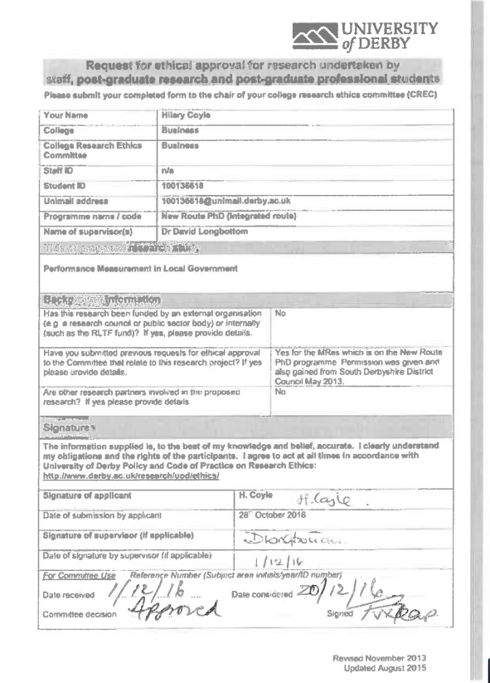

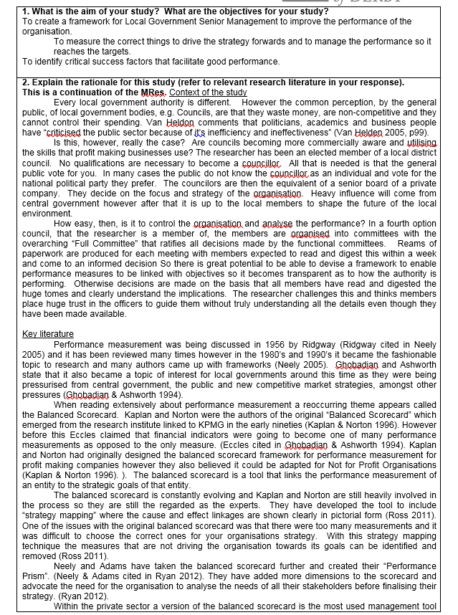

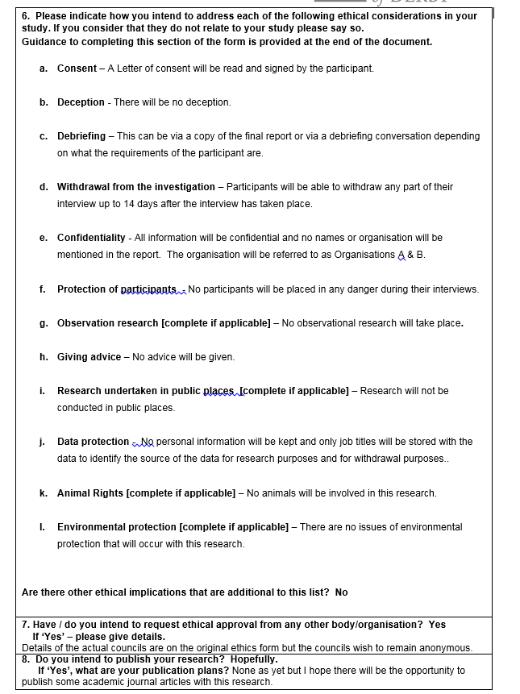

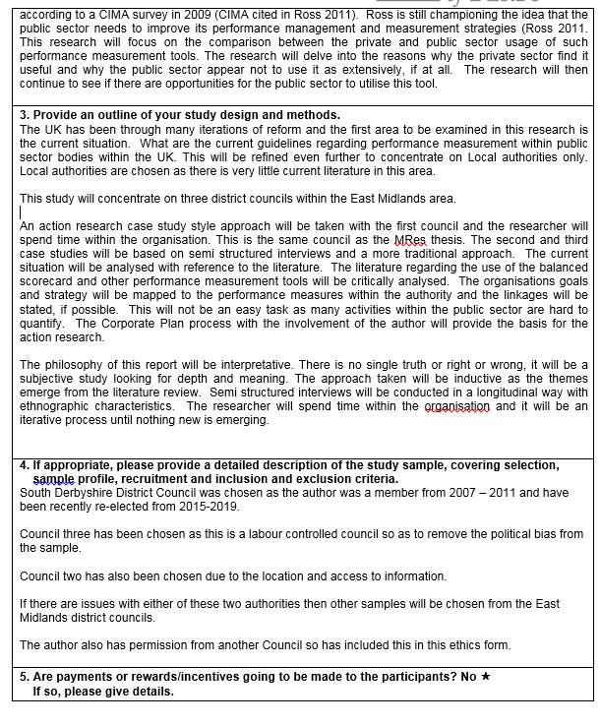

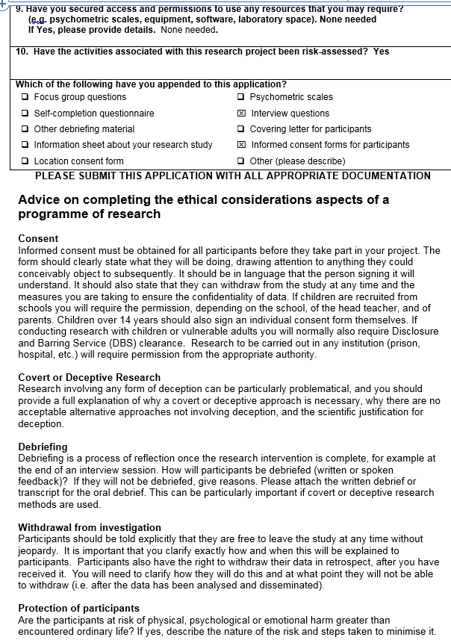



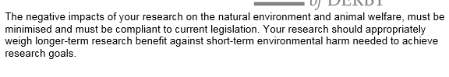

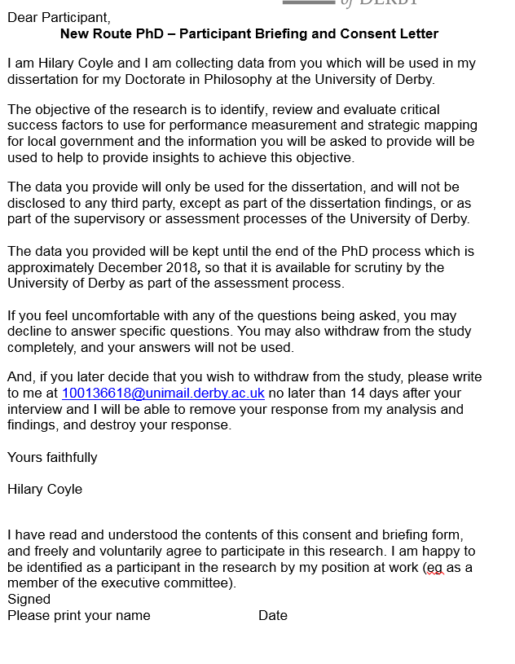

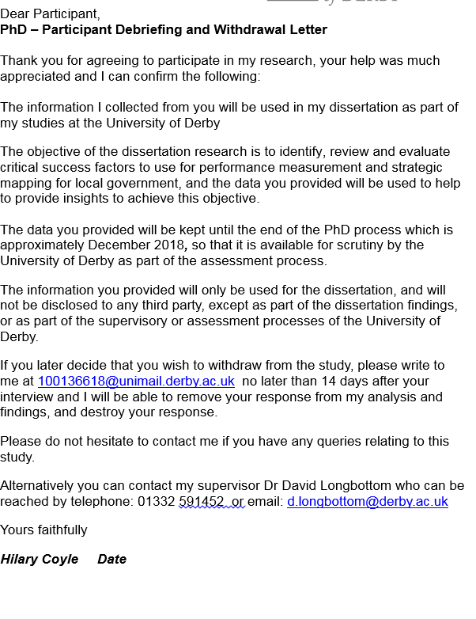

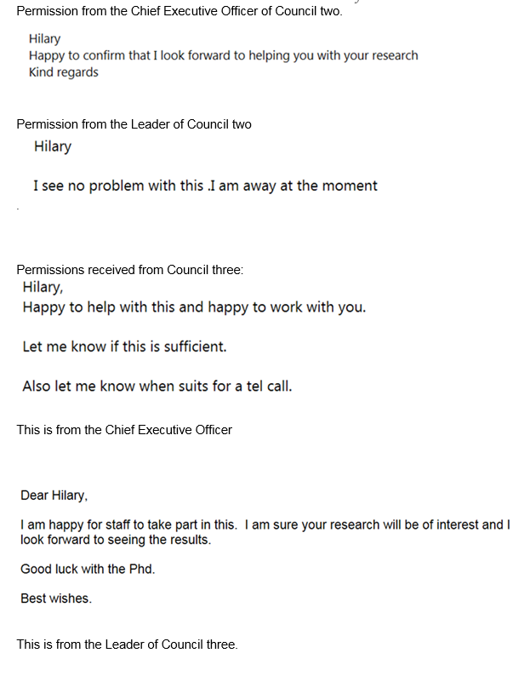

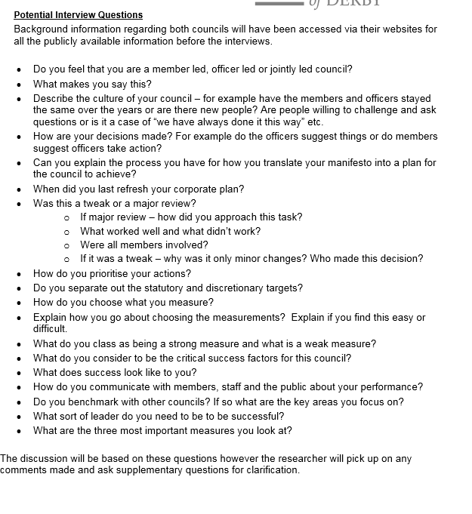

End of ethical approval form.

**2. Detailed documentation of transcribing process.**

WAV -> MP3 -> YouTube video -> captions/subtitles -> word

The interviews were recorded on a Dictaphone which created a WAV file. In order to use YouTube this file needs to be an MP3 file.

Google search the following: “convert WAV to MP3” and the NCH software was located. [WWW.NCH.com.au](http://WWW.NCH.com.au) This is a free software that can be downloaded.

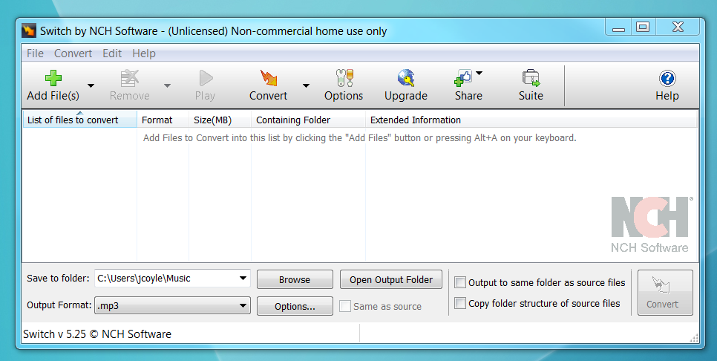

The software is called “switch sounder file converter”. When in the software another application called “WavePad” needs to be downloaded. So in optional programs and extras choose as below.

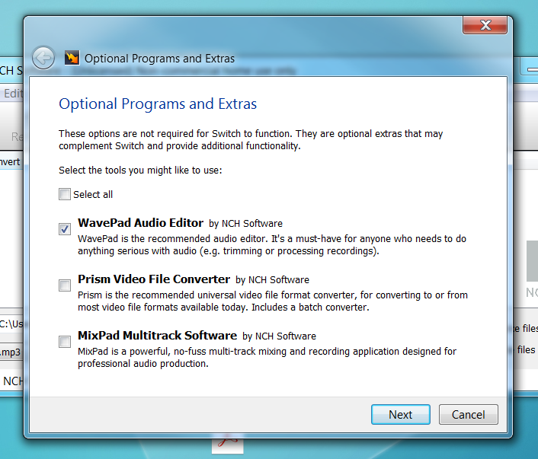

The WavePad audio editor will allow the splitting of the MP3 files to make them a more manageable size. Plus YouTube only accepts files less than 50,000 KB on their free version. Follow the instructions to install.

To break down the file open WavePad and open the MP3 file you want to split.



Then choose edit, split



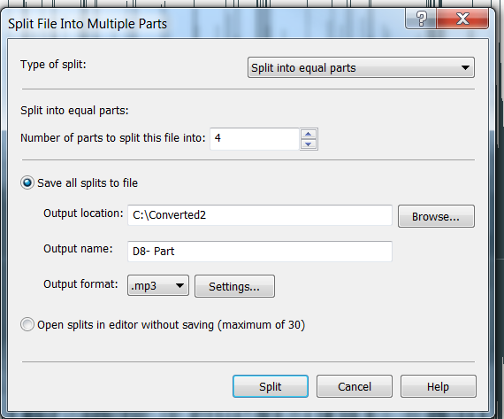

Choose the number of parts to split the file into depending on the length of the interview. For longer interviews you can choose more splits. The smaller the section the faster it will load onto YouTube.

Make sure the format says .mp3. Choose a location where the files can be saved and also a file name. It will number the parts 1, 2, 3 & 4 for a four part split.



The next step is to have a google email account (Gmail) and this will then give access to YouTube and an account can be set up if there is not one already set up.

Go to [www.tunestotube.com](http://www.tunestotube.com) this allows the uploading of mp3 files to YouTube.



Sign in with your google account as below:



Press Allow.

The screen below will appear.



Click on upload files and choose which MP3 file you want to upload. Also upload a photo or press create background. This is needed to create the file in YouTube. Click on Private. This is very important and means that no one else can see your files. Wait for the files to upload. Once they are ready the red icons are no longer present and the ‘create video’ button appears. It can take a few minutes to upload the file.

Before you can press the ‘create video’ button the “I am not a robot” section needs to be completed. This is a series of fun tasks to complete. The number of tasks varies. Complete these challenges and when tick appear press ‘create video’.

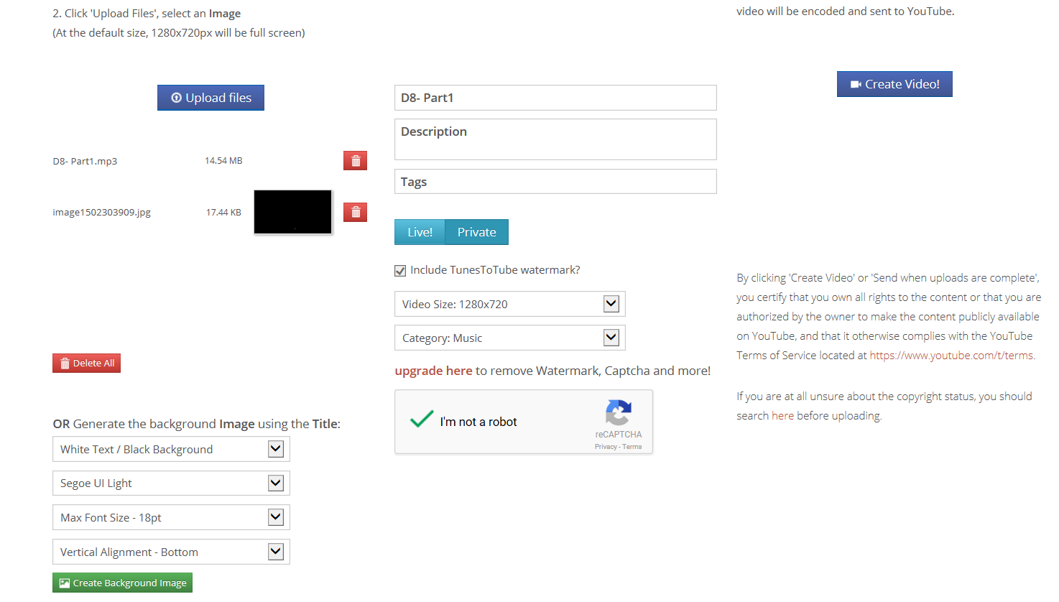



The files do take some time to appear on YouTube so upload all the files you need at this point. Then the next step is to sign into You Tube. Choose my channel.



As you can see there are no uploads that can be seen by the public, all are private.

Choose video manager. Here you will see a list of all the downloaded files. Choose the one you want and press edit, then subtitles/CC.

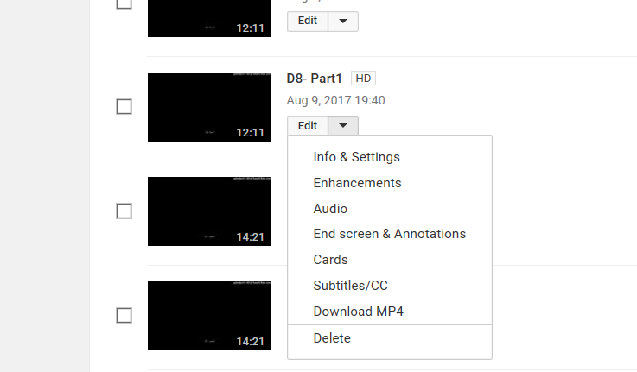

Select the language to English as below.

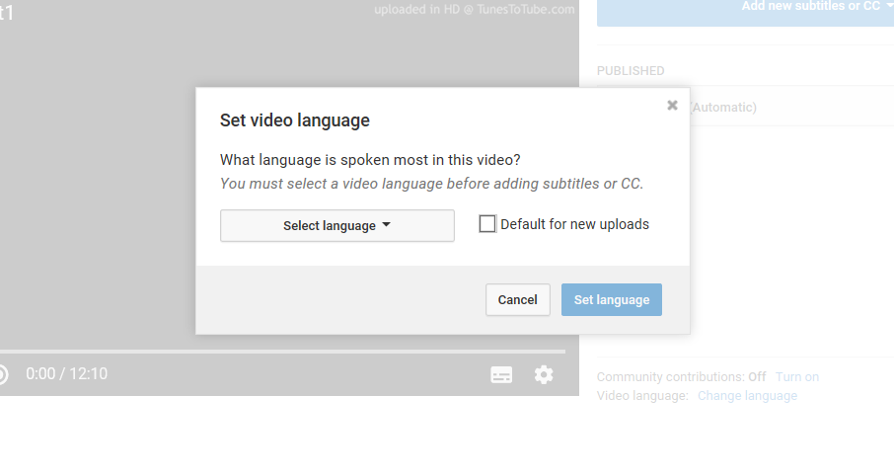

Then click on the English Automatic as below.

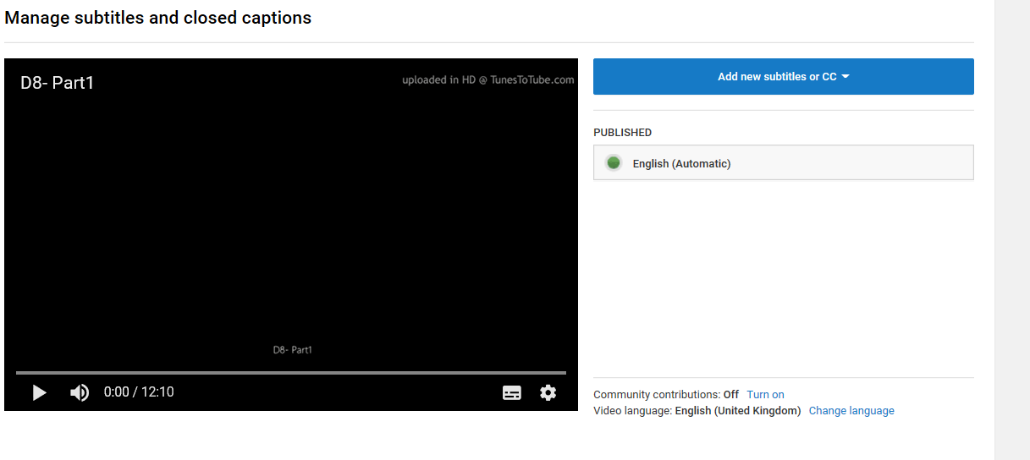

This will then produce a list of subtitles on the left hand side. Click on actions and choose .srt.

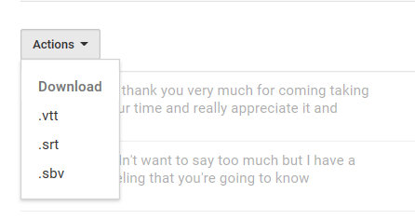

This then puts the captions into a text file as below.

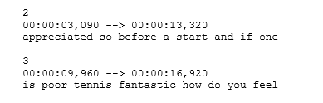

The text file contains many extra numbers and colons and these need to be removed. Use the replace function and find ^# this will find any digit. Replace all and leave the replace section blank and it will delete all the numbers. Then copy the colons that are left and add this into the find box. Again leave the replace box blank and replace all. This will leave just the words with gaps between each lines. Save as a word file and then this can be amended and annotated as necessary. All the words are there and this reduces the time to transcribe tremendously without losing the closeness to the data.