**Application of Metaverse in Higher Education: A Systematic Literature Review and Bibliometric Analysis**

**Abstract:**

**Purpose:** With the evolving landscape of technology and innovations, Metaverse has revealed a huge potential for changing the world. Gradually, it has expanded its wings to different sectors, including higher education. The key purpose of this research work is to synthesize the existing literature on metaverse in higher education and develop future research directions for researchers.

### **Design/methodology/approach:** The present study uses the “Preferred Reporting Items for Systematic Reviews and Meta-Analyses (PRISMA)” technique to recognize relevant articles from the database i.e. SCOPUS. Furthermore, it conducts a “bibliometric analysis and systematic literature review” to explore the research area of metaverse in higher education.

**Findings**: The findings reveal that the synthesis and analysis of existing literature led to the identification of an intellectual structure, which resulted in the formation of four clusters. These clusters are defined as attributes related to metaverse applications in higher education, sustainable management of complex learning practices, customization of the teaching-learning process through the metaverse, and model development. The theoretical structure informs the co-word analysis and thematic map, identifying four themes: the basic theme, motor theme, niche theme, and decline theme. Finally, the social structure is assessed in terms of the author's network and collaboration across countries.

**Implications:** The study investigated the conceptual structure by developing a thematic map and social structure by measuring the relationship between country-author collaboration through bibliographic coupling. The study also identified future research avenues based on the “TCCM (theory, context, characteristics, and methodology)” framework for future researchers and practitioners.

### **Originality/value:** The research study thrives on enlarging the review scope to measure the metaverse's role in higher education. Though bibliometric studies have been developed in the metaverse, no study has attempted to measure the relationship between metaverse in higher education using bibliometric and TCCM framework. Thus, developing a synthesized work provides a comprehensive picture of the research domain.

**Keywords:** Metaverse; Higher Education; Bibliometric; Systematic literature review.

1. **Introduction**

With the growth of digital technology and the rising use of technological tools in education, new opportunities have emerged to address complex challenges (Mustaph, 2021; Kaswan et al., 2024). This shift in digital technology has transformed the teaching and learning process. Consequently, technological advancements have given rise to a concept known as the "Metaverse" (Mystakidis, 2022). It describes a virtual reality (VR) learning environment where professionals from various fields can engage in immersive learning through digital technology (Stephenson, 1992). It is a virtual world of three dimensional that mimics the actual world, enabling avatar-based interactions that enhance user experience and disrupt traditional learning methods (Hollensen *et al.,* 2022). It is an open and shared virtual platform utilizing 3D spaces where users explore, interact with content, and engage with other users as digital avatars. Users own their digital assets and experiences, accessing various activities. The metaverse is critical in achieving sustainable development (SD) by addressing environmental, economic, and social challenges. For example, virtual meetings reduce the need for physical travel, lowering carbon footprints, foster new markets, and enhance global connectivity (Al-Emran, 2023). Metaverse revolutionizes traditional models by providing immersive and interactive learning environments that increase the engagement and participation of students (Hwang *et al*., 2023). Metaverse enables the development of appropriate learning settings, class layouts, and teacher preparation programs (Pradana and Elisa, 2023). The emergence of the metaverse led to the development of many internet-related technologies for teaching and learning(Chau and Yu,2024). Metaverse technology supports several aspects that enhance the creation of interactive models for teachers and students and have an immersive learning experience(Chen,2024). Furthermore, integrating the metaverse in higher education provides multiple benefits such as offering a controlled environment to conduct experiments which would be a challenging task in the physical world (Hermanto and Miftahuddin, 2021). Metaverse provides an elastic, competitive, and participative atmosphere that motivates students to have better learning opportunities (Daz *et al.,*2020). Thus, metaverse not only develops student participation and motivation but also increases the scope to develop a competitive and technology-enabled teaching-learning platform that enhances teachers' and students' skills, capacities, and competencies.

Though in recent times the popularity of metaverse is gaining momentum in every sector including the field of education, but still academic studies are scarce towards measuring the relationship between metaverse application in higher education. The existing studies in the field have provided various insights from various perspectives, methodologies, theories, and applications. To accumulate the existing literature and develop a comprehensive review of the research domain the study used a systematic literature review (SLR) and bibliometric approach which summarize a host of quantitative techniques that are capable of handling large datasets relating to the literature (Donthu et al., 2021). Thus, to understand the relevance of bibliometric analysis and systematic literature review, the current study formulated the stated research questions:

***RQ 1****- How many clusters are developed from existing literature studies on the research domain?*

***RQ 2****- What are the growing research themes in the metaverse field of study?*

***RQ 3*** *- What are the co-authorship patterns developed concerning the country available in the research domain?*

***RQ 4****- What are the most noteworthy “theories, contexts, characteristics, and methodologies (TCCM)” addressed by the existing sample studies?*

***RQ 5****- What are the future research propositions identified for impending researchers in the research domain?*

Thus, considering the stated research questions the resulting research objectives have been formulated:

1. To understand the prevailing research state in the field of metaverse application in higher education by analyzing the extracted data from the database and developing network maps.

2. To identify the evolving themes and develop a model for analyzing the future avenues through the TCCM framework.

The prime need of the study is to have a lasting contribution to the literature in various ways. Firstly, it examines the existing literature studies to identify the emerging themes of metaverse in higher education by developing a cluster map through bibliographic coupling of 14 documents. Secondly, the research findings enable us to understand the current state of research in the research domain. Thirdly, the article through the TCCM framework developed a deeper understanding of existing theories, context, characteristics, and methodologies of the sample studies. Thus, we provide directions for future researchers to measure the application of metaverse in higher education. The study results can benefit academicians, institutions, and policymakers in multiple ways with its practical contributions. Firstly, it acts as a benchmark that identifies the pertinent areas that require considerable consideration with the changing times. Secondly, framing proper strategies by institutions and policymakers can design training and development practices, and student learning-oriented practices to create a competitive environment. Thirdly, policymakers can develop a learning ecosystem that effectively utilizes resources and cost-effective outcomes.

The remainder of the research work is organized into several sections. Section one describes the topic and presents the identified research questions and objectives. Section two describes the theoretical background of the research domain. The methodology structure adopted in the study is explained in section three, followed by the results and discussion in section four, section five explains the model developed in the research study, section six explains the TCCM framework where whereas section seven enumerates on implications of the study, and lastly section eight discussed the conclusion and future research direction.

1. **Theoretical background**

The theoretical background section explores the history and origin of the concept of metaverse, the present state of higher education in India. Furthermore, it emphasizes the metaverse's significant role in the education sector and discusses its potential applications in higher education to enhance results and outcomes.

***2.1 Metaverse***

The term "metaverse" is a combination of “Meta” (indicating virtual and transcendent) and “Verse” (referring to the universe) (Park et al., 2022). The concept was introduced in Neal Stephenson's novel *Snow Crash* in 1992 as a successor to the internet, depicting a vast, immersive digital universe where users interact with one another as "data objects." Mark Zuckerberg, the founder and CEO of Meta, has discussed the concept of an embodied internet and immersive platform known as the metaverse (Zuckerberg, Founder’s Letter). In just one month, Google recorded 2.62 million searches for the term "metaverse" (Google Trends). Tim Sweeney, CEO of Epic Games, describes the metaverse as "a persistent, live, social, interactive, shared virtual world built on the foundations of the internet" (Deloitte Global, 2023). The metaverse represents a vast, immersive digital universe where users can interact in real-time using digital objects (Lee et al., 2023). Inspired by Stephenson, Ron Britvich created a virtual world called “Alpha World,” later known as "Active Worlds," which was launched in 1995. This platform allowed users to engage in digital environments, create their own virtual spaces, and construct houses, streets, and other structures using the tools provided (Kaplan and Haenlein, 2009). These studies aim to enhance the understanding of the metaverse's concept, history, origin, and its transformative impact on education. However, to date, no research has specifically explored how the application of the metaverse in higher education fosters transformative approaches to teaching and learning for both teachers and students nor how it might cultivate greater interest in innovative learning methods among students.

***2.2. Higher Education in India***

Higher education in India has ancient roots, with institutions like Takshashila and Nalanda renowned for their academic excellence. The modern education system began during British rule with the establishment of universities such as the “University of Calcutta, the University of Mumbai, and the University of Madras” in 1857, which adopted a European-style educational model (Tiwari, 2019). After independence, the Indian education system focused on accessibility and the promotion of scientific research (Das, 2017). The University Grants Commission (UGC), established in 1956, was tasked with overseeing higher education and maintaining standards. The creation of “Indian Institutes of Technology (IITs) and Indian Institutes of Management (IIMs” has further enhanced the quality and global competitiveness of higher education. Recently, the National Education Policy (NEP) 2020 has comprehensively revamped the higher education landscape, introducing multidisciplinary innovations in the education sector (Aithal and Aithal, 2020). The private higher education sector has also experienced rapid growth, with notable variations at the national level (Aithal and Kumar, 2016; Yadav et al., 2024; Kumar et al., 2023). This continuous expansion has prompted higher education institutions to embrace technological advancements, resulting in the widespread use of virtual tools and techniques. According to Qiu, Fagoa, and Aracil (2023), adapting teaching methods and motivating students in higher education will help learners stay updated with technological changes while fostering creativity and innovation in their learning processes. These studies aim to improve the understanding of the current state of higher education in India and the role of the NEP policy in transforming the country's education system. However, to date, no research has explored how advanced technological innovations like the metaverse can effect change in higher education or how these technologies impact the teacher-student learning process through the development of customized platforms that utilize minimal resources for maximum benefit.

***2.3 Metaverse in Higher Education in India***

The metaverse, fuelled by Augmented Reality (AR) and Virtual Reality (VR), revolutionizes the education system by eliminating geographical constraints (AlGerafi *et al.*, 2023). History and science classes come alive with immersive experiences, while AR enhances teacher-student interactions. Educators enjoy precise control for safety, and businesses thrive with real-time connections and innovative engagement tools. Moreover, the Metaverse offers boundless learning opportunities with 3D visualization and abundant resources (Burnett and Lisk,2021). Learners delve into dynamic environments, expanding their knowledge horizons and experiencing education in unprecedented ways (Sinha *et al.*, 2012). Thus, the delivery of content will be better. Many researchers have carried out their research in this area (Hwang *et al.*, 2023; Zhang *et al*.,2022; Tlili *et al*.,2022). The metaverse is broadly used for the teaching, learning, and engagement of students. Overall, the existing studies illuminate the metaverse's evolving role in shaping the future of education, promising immersive, interactive, and learner-centric experiences. The use of metaverse will enhance the future of education and learning. It has also changed its dimension from business to corporation, where the education industry needs to upscale the knowledge required (Renu, 2021). This will allow the people to work and play. The metaverse provides a platform that will allow users to connect to multiple platforms and stay in social life through social platforms.

* 1. ***Research Gaps***

Taking together the extensive review, of metaverse application in higher education it has been identified that existing studies (Prakash et al.,2023; Pregowska, Osial, and Gajda, 2024) are narrowly focused with differing approaches. All existing studies present separately different aspects. Furthermore, none of the studies presented collectively to understand the relevance of metaverse in higher education. Hence, the present study adopted an inclusive and complete approach to present the existing studies and identify the emerging themes that contribute to the literature, as well as enabling future researchers to get a comprehensive idea for developing future studies. Therefore, these gaps in the literature provide the impetus to conduct the present study.

**3. Methodology Structure of the study**

The research work adopted two literature review techniques, bibliometric analysis(BA) and systematic literature review (SLR). Bibliometric analysis mostly emphasizes understanding the performance analysis and contribution of existing literature for science mapping. Thus, performance analysis primarily focuses on identifying key contributors, publication trends, and source patterns within the current state of literature (Aparicio *et al*., 2019). In contrast, science mapping explores and elucidates the relationships among research components, helping to reveal the knowledge structure of scientific literature (Donthu *et al*., 2021). The study used the extracted CSV file from the Scopus database to understand and develop various maps based on the researcher's contribution. However, the Systematic Literature Review (SLR) methodology emphasizes a comprehensive understanding of the synthesis and integration of current studies in the field (Johri *et al*., 2024). Systematic literature review focuses on developing a deeper understanding of the existing literature of the research domain and developing future research directions (Sauer and Seuring, 2023). Systematic literature review measures and provides ideas on the current state of the art, findings, research gaps, and direction for future research (Paul and Criado, 2020). The present study adopted the “PRISMA (Preferred Reporting Items for Systematic Reviews and Meta-Analyses)” framework for categorizing, identifying, and finalizing the related studies. The researchers opted for the PRISMA framework as it is best suited for management studies because it successfully clarifies research questions by applying inclusion and exclusion criteria. Furthermore, the PRISMA method simplifies the well-organized and precise examination of huge databases, enabling comprehensive and accurate investigations (Martucci *et al*.,2023; Albhirat *et al*.,2024). The research study used the VOS viewer and Bibiloshiny software to further analyze the extracted data and develop future research propositions (Aria and Cuccurullo, 2017; Van Eck and Waltman, 2022).

Bibliometric analysis was employed for research questions one and three to justify the stated research questions where whereas to justify research question two a combination of bibliometric analysis and systematic literature review was utilized, proving the stated research questions four and five TCCM framework of systematic literature review was applied. The methodological structure adopted in the research study is depicted in Figure 1. The research study adopted a set of keywords in the search option of the homepage to recognize the relevant literature from the database taken in the study i.e. SCOPUS. The principal reason for using the database is its wide coverage of highly apparent journals published by well-known publishers such as Emerald, Taylor and Francis, and Sage (Franciosi *et al*., 2020). This wide coverage of literature enables researchers for an advanced scanning approach to identify relevant articles in their field. Thus, the collection of comprehensive information sheets in the form of CSV (comma-separated value)from bibliographic databases through keyword searches, serves as input for bibliometric analysis (BA) and systematic literature reviews (SLR) (Piwowar-Sulej and Iqbal, 2023).

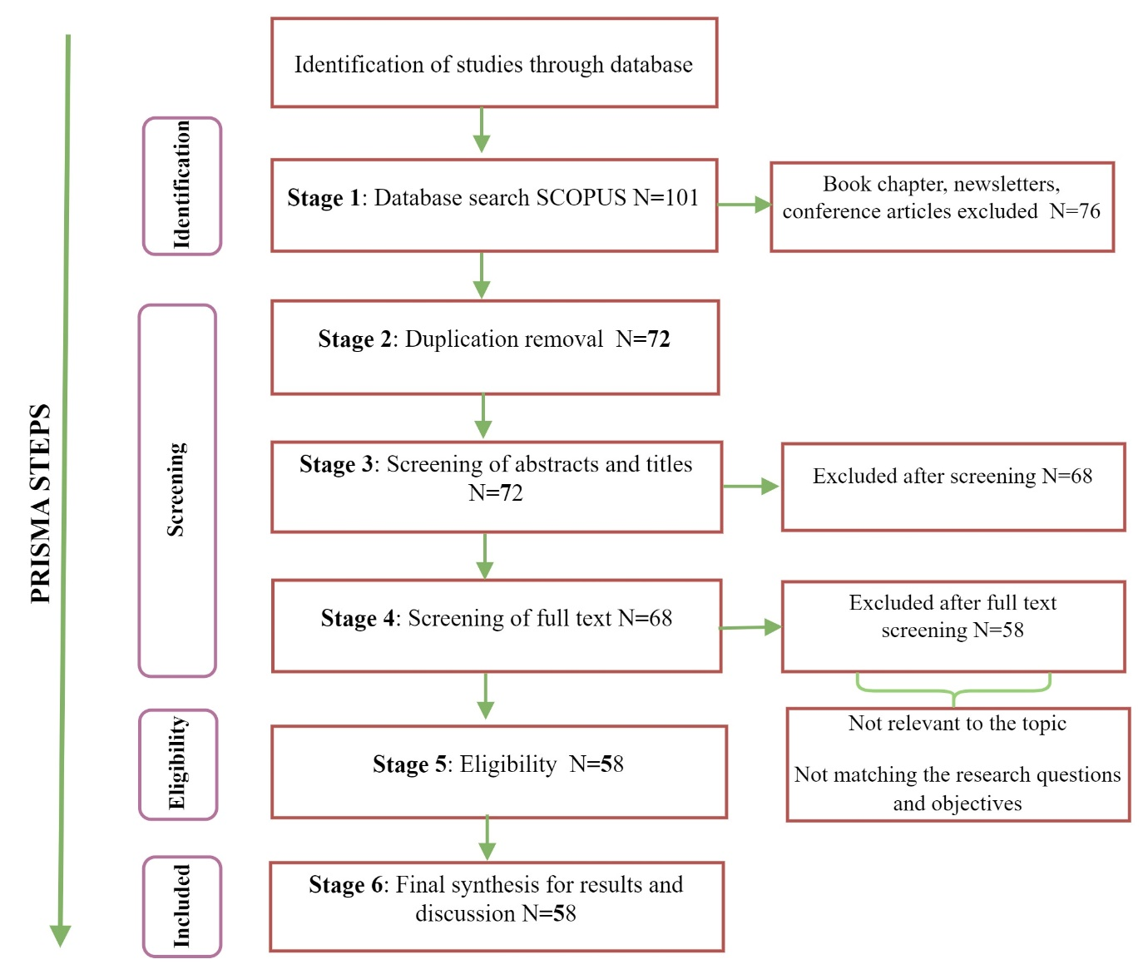

Figure: 1 Methodology Process (Source: Authors’ own creation)

Therefore, the present research work aims to identify relevant literature using the database, i.e Scopus which is considered as the key database with the highest number of journals across various fields and disciplines (Zhu and Liu,2020). The next step the researchers followed after confirming the bibliometric database, was to identify appropriate keyword search strings for position-appropriate literature in the database. The study followed a process with three steps to select the proper keywords as suggested by (Ali *et al*., 2023). The steps are mentioned below:

**Step one**. The first step specifies the authors developed a thoughtful knowledge of the topic about its history, application, and benefits and also the present state of research. **Step two**. The second step followed by the authors is to prepare similar keywords on ‘metaverse’ and ‘higher education.’ **Step three**. Lastly, through reciprocated consensus, the identified keywords were finalized by the authors. After finalizing the required keywords, the authors used the required Boolean operators such as “AND, OR” in the search string using keywords to identify the relevant literature for further analysis and discussion. The search string is “((TITLE-ABS-KEY (" Metaverse" OR "Multiverse" OR "Mega verse" OR "megadiverse") AND TITLE-ABS-KEY ("Higher education" OR "Tertiary" OR "Graduate" OR "Undergraduate")) AND (LIMIT-TO (DOCTYPE, "ar”) AND (LIMIT-TO (LANGUAGE, "English”)) AND (LIMIT-TO (SRCTYPE, "j”)))”. The search query resulted in one hundred fifty-one documents from the Scopus database in the initial search screening. The researchers followed the inclusion/exclusion criteria. The articles published in conferences, books, book chapters, and notes were excluded. The researcher considered publications published in the English language only, the rest were excluded. Further, through a group meeting among the researchers, each document is verified based on whether the stated objective of the study matches the researcher's stated research questions or not. If it is relevant and matches the requirement, then only it was included for further analysis and discussion of the study. Thus, fifty-eight documents were finally obtained after, the inclusion/exclusion stage for further analysis.

**4. Result and discussion**

***4.1. Graphic statistics on the identified data***

The statistics reveal that 160 authors contributed to 58 articles published across 50 journals from 2012 to 2023, indicating an increase in the publication rate. Figure 2 shows a significant spike in article publication starting in 2021. The COVID-19 outbreak in 2020 augmented the technology adoption in both personal and professional settings. This surge in the use of various tools and techniques fostered cohesiveness and paved the way for more effective resource utilization and improved communication among individuals.

Figure: 2 Yearly Publication trend (Source: Authors’ own creation)

From the beginning of the concept of metaverse contributors and practitioners have viewed it as a potential catalyst for revolution and sustainability, impacting social, technological, and educational advancements (Pradana and Elisa, 2023). Therefore, understanding the "role of the metaverse in higher education" through a systematic literature review and bibliometric analysis is crucial for measuring consistent application and long-term growth in this field. The present research aims to assess the current state and develop future directions for scholars and practitioners. The graphical statistics figure illustrates the author's contribution over time and a trend line that indicates annual participation in this research area. This data provides valuable insights for future researchers, helping them recognize opportunities for further investigation and enhanced contributions.

***4.2. Analysis based on citation***

The research followed three important measures: ‘ h-index,’ ‘g-index,’ and ‘m-index’ (Aithal, 2017; Ding, Liu, and Kandonga, 2020). Firstly, the ‘h-index’ measures the publication's relationship with TC ≥ h (Ghani *et al*.,2019), suppose an author has ten publications, out of which three papers have TC ≥ 3, his h-index will be 3. Second, the ‘g-index’ is calculated based on total papers having g2 citations when all the papers are arranged in descending order of TC received (Ameer and Afzal, 2019). Lastly, the ‘m-index’ value is computed only for authors and sources of publications. In this study, the citation analysis results in Table 1 show ‘Shwedeh F′ as the most cited author with three publications, h-index 2, g-index = 2, m-index 1, and TC = 112. The second most cited author is ‘Aburaya A.′ with 1, 0.5, and TC 100 respectively. Regarding highly cited documents, Adwan *et al*. (2023) have the maximum citation count and the TC is 51.

Table 1: Prominent authors, documents, and source (Source: Authors’ own creation)

|  |  |  |  |  |  |  |  |  |  |  |  |  |  |
| --- | --- | --- | --- | --- | --- | --- | --- | --- | --- | --- | --- | --- | --- |
| Authors | h index | m-index | g-index | TC | NP | Documents | TC | Source | h index | m-index | g-index | TC | NP |
| Shwedeh, F. | 2 | 1 | 2 | 112 | 3 | Adwan et al. (2023) | 51 | IEEETLT | 4 | 1 | 2 | 9606 | 3 |
| Aburayya, A. | 1 | 0.5 | 2 | 100 | 2 | Díaz, J. (2020). | 45 | SS | 6 | 1 | 2 |  | 3 |
| Al-Adwan, A.S. | 1 | 0.5 | 2 | 56 | 2 | Salloum et al. (2023) | 30 | ES | 2 | 0.5 | 2 | 25220 | 2 |
| Alderbashi, K.Y. | 1 | 0.67 | 2 | 100 | 2 | Ricardo et. al (2023) | 25 | EIT | 2 | 0.67 | 2 | 10614 | 2 |
| Alkhwaldi, A.F. | 1 | 0.5 | 1 | 11 | 2 | Belei, Noteborn, and Ruyter (2011) | 19 | FE | 2 | 0.5 | 1 | 4554 | 2 |
| George-Reyes, C.E. | 1 | 1 | 2 | 6 | 2 | Sunardi et al. (2022) | 16 | IJDNS | 1 | 1 | 2 | 1177 | 2 |
| López-Caudana, E.O. | 1 | 1 | 2 | 6 | 2 | Jen, Fang and Chun (2023) | 12 | Buildings | 1 | 1 | 2 | 10404 | 1 |
| Abata-Ebire, B.D. | 1 | 1 | 2 | 1 | 1 | Eman et al. (2023) | 15 | BI | 1 | 1 | 2 | 4077 | 1 |
| Abbasi, G.A. | 1 | 1 | 1 | 56 | 1 | Nir, Diana and Mark (2022) | 16 | BEEI | 1 | 1 | 1 | 3741 | 1 |
| Abdurachman, E. | 1 | 1 | 1 | 18 | 1 | Ahmad et al. (2023) | 14 | CE | 1 | 1 | 1 | 2709 | 1 |

TC-Total citations, NP-Net publications, IEEE Transactions on learning technologies- IEEE TLT, Sustainability Switzerland-SS, Electronics Switzerland-ES, Education and Information technologies-EIT, Frontiers in education-FE, International Journal of Data and network science, Buildings, Body Image-BI, Bulletin of Electrical engineering and Informatics-BEEI, Computer and education-CE

Followed by the next article authored by ‘Díaz, J. ′ and published in ‘Sustainability Switzerland’ emerged as the next highest globally cited document. The ‘m-index’ value for the publication source measures the publication continuity in the field of study. The sources of publication with m value ≥ 1 are considered to be consistent contributors to scholarly articles (Hirsch, 2005). The citation analysis findings for this study are in Table 1. The sources with m-index ≥ 1 are ‘Sustainability (Switzerland)’ (m = 1), ‘International Journal of Data and Network Science’ (m = 1), ’Buildings’ (m = 1), ‘Body Image’ (m = 1), ‘Bulletin of Electrical engineering and Informatic’ (m = 1). Citation analysis assesses the scholarly contributions of researchers within a specific field. It examines the structure and evolution of that research domain throughout the academic journey. By identifying metrics such as the h-index, g-index, and m-index, it evaluates the number of author's publications and citations, as well as the impact of their articles through citation rankings. The data explains the inclusive overview of the existing state of research with authors, documents, and sources.

***4.3. Intellectual structure***

The intellectual structure examines the existing literature in the field and provides adequate ideas to the researchers based on co-citation analysis (CCA) and bibliographic coupling (BC) Kleminski, Kazienko, and Kajdanowicz (2022). These are the two principal analyses that help in significant analysis of the intellectual structure of the field of study (Khare and Jain, 2022). Bibliographic coupling is a technique through which the most influential articles are identified and grouped which results in determining clusters (Phan 2021; Tur *et. al,*2021). Table 2 outlines the clusters through bibliographic coupling, the contributing authors, citations for each article, and total link strength. This analysis helps us to understand and refine the extracted articles, facilitating a significant examination of theme development. Clusters identified through bibliographic coupling enumerate the underlying themes of the field of study and present the current state of knowledge (Donthu *et al*., 2021). Hence, the researchers used the technique for identifying the emerging areas of knowledge having limited scholarly publications whereas co-citation analysis establishes a linkage of those studies that are often cited together, which makes it suitable for determining past research trends in the field of study (Van Eck and Waltman, 2022). The present research condition signifies that the existing research state gained momentum after 2021, so it is immaterial to explore and discuss past research trends. Hence, determining the themes through CCA is not relevant at this point, and only BC is sufficient to explain the intellectual structure. The present research study through bibliographic coupling based on the “documents” analyzed the research state of condition (Patil and Rahman, 2023). The document coupling network set a threshold limit of five times citations to extract the required documents. Based on the stated condition it resulted in the identification of nineteen items out of which the largest connected items resulted in the identification of fourteen items. The identified items are grouped into four clusters. The clusters are denoted with different colours such as red, blue, green yellow. Figure 3: represents the bibliographic coupling of documents.

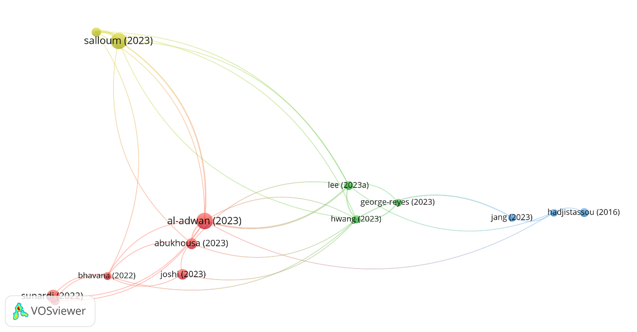

Cluster 4

Cluster 3

Cluster 2

Cluster 1

Figure: 3 Cluster analysis through bibliographic coupling of documents (Source: Authors’ own creation)

Cluster one is represented in red colour, it consists of six documents. AbuKhousa *et al.* (2023) stated that the metaverse enriches the opportunity to expand the learning paths and provides the necessary skills to face the challenges confronted in the way of learning. Further, the study by Adwan *et al.* (2023) discussed identifying the factors that impact the adoption of metaverse by higher education students. It is identified that self-efficacy, perceived innovativeness, and perceived cyber risk are the major factors of perceived usefulness and ease of use. Bhavana and Vijayalakshmi (2022) the study examined the impact of augmented reality on students learning and classroom motivation It was measured in terms of attention, relevance, satisfaction, and confidence. Joshi and Pramod (2023) the study proposed a futuristic and collaborative learning framework that depicts and develops a learning platform for users. Sofianidis (2022) the study examined the student’s perception concerning the immersive experience gained using augmented reality techniques. Sunardi *et al*. (2022) the study discussed measuring the impact of metaverse or augmented reality on the learning process. The above discussions on research papers led to the formulation of the stated research propositions based on the cluster:

**Proposition 1:** *To emphasize the role of a metaverse in enhancing the opportunity to develop and foster a culture of innovative learning among students.*

**Proposition 2:** *To explore and identify the impact of metaverse and augmented reality on classroom teaching practices and develop strategies to meet the changing needs.*

**Proposition 3:** *To analyze how metaverse develops sustainable strategies in the long run resulting in technology-enabled learning practices for learners and teachers.*

Table: 2 Intellectual structure through bibliographic coupling (Source: Authors’ own creation)

|  |  |  |  |  |  |
| --- | --- | --- | --- | --- | --- |
| **Cluster** | **Cluster Name** | **Title** | **Authors** | **Citations** | **TLS (Total link strength)** |
| Cluster one | Identifying attributes of metaverse application in higher education |  |  |  |  |
|  | | Envisioning Architecture of Metaverse Intensive Learning Experience (MiLEx): Career Readiness in the 21st Century and Collective Intelligence Development Scenario | AbuKhousa *et al. (*202*3)* | 8 | 16 |
| Extending the Technology Acceptance Model (TAM) to Predict University Students’ Intentions to Use Metaverse-Based Learning Platforms | Adwan *et al.* (2023) | 24 | 15 |
| AI-Based Metaverse Technologies Advancement Impact on Higher  Education Learners | Bhavana and Vijayalakshmi (2022) | 6 | 7 |
| A Collaborative Metaverse-based A-La-Carte Framework for Tertiary Education (CO-MATE) | Joshi and Pj(2023) | 10 | 3 |
| Why Do Students Prefer Augmented Reality: A Mixed-Method Study on Preschool Teacher Students’ Perceptions on Self-Assessment AR Quizzes in Science Education. | Sofianidis(2022) | 8 | 3 |
| Acceptance of augmented reality in video conference-based learning during the COVID-19 pandemic in higher education. | Sunardi *et al*. (2022) | 15 | 3 |
| Cluster two | Sustainable handling of complex learning Practices |  |  |  |  |
|  | | Imbrication of the Metaverse in the complexity of education 4.0: Approach from an analysis of the literature. | Reyes *et al*. (2023) | 5 | 3 |
| Conceptions of the metaverse in higher education: A draw-a-picture analysis and surveys to investigate the perceptions of students with different motivation levels | Hwang, Tu and Chu (2023) | 6 | 12 |
| Exploring problem-based learning curricula in the metaverse: The hospitality students' perspective | Lee and Jo (2023) | 7 | 11 |
| Cluster three | Customization through metaverse in the teaching-learning process. |  |  |  |  |
|  | | Culturally Afforded Tensions in the Second Life Metaverse: From Sustainability Initiatives in Europe to Sustainability Practices in the United States | Hadjistassou (2016) | 7 | 1 |
| Exploring the Impact of Avatar Customization in Metaverse: The Role of the Class Mode on Task Engagement and Expectancy-Value Beliefs for Fashion Education | Jang and Kim (2023) | 6 | 3 |
| Comparative Case Study of Teamwork on Zoom and Gather.Town | Lee *et al*. (2023) | 5 | 4 |
| Cluster 4 | Model development |  |  |  |  |
|  | | Machine learning-based model for perusing the adoption of metaverse in higher education in UAE | Aburayya *et al*. (2023) | 8 | 16 |
| Sustainability Model for the Continuous Intention to Use Metaverse Technology in Higher Education: A Case Study from Oman | Salloum *et al.* (2023) | 23 | 18 |

Cluster two is represented in green colour, it consists of three documents, The first document by Reyes *et al*. (2023) discussed measuring the benefits of the metaverse on learning among students, it enriched the ability to understand the various intricacies and solve complex problems. Hwang, Tu, and Chu (2023) noted that the metaverse has garnered significant interest from educators and researchers alike, as it provides students with a more expansive experiential learning process. Similarly, Lee and Jo (2023) highlighted that the innovative features of the metaverse enhance the learning experience by fostering active participation in the evolving educational landscape. These insights from the research papers have informed the following research propositions:

**Proposition 4:** *To underline the role of a metaverse in measuring students' perception of a changing education environment and learning among students.*

**Proposition 5:** *To explore the impact of metaverse handling complex problems in teaching practices and develop strategies to meet the changing needs.*

**Proposition 6:** *Analyze how the metaverse mobilizes and provides sustainable strategies for optimum resource utilization in higher education.*

Cluster three is represented in blue colour. It consists of three articles. The first document by Hadjistassou (2016) the study discussed the importance of cultural constraints in the teaching-learning process. The application of the metaverse can develop reasonable and socially realistic practices that can understand cultural pragmatism and expand the teaching process among students. Jang and Kim (2023) found that avatar customization increased student engagement, fostered positive expectations, and improved learning outcomes by examining the effects of metaverse platforms such as ZOOM and Gather. Town. The research indicated that students were particularly drawn to Gather. Town, where avatars enhance emotional expression and empowerment (Lee et al., 2023). These insights from the research papers have led to the development of the following research propositions:

**Proposition 7:** *To examine the role of a metaverse in developing cultural attributes in students' learning process.*

**Proposition 8:** *To analyze the trends responsible for the change management process through metaverse in the teaching-learning.*

Cluster four is represented in yellow colour. It consists of two articles. The first article Aburayya *et al*. (2023) discussed the technology acceptance model (TAM) adoption through two determinants: perceived price and perceived ubiquity. The next article by Salloum et al (2023) discussed on adopting the metaverse in educational institutions has a lasting impact on “innovativeness, context awareness, perceived enjoyment, ubiquity, complexity, and value”. The findings of the study signify innovation plays an important role in determining the importance of metaverse application in the education sector.

**Proposition 9:** *To analyze the adoption of metaverse practices aligning with innovativeness, context awareness, and perceived enjoyment, in the teaching-learning.*

***4.4 Theoretical structure***

Co-word analysis examines a research field based on conceptual structure and the repetition of keywords Donthu *et al*. (2021). It measures the relevance of keywords in terms of their repetition in the existing literature and how frequently the keywords are repeated and how closely they are related (Kumar, George, and PS, 2023; Wang *et al*.,2012). Co-word analysis objectively analyzes the evolving themes, it provides the linkage and frequency of keywords (Ülker, Ülker and Karamustafa, 2023). The research study through co-word analysis analyzed the repetition of keywords and the citation and total link strength among the keywords. Table: 3 discusses the top ten keywords, citations, and total link strength among the keywords. The researchers considered the “author keywords” with a threshold limit of two times repetition which led to the identification of twenty-six keywords. Figure 4 analyzes the co-word structure of highly used keywords in the existing literature. The co-word analysis investigates how authors use recurring keywords to identify interconnected research themes based on their specific terminology. This approach aims to uncover patterns and trends within existing research.

Table: 3 -Co-word analysis (Source: Authors’ own creation)

|  |  |  |
| --- | --- | --- |
| ***Keywords*** | ***Citations*** | ***Total link strength (TLS)*** |
| Metaverse | 32 | 57 |
| Higher education | 11 | 28 |
| Virtual reality | 9 | 17 |
| Educational Innovation | 3 | 12 |
| Augmented Reality | 5 | 10 |
| Education | 4 | 9 |
| Artificial Intelligence | 4 | 8 |
| Challenges | 2 | 7 |
| Learning | 3 | 7 |
| Collaborative learning | 2 | 5 |

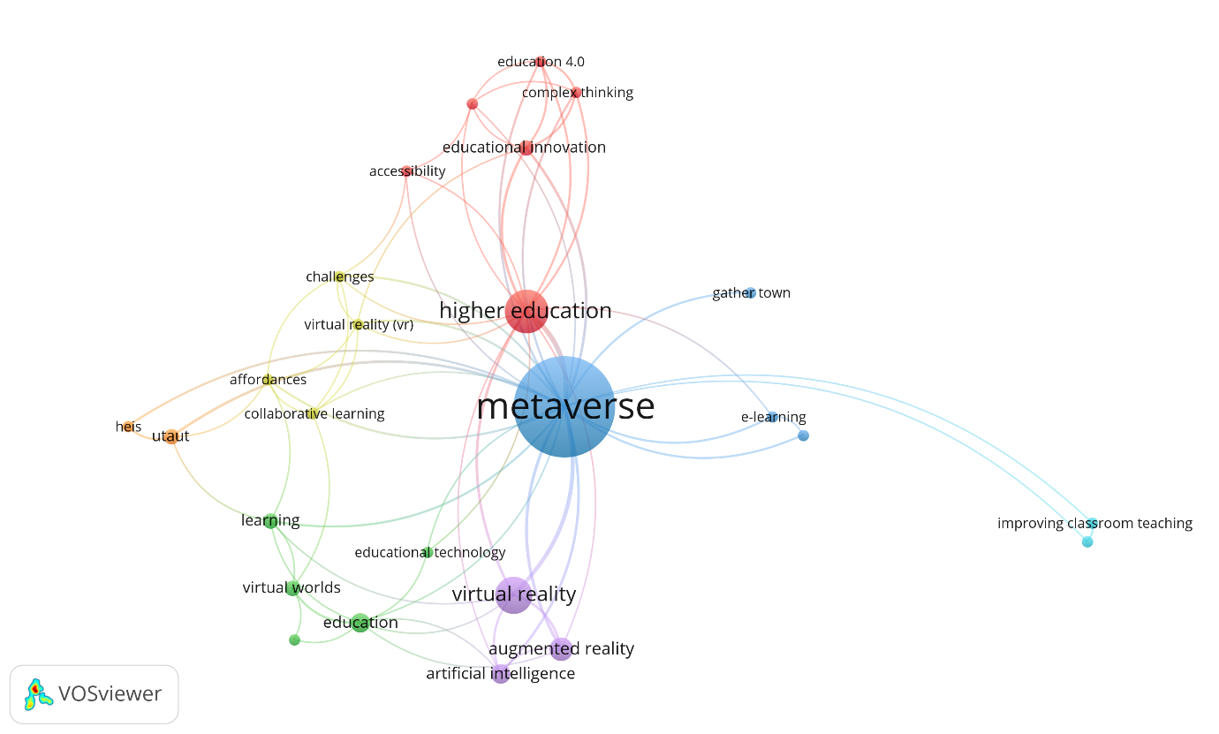

Figure: 4 Co-word analysis using author keywords (Source: Authors’ own creation)

The extracted thematic structure using Bibiloshiny is plotted in a two-dimensional plane having two axes such as “Density” and “Centrality”. The centrality explains the intensity whereas density explains the strength of the link (Tennekes,2018; Sabaa *et al*.,2023)

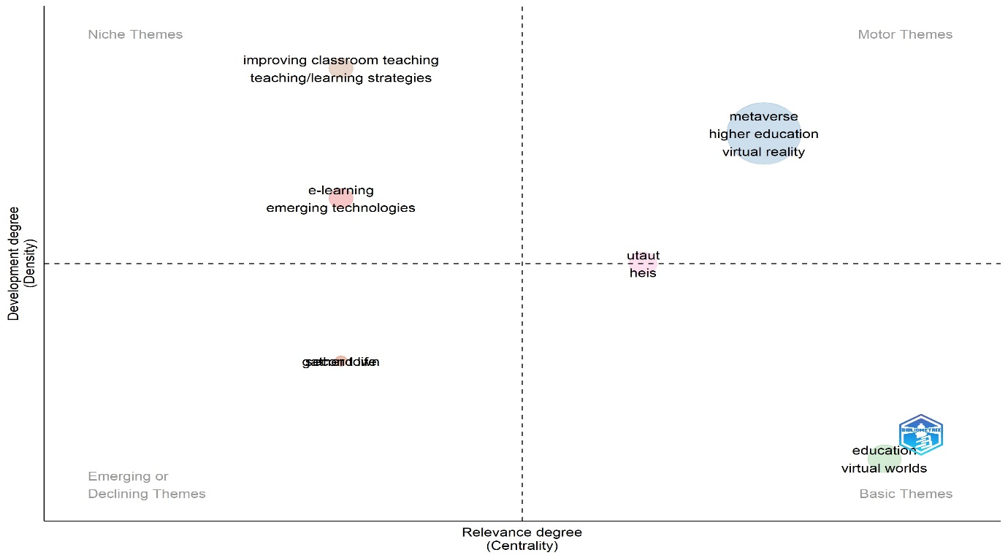

Figure: 5 Thematic Map (Source: Authors’ own creation)

Figure 5 explains the thematic map. The matrix has four quadrants. The right corner quadrant is termed as “Basic theme”. It represents the highly relevant but not explored very much. The next quadrant in the top right corner is called “motor theme”. The keywords in the theme are metaverse, higher education, and virtual reality. The theme is termed as “metaverse application in higher education”. The third quadrant in the left top corner is termed as “Niche themes”. The quadrant where research needs to be explored by future researchers is termed as “application of emerging technologies in learning practices”. The next quadrant is termed an “emerging or declining theme” though much research has not been contributed, so researchers can contribute to a great extent and develop studies.

***4. 5 Societal Structure***

The social structure analyzes the author's network working collaboratively in the research domain. The study used the ‘country contribution’ as a parameter in the bibliographic coupling, to develop the map as shown in Fig.6 and Table 4. The map denotes the connection size and represents the weightage in terms of countries and their contribution to the research domain (Olaleye *et al*., 2023 Rojas *et al*.,2023). Fig. 6 reveals that China (TLS = 811, TP = 7, TC = 41) and South Korea (TLS = 150, TP = 7, TC = 25) are the contributing countries with quality research in the research domain.

Table 4: Countries' statistics based on bibliographic coupling (Source: Authors’ own creation)

|  |  |  |  |  |
| --- | --- | --- | --- | --- |
| Cluster | Country | TD | TC | TLS |
| 1 | Brazil | 2 | 37 | 20 |
| 1 | Colombia | 3 | 46 | 33 |
| 1 | Mexico | 3 | 5 | 43 |
| 1 | United States of America | 4 | 46 | 36 |
| 2 | Hongkong | 2 | 6 | 95 |
| 2 | South Korea | 7 | 25 | 150 |
| 2 | Spain | 6 | 10 | 139 |
| 2 | Turkey | 2 | 4 | 160 |
| 3 | Indonesia | 3 | 42 | 642 |
| 3 | Jordan | 4 | 30 | 656 |
| 3 | Malaysia | 3 | 35 | 914 |
| 4 | Egypt | 2 | 19 | 398 |
| 4 | United Arab Emirates | 4 | 42 | 595 |
| 4 | United Kingdom | 3 | 33 | 688 |
| 5 | China | 7 | 41 | 811 |
| 5 | India | 5 | 18 | 394 |

Table 4, reveals that Sixteen countries have formed five clusters. Countries with significant contributions are Mexico, the United Kingdom, the United States of America, South Korea, and India. Cluster one countries hold the highest number of citations. At the same time, cluster two countries have published an extreme amount of articles (17) on metaverse in higher education. Cluster three has published 10 studies, and Cluster four nations have produced 10 studies on the research domain; these studies were 94 times cited in the research work. Lastly, cluster five has produced 12 documents having been cited by 59 times.

The social structure examines the relational framework within the research domain. The author’s network map reveals the connections within the current domain highlighting the most productive network of authors by country, and showcasing those who have made substantial expansion of research work to the field.

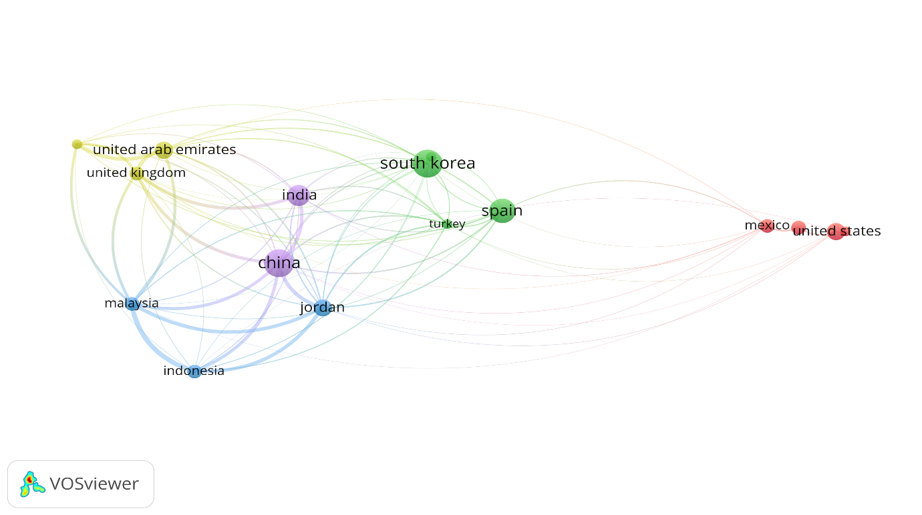

Figure: 6 Country Collaboration (Source: Authors’ own creation)

**5. Model of a metaverse in higher education**

The discussion of different clusters identified from bibliographic coupling and their relationships from the intellectual, conceptual structure, and social structure, this section presents a model in Figure 7 for higher educational institutions to adopt metaverse techniques and develop strategies to handle teaching-learning practices. The integrative framework discusses the dimensions, prerequisites, and outcomes of the metaverse in the field of higher education and also the development of customized learning practices for designing futuristic strategies. Thus, decision-makers need to assess the application of the metaverse and establish effective mechanisms to determine the required actions. Prakash *et al*. (2023) discussed metaverse has expanded and created new opportunities for experiential learning. Burnett, Harvey, and Kay (2022) discussed metaverse practices are enhancing the positivity and motivation to learn and develop strategies to enhance the practices through technology-driven processes. Further, Hwang, Tu, and Chu (2023) discussed that metaverse application has significant motivation among the students which closely impacts mindsets, attitudes, and self-efficacy. The model is outlined in three interrelated phases: dimensions, prerequisites, and outcomes. The next level focuses on the development of customized learning practices. The third level addresses enhancing the capabilities of higher education institutions and adopting a forward-looking approach. The developed framework broadly analyzes the positive way of applying of metaverse in the field of higher education. The study findings further indicate that the application of metaverse in higher education is more inclined towards various dimensions such as personalized education services, it is very to encourage learners to have an immersive learning experience through exploration. Developing a customized learning environment can motivate learners to enhance their skills and achievements (Kye *et al*.,2021; Zhao *et al*.,2022). metaverse integration in teaching and learning will influence positively through enhanced human-technology interaction (Lee and Hwang,2022). Tlili *et al.*(2022) discussed metaverse use in teaching-learning encourages the development of collaborative platforms, minimizes physical presence, and also optimizes communication among teachers and students, and creates possibilities for new collaborative projects. Onu, Pradhan, and Mbohwa (2024) discussed “flexibility” and addressed metaverse development is often praised for its revolutionary contributions to creating applications that foster collaborative networks and enhance communication between learners and teachers, leading to better outcomes. The pre-requisites for the application of metaverse such as integrating culture develop a smooth integration of cultural values and technology. It facilitates and provides platforms to create an interest and understanding among students to enhance their skills and meet greater levels of satisfaction for better results (Chen *et al*.,2023). Kfairy, Ahmed, and Khalil (2024) recognized the importance of data availability to the existing skills and capabilities of learners. It focused on developing various applications that enhance learning abilities and improve ease of use.Shu and Gu (2023) emphasized that creating integrated training programs and providing management support will create new opportunities and promote a culture of broadening learning. This will facilitate the transfer of knowledge from teachers to learners, enhancing their overall experience.The framework explores how the metaverse can lead to various outcomes, including the development of an appropriate technology platform that enhances the educational landscape. It fosters to development of sustainable practices that will enhance the teaching and learning process ensuring an elevating experience that will increase the familiarity with technological advancement (Kumar et al.,2023).Furthermore, the metaverse involves virtually enhanced reality and physically persistent spaces, which include mapping the virtual and real worlds and fostering social interactions which provide freedom for creation and sharing, as well as new experiences and high levels of immersion through virtualization (Kye et al., 2021; Zhang et al., 2022). Lin et al. (2022) proposed that applying the metaverse will offer effective mechanisms for minimizing risks and enhancing safety supervision in developing blended learning tools for both students and teachers, thereby creating reliable platforms for teaching and learning exchange.The most promising feature of the metaverse is “enhancing self-efficacy” which will develop social skills and competencies to develop communication as well as increase the ability to construct relationship management among the students and teachers.The discussion of the developed model clearly illustrates how the application of the metaverse in higher education can provide numerous benefits. According to Hwang and Chien (2022) and Alfaisal, Hashim, and Azizan (2024), metaverse applications in higher education can offer various "customized learning practices," including avatar customization, personalized learning curricula, the implementation of e-learning methods, and tailored learning packages, such as project-based learning.

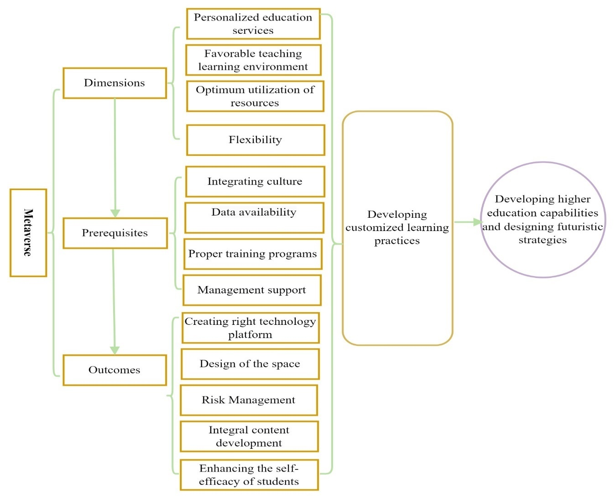

Figure 7: Model for Future Research Studies (Source: Authors’ own creation)

Researchers, educators, and administrators in educational institutions must understand and explore the application of metaverse technology to develop practices that mitigate risks and improve resource management. Effective mechanisms can enhance benefits and address challenges related to outcomes. The proposed framework will enable academic institutions to fully comprehend the dimensions, and pre-requisites and improve results, ultimately minimizing risks and maximizing customized learning practices for enhancing their capabilities and designing futuristic strategies to create excellence and benchmark their performance.

**6.** **Future research avenues through the theory, context, characteristics, and methodology (TCCM) framework**

The results and findings of the research provide valuable insights to assess the present state of research on the "metaverse for higher education." As it is in its early stages, many elements still remain to be examined to gain a clearer understanding of its future development (Salloum et al., 2023; Prakash et al., 2023). This section aims to present a future research agenda for scholars, emphasizing the application of the metaverse in higher education can help achieve sustainable goals and desired outcomes. Further, with the TCCM (theory, context, characteristics, and methodology) framework proposed by Paul and Rosado-Serrano (2019), the research aims to understand the key aspects of the existing state of research and suggest directions for future researchers.

**6.1 Theory**

With the changing times, metaverse has become an emerging area for researcher practitioners and many a long way to go as it is in its emerging stage further in the next 3-4 years it will be involved in all domains including higher education. The application of metaverse technology is anticipated to reach a sophisticated level by 2035. Metaverse enables to transformation of nations, people attributes, companies, and societies through its significant features and benefits. Practitioners and the research community need to work together to advance the metaverse and shape its evolution for the benefit of society. Researchers have laid a strong theoretical foundation for the metaverse, offering valuable insights that can inform its future direction. These theories use principles that are practical based. The theories help the researchers to quantify the results in measurable outcomes. (Joshi *et al*., 2023). The metaverse usage has a high potential for individuals, and researchers which act as an anchor in well-known theory/theories (Sindhu and Bharti, 2020). Due to the present disruptive nature and future potential of the metaverse, a theoretical framework is crucial for defining its role in innovation development. This framework should draw from two primary areas: i) social-pragmatic learning and ii) technology adoption and acceptance (Al-Emran, 2023). Considering, the diverse global population, the "human verse" concept serves as a human-centric approach to learning across multiple generations—"Generation X, Baby Boomers, Generation Alpha, Millennials, and Generation Z” (World Economic Forum, 2023). The challenge for global businesses lies in adopting metaverse technology for various purposes. To address these challenges, a focus on education and literacy in the metaverse is essential. Since a one-size-fits-all teaching approach does not cater to all generations, future research should investigate innovative methods for educating individuals about metaverse technology. This exploration should be framed through social-pragmatic learning theories (Conruyt et al., 2016). Individuals need to develop elastic and strong social-cognitive skills to effectively understand and navigate the metaverse in various interactive contexts (Tomasello, 2000). Researchers and practitioners are encouraged to utilize social-pragmatic learning theories to cultivate skilled individuals in metaverse applications for sustainable development. In addition to imparting technical knowledge about the metaverse, researchers must identify and prioritize factors that influence behavioral intentions toward accepting and adopting this technology. Although several frameworks, such as the “Technology Acceptance Model (TAM), the Push-Pull–Mooring (PPM) model, and the Unified Theory of Acceptance and Use of Technology (UTAUT)”, offer valuable insights into these factors (Teng et al., 2022), there have been few studies specifically exploring behavioral intentions regarding metaverse adoption (Wang and Shin, 2022). Nonetheless, there are significant opportunities for future research in this area. Table 5 outlines the theories discussed in the sampled studies, providing insights for future researchers on potential avenues for exploration.

Table 5: Theories – Metaverse in Higher Education (Source: Authors’ own creation)

|  |  |
| --- | --- |
| **Theories addressed by sample** | **Reference** |
| Individual theories | Sindhu and Bharti (2020) |
| Social-pragmatic learning | Al-Emran (2023); Conruyt et al. (2016) |
| Technology adoption and acceptance | Al-Emran (2023) |
| Social-cognitive learning | Tomasello (2000) |
| Push-pull–mooring | Teng et al. (2022) |
| Unified Theory of Acceptance and Use of Technology | Teng et al. (2022) |
| Behavioural intentions | Wang and Shin (2022) |

**6.2. Context**

The metaverse is set to influence nearly every sector and industry, regardless of size or function (Dwivedi et al., 2022). However, due to the rapidly evolving nature of this technology, only a limited number of sectors are currently adopting or considering its use for business purposes. Various studies highlight the sectors leveraging the metaverse for educational purposes. It has the potential to provide equal, equitable, and high-quality educational opportunities through immersive, game-like experiences (Park and Kim, 2022; Park et al., 2021), thus contributing to viable economic solutions. Additionally, online education methods have gained popularity, especially after the COVID-19 pandemic. The metaverse can enhance student engagement (Dwivedi et al., 2022; Wang et al., 2022). Another significant application in higher education is upskilling individuals across various age groups and professions (Jagatheesaperumal et al., 2024). Lifelong learning necessitates the integration of technology in education for societal improvement (AbuKhousa et al., 2023). This discussion highlights the industries currently utilizing or considering the metaverse for educational purposes. Despite its considerable potential, there remains a significant gap in widespread adoption. Table 6 provides insights into the contexts explored in the sample studies. Therefore, future research should focus on conducting more comprehensive studies across diverse educational sectors to enhance understanding and application of the metaverse.

Table 6: Context - Metaverse in higher education. (Source: Authors’ own creation)

|  |  |
| --- | --- |
| **Context** | **Reference** |
| Immersive and game-like experiences | Park et al. (2021); Park and Kim (2022) |
| Online methods of learning- student engagement | Al-Emran (2023); Conruyt et al. (2016) |
| Upskilling the individuals | Jagatheesaperumal et al. (2024) |
| Lifelong learning | AbuKhousa et al (2023) |

**6.3 Characteristics**

This section presents the key independent and dependent variables discussed in the metaverse in higher education research. It signifies what are the variables majorly considered in existing literature studies. Table 7 presents the different variables according to the nature of the analysis. The investigation of the sample studies identified the independent and dependent variables that are used in the studies. Chanda, Pabalkar, and Sharma (2024) discussed on measuring the student’s attitude is influenced by the perceived utility and simplicity of use. Onecha *et al*. (2023) discussed the independent variable developing a new environment and its influence on the dependent variable learning process. Jang and Kim (2023) studied measuring the relationship between value toward learning and positive class engagement. Despite the contribution of sample studies, it has many features to be uncovered. The sample studies indicate that 50% of studies majorly focused on the learning environment as the independent variable and the continuous learning attitude of students as the dependent variable. Next, 35% of studies concentrated on users’ behaviour and experience, rest 15% focused on innovation beliefs and efforts of students. Thus, a review of existing sample studies by researchers extensively signified the potential of metaverse application in higher education. Further, future researchers should adopt a comprehensive review approach and develop studies that can address various aspects of security, privacy, and relative implementation in the field of higher education for prospective outcomes.

Table 7: Variables Identified in the Sample Studies (Source: Authors’ own creation)

|  |  |
| --- | --- |
| **Variables** | **References** |
| *Independen*t  student’s attitude  new environment  expectancy and value toward learning  Learning Ecosystem  Technology Integration  Behavioural Intention of Students  Self-directed learning  immersive and realistic learning | Chanda, Pabalkar, and Sharma (2024)  Onecha et al. (2023  Jang and Kim (2023)  Abu Khousa, Tahawy and Atif (2023)  Shwedeh, F. (2024)  Ibili et al. (2024)  Leem and Jo (2023) |
| *Dependent*  perceived utility and simplicity of use  learning process  positive class engagement  Creative learning  Continuous learning  Resource Optimization  Virtual space |

**6.4 Methodology**

In this section, the researchers analyzed the methodology used by the existing researchers in the sample studies. Table: 8 provides the various types of methodology or research types identified in the sample studies. Majorly, five types of research types are classified in the sample studies, 20% of research articles are based on empirical research, simultaneously other research types are also covered. In terms of mixed 20% of studies have been used whereas conceptual, qualitative, and review of the existing sample studies covered 30% of studies have contributed to the field. On the other hand, 30% of studies focused on analyzing the application of metaverse through multi-criteria decision-making techniques (MCDM).

Table 8. Types of methodology or research types identified in the sample studies (Source: Authors’ own creation)

|  |  |
| --- | --- |
| **Methodology Type** | **References** |
| Empirical | Jang and Kim (2023), AbuKhousa, Tahawy and Atif, (2023), Ibili et al. (2024), Pyae *et al*. (2023) |
| Mixed | Shwedeh, F. (2024), Li *et al.* (2024), Hoter and Nagar (2023) |
| Conceptual, qualitative, and review | Battal and Taşdelen (2023), Reyes et al. (2023), Joshi and Pramod (2023) |
| MCDM | Tian, Chang and Feng (2023), Jang and Kim (2023) |

**7. Implications**

The research study conducted a systematic literature review and bibliometric analysis to assess the current state of research on the role of the metaverse in higher education. The findings indicate that implementing the metaverse can broaden educational opportunities and facilitate the development of more personalized learning practices. It is essential for educators to continually enhance their skills and competencies to adapt to evolving demands. Furthermore, the application of the metaverse offers consistent opportunities to explore new dimensions and create tailored learning materials for students. Teachers can innovate and invigorate classroom instruction by integrating technology. The metaverse also provides avenues to develop inclusive and accessible teaching methods, contributing to the sustainable development goal of quality education (SDG 4). Additionally, policymakers and institutional leaders should implement training programs to enhance teachers’ knowledge and skills, fostering a dynamic, engaging, and collaborative environment for students. Overall, the study highlights identified clusters and a developed model to demonstrate that the application of the metaverse can yield significant benefits for teachers, students, and policymakers. It emphasizes the potential to make teaching and learning more interactive and to cultivate a culture of transformation toward new methods, tools, and techniques.

**8. Conclusion and future research perspective**

The present research work through systematic literature review (SLR) and bibliometric analysis using the PRISMA technique, through the extracted CSV from the SCOPUS database followed an all-inclusive screening process, the dataset was refined to include 58 research articles. The analysis of the research work provides a thorough insight into important publications and examines factors such as publication on a yearly basis, authors, journals, countries, co-word patterns, and cluster analysis within the context of the metaverse in higher education., the study employed two data visualization tools, Bibiloshiny along with R programming and VOS Viewer, to enhance the analysis. It explored various aspects of metaverse applications in higher education through a model based on bibliographic coupling and thematic map analysis. Through cluster analysis, the researchers identified four emerging research themes and proposed future research directions within these areas, outlining potential avenues for further investigation. Moreover, the metaverse offers significant potential for creating inclusive and immersive experiences. To broaden the research scope, future studies should focus on understanding users' motivations, preferences, and the value they attribute to their avatars in virtual reality. It is also crucial to develop research that assists educators in navigating the complexities of integrating the metaverse into teaching and learning. Lastly, future researchers could incorporate quantitative methods such as AHP, DEMATEL, and FUZZY-AHP to gain deeper insights into the subject and enrich the academic literature.

**References:**

* AbuKhousa, E., El-Tahawy, M.S. and Atif, Y. (2023), “Envisioning architecture of metaverse intensive learning experience (MiLEx): Career readiness in the 21st century and collective intelligence development scenario”, *Future Internet*, Vol. 15 No. 2, pp. 53-64.
* Aburayya, A., Salloum, S., Alderbashi, K., Shwedeh, F., Shaalan, Y., Alfaisal, R., and Shaalan, K. (2023), “SEM-machine learning-based model for perusing the adoption of metaverse in higher education in UAE”, *International Journal of Data and Network Science*, Vol.*7* No.2, pp. 667-676.
* Aithal, P. S. (2017), “Comparative study of various research indices used to measure the quality of research publications”, International *Journal of Applied and Advanced Scientific Research* Vol.2 No.1, pp. 81-89.
* Aithal, P.S. and Aithal, S. (2020), “Implementation strategies of higher education part of national education policy 2020 of India towards achieving its objectives”, *International Journal of Management, Technology, and Social Sciences (IJMTS)*, Vol. 5 No. 2, pp. 283-325.
* Aithal, P.S. and Kumar, P.M. (2016), “Opportunities and challenges for private universities in India”, *International Journal of Management, IT and Engineering*, Vol. 6 No. 1, pp.88-113.
* Al-Adwan, A. S., Li, N., Al-Adwan, A., Abbasi, G. A., Albelbisi, N. A.,and Habibi, A. (2023), “Extending the technology acceptance model (TAM) to Predict University Students’ intentions to use metaverse-based learning platforms”, *Education and Information Technologies*, Vol.*28* No.11, pp.15381-15413.
* Albhirat, M. M., Rashid, A., Rasheed, R., Rasool, S., Zulkiffli, S. N. A., and Zia-ul-Haq, H. M. (2024), “The PRISMA statement in enviropreneurship study: a systematic literature and a research agenda”, *Cleaner Engineering and Technology*, 100721.
* Al-Emran, M. (2023), “Beyond technology acceptance: Development and evaluation of technology-environmental, economic, and social sustainability theory”, *Technology in Society*, Vol *75*, p.102383.
* Alfaisal, R., Hashim, H., and Azizan, U. H. (2024), “ Metaverse system adoption in education: a systematic literature review”. *Journal of Computers in Education*, Vol.*11* No.1, pp.259-303.
* AlGerafi, M.A., Zhou, Y., Oubibi, M. and Wijaya, T.T. (2023), “Unlocking the potential: A comprehensive evaluation of augmented reality and virtual reality in education”, *Electronics*, Vol12 No.18, p.3953.
* Al-kfairy, M., Ahmed, S., and Khalil, A. (2024), “Factors impacting users’ willingness to adopt and utilize the Metaverse in education: A systematic review”, *Computers in Human Behavior Reports*, 100459.
* Alkhwaldi, A.F. (2024), “Investigating the Social Sustainability of Immersive Virtual Technologies in Higher Educational Institutions: Students’ Perceptions toward Metaverse Technology”, *Sustainability*, Vol. 16 No. 2, p 934.
* Ameer, M., and Afzal, M. T. (2019), “Evaluation of h-index and its qualitative and quantitative variants in Neuroscience”, Scientometrics, Vol.*121* No.2, pp.653-673.
* Angom, S. (2015), “Private higher education in India: A study of two private universities”, *Higher Education for the Future* Vol. 1 No. 2, pp.92-111.
* Aparicio, G., Iturralde, T., and Maseda, A. (2019), “Conceptual structure and perspectives on entrepreneurship education research: A bibliometric review”, *European research on management and business economics*, Vol.*25* No.3, pp.105-113.
* Aria, M., and Cuccurullo, C. (2017), “Bibliometrix: An R-tool for comprehensive science mapping analysis”, *Journal of Informetrics*, Vol.*11* No.4, pp.959-975.
* Battal, A., and Taşdelen, A. (2023), “The use of virtual worlds in the field of education: A bibliometric study”, *Participatory Educational Research*, Vol.*10* No1, pp. 408-423.
* Belei, N., Noteborn, G. and De Ruyter, K. (2011), “It’s a brand-new world: Teaching brand management in virtual environments”, *Journal of Brand Management*, Vol *18*, pp.611-623.
* Bhavana, S., and Vijayalakshmi, V. (2022), “AI-based metaverse technologies advancement impact on higher education learners”, *Transactions on Systems*, *21*, pp.178-184.
* Burnett, G. E., Harvey, C., and Kay, R. (2022), “Bringing the metaverse to higher education: engaging university students in virtual worlds. In *Methodologies and Use Cases on Extended Reality for Training and Education* (pp. 48-72). IGI Global.
* Burnett, J.R. and Lisk, T.C. (2021), “The future of employee engagement: Real-time monitoring and digital tools for engaging a workforce”, *International Perspectives on Employee Engagement,* pp. 117-128.
* Chafiq, N., Elimadi, I. and Talbi, M., 2024, February. The potential of the metaverse in hybrid language training: towards an innovative, interactive and social device. In *E-Learning and Smart Engineering Systems (ELSES 2023)* (pp. 293-304). Atlantis Press.
* Chanda, R.S., Pabalkar, V. and Sharma, S. (2024), "Attitude and behavioural intention for using metaverse in education: learner’s perspective", *Journal of Applied Research in Higher Education*, Vol. ahead-of-print No. ahead-of-print.
* Chen, X., Zou, D., Xie, H., and Wang, F. L. (2023), “Metaverse in education: contributors, cooperations, and research themes”, *IEEE Transactions on Learning Technologies*, Vol.*16* No.6, pp.1111-1129.
* Chua, H. W., and Yu, Z. (2024), “A systematic literature review of the acceptability of the use of Metaverse in education over 16 years”, *Journal of Computers in Education*, Vol.*11* No.2, pp.615-665.
* Das, S.(2017), “Development Of Higher Education In India During 1900 To 1947”, *And Development*, Vol. 7 No. 13, p.71.
* Díaz, J.,(2020), “Virtual world as a complement to hybrid and mobile learning”, *International Journal of Emerging Technologies in Learning (iJET)*, Vol. 15 No. 22, pp.267-274.
* Ding, J., Liu, C., and Kandonga, G. A. (2020), “Exploring the limitations of the h-index and h-type indexes in measuring the research performance of authors”. *Scientometrics*, *122*, 1303-1322.
* Donthu, N., Kumar, S., Mukherjee, D., Pandey, N., and Lim, W. M. (2021). How to conduct a bibliometric analysis: An overview and guidelines. *Journal of Business Research*, *133*, 285-296.
* Dwivedi, Y.K., Hughes, L., Wang, Y., Alalwan, A.A., Ahn, S.J., Balakrishnan, J., Barta, S., Belk, R., Buhalis, D., Dutot, V. and Felix, R. (2023), “Metaverse marketing: How the metaverse will shape the future of consumer research and practice”, *Psychology & Marketing*, Vol. 40 No. 4, pp.750-776.
* Franciosi, C., Voisin, A., Miranda, S., Riemma, S., and Iung, B. (2020), “Measuring maintenance impacts on the sustainability of manufacturing industries: from a systematic literature review to a framework proposal”, Journal *of Cleaner Production*, *260*, 121065.
* George-Reyes, C. E., Peláez Sánchez, I. C., Glasserman-Morales, L. D., and López-Caudana, E. O. (2023), “The Metaverse and complex thinking: opportunities, experiences, and future lines of research”, *Frontiers in Education* (Vol. 8, p. 1166999).
* Ghani, R., Qayyum, F., Afzal, M. T., and Maurer, H. (2019), “Comprehensive evaluation of h-index and its extensions in the domain of mathematics.”, *Scientometrics*, *118*, pp.809-822.
* Hadjistassou, S. K. (2016), “Culturally afforded tensions in the second life metaverse: From sustainability initiatives in Europe to sustainability practices in the United States.”, *International Journal of Web-Based Learning and Teaching Technologies*, Vol.*11* No.2, pp.14-38.
* Hollensen, S., Kotler, P. and Opresnik, M.O., 2022. Metaverse–the new marketing universe. *Journal of Business Strategy*, Vol.*44* No.3, pp.119-125.
* Hwang, G. J., and Chien, S. Y. (2022), “Definition, roles, and potential research issues of the metaverse in education: An artificial intelligence perspective”. *Computers and Education: Artificial Intelligence*, *3*, 100082.
* Hwang, G. J., Tu, Y. F., and Chu, H. C. (2023), “Conceptions of the metaverse in higher education: A draw-a-picture analysis and surveys to investigate the perceptions of students with different motivation levels”, Computers *& Education*, *203*, 104868.
* Hwang, Y., Shin, D. and Lee, H (2023), “Students’ perception on immersive learning through 2D and 3D metaverse platforms”, *Educational technology research and development*, Vol. 71 No. 4, pp.1687-1708.
* İbili, E., Ölmez, M., Cihan, A., Bilal, F., İbili, A. B., Okumus, N., and Billinghurst, M. (2023), “Investigation of learners’ behavioural intentions to use metaverse learning environment in higher education: a virtual computer laboratory”, *Interactive Learning Environments*, 1-26.
* Jagatheesaperumal, S.K., Ahmad, K., Al-Fuqaha, A. and Qadir, J. (2024), “Advancing education through extended reality and internet of everything enabled metaverses: applications, challenges, and open issues”, *IEEE Transactions on Learning Technologies*.
* Jang, J., and Kim, J. (2023), “Exploring the impact of avatar customization in metaverse: The role of the class mode on task engagement and expectancy-value beliefs for fashion education”, *Mobile Information Systems*, *2023*.
* Johri, A., Joshi, P., Kumar, S., and Joshi, G. (2024), “Metaverse for Sustainable Development in a bibliometric analysis and systematic literature review”, *Journal of Cleaner Production*, 140610.
* Joshi, G., Gour, P.N., Soti, P., Aggarwal, A., Singh, H. and Gupta, S.K. (2023), “Factors influencing behavioural intentions towards investment in cryptocurrency: a study on generation Z female of India”, In *Intelligent Systems and Applications: Select Proceedings of ICISA 2022,* Singapore: Springer Nature Singapore, pp. 495-505
* Joshi, S., and Pramod, P. J. (2023), “A collaborative metaverse-based a-la-carte framework for tertiary education (CO-MATE)”, *Heliyon*, Vol.*9* No.2.
* Kaplan, A.M. and Haenlein, M. (2009), “The fairyland of Second Life: Virtual social worlds and how to use them”, Business Horizons, Vol 52 No 6, pp.563-572.
* Kaswan, M.S., Chaudhary, R., Garza-Reyes, J.A. and Singh, A. (2024), "A review of Industry 5.0: from key facets to a conceptual implementation framework", International Journal of Quality & Reliability Management, Vol. ahead-of-print No. ahead-of-print. https://doi.org/10.1108/IJQRM-01-2024-0030.
* Khare, A., and Jain, R. (2022), “Mapping the conceptual and intellectual structure of the consumer vulnerability field: A bibliometric analysis”, *Journal of Business Research*, *150*, pp.567-584.
* Kleminski, R., Kazienko, P., and Kajdanowicz, T. (2022), “Analysis of direct citation, co-citation and bibliographic coupling in scientific topic identification. *Journal of Information Science*, Vol.*48* No.3, pp.349-373.
* Kumar, D., Haque, A., Mishra, K., Islam, F., Mishra, B. K., and Ahmad, S. (2023), “Exploring the transformative role of artificial intelligence and metaverse in education: A comprehensive review”, *Metaverse Basic and Applied Research*, *2*, 55-55.
* Kumar, M., George, R. J., and PS, A. (2023), “Bibliometric analysis for medical research”, Indian *Journal of Psychological Medicine*, Vol.*45* No.3, pp. 277-282.
* Kumar, U., Kaswan, M. S., Kumar, R., Chaudhary, R., Garza-Reyes, J. A., Rathi, R., & Joshi, R. (2024). A systematic review of Industry 5.0 from main aspects to the execution status. The TQM Journal, 36(6), 1526–1549. https://doi.org/10.1108/TQM-06-2023-0183.
* Kye, B., Han, N., Kim, E., Park, Y., and Jo, S. (2021), “Educational applications of metaverse: possibilities and limitations. *Journal of educational evaluation for health professions”*, *18*.
* Kye, B., Han, N., Kim, E., Park, Y., and Jo, S. (2021), “Educational applications of metaverse: possibilities and limitations”. *Journal of educational evaluation for health professions*, *18*.
* Lee, H., and Hwang, Y. (2022), “Technology-enhanced education through VR-making and metaverse-linking to foster teacher readiness and sustainable learning”, *Sustainability*, Vol.*14* No.8, 4786.
* Lee, N., and Jo, M. (2023), “Exploring problem-based learning curricula in the metaverse: The hospitality students' perspective,” *Journal of Hospitality, Leisure, Sport & Tourism Education*, *32*, 100427.
* Lee, Y., Jung, J. H., Kim, H., Jung, M., and Lee, S. S. (2023), “Comparative case study of teamwork on Zoom and Gather. Town”, *Sustainability*, Vol.*15* No.2, 1629.
* Li, D.(2022), ”The Shift to Online Classes during the COVID-19 Pandemic: Benefits, Challenges, and Required Improvements from the Students' Perspective”, Electronic Journal of E-Learning, Vol 20 No 1, pp.1-18.
* Lin, H., Wan, S., Gan, W., Chen, J., and Chao, H. C. (2022), “ Metaverse in education: Vision, opportunities, and challenges”. In *2022 IEEE International Conference on Big Data (Big Data)* pp. 2857-2866.
* Linnenluecke, M. K., Marrone, M., and Singh, A. K. (2020), “Conducting systematic literature reviews and bibliometric analyses”, *Australian Journal of Management*, Vol.*45* No.2, pp.175-194.
* Marshall, A. L., and Wolanskyj-Spinner, A. (2020),“COVID-19: challenges and opportunities for educators and generation Z learners”, *Mayo Clinic Proceedings*, Elsevier.Vol. 95, No. 6, pp. 1135-1137.
* Martucci, A., Gursesli, M. C., Duradoni, M., and Guazzini, A. (2023), “Overviewing gaming motivation and its associated psychological and sociodemographic variables: a PRISMA systematic review”, *Human Behavior and Emerging Technologies*, No.1, 5640258.
* Mustapha, I., Van, N. T., Shahverdi, M., Qureshi, M. I., and Khan, N. (2021), “Effectiveness of digital technology in education during COVID-19 pandemic. A bibliometric analysis.
* Mystakidis, S. (2022). Metaverse. *Encyclopedia*, *2*(1), 486-497.
* Nguyen, L.H., Joshi, A.D., Drew, D.A., Merino, J., Ma, W., Lo, C.H., Kwon, S., Wang, K., Graham, M.S., Polidori, L. and Menni, C. (2022), “Self-reported COVID-19 vaccine hesitancy and uptake among participants from different racial and ethnic groups in the United States and United Kingdom”, Nature communications, Vol. 13 No. 1
* Olaleye, S. A., Mogaji, E., Agbo, F. J., Ukpabi, D.,and Gyamerah Adusei, A. (2023), “The composition of data economy: a bibliometric approach and TCCM framework of conceptual, intellectual and social structure”,  *Information Discovery and Delivery*, Vol.*51* No.2, pp.223-240.
* Onecha, B., Cornadó, C., Morros, J. and Pons, O.(2023), “New approach to design and assess metaverse environments for improving learning processes in higher education: the case of architectural construction and rehabilitation”, *Buildings*, Vol. 13 No. 5, 1340
* Onu, P., Pradhan, A., and Mbohwa, C. (2024), “Potential to use metaverse for future teaching and learning”. *Education and Information Technologies*, Vol.*29* No.7,pp. 8893-8924.
* Öztürk, O., Kocaman, R., & Kanbach, D. K. (2024), “How to design bibliometric research: an overview and a framework proposal”, *Review of managerial science*, 1-29.
* Park, S., Min, K. and Kim, S. (2021), “Differences in learning motivation among Bartle’s player types and measures for the delivery of sustainable gameful experiences”, *Sustainabilit*y, Vol. 12 No. 16, 9121
* Patil, T., and Rahman, Z. (2023), “Mapping the Cause-Related Marketing (CRM) field: document co-citation and bibliographic coupling approach”, *International Review on Public and Nonprofit Marketing*, Vol.*20* No.2, pp.491-520.
* Paul, J.,and Criado, A.R. (2020), “ The art of writing a literature review: What do we know and what do we need to know?”, *International Business Review*, Vol..29 No.4,pp,101717
* Pellegrino, A., Stasi, A. and Wang, R.(2023), “Exploring the intersection of sustainable consumption and the Metaverse: A review of current literature and future research directions”, Heliyon.
* Phan Tan, L. (2021), “Mapping the social entrepreneurship research: Bibliographic coupling, co-citation, and co-word analyses”, *Cogent Business & Management*, Vol.*8* No.1, 1896885.
* Piwowar-Sulej, K., and Iqbal, Q. (2023), “Leadership styles and sustainable performance: A systematic literature review”,. *Journal of Cleaner Production*, *382*, 134600.
* Pradana, M., and Elisa, H. P. (2023), “Metaverse in education: A systematic literature review. *Cogent Social Sciences*, Vol.*9* No.2, 2252656.
* Prakash, A., Haque, A., Islam, F., and Sonal, D. (2023), “Exploring the Potential of Metaverse for Higher Education: Opportunities, Challenges, and Implications,” *Metaverse Basic and Applied Research*, *2*, 40-40.
* Pregowska, A., Osial, M., and Gajda, A. (2024), “What will the education of the future look like? How have Metaverse and Extended Reality affected the higher education systems?”, *Metaverse Basic and Applied Research*, *3*, pp.57-57.
* Pyae, A., Ravyse, W., Luimula, M., Pizarro-Lucas, E., Sanchez, P. L., Dorado-Diaz, I. P., and Thaw, A. K. (2023), “Exploring User Experience and Usability in a Metaverse Learning Environment for Students: A Usability Study of the Artificial Intelligence, Innovation, and Society (AIIS). *Electronics*, Vol.*12* No.20, 4283.
* Qiu, Y., Isusi-Fagoaga, R., and García-Aracil, A. (2023), “Perceptions and use of metaverse in higher education: A descriptive study in China and Spain”, *Computers and Education: Artificial Intelligence*, *5*, 100185.
* Renu, N.(2021),”Technological advancement in the era of COVID-19”,SAGE Open Medicine, Vol. 9
* Rojas-Sánchez, M. A., Palos-Sánchez, P. R.,and Folgado-Fernández, J. A. (2023), “Systematic literature review and bibliometric analysis on virtual reality and education”, *Education and Information Technologies*, Vol.*28* No.1, pp.155-192.
* Sabaa, M. R., Salman, A. D., Dakhil, A. J., Jawad, S. I., Karkush, M. O., and Athab, A. (2023), “Production Thematic Maps of Bearing Capacity of Shallow Foundation for Al-Basrah Soil Using Standard Penetration Data and GIS”, *Journal of Rehabilitation in Civil Engineering*, Vol.*11* No.4, pp.77-90.
* Salloum, S., Al Marzouqi, A., Alderbashi, K. Y., Shwedeh, F., Aburayya, A., Al Saidat, M. R., and Al-Maroof, R. S. (2023), “Sustainability model for the continuous intention to use metaverse technology in higher education: a case study from Oman”, *Sustainability*, Vol.*15* No.6, 5257.
* Sauer, P. C., and Seuring, S. (2023), “How to conduct systematic literature reviews in management research: a guide in 6 steps and 14 decisions”,. *Review of Managerial Science*, Vol.*17* No.5, pp.1899-1933.
* Shu, X., and Gu, X. (2023), “An empirical study of A smart education model enabled by the edu-metaverse to enhance better learning outcomes for students”, *Systems*, Vol.*11* No.2, 75.
* Sinha, P., Arora, M. and Mishra, N.M. (2012), “Framework for a knowledge management platform in higher education institutions”, *International Journal of Soft Computing and Engineering*, Vol. 2 No. 4, pp. 96-100.
* Sofianidis, A. (2022), “Why do students prefer augmented reality: A mixed-method study on preschool teacher students’ perceptions on self-assessment AR quizzes in science education”, *Education sciences*, Vol.*12* No.5, 329.
* Stephenson, N. (1992). “Snow crash”, New York: Bantam Books.
* Sunardi, S., Ramadhan, A., Abdurachman, E., Trisetyarso, A.,and Zarlis, M. (2022)., “Acceptance of augmented reality in video conference-based learning during the COVID-19 pandemic in higher education”, *Bulletin of Electrical Engineering and Informatics*,  Vol.*11* No.6, pp.3598-3608.
* Tennekes, M. (2018), “Thematic Maps in R”, Journal *of Statistical Software*, *84*, pp.1-39.
* Tlili, A., Huang, R., Shehata, B., Liu, D., Zhao, J., Metwally, A. H. S., and Burgos, D. (2022), “Is Metaverse in education a blessing or a curse: a combined content and bibliometric analysis” *Smart Learning Environments*, Vol.*9* No.1, pp1-31.
* Tomasello, M. (2000),“The social-pragmatic theory of word learning”, *Pragmatics. Quarterly publication of the International Pragmatics Association (IPrA)*, Vol. 10 No. 4, pp.401-413.
* Ülker, P., Ülker, M., and Karamustafa, K. (2023), “Bibliometric analysis of bibliometric studies in the field of tourism and hospitality”, *Journal of Hospitality and Tourism Insights*, Vol.*6* No.2, pp.797-818.
* Van Eck, N. J., and Waltman, L. (2022), “Crossref as a source of open bibliographic metadata.
* Wang, G. and Shin, C. (2022) “Influencing factors of usage intention of metaverse education application platform: Empirical evidence based on PPM and TAM models”, *Sustainability*, Vol. 14 No. 24
* Wang, Y., Lee, L.H., Braud, T. and Hui, P. (2022) “Re-shaping post-COVID-19 teaching and learning: A blueprint of virtual-physical blended classrooms in the metaverse era”, In *2022 IEEE 42nd International Conference on Distributed Computing Systems Workshops (ICDCSW)*, IEEE, pp. 241-247.
* Wang, Z. Y., Li, G., Li, C. Y., and Li, A. (2012), “Research on the semantic-based co-word analysis”, Scientometrics, Vol.*90 No.*3, pp.855-875.
* Xu, W., Zhang, N. and Wang, M. (2024), "The impact of interaction on continuous use in online learning platforms: a metaverse perspective", *Internet Research*, Vol. 34 No. 1, pp. 79-106.
* Yadav, V., Kumar, V., Gahlot, P., Mittal, A., Kaswan, M.S., Garza-Reyes, J.A., Rathi, R., Antony, J., Kumar, A. and Owad, A.A. (2024), "Exploration and mitigation of green lean six sigma barriers: a higher education institutions perspective", The TQM Journal, Vol. 36 No. 7, pp. 2132-2153. https://doi.org/10.1108/TQM-03-2023-0069
* Zhang, X., Chen, Y., Hu, L., and Wang, Y. (2022), “The metaverse in education: Definition, framework, features, potential applications, challenges, and future research topics”, *Frontiers in Psychology*, *13*, 1016300.
* Zhao, Z., Zhao, B., Ji, Z., and Liang, Z. (2022), “On the personalized learning space in educational metaverse based on heart rate signal. *International Journal of Information and Communication Technology Education (IJICTE)”,* Vol.*18* No.2, pp.1-12.
* Zhou, Z., Chen, Z. and Jin, X.-L. (2024), "A review of the literature on the metaverse: definition, technologies, and user behaviors", *Internet Research*, Vol. 34 No. 1, pp. 129-148.
* Zhu, J., and Liu, W. (2020), “A tale of two databases: The use of Web of Science and Scopus in academic papers”, *Scientometrics*, Vol.*123* No.1, pp.321-335.
* Zhu, R. and Yi, C. (2024), "Avatar design in Metaverse: the effect of avatar-user similarity in procedural and creative tasks", *Internet Research*, Vol. 34 No. 1, pp. 39-57.