**Staff Communication at School and Student-Student Relationship Quality in the Classroom: Direct and Indirect Effects on Students’ Experiences as Bullies, Bullied, and Bully-Victims**

Saskia M. Fischer1,2, Peter J. R. Macaulay3, & Ludwig Bilz1

1Brandenburg University of Technology Cottbus-Senftenberg, Senftenberg, Germany, 2RheinMain University of Applied Sciences, Wiesbaden, Germany

3University of Derby, Derby, UK

**Author Note**

Saskia M. Fischer, Department of Health Sciences, Brandenburg University of Technology Cottbus-Senftenberg, Senftenberg, Germany, and Faculty of Applied Social Sciences, RheinMain University of Applied Sciences, Wiesbaden, Germany, E-mail: saskia.fischer@b-tu.de, ORCID iD: https://orcid.org/0000-0003-2753-6297; Peter J. R. Macaulay, School of Psychology, University of Derby, Derby, England, E-mail: p.macaulay@derby.ac.uk, ORCID iD: 0000-0003-4891-9940; Ludwig Bilz, Department of Health Sciences, Brandenburg University of Technology Cottbus-Senftenberg, Senftenberg, Germany, E-mail: ludwig.bilz@b-tu.de, ORCID iD: https://orcid.org/0000-0003-3017-0492

Correspondence concerning this article should be addressed to Saskia M. Fischer, Brandenburg University of Technology, Department of Health Sciences, Universitätsplatz 1, 01968 Senftenberg, Germany. E-mail: [saskia.fischer@b-tu.de](mailto:saskia.fischer@b-tu.de)

**Funding**

This work was supported by the German Research Foundation (Grant No. BI 1046/6-1).

**Human Ethics and Consent to Participate**

Ethical approval was gained by the data protection officer and the federal state’s education authority where the participating schools reside. APA ethical standards were followed in the conduct of the study. The study is in accordance with the Declaration of Helsinki. Informed consent was obtained.

**Consent for Publication**

Not Applicable

**Data Availability**

Data are not deposited. The output files of the statistical analyses are published in the Electronic Supplement.

**Authors’ Contributions**

All authors were involved in the conception of the article. Saskia M. Fischer was included in the data collection process, performed the calculations, and wrote the article. Peter J. R. Macaulay and Ludwig Bilz supplemented earlier drafts of the article and contributed to the further development of the manuscript. Ludwig Bilz coordinated the research project in which the data for this study was collected.

**Acknowledgements**

Not Applicable

**Conflict of Interest**

Saskia M. Fischer and Ludwig Bilz declare no conflict of interest. Peter J. R. Macaulay serves on the Editorial Board of International Journal of Bullying Prevention. Peter J. R. Macaulay was not included in the review process or decision process of this manuscript.

**Abstract**

Bullying research is often based upon Bronfenbrenner’s socioecological model, focusing on contextual level aspects associated with individual bullying experiences. Thus, various relevant contextual determinants of bullying have been identified, including classroom climate and school climate. However, even if interpersonal relationships are defined broadly in the definitions of classroom and (especially) school climate, its empirical investigation is limited to student-student or student-teacher relationships. In the current study, we included aspects of teacher-teacher relationships in the analyses by investigating staff communication at school. We investigated the associations between staff communication, student-student relationship quality in the classroom, and students’ bullying experiences. In addition, we investigated if staff communication may be indirectly linked to students’ bullying experiences via student-student relationships in the classroom. The sample was drawn from 556 teachers (79% female, Mage = 50.6, SDage = 8.44) and 2,071 students (49% female, Mage = 13.63, SDage = 1.17) in 114 classes across 24 schools in Germany. Two-level- and three-level models were performed. Findings suggest that rivalry as an aspect of student-student relationships in the classroom (a part of the classroom climate) is associated with students’ bullying experiences as bullies, victims, and bully-victims. While staff communication is not directly associated with students’ bullying experiences, it is indirectly associated with it via rivalry in the classroom. The findings also show that staff communication at school is associated with student-student relationships in the classroom. The study has implications for school-wide anti-bullying measures that should also include teacher-teacher aspects, and that future research should endeavour to include both class-level and school-level contexts. *Keywords:* Bullying, class climate, school climate, staff communication, three-level, mediation

Staff Communication at School and Student-Student Relationship Quality in the Classroom: Direct and Indirect Effects on Students’ Experiences as Bullies, Bullied, and Bully-Victims

**Introduction**

Bullying is defined in different ways, but most often following Olweus’ definition that recognises bullying as a form of aggression that is intentionally and repeatedly carried out with a power imbalance between those involved (Olweus, 1994; Slattery et al., 2019). Despite a decline over several years, bullying is still a common phenomenon in the school environment. Internationally, about 6% of all students bully others and about 10 % report that they have been bullied at school. In some countries, up to 34% of students reported being bullied (Cosma et al., 2024). In Germany, approximately 14% of all students have experienced bullying as bullies, bullied, or bully-victims (Fischer & Bilz, 2024). The large number of students affected by bullying is particularly problematic against the background of the possible severe and long-lasting negative consequences. This is especially true for victims of bullying (Heerde & Hemphill, 2019; Schoeler et al., 2018; Moore et al., 2017), but also for the students who perform the bullying (Evans et al., 2018; Heerde & Hemphill, 2019), or for those who witness bullying (Midgett & Doumas, 2019). Involvement in bullying can present an array of negative consequences across educational, social, and psychological domains. For instance, the consequences of bullying can lead to internalising and externalising problems (D’Urso & Symonds, 2022; Schoeler et al., 2018), loneliness (Acquah et al., 2016), depression (Midgett & Doumas, 2019; Ye et al., 2023), anxiety (Acquah et al., 2016; Boulton & Macaulay, 2023), and reduced self-esteem (Choi & Park, 2021; O’Moore & Kirkham, 2001), and in worst cases self-harm and suicidal ideation (Heerde & Hemphill, 2019; Moore et al., 2017). Such consequences can spill into the school environment and have an impact on academic achievement (Samara et al., 2021), classroom concentration (Boulton & Macaulay, 2023), and feelings of safety at school (Zacharia et al., 2022).

Facing such negative consequences, it is encouraging that many risk and protective factors have been identified by research in the past years (see Zych et al., 2015, 2019, 2021). For instance, Zych et al. (2021) identified gender, substance use, self-control, and bonding with classmates to name a few as predictors of bullying victimisation and perpetration. Much of that research is guided by Bronfenbrenner’s socioecological model (Azeredo et al., 2015; Doumas & Midgett, 2019; Dorio et al., 2020; Espelage et al., 2019; Forsberg et al., 2024; Swearer & Hymel, 2015), focusing on contextual level aspects associated with individual bullying experiences. In such research, school climate as well as classroom climate (even if much more seldomly assessed) has been repeatedly mentioned as an important contextual aspect of school bullying (Cook et al., 2010; Espelage et al., 2019; Saarento et al., 2015; Thornberg et al., 2017, 2018; Zych et al., 2015, 2019, 2021). School climate is defined differently across different studies (e.g., Azeredo et al., 2015; Dorio et al., 2020; Thapa et al., 2013), but most definitions include, among other aspects, interpersonal relationships at school (Azeredo et al., 2015; Thapa et al., 2013; Wang & Degol, 2016; Wang et al., 2013). Classroom climate is closely related to the concept of school climate but with a focus on relationships at the class level rather than the school level (Košir et al. 2020; Thornberg et al., 2017, 2018). However, even if interpersonal relationships are defined broadly in the definitions of classroom and especially school climate, its empirical investigation is limited to student-student or student-teacher relationships (Kohl et al., 2013; Lenz et al., 2021; Swearer & Hymel, 2015; Thapa et al., 2013). At the same time, the role of teachers in the management of student bullying has been stressed for years in bullying research, with an increasing interest in recent years (Colpin et al., 2021; van Aalst et al., 2024; Wachs et al., 2019; Wang et al., 2013). Teachers act as socialization partners for students and, in that role, can shape students’ norms and values (Bierman, 2011; Farmer et al., 2011; Longobardi et al., 2020; Yoon & Barton, 2008). Further, teachers’ intervention behaviour in incidents of bullying can shape students’ behaviour in such situations, mostly building theoretically upon models of social learning (Elledge et al., 2013). Against this background, it is surprising that teacher-teacher relationships have hardly been investigated as an aspect of school climate in the context of bullying.

Another limitation of the current state of research on school and classroom climate in bullying research is the isolated investigation of contexts. Following Bronfenbrenner’s socioecological model, different contextual aspects influence each other (Bronfenbrenner, 1994; Merçon‐Vargas et al., 2020). However, different contextual levels are usually mentioned and discussed in bullying research, but they are hardly investigated together in empirical analyses. In this study, we broaden the contextual perspective on classroom climate, school climate, and bullying. Firstly, we focus on the under-investigated aspect of teacher-teacher relationships as one part of the school climate by analysing teachers’ staff communication climate. Following Bronfenbrenner’s model, we argue that staff communication climate is an aspect of the exosystem that interacts with the student-student relationships at the microsystem. We analyse possible direct and indirect effects of both aspects of the school environment (staff communication at the school and student-student relationships in the classroom) on students’ bullying experiences.

**School Climate and its Association to Bullying**

Although it has been frequently studied, there is no consensus on the definition of school climate. School climate is rather considered an umbrella term and a multifaceted construct (Dorio et al., 2020; Marraccini et al., 2020; Wang & Demol, 2016). In a systematic review, Wang and Degol (2016) identified four domains of school climate: academic climate, community (including interpersonal relationships within the school), safety (including both physical and emotional security at school), and institutional environment. When the domain “community” is investigated, social interactions between adults and students are most often included (Wang et al., 2013).

Findings show that a positive school climate (e.g., a climate that supports learning, security, and positive social relationships) can be associated with less aggression and bullying at school. In previous meta-analyses, school climate was negatively linked to aggression at school (Steffgen et al., 2013), involvement in cyberbullying (Kowalski et al., 2014), and involvement in bullying as bullies, victims, and bully-victims (Cook et al., 2010; Zych et al., 2015, 2019). Findings from single studies have supported this association further (Dorio et al., 2020; Doumas & Midgett, 2019; Gage et al., 2014; Konishi et al., 2017; Winnaar et al., 2018). In addition, a literature review showed that a positive school climate can buffer against the negative effects of homophobic bullying victimisation (Espelage et al., 2019). Taken together, the improvement of a negative school climate can be seen as an important strategy to prevent bullying (Wang et al., 2013). However, the diverse conceptualisations and operationalisations of school climate complicate the comparison of results and the identification of important aspects of school climate for students’ bullying involvement.

Because school climate is a multifaceted construct, different aspects of school climate can be assigned to different systems in Bronfenbrenner’s socioecological model that is often used to explain students’ bullying experiences. The school is a system to which the students belong, making the school a microsystem for students. That means that shared norms and values at school, school belonging and school environment including school safety can be considered as a part of the microsystem (Hong & Espelage, 2012). However, the domain “community” (Wang & Demol, 2016) can be assigned to different levels of the socioecological model. Interpersonal relationships between the students at school can be assigned to the microsystem. Interpersonal relationships between school staff (e.g., teachers) and students, however, are part of the mesosystem, the system in which different microsystems interact with each other (Hong & Espelage, 2012). Further, interpersonal relationships within the school also include relationships that do not include the students directly but that also affect the students. Such aspects are assigned to the exosystem (Hong & Espelage, 2012). As such, staff communication can be assigned to the exosystem.

**Staff Communication as Part of the School Climate**

One of the first analyses of the associations between school climate and student bullying focused on staff factors, namely professional cooperation, as a part of the professional school climate (Roland & Galloway, 2004). The authors compared two schools with high and low bullying levels in the sample and found that the professional culture, including staff cooperation, was significantly lower at the school with high bullying rates. This perspective on school climate was not followed by further research. To the authors knowledge, only two studies included staff collaboration in the assessment of school climate and bullying rates, reporting small associations between low staff collaboration and higher physical bullying (Richard et al., 2012) and higher general bullying perpetration (Ertesvåg & Roland, 2015). However, Richard et al. (2012) did not interpret or discuss this finding in their study. The study of Ertesvåg and Roland (2015), again, used extreme group comparisons between schools with low and high levels of bullying, resulting in methodological limitations. Beyond these limitations, the sheer number of these two studies illustrates that staff relationships in this context have rarely been studied. Beyond the complex concept of school climate, single studies on teachers’ work condition mention the relevance of teacher-teacher relationships (Guo, 2012, as cited in Thapa et al., 2013; Rajaleid et al., 2020). Such studies are important to understand the complexity of important interpersonal relationships at schools but further studies on the complex relationships between staff interaction and student interaction are needed.

Research on teachers’ bullying intervention shows that intervention success can be increased when teachers collaborate with external partners, parents, and each other (van Aalst et al., 2024; Wachs et al., 2019). Especially when teachers are expected to collaborate with each other, they need a good level of staff communication. Against the background of teachers’ role as partners for socialisation and social learning, the way teachers communicate with each other may also be important for students’ bullying behaviour. Conflictful or disrespectful staff interaction may work as negative role models for student interaction, supporting a student climate that can increase bullying. Further, staff communication of good quality is the basis for a clear and consistent anti-bullying policy at school that can be communicated to students, but also to parents (Ertesvåg & Roland, 2015; Richard et al., 2012).

**Classroom Climate and its Association to Bullying**

While there is much research on school climate and its association to student bullying (e.g. Zych et al., 2015, 2019, 2021), classroom climate has been investigated much more seldomly (Kloo et al., 2023; Thornberg et al., 2017, 2018). In several school systems, students learn in at least relatively stable class groups. For example, in Germany, where the study presented here was conducted, students usually spend the whole school day at the school within the same group of students, throughout each year Exceptions from such stable class groups can usually only be found for single lessons or the last two to three years of grammar school. Taking this into account, the class group is an important developmental context for students in at least these school systems, highlighting the importance of classroom climate for the development of student bullying. Several researchers stress that both the school and the class are important developmental contexts for student bullying (Coelho & Sousa, 2018; Ertesvåg & Roland, 2015; Saarento et al., 2015; Swearer & Hymel, 2015; Veenstra & Lodder, 2022). However, the term classroom climate is relatively new to bullying research.

Class climate (Thornberg et al., 2017) or classroom climate (Thornberg et al., 2018) is closely related to school climate, with school climate referring to the whole school and classroom climate referring to the class context (Thornberg et al., 2018). Thornberg and colleagues (2017) referred to the construct of school climate and the importance of relationship quality in it and defined the term ‘class relational climate’ as ‘the degree of caring, warm, supportive and respectful teacher–student and student–student interaction patterns and relationships in the class’ (Thornberg et al., 2017, p. 535). In the current study, we investigate the quality of the student-student relationship within a classroom as one part of the classroom climate. We assume that both interpersonal relationships at the school and the classroom are important for students.

This means that in empirical analyses both the content of the items and the aggregation of the data should be done to the level that is to be studied. In some studies, this is not done, with items referring to the whole school, but being aggregated at the class level (e.g. Låftman et al., 2017). Such findings illustrate the importance of the distinction between school climate and classroom climate. When applying the socioecological model, classroom climate is a part of the microsystem as the students are part of the classroom.

Even if not mentioning the term classroom climate explicitly, some studies have investigated aspects of classroom climate. This especially includes bullying-related classroom norms (e.g., norms about appropriate behaviour and students’ defending behaviour) which are found to be associated with the frequency of bullying (Kollerová et al., 2018; Košir et al., 2020). Further, some findings have focused on student-student relationships in the classroom. For instance, higher levels of cohesion and positive student-student relationships among the students in a class are associated with students’ higher willingness to intervene in incidents of bullying (Wachs et al., 2018), less cyberbullying (Wang et al., 2021), and less general bullying victimisation (Thornberg et al., 2017). Such findings support the relevance of further investigating class climate aspects in bullying research. Veenstra and Lodder (2022) call for analysing classroom norms when investigating individual behaviour and suggest analysing the possible impact of teachers on social norms within a classroom.

**Associations Between School Level and Class Level**

Bronfenbrenner’s socioecological models do not only differentiate different contexts that shape development but also assume that these different contexts influence each other, with more outside contexts (e.g., macrosystems, exosystems) influencing the more proximal ones (e.g., microsystems) (Bronfenbrenner, 1994; Kohl et al., 2013; Merçon‐Vargas et al., 2020; Wang & Degol, 2016). Classroom climate can be understood as an aspect of school climate (Thornberg et al., 2018). As a result, it is to be expected that school climate aspects affect classroom climate parts.

Teacher-teacher relationships as a part of the school climate can be assigned to the exosystem. Student-student relationships as an aspect of the classroom climate can be assigned to the microsystem. Based on socialisation and social learning theories and Bronfenbrenner’s idea of proximal processes, it is expected that teacher-teacher relationships at school (exosystem) affect students’ behaviour via student-student relationships within the classroom (miscrosystem) (see Figure 1).

**Figure 1**

*Assumed associations between students’ bullying experiences, student-student relationships in the classroom, and teacher-teacher-relationships*

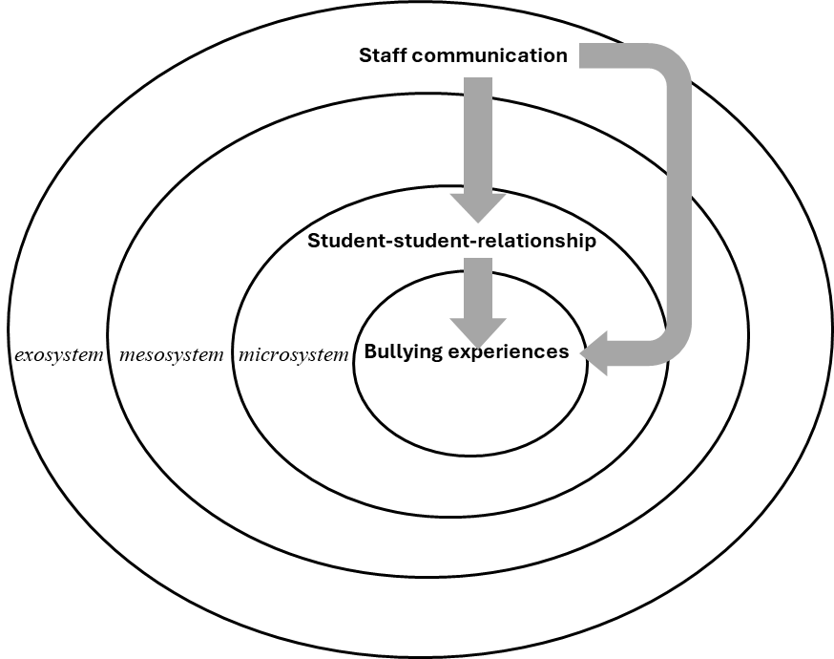

**The Current Study**

Based on Bronfenbrenner’s socioecological model and the assumed proximal processes between different levels, the theory of social learning, and teachers’ role as socialisation partners for students, we argue that staff communication can be an important construct in research on student bullying. In the current study, we focus on staff communication as an aspect of teacher-teacher relationships and, with that, of school climate, and on aspects of student-student relationships within the classroom as a part of classroom climate. We ask if staff communication at school (as one aspect of school climate) and classroom climate (measured as student-student relationships in the classroom) are directly associated with students’ bullying experiences. In addition, we want to know if staff communication is indirectly linked to classroom climate via student-student communication in the classroom (see Figure 1).

We expect that:

1. Student-student relationship quality in the classroom (hypothesis 1a) and staff communication at school (hypothesis 1b) are associated directly with students’ experiences as bullies, victims, and bully-victims.
2. Staff communication at school and student-student relationship quality in the classroom are associated with each other.
3. Staff communication is indirectly linked to students’ experiences as bullies, victims, and bully-victims via the student-student relationship quality in the classroom.

**Method**

**Participants**

The teacher and student data were collected in a stratified random school sample (strata: school type) in a federal state in eastern Germany. Three relevant school types were included that represent the educational system in that federal state: grammar schools, where students from year five to twelve are prepared for university study (*n* = 7), high schools, in which students are taught from year five to ten and mainly prepared for vocational training (*n* = 13), and schools for special education, where students with special educational needs are taught (*n* = 4). The number of schools for each type of school are representative of the distribution of students in the federal German state.

Data from 2,071 students (48.62% female, *M*Age = 13.64 years, *SDage* = 1.17, range: 12 to 17 years) from 114 classes and their 556 teachers (79.38% female, *M*Age = 50.59 years, *SDage* = 8.44; *M*work experience = 26.44 years, *SD* = 9.97) from 24 schools were collected in the study. The response rate was 60% at school level, 78% at student level, and 81% at teacher level. Students in the sample attended years 6 or eight with the mean age of *M* = 12.68 years (*SD* = 0.77) in year 6 and a mean age of *M* = 14.62 (*SD* = 0.91) in year eight.

**Procedure**

Ethical approval was gained by the data protection officer and the federal state’s education authority where the participating schools reside. After the random selection of the schools using Probability-Proportional-to-Size Sampling (PPS), the principals of the randomly chosen schools were informed via mail, and follow-up telephone calls were made afterward. Most principals discussed the possible participation in the study with the teachers and parent representatives. Upon receiving consent from the principal, information materials were sent to the schools and distributed to students in participating classes. Data were collected at the schools between June and October 2014. Only students and teachers who wished to participate and, only for the students, whose parents had also signed consent forms could participate in the study. Informed consent was obtained.

Students and teachers answered the questionnaire in approximately 45 minutes, on average. Student data were collected during regular school hours on an appointed day. At least one member of the research team was in the class during the whole duration of the data collection and students were told that they could refrain from participating at any point in time without any negative consequences. Teachers filled out their questionnaires at any time that was convenient for them. On the date of student data collection, the members of the research team collected all teacher questionnaires from a central location in the schools where the teachers collected their questionnaires in sealed envelopes. Schools received financial compensation if they reached approximately 70% of teacher participation to increase teachers’ motivation to participate in the study.

**Measures**

***Students’ Bullying Experiences***

Students’ bullying experiences were assessed via self-report using the two global items of the Revised Olweus Bully/Victim Questionnaire (OBVQ; Olweus, 1996). Firstly, a short definition of bullying, appropriate for the age group of the students, was provided to the students. Secondly, students were asked how frequently they bullied others or were bullied by others during the past month. Students could choose between five answers indicating the frequency of their bullying experiences: 1 = *no experiences with bullying*, 2 = *once or twice*, 3 = *two to three times per month*, 4 = *once a week*, 5 = *more than once a week*. Students were classified as bullied students (students with victimisation experiences) or bullies (bullying perpetration behaviour) when they indicated victimisation experiences or perpetration behaviour two to three times per month or more (answers 3 to 5; Olweus, 2010). Students who were both classified as bullied and bullies were labelled as combined bully-victims. All three bullying roles are analysed in three separate, binary variables. Data on bullying others were reported by *n* = 2,042 students (*n* = 29 [1.40%] missing data), data on being bullied by *n* = 2,020 (*n* = 51 [2.46%] missing data), and data for both victimisation and perpetration were reported by *n* = 2,002 students (*n* = 69 [3.33%] missing data).

For the analyses, students’ bullying experiences were analysed in reference to classroom- and school-level variables. Therefore, the intra-class-correlations (ICCs) of the three variables on students’ bullying experiences were calculated based on the between level variance based on Muthén and Muthén (2011; p. 66). At classroom level (level 2), the ICC for victimisation was ICC = .02, ICC = .03 for bullying perpetration, and ICC = .05 for bully-victims. The average cluster size at classroom level was 17.72 for victimisation, 17.91 for bullying perpetration, and 17.56 for bully-victims. Based on the ICC and the average cluster size, the ICC(2) was calculated as a measure of the reliability of the aggregated data (Bliese, 2000). The ICC(2) are ICC(2) = .27 for victimisation, ICC(2) = .36 for bullying perpetration, and ICC(2) = .48 for bully-victims. At school level (level 3), the ICCs were ICC = .01 for victimisation, ICC = .02 for bullying perpetration, and ICC = .05 for bully-victim experiences. The average cluster size at school level was 84.17 for victimisation, 85.08 for perpetration, and 83.42 for bully-victims. The ICC(2) are ICC(2) = .46 for victimisation, ICC(2) = .63 for perpetration, and ICC(2) = .81. As values of the ICC(2) below .50 indicate a poor reliability (Bobak et al., 2018), the reliability of the bullying experiences at class level is problematic. This can be explained by the low level of shared variance at class level. At the school level, the high average cluster size increases the ICC(2) as a reliability measure. However, because of the nature of the analyses that include additional data at the class and school level, the aggregated values are used to be able to perform the analyses.

***Student-student relationship quality in the classroom***

Student-student relationship quality in the classroom (as an aspect of classroom climate) was assessed using the Linzer Questionnaire of Classroom Climate for years 4 to 8 (Eder & Mayr, 2000). The questionnaire consists of two parts, one referring to the whole school and one referring to the class. Only the part referring to the class was used in this study. This part originally consists of 42 items and 4 scales, but as the data reported here were part of a more complex study on teachers’ intervention behaviour in student bullying, only three scales with a total of 9 items were used for economic reasons. These scales, all assessed with three items each, are *rivalry among the students at class* (“In our class, students often argue about who is better at school”, “When someone makes a mistake the others are secretly happy”, “Some students always try to make themselves look good by putting others down”), *sense of community in the class* (“When a student does something well, the others are happy for him/her”, “Students like to help each other”, “If someone says something against our class, we all stick together”), and *tendency to disturb* (“Sometimes we deliberately disturb the class”, “It is often not easy for the teachers to keep our class quite”, “Some students disturb the lessons again and again, although the others want to cooperate”) . Answers were given on a 5-point scale: 1 = *not true at all*, 2 = *not true*, 3 = *neither/nor*, 4 = *pretty much true*, 5 = *exactly true*. Data are treated as continuous data (Rhemtulla et al., 2012). All items were presented in their original German version; items and answers were translated for this publication. All nine items on student-student relationships in the classroom were answered by 2,056 students (*n* = 15 [0.72%] missing data).

A recent study supported the structure of the questionnaire suggested by the authors of the original scale (Hank et al., 2022). However, classroom climate in the sense of the questionnaire was shown to be a relatively homogenous construct with significant overlap of certain scales, although these were not the scales that were used in our study. To validate the postulated structure of the three subscales used, we conducted a CFA with the data of our study, testing both the three-factor and a one-factor solution. The three-factor solution showed a good fit to the data (Χ2 (24) = 136.92, *p* < .001, RMSEA = .048 (90% CI: .040; .056), CFI = .968, SRMR = .032), while the one-factor solution showed an unacceptable fit to the data according to the coefficients RMSEA, CFI, and SRMR and common suggestions (e.g., Schermelleh-Engel et al., 2003) (Χ2 (27) = 1570.36, *p* < .001, RMSEA = .167 (90% CI: .160; .174), CFI = .558, SRMR = .109). As a result, all analyses of classroom climate are conducted with the three scales. Composite reliability (CR) and average variance extracted (AVE) for the three subscales are: CR = .64, AVE = .38 for subscale rivalry; CR = .71, AVE = .45 for subscale sense of community; CR = .71, AVE = .45 for subscale tendency to disturb. For each scale, higher scores indicate higher levels on the respective scale.

In the statistical analyses, classroom climate was modelled at the class level by aggregating individual student data at class level. In the analyses of indirect associations, the three subscales of classroom climate were investigated in a three-level model. Therefore, both the shared variance at class level and at school level is relevant for the analysis. ICCs of the three scales at class level (level 2) are: ICC = .09 for rivalry, ICC = .21 for sense of community, and ICC = .26 for the tendency to disturb. Average cluster size is 17.69 for rivalry, 17.53 for sense of community, and 17.59 for the tendency to disturb. The ICC(2) are ICC(2) = .64 for rivalry, ICC(2) = .82 for sense of community, and ICC(2) = .86 for the tendency to disturb, indicating sufficient reliability of the aggregated data at the class level (Bobak et al., 2018). At the school level, the ICCS are ICC = .04 for rivalry, ICC = .09 for sense of community, and ICC = .11 for the tendency to disturb. The average cluster size at school level is 84.04 for rivalry, 83.25 for sense of community, and 83.54 for the tendency to disturb. The ICC(2) are ICC(2) = .78 for rivalry, ICC(2) = .89 for sense of community, and ICC(2) = .91 for the tendency to disturb, indicating sufficient reliability of the aggregated data at the school level (Bobak et al., 2018). As the individual data on classroom climate are only used to form the cluster variable, classroom climate is only included with cluster-level variables in the analyses of indirect effects in the three-level models (Pituch & Stapleton, 2012).

***Staff Communication at school***

Staff communication as an aspect of school climate in the sense of teacher-teacher relationships was measured with the scale Staff Communication (Gerecht et al., 2007). Answers are measured on a 4-point scale: 1 = *not at all true*, 2 = *rather not true*, 3 = *rather true*, 4 = *completely true*. Data on staff communication were given by *n* = 533 teachers (*n* = 23 [4.14%] missing data).

According to the authors of the original scale, the scale consists of two subscales. Subscale 1 (“General satisfaction”) consists of three relatively broad items which are introduced with “I am satisfied with…”, following three statements (“…the working atmosphere at my school”, “…the relationship with my colleagues”, “…the communication with my colleagues”). The second subscale (“Tone and conflicts”) consists of two items that are more detailed (“The tone among colleagues is friendly”, “Tensions or conflicts among colleagues are well resolved”). The authors of the original scale did not name the subscales. The subscale names used here were given by the authors of the current study.

The dimensionality of the scale was tested in the data of our study. The fit of the 2-factor solution (Χ2 (4) = 18.23, *p* < .001, RMSEA = .082 (90% CI: .046; .121), CFI = .988, SRMR = .019) was better than the fit of the 1-factor solution to the data (Schermelleh-Engel et al., 2003) (Χ2 (5) = 48.38, *p* < .001, RMSEA = .128 (90% CI: .096; .162), CFI = .963, SRMR = .033). As a result, all calculations were done with the two subscales of staff communication. Composite reliability for subscale 1 (General satisfaction) is CR = .84, average variance extracted is AVE = .64. For subscale 2 (Tone and conflicts), CR = .87 and AVE = .78, indicating good reliability for both subscales. For both scales, higher values indicate more positive aspects of staff communication climate.

Staff communication is analysed by aggregating individual teacher data at school level (level 3). ICCs are ICC = .23 both for subscale 1 (General satisfaction) and subscale 2 (Tone and conflicts). The average cluster size is 21.79 for subscale 1 and 21.96 for subscale 2 resulting in an ICC(2) = .87 for subscale 1 (General satisfaction) and ICC(2) = .87 for subscale 2 (Tone and conflicts), indicating a good reliability of both subscales at the school level.

***Control Variables***

Research suggests that bullying experiences (especially the experience of being victimised) vary between boys and girls, between different age groups, and between types of school (e.g. Cook et al., 2010; Fischer & Bilz, 2024; Smith et al., 2019; Zych et al., 2021). To address such differences, gender (binary variable, 0 = boys, 1 = girls; *n* = 4 students who did not indicate their gender were excluded from the analyses), year (0 = year 6, 1 = year 8; no missing data), and type of school (no missing data) were added as control variables to the multilevel regression analyses. For type of school, two dummy-variables for schools for special education (dummy-variable Special School: 0 = other type of school, 1 = school for special education) and for high schools (dummy-variable High School: 0 = other type of school, 1 = high school) were included. That means that grammar schools build the reference category.

**Statistical Analyses**

Data was clustered in three levels: Individual level (level 1), class level (level 2), and school level (level 3). The intra-class-correlations of the variables show that the clustering needs to be considered in the analyses (see section Measures).

Firstly, associations between students’ bullying experiences and student-student relationship quality in the classroom (hypothesis 1a) and staff communication (hypothesis 1b) as well as between staff communication and student-student relationship quality in the classroom (hypothesis 2) are investigated in two-level models. Multilevel models are necessary to address the clustering of the data. This is especially true as student-student relationship quality was measured by aggregating individual data at the class level. To investigate hypothesis 1a and 1b, logistic two-level models are conducted because the outcomes (students’ bullying experiences) are binary. For hypothesis 2, linear two-level analyses are used because the outcomes (student-student relationship quality in the classroom) are metric. Separate models are conducted for each sub-scale of the outcomes (i.e. different models for victimisation, perpetration, and bully-victims; different models for the three scales of student-student relationship quality in the classroom).

For the analyses of indirect effects (hypothesis 3), a three-level regression model is used to investigate the proposed indirect effect of student-student relationship quality in the classroom on the association between staff communication and students’ bullying experiences. As the outcomes (bullying experiences) are binary, logistic three-level analyses are conducted. The assumed indirect effect is investigated with multilevel modelling of manifest variables in a 3-2-1 design with the independent variable (staff communication) on level 3, an intermediate variable (student-student relationship quality in the classroom) on level 2 (but also with variance on level 3 due to clustering) and the outcome (students’ bullying experiences) at level 1 (with variance at level 2 and level 3) (Williams et al., 2022). For the intermediate variable, the variance of the individual student data for student-student relationship quality in the classroom was modelled at level 2 and level 3 (see the ICC reported in the section Measures; Williams et al., 2022). As the intermediate variable is the student-student relationship quality in the classroom, a cluster-level indirect effect is assumed in which an individual outcome (bullying experience) is impacted by a cluster-level variable (Pituch & Stapleton, 2012).

In all models, metric predictors (scales of classroom climate or staff communication climate) are grand-mean centred. Descriptive analyses were conducted with SPSS 29. Multilevel analyses were conducted in Mplus 8.10. In the two-level analyses, MLR is used as an estimator. In the analysis of the indirect effect in the three-level model, Bayes estimation is used. Listwise-delete was used to handle missing data. The Mplus input code for the analyses of the assumed indirect effects in the three-level model is provided in the Electronic Supplement.

**Results**

**Descriptive Results**

In Table 1, the frequency of bullying experiences reported by the students as well as the means and standard deviations of student-student relationship quality in the classroom (reported by the students) and staff communication (reported by the teachers) are presented for the three different levels. In Table 2, the bivariate correlations between bullying experiences, student-student relationship quality in the classroom, and staff communication without consideration of the clustering are reported, showing several significant correlations between the constructs.

**Table 1**

*Frequency, mean (M), and standard deviation (SD) for bullying experiences, classroom climate, and staff communication climate at individual, class, and school level.*

|  |  |  |  |
| --- | --- | --- | --- |
|  | Individual level  (*N* = 2,071) | Class level  (*N* = 114) | School level  (*N* = 24) |
| Bullying experience (reported by the students) | | |  |
| Victimisation | 11.5% | - | - |
| Perpetration | 9.5% | - | - |
| Bully-victims | 1.7% | - | - |
| Student-student relationship quality (reported by the students) | | |  |
| Rivalry | - | *M* = 2.71 (*SD* = 0.35) | - |
| Sense of community | - | *M* = 3.39 (*SD* = 0.46) | - |
| Tendency to disturb | - | *M* = 3.68 (*SD* = 0.50) | - |
| Staff communication (reported by the teachers) | | | |
| General satisfaction | - | - | *M* = 3.07 (*SD* = 0.29) |
| Tone and conflicts | - | - | *M* = 3.15 (*SD* = 0.28) |

**Table 2**

*Bivariate correlations between the different aspects of bullying experiences,* student-student relationship quality in the classroom*, and staff communication*

|  |  |  |  |  |  |  |  |
| --- | --- | --- | --- | --- | --- | --- | --- |
|  | [1] | [2] | [3] | [4] | [5] | [6] | [7] |
| [1] Bullying victimisation |  |  |  |  |  |  |  |
| [2] Bullying perpetration | .07*** |  |  |  |  |  |  |
| [3] Bully-victims | .37*** | .42*** |  |  |  |  |  |
| [4] Rivalry | .12*** | .12*** | .06** |  |  |  |  |
| [5] Sense of community | -.12*** | -0.8*** | -.05* | -.05*** |  |  |  |
| [6] Tendency to disturb | .07*** | -07** | .05* | .41*** | -.41*** |  |  |
| [7] General satisfaction | .02 | .02 | .02 | -.17*** | .02 | -.18*** |  |
| [8] Tone and conflicts | .04 | .05* | .02 | .03 | -.14*** | -.08*** | .89*** |

*Note.* Pearson correlation. [1] – [3]: Individual student data, bullying experiences. [4] – [6]: Student data aggregated at class level, student-student relationship quality. [7] – [8]: Teacher data aggregated at school level, staff communication. \*\*\**p* < .001. \*\**p* < .01. \**p* < .05.

**Two-Level Analyses of the Associations Between Bullying Experiences, Student-Student Relationship Quality, and Staff Communication**

Hypotheses 1 and 2 address the associations between students’ bullying experiences, student-student relationship quality, and staff communication. Two-level analyses including the control variables gender, year, and type of school were conducted with different analyses for each outcome. The results of the different analyses are presented in Table 3.

The results show that rivalry among students in the classroom is significantly associated with more bullying experiences as bullies, victims, and bully-victims. The other two aspects of relationship quality between students (sense of community, tendency to disturb), however, are not associated with students’ bullying experiences. Staff communication at school (general satisfaction, and tone and conflicts) is not associated with students’ bullying experiences, but with rivalry among students in the classroom: Higher levels of general satisfaction of teachers with the communication among staff at school are associated with less rivalry among students in the classroom, while higher values in tone and conflicts are associated with more rivalry in the classroom.

**Table 3**

*Two-level analyses of the associations between students’ bullying experiences, classroom climate, and staff communication climate including control variables*

|  |  |  |
| --- | --- | --- |
|  | OR [95% CI] | *p* |
| Hypothesis 1a: Student-student relationship quality (class level) and bullying experiences | | |
| Outcome 1: Victimisation |  |  |
| **Rivalry (level 2)** | **2.24 [1.41, 3.32]** | **.001** |
| Sense of Community (level 2) | 0.80 [0.57, 1.06] | .193 |
| Tendency to Disturb (level 2) | 1.10 [0.79, 1.46] | .557 |
| Year (level 2) | 0.90 [0.69, 1.13] | .433 |
| Type of School: High school vs. different (level 2) | 1.40 [0.99, 1.87] | .055 |
| **Type of school: Special school vs. different (level 2)** | **2.71 [1.48, 4.95]** | **.001** |
| Gender (level 1) | 1.10 [0.81, 1.50] | .541 |
| Outcome 2: Perpetration |  |  |
| **Rivalry (level 2)** | **2.75 [1.59, 4.76]** | **< .001** |
| Sense of Community (level 2) | 1.07 [0.67, 1.68] | .788 |
| Tendency to Disturb (level 2) | 1.29 [0.82, 1.94] | .216 |
| **Year (level 2)** | **1.46 [1.05, 2.01]** | **.023** |
| **Type of School: High school vs. different (level 2)** | **1.52 [1.01, 2.27]** | **.043** |
| **Type of school: Special school vs. different (level 2)** | **3.19 [1.64, 6.23]** | **.001** |
| **Gender (level 1)** | **0.62 [0.45, 0.87]** | **.005** |
| Outcome 3: Bully-Victim |  |  |
| **Rivalry (level 2)** | **4.26 [1.52, 11.82]** | **.006** |
| Sense of Community (level 2) | 1.15 [0.51, 2.59] | .729 |
| Tendency to Disturb (level 2) | 2.31 [0.99, 5.37] | .051 |
| Year (level 2) | 1.76 [0.89, 3.49] | .106 |
| Type of School: High school vs. different (level 2) | 1.23 [0.45, 3.35] | .682 |
| **Type of school: Special school vs. different (level 2)** | **9.78 [2.86, 33.45]** | **< .001** |
| Gender (level 1) | 0.52 [0.21, 1.27] | .148 |
| Hypothesis 1b: Staff Communication (school level) and bullying experiences | | |
| Outcome 1: Victimisation |  |  |
| General Satisfaction (level 3) | 0.83 [0.14, 5.10] | .842 |
| Tone and Conflicts (level 3) | 1.27 [0.24, 6.75] | .776 |
| **Type of School: High school vs. different (level 3)** | **1.95 [1.36, 2.80]** | **< .001** |
| **Type of school: Special school vs. different (level 3)** | **3.03 [1.57, 5.81]** | **.001** |
| Gender (level 1) | 1.12 [0.82, 1.51] | .471 |
| Year (level 1) | 0.94 [0.81, 1.10] | .452 |
| Outcome 2: Perpetration |  |  |
| General Satisfaction (level 3) | 0.59 [0.10, 3.42] | .557 |
| Tone and Conflicts (level 3) | 2.21 [0.36, 13.74] | .394 |
| **Type of School: High school vs. different (level 3)** | **1.87 [1.31, 2.67]** | **.001** |
| **Type of school: Special school vs. different (level 3)** | **2.75 [1.76, 4.31]** | **< .001** |
| **Gender (level 1)** | **0.63 [0.42, 0.94]** | **.024** |
| **Year (level 1)** | **1.22 [1.05, 1.41]** | **.009** |
| Outcome 3: Bully-Victim |  |  |
| General Satisfaction (level 3) | 4.14 [0.04, 454.87] | .553 |
| Tone and Conflicts (level 3) | 0.25 [0.02, 34.12] | .584 |
| Type of School: High school vs. different (level 3) | 2.31 [0.78, 6.89] | .132 |
| **Type of school: Special school vs. different (level 3)** | **8.42 [2.60, 27.39]** | **< .001** |
| Gender (level 1) | 0.56 [0.27, 1.17] | .122 |
| Year (level 1) | 1.24 [0.93, 1.65] | .138 |
|  | β [95% CI] | *p* |
| Hypothesis 2: Staff communication (school level) and student-student relationship quality (aggregated at class level) | | |
| Outcome 1: Rivalry |  |  |
| **General Satisfaction (level 3)** | **-1.09 [-1.98, -0.20]** | **.017** |
| **Tone and Conflicts (level 3)** | **0.90 [0.15, 1.65]** | **.019** |
| **Type of School: High school vs. different (level 3)** | **0.43 [0.04, 0.81]** | **.029** |
| Type of school: Special school vs. different (level 3) | 0.09 [-0.21, 0.38] | .561 |
| Year (level 2) | 0.11 [-0.06, 0.29] | .212 |
| Gender: Portion of female in the class (level 2) | -0.05 [-0.32, 0.23] | .743 |
| Outcome 2: Sense of Community |  |  |
| General Satisfaction (level 3) | 0.11 [-0.13, 0.34] | .736 |
| Tone and Conflicts (level 3) | -0.28 [-1.00, 0.45] | .454 |
| **Type of School: High school vs. different (level 3)** | **-0.72 [-1.01, -0.43]** | **< .001** |
| **Type of school: Special school vs. different (level 3)** | **-0.55 [-0.95, -0.14]** | **.008** |
| Year (level 2) | 0.11 [-0.13, 0.34] | .378 |
| Gender: Portion of female in the class (level 2) | 0.10 [-0.15, 0.34] | .450 |
| Outcome 3: Tendency to Disturb |  |  |
| General Satisfaction (level 3) | -0.53 [-1.35; 0.29] | .208 |
| Tone and Conflicts (level 3) | 0.22 [-0.59; 1.03] | .595 |
| **Type of School: High school vs. different (level 3)** | **0.44 [0.14; 0.74]** | **.004** |
| Type of school: Special school vs. different (level 3) | 0.13 [-0.30; 0.57] | .549 |
| Year (level 2) | -0.16 [-0.37; 0.05] | .134 |
| Gender: Portion of female in the class (level 2) | -0.13 [-0.41; 0.15] | .370 |

*Note.* Significance predictors are printed in bold. Year: 0 = year 6, 1 = year 8. Gender: 0 = male, 1 = female. Type of school: 0 = different school, 1 = high school resp. school for special education. Hypotheses 1a and 1b: Logistic binary regression. Hypothesis 2: Linear regression. For the linear regression, standardised estimates are given. To consider gender as a control variables in the analyses on hypothesis 2, gender was aggregated at class level, showing the portion of female students in the class.

**Indirect effect in the three-level model**

In hypothesis 3, it is expected that there is an indirect association between staff communication and students’ bullying experiences via student-student relationship quality in the classroom. In the two-level analyses, it was shown that there is no direct effect between staff communication and students’ bullying experiences. However, such a direct effect is not necessary for a complex indirect effect (Rucker et al., 2011; Zhao et al., 2010). To investigate such a possible indirect effect, associations between the intermediate variable and the independent variable (staff communication and student-student relationship quality in the classroom) and the dependent variable (student-student relationship quality in the classroom and students’ bullying experiences) are necessary. The two-level analyses show that this requirement is met for rivalry in the classroom and students’ bullying victimisation, perpetration, and bully-victim experiences. Therefore, analyses of indirect effects were conducted with rivalry in the classroom as an intermediate variable. In the analyses, students’ gender, year, and type of school were added as control variables for students’ bullying experiences.

The models for the association between staff communication and students’ bullying experiences via rivalry in the classroom is shown in Figures 2 to 4 (Figure 2: Victimisation; Figure 3: Bullying perpetration; Figure 4: Bully-victim). For the intermediate variable, the variance at level 3 and level 2 was modelled to build the complex 3-2-1 effect model that is proposed (Williams et al., 2022).

The results show that significant indirect effects between staff communication at school and students’ bullying experiences exist via rivalry among students in the classroom for all three types of bullying experiences that had been investigated. Higher levels of general satisfaction of teachers with the communication among staff are significantly associated with less experiences of students as victims, bullies, and bully-victims (OR of the indirect effect < 1). This can be explained with the finding that higher levels of general satisfaction with staff communication of teachers at school are associated with less rivalry in the classroom, while higher levels of rivalry increasing students’ bullying experiences. However, the opposite effect can be found for higher levels of tone and conflicts among staff. Higher levels of tone and conflicts among staff at school are significantly associated with an increase in rivalry among students in the classroom and, with that, with higher bullying experiences of students as victims, bullies, and bully-victims.

**Figure 2**

*Indirect association between staff communication and students’ bullying victimisation via rivalry in the classroom*

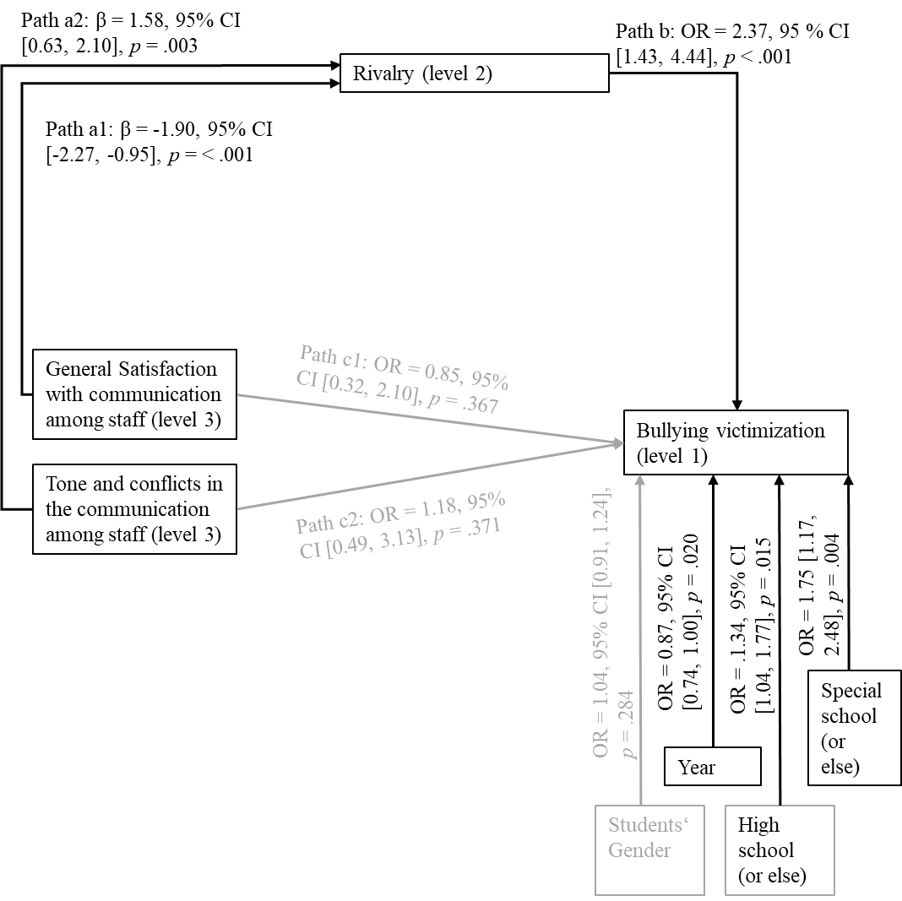

*Note.* OR calculated from the unstandardized estimates. Non-significant paths (*p* > .05; 95% CI for OR crosses 1) are printed in grey. Indirect effects: a1*b: OR = 0.35, 95% CI [0.12, 0.74], *p* < .001; a2*b: OR = 2.43, 95% CI [1.28, 7.03], *p* = .003. Total effect “general satisfaction” (a1*b + c1): OR = 0.29, 95% CI [0.06, 1.04], *p* = .029. Total effect “tone and conflicts” (a2*b + c2): OR = 2.89, 95% CI [0.89, 14.15], *p* = .041. Indirect effect calculated from unstandardised estimates.

**Figure 3**

*Indirect association between staff communication and students’ bullying perpetration via rivalry in the classroom*

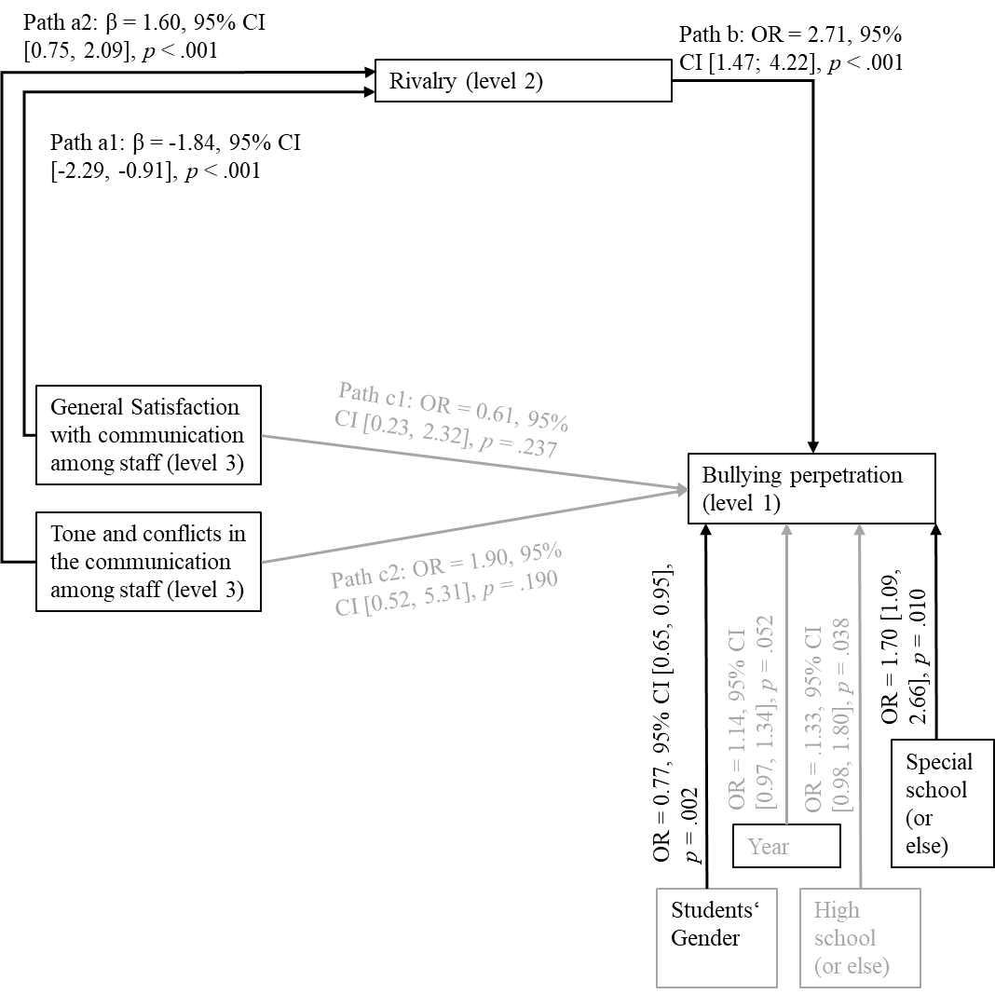

*Note.* OR calculated from the unstandardized estimates. Non-significant paths (*p* > .05; 95% CI for OR crosses 1) are printed in grey. Indirect effects: a1*b: OR = 0.29, 95% CI [0.11, 0.79], *p* < .001; a2*b: OR = 3.00, 95% CI [1.21, 6.82], *p* < .001. Total effect “general satisfaction” (a1*b + c1): OR = 0.17, 95% CI [0.04, 1.20], *p* = .038. Total effect “tone and conflicts” (a2*b + c2): OR = 5.70, 95% CI [0.86, 20.49], *p* = .043. Indirect effect calculated from unstandardised estimates.

**Figure 4**

*Indirect association between staff communication and students’ experiences as bully-victims via rivalry in the classroom*

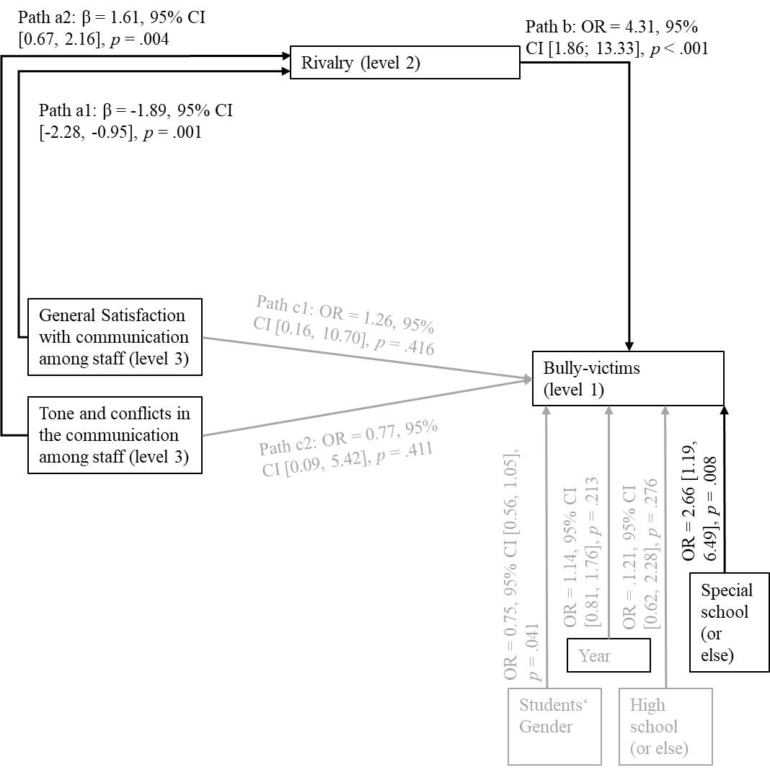

*Note.* OR calculated from the unstandardized estimates. Non-significant paths (*p* > .05; 95% CI for OR crosses 1) are printed in grey. Indirect effects: a1*b: OR = 0.17, 95% CI [0.03, 0.56], *p* = .001; a2*b: OR = 4.66, 95% CI [1.57, 26.31], *p* = .004. Total effect “general satisfaction” (a1*b + c1): OR = 0.21, 95% CI [0.01, 2.56], *p* = .116. Total effect “tone and conflicts” (a2*b + c2): OR = 4.01, 95% CI [0.33, 51.42], *p* = .150. Indirect effect calculated from unstandardised estimates.

In addition to the results presented, we also tested a complex model including all sub-scales of the student-student relationship quality. No further significant direct or indirect effects were revealed for students’ bullying victimisation, bullying perpetration, or experiences as bully-victims.

**Discussion**

In the current study, we broadened the perspective on the associations between school level factors, class level factors, and bullying experiences by including teacher-teacher relationships and student-student relationships in the analyses. We investigated whether student-student relationship quality (hypothesis 1a) and staff communication (hypothesis 1b) as an aspect of school climate were associated with students’ bullying experiences and we investigated possible relationships between staff communication and student-student relationship quality (hypothesis 3). In addition, we tested if staff communication may be indirectly associated with students’ bullying experiences via student-student relationship quality (hypothesis 3).

Hypothesis 1a could partly be confirmed: Student-student relationship quality is associated with students’ bullying experiences but only for one aspect. The more rivalry is between students in a classroom, the more bullying victimisation, perpetration, and bully-victims in the classroom. Staff communication at school, instead, was not associated with students’ bullying experiences. That means that hypothesis 1b could not be confirmed. When looking at the associations between student-student relationship quality in the classroom and staff communication at school (hypothesis 2), again, rivalry is the only relevant aspect of student-student relationship quality for this association: Higher levels of general satisfaction of teachers with the communication climate among staff is associated with less rivalry between students in the classroom, while better tone and conflict resolution among staff goes along with more rivalry between students. This association is surprising and will be discussed in more detail the following sections. Hypothesis 3 focussed on a possible indirect effect between staff communication and students’ bullying experiences via student-student relationship quality in the classroom. The assumed indirect effect was found, confirming hypothesis 3: While no direct associations exist between staff communication and students’ bullying experiences, it was shown that staff communication is indirectly related to students’ bullying experiences via rivalry in the classroom. At schools in which teachers experience less general satisfaction with the communication climate among staff and better tone and conflict resolution among staff, students experience higher levels of rivalry between them in the classes at the school. When there is more rivalry in the classroom, in turn, students report to experience more bullying as bullied, bullies, and bully-victims. That means that higher satisfaction with staff communication among teachers is associated with less bullying (via less rivalry between students in the classroom), while higher levels of tone and conflicts among staff at school are associated with more bullying experiences of the students (via less rivalry among students in the classroom).

With that, the findings of the current study stress that the whole school needs to be included in bullying research and anti-bullying measures. Complex social systems need to be addressed which do not only include the classroom as a direct social context for students but also aspects of the school and relationships among staff.

**Student-student relationship quality and Students’ Bullying Experiences (hypothesis 1a)**

In the current study, student-student relationship quality was assessed with three sub-types: rivalry among the students in the classroom, sense of community in the classroom, and the tendency to disturb. The results show that the tendency to disturb and the sense of community between students in the classroom are not related to students’ bullying experiences. However, the more rivalry in the classroom, the more students experience bullying as bullied, bullies, and bully-victims.

The finding that students’ bullying experiences differ depending on the student-student relationship quality (as an aspect of classroom climate) that the students experience is in line with understanding bullying as a socioecological phenomenon (Azeredo et al., 2015; Doumas & Midgett, 2019; Dorio et al., 2020; Espelage et al., 2019; Forsberg et al., 2024; Swearer & Hymel, 2015). In addition, it is in line with studies showing that climate aspects such as positive social relationships are associated with less aggression and bullying (Cook et al., 2010; Kowalski et al., 2014; Steffgen et al., 2013; Zych et al., 2015, 2019). However, in contrast to previous studies, this finding was found for the classroom level. The relevance of classroom climate is probably particularly high in school systems with stable groups of students in the classroom, such as the school system in Germany.

In addition to the associations with student-student relationship quality, male gender has been identified as a risk factor for bullying others and for being both bullied and bullying others (bully-victims). This is in line with previous research (Cook et al., 2010; Fischer & Bilz, 2024). Further, attending a school for special education has been identified as a risk for bullying others and for being bullied. Students with special educational needs (who typically visit a school for special education) are found to have higher risks for bullying involvement (Rose et al., 2009). Attending high school was also related with higher bullying risks, meaning that students at grammar schools typically experience less bullying than students at other school types. This is also in line with other studies (e.g., Fischer & Bilz, 2024). Further results suggest that older age may be an additional risk factor for bullying others. However, that risk factor was not relevant in the analyses including both the class and school level. When interpreting that finding, it needs to be considered that only two age groups were included in the data (year 6 and year 8 with mean ages of 12.7 and 14.6 years, respectively) so age differences should not be considered in this sample.

**Staff Communication and Student-Student Relationship Quality (hypothesis 2)**

As social contexts influence each other (e.g. Bronfenbrenner, 1994; Merçon‐Vargas et al., 2020), we expected associations between staff communication at school and student-student relationship quality in the classroom. The results supported this hypothesis: rivalry in the classroom is higher in schools in which teachers are less satisfied with staff communication and at schools in which staff experiences a more friendly tone and better conflict resolution among staff. The finding that higher rivalry can be found in schools with less general satisfaction with staff communication is found as expected. When teachers are less satisfied with the communication among them and other staff members in general, they may communicate less, may work together less often, and may also be less satisfied with working at the school in general. The perceived communication climate can affect a person’s identification with their own work organisation. Higher levels of identification, in turn, increase the commitment to the work institution and are associated with higher levels of job satisfaction in general (Bartels et al., 2007; Schad, 2019). Lower levels of job satisfaction may lower teachers’ engagement in teaching and class management (Bilz et al., 2022), decreasing classroom climate and increasing rivalry as teachers are less engaged in managing students’ social interactions. This may affect social interactions and social norms between students in the classroom. As a result, students may act highly competitive without supporting each other. However, associations between teachers’ general satisfaction with staff communication climate and students’ sense of belonging could also be expected but were not found. Further analyses and studies on the associations between teachers’ satisfaction with staff communication and students’ perceived student-student relationship quality are needed.

The positive association between higher levels of teachers’ perceived positive tone and conflicts resolution and higher levels of classroom rivalry was not expected. Instead, the perception of positive tone and conflict resolution would have been expected to be related to less rivalry in the classroom. However, a possible explanation may be found in the wording of the items. For example, agreement with the statement “Tensions or conflicts among colleagues are well resolved” were labelled as positive satisfaction of tone and conflict resolution. However, such answers of the teachers may also have implications for the level of conflicts and tension itself. Teachers who indicated that conflicts are usually well resolved may experience higher levels of conflicts among staff in general. That would mean that higher scores in “tone and conflicts” may be associated with more conflicts among staff. This is especially true as the scale only consists of two items. Following the assumption that teachers act as role models and socialisation partners for students (Bierman, 2011; Colpin et al., 2021; Elledge et al., 2013; Farmer et al., 2011; Longobardi et al., 2020; Yoon & Barton, 2008), this may be associated with more conflicts and worse student-student relationship quality, as well.

A different explanation of the found negative association between teachers’ perceived tone and conflicts and classroom climate may be that schools who have better conflict resolution may also have a better culture of failure. They may also be more sensitive to the meaning of positive interactions at school. In turn, students may be more sensitive to rivalry among the classroom, leading to higher rivalry scores. In this case, schools with better tone and conflict resolution may not necessarily have more rivalry in the classrooms than other schools, but they be more sensitive to it, resulting in higher scores.

In summary, the current findings on the associations between staff communication at school and student-student relationship quality in the classroom must be understood as exploratory findings. The findings show that aspects of school climate and classroom climate are associated with each other. However, further studies are needed to understand the nature of the associations better. This is also true as climate aspects at classroom level may also affect school climate aspects. Such causal relationships cannot be investigated in the current study but could be investigated in future longitudinal studies.

**Staff Communication and Students’ Bullying Experiences (hypotheses 1b and 3)**

There is an indirect association between staff communication and students’ bullying experiences as bullied, bullies, and bully-victims via the rivalry in the classroom. Following Zhao et al. (2010), it is an indirect effect only. That means that staff communication at school and student bullying are only associated via rivalry between students in the classroom.

The finding stresses the importance of the role of teachers on the bullying process (e.g. Colpin et al., 2021). It can be expected that teachers who are generally satisfied with the communication among staff may communicate more, enhancing collaboration. Collaboration, in turn, is important for teachers to successfully intervene in bullying situation (van Aalst et al., 2024; Wachs et al., 2019). That also means that further aspects such as teachers’ interventions in incidents of bullying or particular response strategies that teachers use may mediate the association between staff communication climate and students’ bullying experiences. Possible indirect effects should be investigated. Such analyses may also include students’ perspectives on teachers’ bullying response strategies, resulting in three-level models like they were used in the current study. In addition, especially when thinking of teachers as role models, further aspects of staff communication and staff interaction could be interesting to investigate. This may especially include disrespectful interactions among staff and negative strategies of conflict resolution that may also affect students’ interactions in the classroom.

**Limitations**

In the current study, we investigated staff communication as an aspect of school climate. However, school climate is a much more complex construct. While we think that the teacher-teacher relationships are an under-investigated aspect of school climate that needs to be investigated, many more aspects of school climate need to be assessed when investigating school-level aspects of students’ bullying experiences. In addition, we expect that staff communication is a basis for teacher collaboration. However, it is suggested to directly investigate teacher collaboration in further studies. When interpreting staff communication, we focused mainly on teacher-teacher interactions. This is valid as teachers are the biggest group of school staff in Germany. However, schools usually also have staff in an administration office, caretaker roles, and school social workers who may have been included in teachers’ ratings of communication among school staff.

Just as school climate, classroom climate is also a concept that is much broader than the student-student interactions that were investigated here. Especially aspects such as rules and norms can affect students’ bullying experiences and bullying behaviours, as was shown in earlier studies. Further aspects of classroom climate can be included in future analyses.

The instrument that was used to assess staff communication only has a few items with only two items for the second scale (tone and conflicts). This limits the validity of the scale. In addition, the items have important limitations because of the wording that was used. It is not clear if high scores on the item “Tensions or conflicts among colleagues are well resolved” mean good conflict resolution, or the existence of conflicts in general. This complicates the interpretation of the current findings. More complex instruments should be used to investigate staff communication in future studies. In the measurement of students’ bullying experiences, students’ answers were categorised into experiences as bullies and victims via a yes and no response. The categorisation into a binary variable was done to address the repetition of bullying as a definition criterion. However, the categorisation also results in a loss of variance. In addition, the reliability of the measures of the bullying experiences is not sufficient at the class level. This is due to the low level of shared variance. Higher reliability scores could be reached with higher average cluster sizes.

The structure of the subscales for classroom climate and staff communication climate haven been testes in CFA. Even if the CFA results were acceptable, the reliability of the subscales for classroom climate are mediocre. This can limit the quality of the findings.

The current analyses are based on cross-sectional data. If negative aspects of classroom climate increases bullying or if bullying lowers classroom climate cannot be answered with the current data. Further, we only investigated indirect effects between staff communication and students’ bullying experiences via aspects of the student-student relationship quality in the classroom. However, it can also be expected that especially the frequency of bullying in a classroom or a school also affects teacher interactions and the climate among staff. Complex interactions can be expected that could be analysed further with longitudinal data.

For the analyses of the indirect effect, the variance of student-student relationship quality in the classroom as the intermediate variable was modelled at level 2 and 3. Following Pituch and Stapleton (2012), we did not expect the indirect effect to flow through a level 1 association but expected a cluster-only indirect effect as the intermediate variable is a climate variable. Therefore, the intermediate variable was only modelled at the two cluster levels, not at the individual level. However, researchers may also decide that the individual perception of student-student relationship quality can be relevant as well, building other models and maybe also including further data on individual perceptions of climate aspects (Pituch & Stapleton, 2012).

**Conclusions and Implications for Practice and Future Research**

The current findings support the assumption that complex interactions between school level and class level exist in bullying processes. Teacher-teacher relationships may affect student-student relationships in the classroom which, in turn, affect bullying involvement. As a result, not only students, but also teachers should be included in anti-bullying measures. Communication among staff may even have implications for students’ bullying involvement. Even if staff communication at school is not directly linked to student bullying, it can make a difference to class-level aspects that are important for student bullying. Consequently, anti-bullying measures in school can be understood as a very broad variety of measures. As bullying is closely related to complex associations in the classroom and the whole school, many measures of school development that are aimed at improving aspects of school climate can help to decrease bullying, as well. Such measures can also include strategies to improve climate among staff. Improving teacher-teacher relationships, staff communication, and staff interaction is a new opportunity for bullying prevention and intervention. Even if not included directly, school staff also is an important exosystem for students. The current findings suggest that improvement of relationships between staff could also have positive consequences for student-student relationships and bullying among students.

Practical anti-bullying-measures should include the staff system. The climate among staff should be addressed as well. For schools, the findings mean that schools gained an additional tool for anti-bullying measures: Working on improvement of teacher-teacher relationships, satisfaction with staff communication, and job satisfaction can have positive consequences not only for the teachers, but also for the students.

Bullying research should be more sensitive to the complex associations between school level and class level aspects. Empirical analyses should include more than one system at the same time when possible. Three-level models should be used for bullying analyses more often. Looking at the different levels separately is important to understand details, but class and school level aspects should be included in complex statistical models to increase the understanding of bullying. Different contexts are closely related with each other, and researchers should try to address such interdependencies in statistical models as good as possible.

**Abbreviations**

Not Applicable

**[Declaration section removed for review process]**

**References**

Acquah, E. O., Topalli, P. Z., Wilson, M. L., Junttila, N., & Niemi, P. M. (2016). Adolescent loneliness and social anxiety as predictors of bullying victimisation. *International Journal of Adolescence and Youth*, *21*(3), 320-331. <https://doi.org/10.1080/02673843.2015.108344>

Azeredo, C. M., Rinaldi, A. E. M., Moraes, C. L. de, Levy, R. B., & Menezes, P. R. (2015). School bullying: A systematic review of contextual-level risk factors in observational studies. *Aggression and Violent Behavior, 22*, 65–76. <https://doi.org/10.1016/j.avb.2015.04.006>

Bartels, J., Pruyn, A., de Jong, M., & Joustra, I. (2007). Multiple organizational identification levels and the impact of perceived external prestige and communication climate. *Journal of Organizational Behavior, 28*, 173–190. <https://doi.org/10.1002/job.420>

Bierman, K. L. (2011). The promise and potential of studying the “invisible hand” of teacher influence on peer relations and student outcomes: A commentary. *Journal of Applied Developmental Psychology, 32*(5), 297–303. <https://doi.org/10.1016/j.appdev.2011.04.004>

Bilz, L., Fischer, S. M., Hoppe-Herfurth, A.-C., & John, N. (2022). A consequential partnership. The association between teachers’ well-being and students’ well-being and the role of teacher support as a mediator. *Zeitschrift für Psychologie, 230*(3), 264–275. <https://doi.org/10.1027/2151-2604/a000497>

Bliese, P. D. (2000). Within-group agreement, non-independence, and reliability: Implications for data aggregation and analysis. In K. J. Klein & S. W. Kozlowski (Eds.), *Multilevel theory, research, and methods in organizations* (pp. 349–381). Jossey-Bass.

Bobak, C. A., Barr, P. J., & O’Malley, A. J. (2018). Estimation of an inter-rater intra-class correlation coefficient that overcomes common assumption violations in the assessment of health measurement scales. *BMC Medical Research Methodology, 18*, 93. <https://doi.org/10.1186/s12874-018-0550-6>

Boulton, M. J., & Macaulay, P. J. (2023). Does authentic self‐esteem buffer the negative effects of bullying victimisation on social anxiety and classroom concentration? Evidence from a short‐term longitudinal study with early adolescents. *British Journal of Educational Psychology*, *93*(2), 500-512. <https://doi.org/10.1111/bjep.12573>

Bronfenbrenner, U. (1994). Ecological models of human development. In M. Gauvain & M. Cole (Hrsg.), *Readings on the Development of Children* (2. Aufl., S. 37–43). Free-

man.

Choi, B., & Park, S. (2021). Bullying perpetration, victimisation, and low self-esteem: Examining their relationship over time. *Journal of youth and adolescence*, *50*, 739-752. <https://doi.org/10.1007/s10964-020-01379-8>

Coelho, V. A., & Sousa, V. (2018). Class-level risk factors for bullying and victimization in Portuguese middle schools. *School Psychology International, 39*(2), 121–137. <https://doi.org/10.1177/0143034317749992>

Colpin, H., Bauman, S., & Menesini, E. (2021). Teachers’ responses to bullying: Unravelling their consequences and antecedents. Introduction to the special issue. *European Journal of Developmental Psychology, 18*(6), 781–797. <https://doi.org/10.1080/17405629.2021.1954903>

Cook, C. R., Williams, K. R., Guerra, N. G., Kim, T. E. & Sadek, S. (2010). Predictors of bullying and victimization in childhood and adolescence: A meta-analytic investigation. *School Psychology Quarterly, 25*(2), 65–83. <https://doi.org/10.1037/a0020149>

Cosma, A., Molcho, M., & Pickett, W. (2024). A focus on adolescent peer violence and bullying in Europe, central Asia and Canada. Health Behaviour in School-aged Children international reort from the 2021/2022 survey. Volume 2. Volume 2. World Health Organization. Regional Office for Europe. <https://iris.who.int/handle/10665/376323>

D’Urso, G., & Symonds, J. (2022). Developmental cascades of internalizing and externalizing problems from infancy to middle childhood: longitudinal associations with bullying and victimisation. *Journal of school violence*, *21*(3), 294-311. <https://doi.org/10.1080/15388220.2022.2081856>

Dorio, N. B., Clark, K. N., Demaray, M. K., & Doll, E. M. (2020). School climate counts: A longitudinal analysis of school climate and middle school bullying behaviors. *International Journal of Bullying Prevention, 2*, 292–308. <https://doi.org/10.1007/s42380019-00038-2>

Doumas, D. M., & Midgett, A. (2019). The effects of students’ perceptions of teachers’ antibullying behavior on bullying victimization: Is sense of school belonging a mediator? *Journal of Applied School Psychology, 35*(1), 37–51. <https://doi.org/10.1080/15377903.2018.1479911>

Eder, F., & Mayr, J. (2000). Linzer Fragebogen zum Schul- und Klassenklima für die 4. und 8. Klassenstufe [Linzer Questionnaire of Classroom Climate for years 4 to 8]. Hogrefe.

Elledge, C. L., Williford, A., Boulton, A. J., DePaolis, K. J., Little, T. D., & Salmivalli, C. (2013). Individual and contextual predictors of cyberbullying: The influence of children's provictim attitudes and teachers' ability to intervene. *Journal of Youth and Adolescence*, *42*(5), 698–710. <https://doi.org/10.1007/s10964-013-9920-x>

Espelage, D. L., Low, S. K., & Jimerson, S. R. (2014). Understanding school climate, aggression, peer victimization, and bully perpetration: Contemporary science, practice, and policy. *School Psychology Quarterly, 29*(3), 233–237. <http://dx.doi.org/10.1037/spq0000090>

Espelage, D. L., Valido, A., Hatchel, T., Ingram, K. M., Huang, Y., & Torgal, C. (2019). A literature review of protective factors associated with homophobic bullying and its consequences among children & adolescents. *Aggression and Violent Behavior, 45*, 98–110. <https://doi.org/10.1016/j.avb.2018.07.003>

Evans, C. B. R., Smokowski, P. R., Rose, R. A., Mercado, M. C., & Marshall, K. J. (2018). Cumulative bullying experiences, adolescent behavioral and mental health, and academic achievement: An integrative model of perpetration, victimization, and bystander behavior. *Journal of Child and Family Studies, 27*. <https://doi.org/10.1007/s10826-018-1078-4>

Farmer, T. W., McAuliffe Lines, M., & Hamm, J. V. (2011). Revealing the invisible hand: The role of teachers in children's peer experiences. *Journal of Applied Developmental Psychology, 32*(5), 247–256. <https://doi.org/10.1016/j.appdev.2011.04.006>

Fischer, S. M., & Bilz, L. (2024). Traditional bullying and cyberbullying at schools in Germany: Results of the HBSC study 2022 and trends from 2009/10 to 2022. *Journal of Health Monitoring, 9*(1), 42–61. <https://doi.org/10.25646/11872>

Forsberg, C., Sjögren, B., Thornberg, R., Hong, J. S., & Longobardi, C. (2024). Longitudinal reciprocal associations between student–teacher relationship quality and verbal and relational bullying victimisation. *Social Psychology of Education*, *27*(1), 151-173. <https://doi.org/10.1007/s11218-023-09821-y>

Gage, N. A., Prykanowski, D. A., & Larson, A. (2014). School climate and bullying victimization: A latent class growth model analysis. *School Psychology Quarterly, 29*(3), 256–271. <https://doi.org/10.1037/spq0000064>

Gerecht, M., Steinert, B., Klieme, E., & Döbrich, P. (2007). Skalen zur Schulqualität [Scales on the Quality of Schools]. Dokumentation der Erhebungsinstrumente. Pädagogische Entwicklungsbilanzen mit Schulen (PEB). Skala Kommunikation im Kollegium (S. 28). Materialien zur Bildungsforschung Band 17. DIPF. <https://www.pedocs.de/volltexte/2010/3121/pdf/MatBild_Bd17_D_A.pdf>

Hank, P., Baltes-Götz, B., & Preckel, F. (2022). Welche Klimadimensionen misst der Linzer Fragebogen zum Schul- und Klassenklima für die 4.-8. Klasse (LFSK 4-8; Eder, 2000)? [Which classroom climate dimensions does the Linzer Questionnaire of Classroom Climate 4-8 measure?]. *Diagnostica, 68*(1), 28–38. <https://doi.org/10.1026/0012-1924/a000280>

Heerde, J. A., & Hemphill, S. A. (2019). Are bullying perpetration and victimization associated with adolescent deliberate self-harm? A meta-analysis. *Archives of Suicide Research, 23*(3), 353–381. <https://doi.org/10.1080/13811118.2018.1472690>

Kloo, M., Thornberg, R., & Wänström, L. (2023). Classroom-level authoritative teaching and its associations with bullying perpetration and victimisation. *Journal of school violence*, *22*(2), 276-289. <https://doi.org/10.1080/15388220.2023.2180746>

Kohl, D., Recchia, S., & Steffgen, G. (2013). Measuring school climate: An overview of measurement scales. *Educational Research, 55*(4), 411–426. <https://doi.org/10.1080/00131881.2013.844944>

Kollerová, L., Yanagida, T., Mazzone, A., Soukup, P., & Strohmeier, D. (2018). “They think that I should defend”: Effects of peer and teacher injunctive norms on defending victimized classmates in early adolescents. *Journal of Youth and Adolescence, 47*(11), 2424–2439. <https://doi.org/10.1007/s10964-018-0918-2>

Konishi, C., Hymel, S., & Waterhouse, T. (2017). Investigating associations between school climate and bullying in secondary schools: Multilevel contextual effects modelling. *School Psychology International, 38*(3), 240–263. <https://doi.org/10.1177/0143034316688730>

Košir, K., Klasinc, L., Špes, T., Pivec, T., Cankar, G., & Horvat, M. (2020). Predictors of self-reported and peer-reported victimization and bullying behavior in early adolescents: The role of school, classroom, and individual factors. *European Journal of Psychology of Education, 35*(2), 381–402. <https://doi.org/10.1007/s10212-019-00430-y>

Kowalski, R. M., Giumetti, G. W., Schroeder, A. N. & Lattanner, M. R. (2014). Bullying in the digital age: A critical review and meta-analysis of cyberbullying research among youth. *Psychological Bulletin, 140*(4), 1073–1137. <https://doi.org/10.1037/a0035618>

Låftman, S. B., Östberg, V., & Modin, B. (2017). School climate and exposure to bullying: A multilevel study. *School Effectiveness and School Improvement, 28*(1), 153–164. <https://doi.org/10.1080/09243453.2016.1253591>

Lenz, A. S., Rocha, L., & Aras, Y. (2021). Measuring school climate: A systematic review of initial development and validation studies. *International Journal for the Advancement of Counselling, 43*, 48–62. <https://doi.org/10.1007/s10447-020-09415-9>

Longobardi, C., Settanni, M., Lin, S., & Fabris, M. A. (2020). Student-teacher relationship quality and prosocial behaviour: The mediating role of academic achievement and a positive attitude towards school. *The British Journal of Educational Psychology, 91*(2), 547–562. <https://doi.org/10.1111/bjep.12378>

Marraccini, M., Fang, Y., Levine, S. P., Chin, A. J., & Pittleman, C. (2020). Measuring student perceptions of school climate: A systematic review and ecological content analysis. *School Mental Health, 12*, 195–221. <https://doi.org/10.1007/s12310-019-09348-8>

Merçon‐Vargas, E. A., Lima, R. F. F., Rosa, E. M., & Tudge, J. (2020). Processing proximal processes: What Bronfenbrenner meant, what he didn’t mean, and what he should have meant. *Journal of Family Theory & Review, 12*(3), 321–334. <https://doi.org/10.1111/jftr.12373>

Midgett, A. & Doumas, D. M. (2019). Witnessing bullying at school: The association between being a bystander and anxiety and depressive symptoms. *School Mental Health, 11*(3), 454–463. <https://doi.org/10.1007/s12310-019-09312-6>

Moore, S. E., Norman, R. E., Suetani, S., Thomas, H. J., Sly, P. D., & Scott, J. G. (2017). Consequences of bullying victimization in childhood and adolescence: A systematic review and meta-analysis. *World Journal of Psychiatry, 7*(1), 60–76. <https://doi.org/10.5498/wjp.v7.i1.60>

Muthén, L. K. & Muthén, B. (2011). Multilevel modelling with latent variables using Mplus: Cross-sectional analysis. Course 7. <http://www.statmodel.com/topic7.shtml> [09.04.2024].

O’Moore, M., & Kirkham, C. (2001). Self‐esteem and its relationship to bullying behaviour. *Aggressive Behavior: Official Journal of the International Society for Research on Aggression*, *27*(4), 269-283. <https://doi.org/10.1002/ab.1010>

Olweus, D. (1994). Bullying at school: Basic facts and effects of a school based intervention program. *Journal of Child Psychology and Psychiatry, and Allied Disciplines, 35*(7), 1171–1190. <https://doi.org/10.1111/j.1469-7610.1994.tb01229.x>

Olweus, D. (1996). *The revised Olweus bully/victim questionnaire*. Bergen. University of Bergen, Research Center for Health Promotion.

Olweus, D. (2010). Understanding and researching bullying. Some critical issues. In S. R. Jimerson, S. M. Swearer, & D. L. Espelage (Hrsg.), *The Handbook of Bullying in Schools: An International Perspective* (S. 9–33). Routledge.

Pituch, K. A., & Stapleton, M. L. (2012). Distinguishing between cross- and cluster-level mediation processes in the cluster randomized trial. *Sociological Methods & Research, 41*(4), 630–670. <https://doi.org/10.1177/0049124112460380>

Rajaleid, K., Brolin Låftman, S., & Modin, B. (2020). School-contextual paths to student bullying behaviour: Teachers under time pressure are less likely to intervene and the students know it! *Scandinavian Journal of Educational Research, 64*(5), 629–644. <https://doi.org/10.1080/00313831.2020.1761446>

Rhemtulla, M., Brosseau-Liard, P. É., & Savalei, V. (2012). When can categorical variables be treated as continuous? A comparison of robust continuous and categorical SEM estimation methods under suboptimal conditions. *Psychological Methods, 17*(3), 354–373. <https://doi.org/10.1037/a0029315>

Richard, J. F., Schneider, B. H., & Mallet, P. (2012). Revisiting the whole-school approach to bullying: Really looking at the whole school. *School Psychology International, 33*(3), 263–284. <https://doi.org/10.1177/0143034311415906>

Roland, E., & Galloway, D. (2004). Professional cultures in schools with high and low rates of bullying. *School Effectiveness and School Improvement, 15*(3–4), 241–260. <https://doi.org/10.1080/09243450512331383202>

Rose, C. A., Espelage, D. L., & Monda-Amaya, L. E. (2009). Bullying and victimisation rates among students in general and special education: A comparative analysis. *Educational Psychology, 29*(7), 761–776. <https://doi.org/10.1080/01443410903254864>

Rucker, D. D., Preacher, K. J., Tormala, Z. L., & Petty, R. E. (2011). Mediation analysis in social psychology: Current practices and new recommendations. *Social and Personality Psychology Compass, 5*(6), 359–371. <https://doi.org/10.1111/j.1751-9004.2011.00355.x>

Saarento, S., Garandeau, C. F., & Salmivalli, C. (2015). Classroom- and school-level contributions to bullying and victimization: A review. *Journal of Community & Applied Social Psychology, 25*(3), 204–218. <https://doi.org/10.1002/casp.2207>

Samara, M., Da Silva Nascimento, B., El-Asam, A., Hammuda, S., & Khattab, N. (2021). How can bullying victimisation lead to lower academic achievement? A systematic review and meta-analysis of the mediating role of cognitive-motivational factors. *International journal of environmental research and public health*, *18*(5), 2209. <https://doi.org/10.3390/ijerph18052209>

Schad, E. (2019). No time to talk! Teachers’ perceptions of organizational communication: Context and climate. *Educational Management Administration & Leadership, 47*(3), 421–442. <https://doi.org/10.1177/1741143217739358>

Schoeler, T., Duncan, L., Cecil, C. M., Ploubidis, G. B., & Pingault, J.-B. (2018). Quasi-experimental evidence on short- and long-term consequences of bullying victimization: A meta-analysis. *Psychological Bulletin, 144*(12), 1229–1246. <https://doi.org/10.1037/bul0000171>

Schermelleh-Engel, K., Moosbrugger, H., & Müller, H. (2003). Evaluating the fit for structural equation models: Tests of significance and descriptive goodness-of-fit measures. *Methods of Psychological Research Online, 8*(2), 28–74.

Slattery, L. C., George, H. P., & Kern, L. (2019). Defining the word bullying: Inconsistencies and lack of clarity among current definitions. *Preventing School Failure: Alternative Education for Children and Youth, 63*(3), 227–235. <https://doi.org/10.1080/1045988X.2019.1579164>

Smith, P. K., López-Castro, L., Robinson, S., & Görzig, A. (2019). Consistency of gender differences in bullying in cross-cultural surveys. *Aggression and Violent Behavior, 45*(1), 33–40. <https://doi.org/10.1016/j.avb.2018.04.006>

Steffgen, G., Recchia, S., & Viechtbauer, W. (2013). The link between school climate and violence in school: A meta-analytic review. *Aggression and Violent Behavior, 18*, 300–309. <http://dx.doi.org/10.1016/j.avb.2012.12.001>

Swearer, S. M., & Hymel, S. (2015). Understanding the psychology of bullying: Moving toward a social-ecological diathesis-stress model. *The American psychologist, 70*(4), 344–353. <https://doi.org/10.1037/a0038929>

Thapa, A., Cohen, J., Guffey, S., & Higgins-D’Alessandro, A. (2013). A review of school climate research. *Review of Educational Research, 83*(3), 357–385. <https://doi.org/10.3102/0034654313483907>

Thornberg, R., Wänström, L., & Jungert, T. (2018), Authoritative classroom climate and its relations to bullying victimization and bystander behaviors, *School Psychology International, 39*(6), 663-680. <https://doi.org/10.1177/0143034318809762>

Thornberg, R., Wänström, L., & Pozzoli, T. (2017) Peer victimisation and its relation to class relational climate and class moral disengagement among school children. *Educational Psychology, 37*(5), 524–536. <https://doi.org/10.1080/01443410.2016.1150423>

van Aalst, D. A., Huitsing, G., & Veenstra, R. (2024). Understanding Teachers’ Likelihood of Intervention in Bullying Situations: Testing the Theory of Planned Behavior. *International Journal of Bullying Prevention*, 1-11. <https://doi.org/10.1007/s42380-024-00209-w>

Veenstra, R., & Lodder, G. M. A. (2022). On the microfoundations of the link between classroom social norms and behavioral development. *International Journal of Behavioral Development, 46*(5), 453–460. <https://doi.org/10.1177/01650254221100228>

Wachs, S., Bilz, L., Fischer, S. M., Schubarth, W., & Wright, M. F. (2018). Students’ willingness to intervene in bullying: Direct and indirect associations with classroom cohesion and self-efficacy. *International Journal of Environmental Research and Public Health, 15*(11), 2577. <https://doi.org/10.3390/ijerph15112577>

Wachs, S., Bilz, L., Niproschke, S., & Schubarth, W. (2019). Bullying intervention in schools: A multilevel analysis of teachers’ success in handling bullying from the students’ perspective. *The Journal of Early Adolescence, 39*(5), 642–668. <https://doi.org/10.1177/0272431618780423>

Wang, C., Berry, B., & Swearer, S. M. (2013). The critical role of school climate in effective bullying prevention. *Theory Into Practice, 52*, 296–302. <https://doi.org/10.1080/00405841.2013.829735>

Wang, M.-T. & Degol, J. L. (2016). School climate: A review of the construct, measurement, and impact on student outcomes. *Educational Psychology Review, 28*, 315–352. <https://doi.org/10.1007/s10648-015-9319-1>

Wang, P., Wang, X., & Lei, L. (2021). Gender differences between student-student relationship and cyberbullying perpetration: An evolutionary perspective. *Journal of Interpersonal Violence, 36*(19–20), 9187–9207. <https://doi.org/10.1177/0886260519865970>

Williams, N. J., Preacher, K. J., Allison, P. D., Mandell, D. S., & Marcus, S. C. (2022). Required sample size to detect mediation in 3-level implementation studies. *Implementation Science, 17*, Art. 66. <https://doi.org/10.1186/s13012-022-01235-2>

Winnaar, L., Arends, F., & Beku, U. (2018). Reducing bullying in schooly by focusing on school climate and school socio-economic status. *South African Journal of Education, 38*(Suppl. 1), Art. #1596. <https://doi.org/10.15700/saje.v38ns1a1596>

Ye, Z., Wu, D., He, X., Ma, Q., Peng, J., Mao, G., Feng, L., & Tong, Y. (2023). Meta-analysis of the relationship between bullying and depressive symptoms in children and adolescents. *BMC psychiatry*, *23*(1), 1-13. <https://doi.org/10.1186/s12888-023-04681-4>

Yoon, J. S. & Barton, E. (2008). The role of teachers in school violence and bullying prevention. In T. W. Miller (Hrsg.), *School Violence and Primary Prevention* (S. 249–275). Springer.

Zacharia, M. G., & Yablon, Y. B. (2022). School bullying and students’ sense of safety in school: the moderating role of school climate. *European Journal of Psychology of Education*, *37*(3), 903-919. <https://doi.org/10.1007/s10212-021-00567-9>

Zhao, X., Lynch, J. G.,, & Chen, Q. (2010). Reconsidering Baron and Kenny: Myths and truths about mediation analysis. *The Journal of Consumer Research, 37*(2), 197–206. <https://doi.org/10.1086/651257>

Zych, I., Farrington, D. P., Llorent, V. J., Ribeaud, D., & Eisner, M. P. (2021). Childhood risk and protective factors as predictors of adolescent bullying roles. *International Journal of Bullying Prevention*, *3*, 138-146. <https://doi.org/10.1007/s42380-020-00068-1>

Zych, I., Farrington, D. P., & Ttofi, M. M. (2019). Protective factors against bullying and cyberbullying: A systematic review of meta-analyses. *Aggression and Violent Behavior, 45*, 4–19. <https://doi.org/10.1016/j.avb.2018.06.008>

Zych, I., Ortega-Ruiz, R., & Del Rey, R. (2015). Systematic review of theoretical studies on bullying and cyberbullying: Facts, knowledge, prevention, and intervention. *Aggression and Violent Behavior, 23*, 1–21. <https://doi.org/10.1016/j.avb.2015.10.001>